Supplementary Information
Extramitochondrial Assembly of Mitochondrial Targeting Signal Disrupted Mitochondrial Enzyme Aldehyde Dehydrogenase
Chalongrat Noree*
Institute of Molecular Biosciences, Mahidol University, 25/25 Phuttamonthon 4 Road, Salaya, Phuttamonthon, Nakhon Pathom, 73170 Thailand
*Correspondence:
Chalongrat Noree
Tel: +66-2-4419003
Fax: +66-2-4411013
Email: chalongrat.nor@mahidol.edu

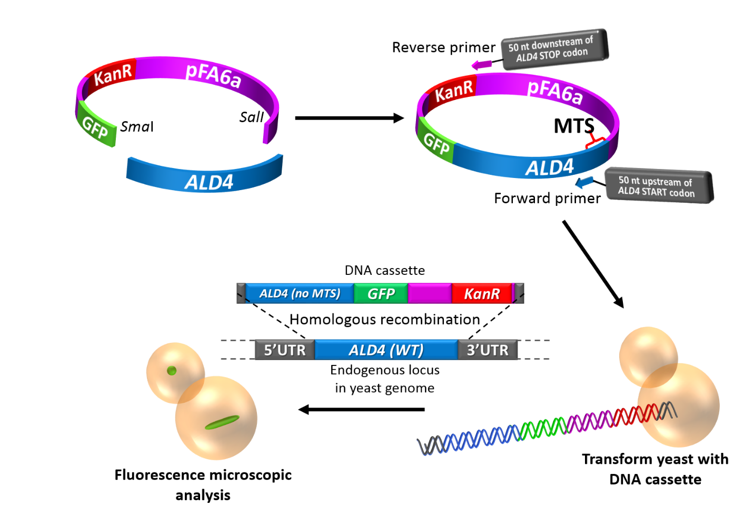
Supplementary Figure S1. Experimental Design. PCR-based modification of the yeast genome was used to delete the MTS coding sequence from chromosomal ALD4, and simultaneously introduce GFP to 3’ of the gene for visualization under fluorescence microscope. MTS-deleted Ald4p-GFP was then observed whether they could form supramolecular structures in the cytoplasm.

A
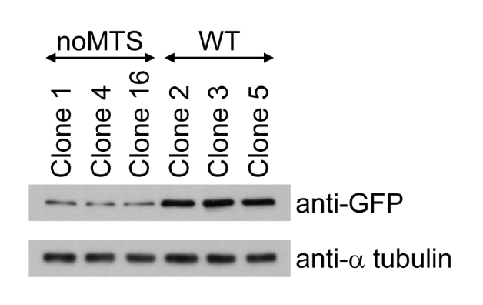
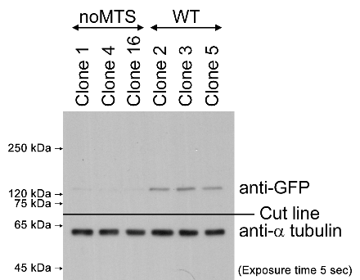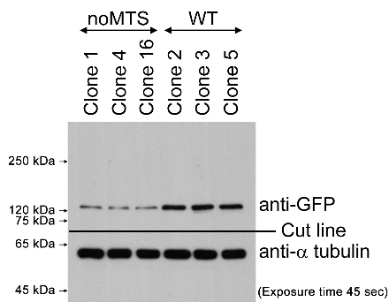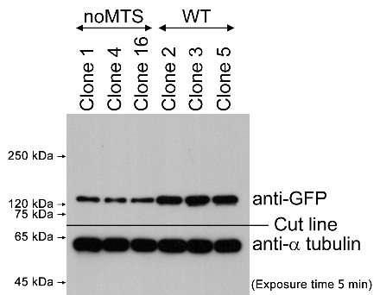

B
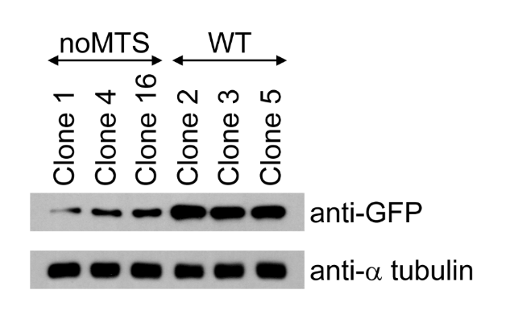
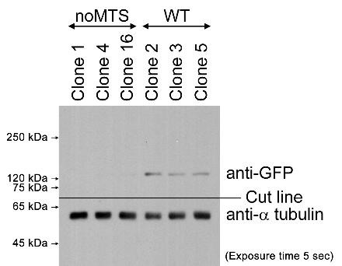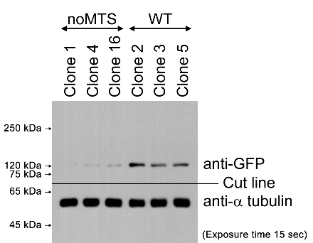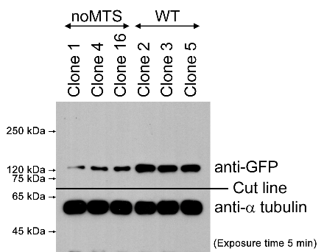

C
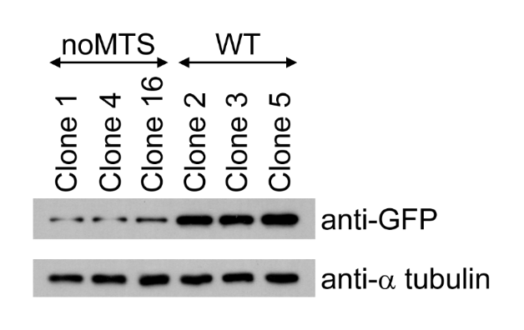
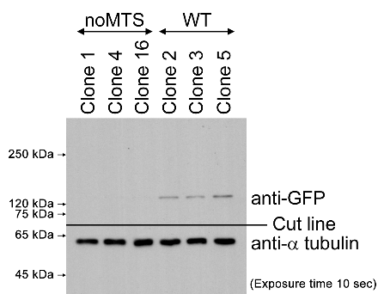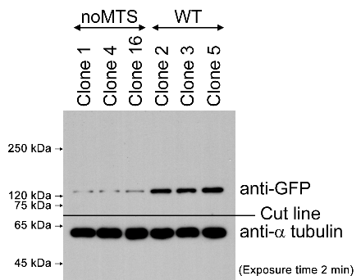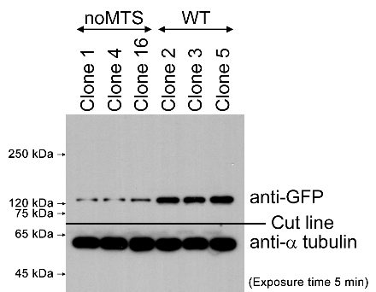
Supplementary Figure S2. Extramitochondrial structure formation of Ald4p(noMTS)-GFP was not driven by overexpression. Three different clones of yeast ALD4(noMTS)::GFP and ALD4(WT)::GFP were grown in liquid YPD at 30°C for 1 day with shaking. Then, 5 OD₆₀₀ cells were taken from each culture to prepare whole cell extract for SDS-PAGE and Western blot analysis. Each membrane was cut into 2 pieces between 75 and 65 kDa of the pre-stained protein ladder. The upper cuts were used to detect GFP-tagged Ald4p(noMTS) and Ald4p(WT) with anti-GFP (81.4 kDa and 84.0 kDa, respectively). The bands of Ald4p(noMTS)-GFP and Ald4p(WT)-GFP were detected slightly above the 120-kDa band of the protein ladder, suggesting that they were being in a dimeric form. The lower cuts were used to detect alpha-tubulin (as internal loading control) (49.7 kDa). Both were later assembled and developed the chemiluminescent signal together. (A), (B), and (C) were three different blots from three independent experiments performed to confirm the results. Full blots with multiple exposure times are shown below the cropped blots.

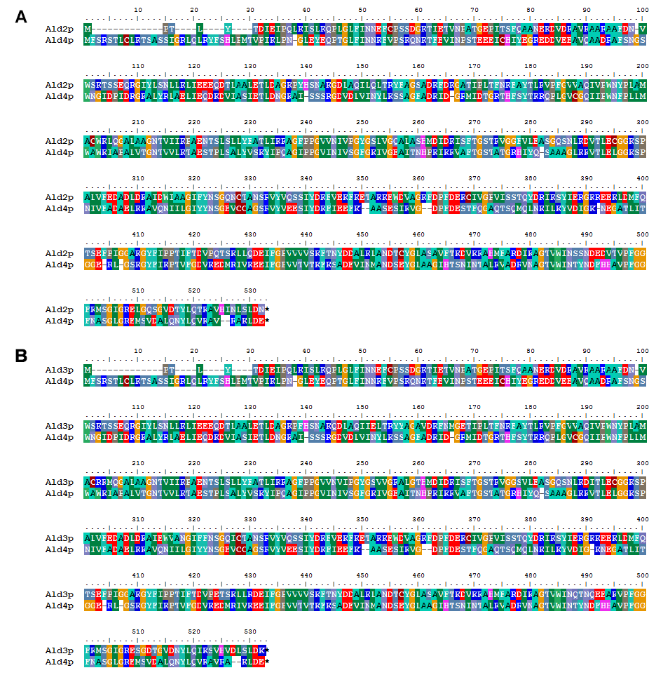
Supplementary Figure S3. Pairwise amino acid sequence alignments of aldehyde dehydrogenase isoenzymes. (A) The alignment of Ald2p (YMR170C, SGDID:S000004780) and Ald4p (YOR374W, SGDID:S000005901) shows 43.7% identity and 59.7% similarity in their amino acid sequences. (B) The alignment of Ald3p (YMR169C, SGDID:S000004779) and Ald4p (YOR374W, SGDID:S000005901) shows 42.4% identity and 59.3% similarity in their amino acid sequences.
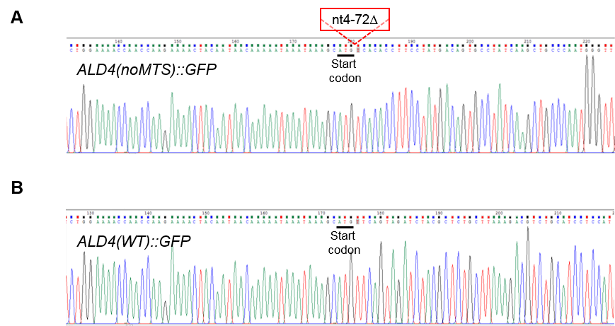
Supplementary Figure S4. Verification of mitochondrial targeting signal removed from the chromosomal gene ALD4 by DNA sequencing. (A) The nucleotides 4 to 72 of ALD4 coding sequence successfully deleted. (B) The wild-type sequence of ALD4 (as control).

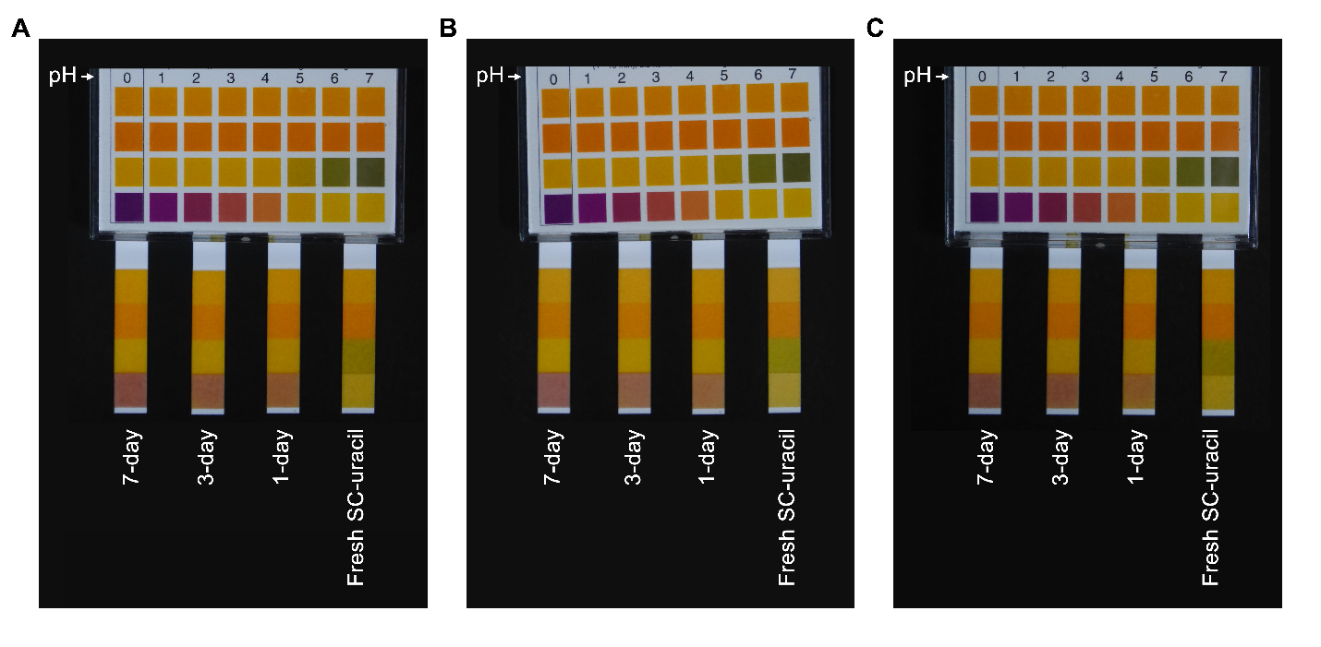
Supplementary Figure S5. Progressive drop of pH values of yeast culture medium SC-uracil. Yeast ALD4(noMTS)::GFP transformed with pVTU-mito-dsRED was grown in SC-uracil at 30°C with shaking for 1 day, 3 days, and 7 days, respectively. The culture media at different time points were isolated and tested for their pH values with pH 0-14 universal indicator strips. (A), (B), and (C) were three independent experiments.

Supplementary Table S1. List of primers used for recombinant DNA cloning, making DNA cassette for yeast transformation, and DNA sequencing.
Primer Code | Sequence (5’ to 3’) | Description | Used with | PCR Product Size
For cloning ALD4 into pFA6a-GFP-kanMX6 (resulting plasmid: pFA6a-ALD4-GFP-kanMX6)
CN0001 | 5’- GGGGTCGACATGTTCAGTAGATCTACGCTCTG -3’ | Forward, for cloning ALD4, SalI site underlined. | CN0002 | 1,575 bp
CN0002 | 5’-AAACCCGGGCTCGTCCAATTTGGCACGG-3’ | Reverse, for cloning ALD4, SmaI site underlined. | CN0001 | 1,575 bp
For making DNA cassette carrying (5’ to 3’): 50 nt upstream of ALD4 start codon + ALD4 coding sequence (without nucleotides coding for MTS) + GFP + kanamycin resistance gene + 50 nt downstream of ALD4 stop codon
DNA template: pFA6a-ALD4-GFP-kanMX6
CN0003 | 5’- GTATCTGGAAAACCAACCAAGAAAACTACAATAACAAAAATAAATAAAGCATGTCACACCTTCCTATGACAGTG -3’ | Forward, with 50 nt upstream of ALD4 start codon, nt73 (underlined) is placed right after start codon. | CN0004 | 4,012 bp
CN0004 | 5’- TTAATTTTATGTATGTAAGCATCGATTGGACACCAGGCTTATTGATGACCATCGATGAATTCGAGCTCG -3’ | Reverse, with 50 nt downstream of ALD4 stop codon, sequence homology to pFA6a-ALD4-GFP-kanMX6 (underlined). | CN0003 | 4,012 bp
For PCR verification of yeast transformants (to check if MTS is removed from ALD4, in the yeast genome)
CN0009 | 5’- GGAAAATGAGGGGCGGGTGTAG -3' | Forward; 200 nt upstream of ALD4 start codon. | JW1623 | 2670 bp (having MTS), 2601 bp (MTS removed)
JW1623 | 5’- GCGACCTCATACTATACCTG -3’ | Reverse; 164 nt downstream of GFP stop codon. | CN0009 | 2670 bp (having MTS), 2601 bp (MTS removed)
For DNA sequencing
CN0009 | 5’- GGAAAATGAGGGGCGGGTGTAG -3' | Forward; 200 nt upstream of ALD4 start codon
CN0010 | 5’- AAGATTGCCCCTGCTTTGG -3’ | Forward; nt 601-619 of ALD4 coding sequence
CN0011 | 5’- TACTTCATTAAGCCAACTGTCTTTG -3’ | Forward; nt 1201-1225 of ALD4 coding sequence

Supplementary Table S2. Data, used to plot graphs in Fig. 4, showing percentage of yeast cells ALD4(noMTS)::GFP with Ald4p(noMTS)-GFP structures comparing between media-shifted and non-shifted conditions.
(A) Three-day cultured cells shifted to fresh medium for 15 min.
Experiment # | Clone 1 |  | Clone 2
Experiment # | Shifted to fresh medium | No medium shift | Shifted to fresh medium | No medium shift
1 | 23.11% | 96.21% | 29.02% | 93.80%
2 | 58.47% | 84.27% | 12.89% | 86.74%
3 | 52.42% | 85.98% | 42.80% | 83.47%
Average | 44.67% | 88.82% | 28.24% | 88.01%
SEM | 10.92% | 3.73% | 8.64% | 3.05%
P-value (two-tailed) | 0.0187 |  | 0.0029

(B) Log-phase cells shifted to old medium for 15 min.
Experiment # | Clone 1 |  | Clone 2
Experiment # | Shifted to old medium | No medium shift | Shifted to old medium | No medium shift
1 | 73.39% | 9.27% | 79.18% | 8.11%
2 | 70.47% | 2.92% | 78.81% | 4.94%
3 | 91.90% | 5.02% | 82.08% | 2.52%
Average | 78.59% | 5.74% | 80.02% | 5.19%
SEM | 6.71% | 1.87% | 1.03% | 1.62%
P-value  (two-tailed) | 0.0005 |  | <0.0001

