Stem cells in middle ear cholesteatoma contribute to its pathogenesis
Julia Nagel^{1,2,}* , Saskia Wöllner^{1,2,}*, Matthias Schürmann¹, Viktoria Brotzmann¹, Janine Müller¹, Johannes FW Greiner^{1,2}, Peter Goon³, Barbara Kaltschmidt^{2,4}, Christian Kaltschmidt² and Holger Sudhoff^{1,#}

¹ Department of Otolaryngology, Head and Neck Surgery, Klinikum Bielefeld, 33604 Bielefeld, Germany
² Department of Cell Biology, University of Bielefeld, 33619 Bielefeld, Germany
³ Department of Dermatology, Norfolk and Norwich University Hospital, Colney Lane, Norwich, NR4 7UY, UK
⁴ AG Molecular Neurobiology, University of Bielefeld, 33619 Bielefeld, Germany
*Authors have equal contributions

#Corresponding Author:
Professor Holger Sudhoff, PhD, MD, FRCS, FRCPath
Department of Otolaryngology, Head and Neck Surgery
Klinikum Bielefeld, Teutoburger Str. 50
33604 Bielefeld, Germany
Tel. + 49 521 581 3301
FAX + 49 521 581 3399
holger.sudhoff@rub.de

Supplementary Information
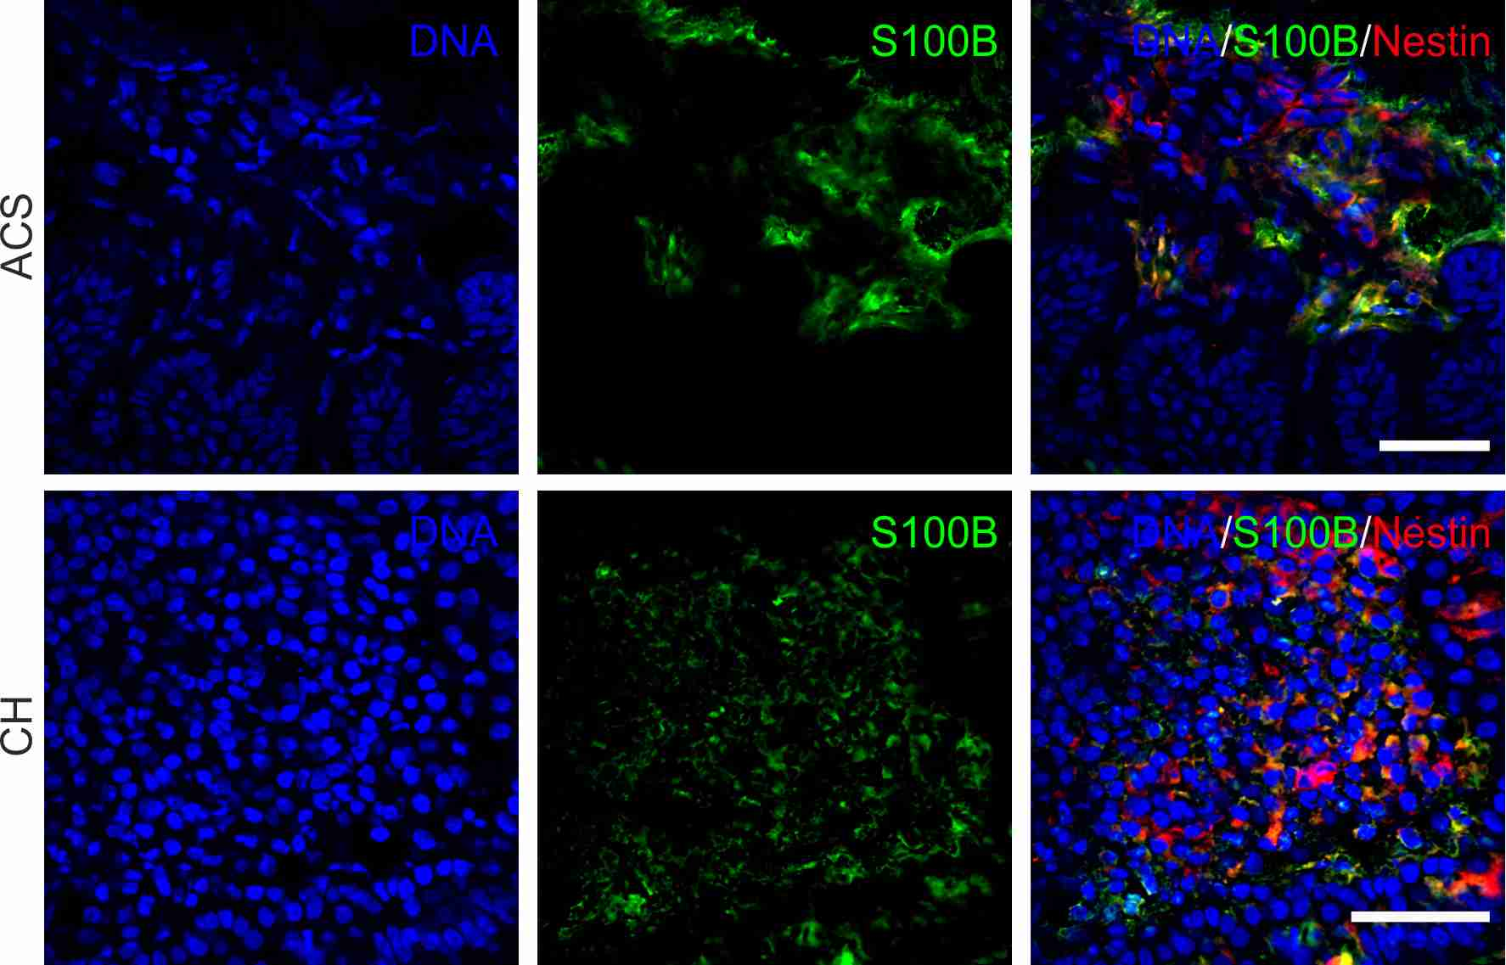
Supplementary figure S1. The co-localization of S100B and Nestin in cholesteatoma and auditory canal skin. Immunohistochemical staining of cryo-sectiones revealed the presence of cells co-expressing S100B and Nestin in cholesteatoma as well as in auditory canal skin tissue. Scale bar: 50µm.

Supplementary figure S2. Positive and negative control of Nestin and S100B immunohistochmistry in cholesteatoma tissue. Scale bar: 50µm.

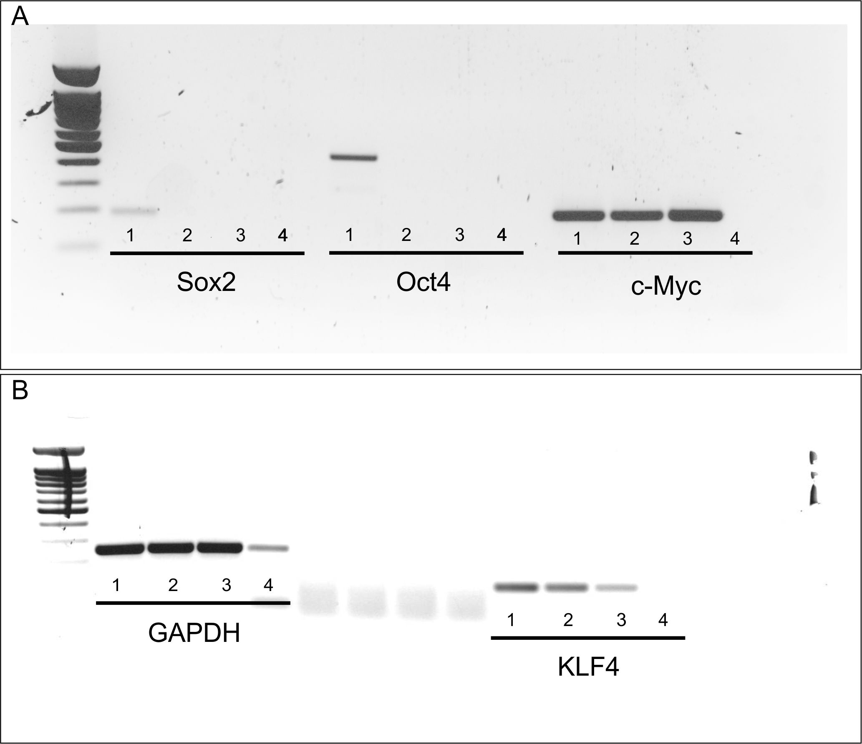
Supplementary figure S3. Gel blot of RT-PCR of the pluripotent factors. A RT-PCR of Sox2, Oct4 and c-Myc. The simple numbering is 1: PT: Positive control, iPSCs, 2: ME-CSCs, 3: ACSCs, 4: NT, No template control. B RT-PCR of GAPDH and KLF4.

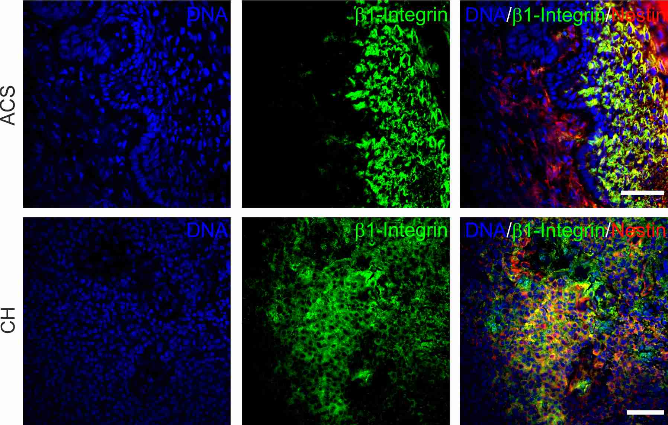
Supplementary figure S4. Co-expression of β1-integrin and Nestin in the cholesteatoma tissue. Immunohistological staining of cholesteatoma tissue (CH) and auditory canal skin (ACS). In the auditory canal skin the β1-integrin expressing cells are separated by the basal layer from the Nestin expressing cells in the lamina propria. In the cholesteatoma tissue β1-integrin shows a high degree of co-localization with Nestin. Scale bar: 50µm.

