miR-9 upregulation leads to inhibition of erythropoiesis by repressing FoxO3
Yunyuan Zhang^{1,2}, Liping Li^{2,4}, Chunjie Yu², Vitalyi Senyuk², Fuxing Li ^{2,3}, John G. Quigley², Tongyu Zhu⁴, Zhijian Qian²*
¹ Department of Clinical laboratory, The Affiliated Hospital of Qingdao University Medical College, Qingdao 266003, China
²Department of Medicine and Cancer Research Center, University of Illinois Hospital and Health Sciences System, Chicago, IL;
³ Department of Pediatrics, Tongji Hospital, Tongji University School of Medicine, Shanghai, China
⁴Fudan University ZhongShan Hospital, Shanghai, China.

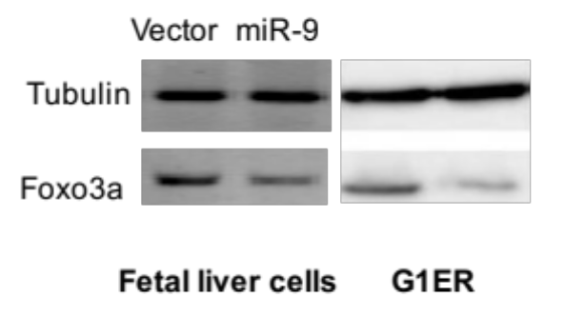
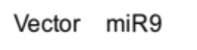

Supplementary Figure 1. Forced expression of miR-9 inhibits Foxo3a expression in fetal liver cells and G1ER cells. Western blot analysis of Foxo3 expression in GFP+ fetal liver cells (left panel) and G1ER cells (right panel) transduced with vector or miR-9

