Mitochondrial imaging in live or fixed tissues using a luminescent iridium complex

Alexandra Sorvina¹, Christie A. Bader¹, Jack R. T Darby², Mitchell C. Lock², Jia Yin Soo², Ian R. D. Johnson¹, Chiara Caporale³, Nicolas H. Voelcker^{4,5}, Stefano Stagni⁶, Massimiliano Massi^{3,1}, Janna L. Morrison², Sally E. Plush^{1,4} and Douglas A. Brooks¹

¹Mechanisms in Cell Biology and Disease Research Group, School of Pharmacy and Medical Sciences, Sansom Institute for Health Research, University of South Australia, Adelaide, South Australia 5001, Australia.
²Early Origins of Adult Health Research Group, School of Pharmacy and Medical Sciences, Sansom Institute for Health Research, University of South Australia, Adelaide, South Australia 5001, Australia.
³Department of Chemistry and Curtin Institute for Functional Molecules and Interfaces, Curtin University, Bentley, Western Australia 6102, Australia.
⁴Future Industries Institute, University of South Australia, Adelaide, South Australia, 5095, Australia.
⁵Drug Delivery, Disposition and Dynamics, Monash Institute of Pharmaceutical Sciences, Monash University, Parkville, Victoria 3052, Australia.
⁶Department of Industrial Chemistry “Toso Montanari”, University of Bologna, Bologna I-40136, Italy.
Correspondence should be addressed to S. E. P. (Sally.Plush@unisa.edu.au) or D.A.B. (Doug.Brooks@unisa.edu.au)

Supplementary Information

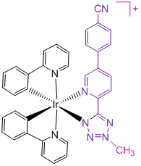
Supplementary Figure 1| Structure of IraZolve-Mito.

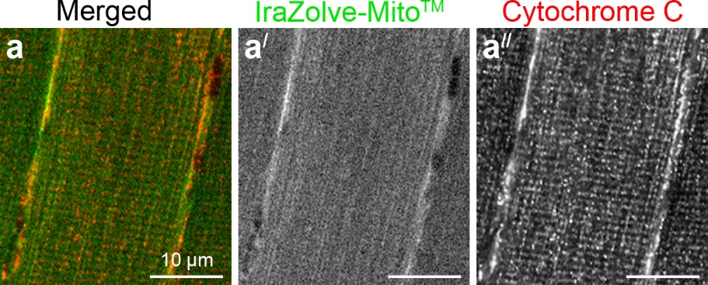
Supplementary Figure 2| Co-staining of IraZolve-Mito with antibody resulted in only faint staining with the former. Confocal micrographs showing subcellular localisation of IraZolve-Mito (green in a; greyscale in a/) in relation to Cytochrome C (red in a; greyscale in a//) in fixed skeletal muscle samples. Scale bars: 10 µm.

Staining protocol for paraffin embedded samples
Formalin-fixed paraffin-embedded skeletal muscle tissue sections (5 µm thick) were dewaxed in xylene, rehydrated in a graded series of ethanol concentrations and then separated in two groups, one of which underwent heat-induced antigen retrieval at pH 6. Sections were stained with IraZolve-Mito for 30 minutes at room temperature and then washed for 5 minutes in PBS. As tissues exhibited strong fluorescence, spectral unmixing procedure was applied for the detection of IraZolve-Mito. Images for IraZolve-Mito were obtained using a 403 nm laser and emission was collected at 608 nm (emission wavelength bandwidth was set to 89.8 nm). Although it was possible to detect IraZolve-Mito in formalin-fixed paraffin-embedded skeletal muscle samples, the staining pattern of this imaging reagent was not maintained.

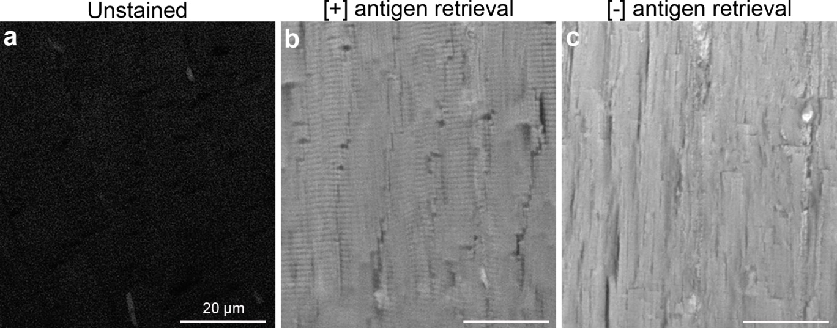
Supplementary Figure 3| Staining pattern of IraZolve-Mito is not maintained in formalin-fixed paraffin-embedded (FFPE) skeletal muscle samples. Representative confocal micrographs showing unstained (a) and stained with IraZolve-Mito (b, c) FFPE skeletal muscle samples. Scale bars: 20 µm.

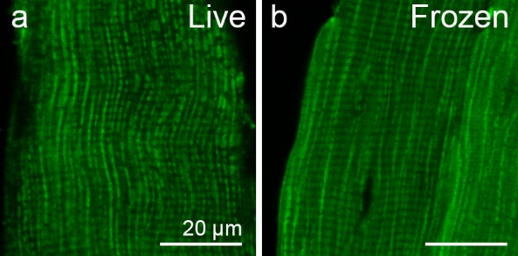
Supplementary Figure 4| Staining pattern of IraZolve-Mito is maintained in frozen skeletal muscle samples. Representative confocal micrographs showing subcellular distribution of IraZolve-Mito in live (a) and frozen (b) skeletal muscle samples. Scale bars: 20 µm.

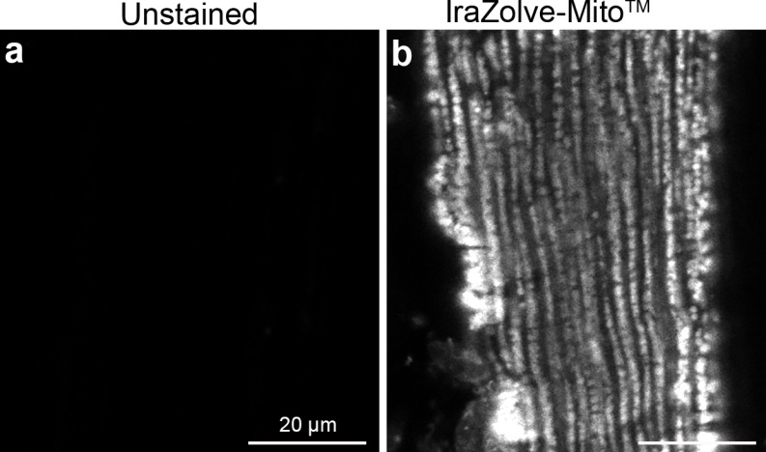
Supplementary Figure 5| Imaging IraZolve-Mito in skeletal muscle samples left panel control unstained tissue, right panel IraZolve-Mito stained tissue.

