Supplementary Information
Mercury transport and human exposure from global marine fisheries

Raphael A. Lavoie*, Ariane Bouffard, Roxane Maranger, and Marc Amyot
GRIL, Département de Sciences Biologiques, Université de Montréal, C.P. 6128, Succursale Centre-ville, Pavillon Marie-Victorin, Montréal, Québec H3C 3J7, Canada
Corresponding author e-mail: lavoie.raphael@gmail.com

Supplementary Table 1 | Results of segmented regressions with breakpoint year ± standard error (SE) and segmented line slopes with lower and upper 95% confidence intervals (CI) for fisheries catch time series of the entire ocean, the coastal ecosystem and the high seas presented in Fig. 1. The Davies test is testing for a non-zero difference-in-slope parameter.

Catch time series | Segmented regression |  |  |  | Davies test | Overall test
 | Breakpoint (year ± SE) | Line | Slope (kmol a⁻¹) | 95% CI |  | R²_{adj} | P
Entire ocean |  | 1 | 1.25 | 1.21–1.29 |  | 0.992 | <0.001
 | 1991 ± 0.7 | 2 | 0.04 | -0.05–0.14 | <0.001
Coastal |  | 1 | 1.11 | 1.07–1.15 |  | 0.987 | <0.001
 | 1989 ± 0.6 | 2 | -0.19 | -0.28– -0.10 | <0.001
High seas |  | 1 | 0.10 | 0.08–0.13 |  | 0.988 | <0.001
 | 1975 ± 1.3 | 2 | 0.27 | 0.26–0.28 | <0.001

Supplementary Table 2 | Trophic level (TL; mean ± SE) from FishBase¹ for each ISSCAAP group.
ISSCAAP group | TL |  |  | Rounded TL ª | N
Abalones, winkles, conchs | 2.1 | ± | 0.24 | 2 | 17
Blue-whales, fin-whales | 3.8 | ± | 0.58 | 4 | 7
Carps, barbels and other cyprinids | 2.8 | ± | 0.28 | 3 | 72
Clams, cockles, arkshells | 2.1 | ± | 0.13 | 2 | 42
Cods, hakes, haddocks | 3.9 | ± | 0.52 | 4 | 72
Crabs, sea-spiders | 2.9 | ± | 0.38 | 3 | 25
Eared seals, hair seals, walruses | 4.2 | ± | 0.59 | 4 | 18
Flounders, halibuts, soles | 3.6 | ± | 0.42 | 4 | 59
Freshwater crustaceans | 2.2 | ± | 0.36 | 2 | 19
Freshwater molluscs | 2.1 | ± | 0.15 | 2 | 3
Herrings, sardines, anchovies | 3.0 | ± | 0.27 | 3 | 55
Horseshoe crabs and other arachnoids | 2.3 | ± | 0.61 | 2 | 1
King crabs, squat-lobsters | 2.3 | ± | 0.24 | 2 | 14
Krill, planktonic crustaceans | 3.1 | ± | 0.34 | 3 | 2
Lobsters, spiny-rock lobsters | 2.7 | ± | 0.35 | 3 | 26
Marine fishes not identified | 3.7 | ± | 0.46 | 4 | 1113
Miscellaneous aquatic invertebrates | 2.7 | ± | 0.53 | 3 | 5
Miscellaneous aquatic mammals | 2.8 | ± | 0.22 | 3 | 2
Miscellaneous coastal fishes | 3.6 | ± | 0.43 | 4 | 420
Miscellaneous demersal fishes | 3.8 | ± | 0.47 | 4 | 181
Miscellaneous diadromous fishes | 3.8 | ± | 0.54 | 4 | 8
Miscellaneous freshwater fishes | 3.4 | ± | 0.42 | 3 | 156
Miscellaneous marine crustaceans | 2.6 | ± | 0.32 | 3 | 7
Miscellaneous marine molluscs | 2.1 | ± | 0.13 | 2 | 1
Miscellaneous pelagic fishes | 3.9 | ± | 0.48 | 4 | 124
Mussels | 2.1 | ± | 0.22 | 2 | 13
Oysters | 2.1 | ± | 0.13 | 2 | 15
River eels | 3.7 | ± | 0.50 | 4 | 5
Salmons, trouts, smelts | 3.5 | ± | 0.35 | 4 | 38
Scallops, pectens | 2.1 | ± | 0.29 | 2 | 15
Sea-squirts and other tunicates | 3.0 | ± | 0.30 | 3 | 4
Sea-urchins and other echinoderms | 2.3 | ± | 0.61 | 2 | 10
Shads | 3.3 | ± | 0.37 | 3 | 25
Sharks, rays, chimaeras | 4.0 | ± | 0.49 | 4 | 155
Shrimps, prawns | 2.6 | ± | 0.35 | 3 | 64
Sperm-whales, pilot-whales | 4.4 | ± | 0.53 | 4 | 27
Squids, cuttlefishes, octopuses | 3.7 | ± | 0.50 | 4 | 30
Sturgeons, paddlefishes | 3.3 | ± | 0.39 | 3 | 11
Tilapias and other cichlids | 2.8 | ± | 0.25 | 3 | 25
Tunas, bonitos, billfishes | 4.3 | ± | 0.66 | 4 | 47
Turtles | 2.6 | ± | 0.33 | 3 | 7
ª Trophic level rounded to the nearest integer.

Supplementary Table 3 | Total mercury (THg) and methylmercury (MeHg) mean concentrations (μg g⁻¹) ± standard deviation for each 41 ISSCAAP group weighted for samples sizes (Hg_{w} ± SD_{w}). These concentrations were paired with annual catch of marine fisheries of the same ISSCAAP groups to estimate Hg export.
ISSCAAP group | Measured Hg_{w} ª |  |  | Whole THg_{w} ^{b} |  |  | Whole MeHg_{w} ^{c} | N | Reference ^{d}
Abalones, winkles, conchs | 0.007 | ± | 0.007 | 0.007 | ± | 0.007 | 0.003 | 15 | ²
Blue-whales, fin-whales | 0.243 | ± | 0.351 | 0.139 | ± | 0.199 | 0.026 | 262 | ³⁻⁸
Carps, barbels and other cyprinids | 0.165 | ± | 0.093 | 0.105 | ± | 0.055 | 0.061 | 420 | ⁹
Clams, cockles, arkshells | 0.024 | ± | 0.022 | 0.024 | ± | 0.022 | 0.011 | 816 | ^{9,10}
Cods, hakes, haddocks | 0.105 | ± | 0.076 | 0.068 | ± | 0.046 | 0.040 | 3062 | ⁹
Crabs, sea-spiders | 0.102 | ± | 0.088 | 0.102 | ± | 0.088 | 0.047 | 1361 | ⁹
Eared seals, hair seals, walruses | 13.1 | ± | 17.8 | 0.450 | ± | 0.601 | 0.086 | 1439 | ^{4,5,10-24}
Flounders, halibuts, soles | 0.190 | ± | 0.100 | 0.119 | ± | 0.060 | 0.069 | 6141 | ⁹
Freshwater crustaceans | 0.210 |  |  | 0.210 |  |  | 0.097 | 1 | ⁹
Freshwater molluscs | 0.020 | ± | 0.013 | 0.020 | ± | 0.013 | 0.009 | 95 | ^{25,26}
Herrings, sardines, anchovies | 0.069 | ± | 0.040 | 0.046 | ± | 0.025 | 0.027 | 2314 | ⁹
Horseshoe crabs and other arachnoids | 0.077 | ± | 0.020 | 0.077 | ± | 0.020 | 0.036 | 214 | ^{27,28}
King crabs, squat-lobsters | 0.096 | ± | 0.085 | 0.096 | ± | 0.085 | 0.044 | 2102 | ^{2,5,9-11,29}
Krill, planktonic crustaceans | 0.013 | ± | 0.008 | 0.013 | ± | 0.008 | 0.006 | 61 | ^{2,5,10,11,29}
Lobsters, spiny-rock lobsters | 0.185 | ± | 0.071 | 0.185 | ± | 0.071 | 0.085 | 172 | ⁹
Marine fishes not identified | 0.340 | ± | 0.454 | 0.202 | ± | 0.247 | 0.117 | 32480 | ^{9,30,31}
Miscellaneous aquatic invertebrates | 0.047 | ± | 0.061 | 0.047 | ± | 0.061 | 0.022 | 7530 | ^{2,5,9-11,25-29}
Miscellaneous aquatic mammals | 10.9 | ± | 37.0 | 1.74 | ± | 7.7 | 0.331 | 2346 | ^{3-8,10-24,32-41}
Miscellaneous coastal fishes | 0.264 | ± | 0.194 | 0.162 | ± | 0.113 | 0.094 | 5212 | ⁹
Miscellaneous demersal fishes | 0.169 | ± | 0.140 | 0.106 | ± | 0.081 | 0.062 | 10126 | ⁹
Miscellaneous diadromous fishes | 0.139 | ± | 0.125 | 0.088 | ± | 0.075 | 0.051 | 4586 | ^{9,30,31}
Miscellaneous freshwater fishes | 0.227 | ± | 0.146 | 0.141 | ± | 0.086 | 0.082 | 9840 | ⁹
Miscellaneous marine crustaceans | 0.096 | ± | 0.085 | 0.096 | ± | 0.085 | 0.044 | 2102 | ^{2,5,9-11,29}
Miscellaneous marine molluscs | 0.020 | ± | 0.019 | 0.020 | ± | 0.019 | 0.009 | 4368 | ^{2,9,10}
Miscellaneous pelagic fishes | 0.587 | ± | 0.637 | 0.341 | ± | 0.341 | 0.198 | 12257 | ⁹
Mussels | 0.026 | ± | 0.015 | 0.026 | ± | 0.015 | 0.012 | 589 | ⁹
Oysters | 0.015 | ± | 0.014 | 0.015 | ± | 0.014 | 0.007 | 2815 | ⁹
River eels | 0.220 | ± | 0.118 | 0.138 | ± | 0.068 | 0.080 | 535 | ⁹
Salmons, trouts, smelts | 0.050 | ± | 0.015 | 0.034 | ± | 0.010 | 0.020 | 2204 | ⁹
Scallops, pectens | 0.064 | ± | 0.027 | 0.064 | ± | 0.027 | 0.030 | 133 | ⁹
Sea-squirts and other tunicates | 0.340 | ± | 0.454 | 0.202 | ± | 0.247 | 0.093 | 32480 | ^{9,30,31}
Sea-urchins and other echinoderms | 0.009 | ± | 0.011 | 0.009 | ± | 0.011 | 0.004 | 15 | ^{2,10}
Shads | 0.077 | ± | 0.029 | 0.051 | ± | 0.018 | 0.030 | 93 | ⁹
Sharks, rays, chimaeras | 0.893 | ± | 0.487 | 0.515 | ± | 0.257 | 0.299 | 3021 | ⁹
Shrimps, prawns | 0.058 | ± | 0.046 | 0.058 | ± | 0.046 | 0.027 | 508 | ^{2,5,9}
Sperm-whales, pilot-whales | 10.2 | ± | 65.0 | 5.27 | ± | 14.1 | 1.00 | 645 | ^{4,7,10,32-41}
Squids, cuttlefishes, octopuses | 0.061 | ± | 0.055 | 0.061 | ± | 0.055 | 0.028 | 735 | ⁹
Sturgeons, paddlefishes | 0.139 | ± | 0.106 | 0.088 | ± | 0.064 | 0.051 | 157 | ^{30,31}
Tilapias and other cichlids | 0.196 | ± | 0.128 | 0.123 | ± | 0.075 | 0.071 | 2907 | ⁹
Tunas, bonitos, billfishes | 0.665 | ± | 0.733 | 0.384 | ± | 0.385 | 0.223 | 6051 | ⁹
Turtles | 0.028 | ± | 0.014 | 0.028 | ± | 0.014 | 0.011 | 28 | ^{42,43}

ª Measurements made on edible portion (fillet or whole for small fish)⁹. Hg measurements on edible portions are assumed to be representative of THg and MeHg⁹.
^{b} THg concentration in fish muscle for each ISSCAAP group was transformed into whole body concentrations according to the equation (1) of main text⁴⁴.
^{c} We used percent of THg as MeHg of 58% for whole fish (n = 39), 46% for whole invertebrates (n = 462), and 39% for various tissues of turtles (n = 944). For marine mammals, we estimated the whole body burden of MeHg using published %MeHg resulting in an average of 19% of THg as MeHg (n = 206).
^{d} The Hg Seafood Database⁹ can be found at the author’s website (http://www.stonybrook.edu/commcms/gelfond/fish/database.html).

Supplementary Table 4 | Per capita methylmercury (MeHg) weekly intake (WI; μg of MeHg / kg of body mass (BM) / week) of marine fish and seafood between 1961 and 2011 for each country based on data of fish and seafood supply available for food consumption from the FAO.
See spreadsheet “Lavoie et al_Hg Fisheries_Supplementary Table4.xlsx”.

Supplementary Table 5 | Average mass (mean ± SD, in metric tonnes; t) of odontocetes, mysticetes and pinnipeds.
Common name | Scientific name | Mass (mean ± SD; t) |  |  | n | Reference
Odontocetes ("Sperm-whales, pilot-whales" group)
Commerson's Dolphin | Cephalorhynchus commersonii | 0.070 | ± | 0.009 | 11 | ⁴⁵
Heaviside's Dolphin | Cephalorhynchus heavisidii | 0.071 |  |  | 1 | ⁴⁵
Beluga Whale | Delphinapterus leucas | 0.38 | ± | 0.07 | 3 | ⁴⁶
Short-beaked Common Dolphin | Delphinus delphis | 0.088 | ± | 0.030 | 246 | ⁴⁵
Pygmy Killer Whale | Feresa attenuata | 0.11 | ± | 0.01 | 9 | ⁴⁵
Short-finned Pilot Whale | Globicephala macrorhynchus | 0.93 | ± | 0.44 | 9 | ⁴⁵
Long-finned Pilot Whale | Globicephala melas | 0.70 | ± | 0.49 | 19 | ⁴⁵
Risso's Dolphin | Grampus griseus | 0.28 | ± | 0.09 | 18 | ⁴⁵
Boto | Inia geoffrensis | 0.08 | ± | 0.03 | 4 | ⁴⁵
Pygmy Sperm Whale | Kogia breviceps | 0.35 | ± | 0.13 | 47 | ⁴⁵
Dwarf Sperm Whale | Kogia sima | 0.15 | ± | 0.05 | 20 | ⁴⁵
Fraser's Dolphin | Lagenodelphis hosei | 0.23 | ± | 0.13 | 2 | ⁴⁵
Atlantic White-sided Dolphin | Lagenorhynchus acutus | 0.15 | ± | 0.04 | 66 | ⁴⁵
White-beaked Dolphin | Lagenorhynchus albirostris | 0.22 | ± | 0.03 | 3 | ⁴⁵
Pacific White-sided Dolphin | Lagenorhynchus obliquidens | 0.11 | ± | 0.03 | 14 | ⁴⁵
Northern Right Whale Dolphin | Lissodelphis borealis | 0.077 | ± | 0.013 | 5 | ⁴⁵
Sowerby's Beaked Whale | Mesoplodon bidens | 0.65 |  |  | 1 | ⁴⁵
Hubbs' Beaked Whale | Mesoplodon carlhubbsi | 0.99 | ± | 0.62 | 2 | ⁴⁵
Blainville's Beaked Whale | Mesoplodon densirostris | 0.78 | ± | 0.23 | 6 | ⁴⁵
Gervais' Beaked Whale | Mesoplodon europaeus | 0.70 | ± | 0.15 | 13 | ⁴⁵
Ginkgo-toothed Beaked Whale | Mesoplodon ginkgodens | 1.0 | ± | 0.41 | 3 | ⁴⁵
Gray's Beaked Whale | Mesoplodon grayi | 1.0 |  |  | 1 | ⁴⁵
True's Beaked Whale | Mesoplodon mirus | 1.1 | ± | 0.23 | 3 | ⁴⁵
Pygmy Beaked Whale | Mesoplodon peruvianus | 0.28 |  |  | 1 | ⁴⁵
Indo-Pacific Finless Porpoise | Neophocaena phocaenoides | 0.033 |  |  | 1 | ⁴⁵
Irrawaddy Dolphin | Orcaella brevirostris | 0.084 | ± | 0.00 | 2 | ⁴⁵
Killer Whale | Orcinus orca | 1.8 | ± | 1.1 | 40 | ⁴⁷
Melon-headed Whale | Peponocephala electra | 0.17 | ± | 0.04 | 3 | ⁴⁵
Porpoise | Phocaena phocaena | 0.049 | ± | 0.015 | 96 | ^{45,46}
Vaquita | Phocoena sinus | 0.045 | ± | 0.006 | 4 | ⁴⁵
Dall's Porpoise | Phocoenoides dalli | 0.10 | ± | 0.03 | 35 | ⁴⁵
Dall's Porpoise | Phocoenoides truei | 0.10 | ± | 0.01 | 2 | ⁴⁵
Sperm Whale | Physeter macrocephalus | 31 | ± | 12 | 50 | ^{45,48}
Ganges River Dolphin | Platanista gangetica | 0.066 | ± | 0.013 | 7 | ⁴⁵
Franciscana | Pontoporia blainvillei | 0.031 | ± | 0.008 | 30 | ⁴⁵
False Killer Whale | Pseudorca crassidens | 0.54 | ± | 0.20 | 7 | ⁴⁵
Tucuxi | Sotalia fluviatilis | 0.030 |  |  | 1 | ⁴⁵
Pantropical Spotted Dolphin | Stenella attenuata | 0.061 | ± | 0.015 | 125 | ⁴⁵
Clymene Dolphin | Stenella clymene | 0.066 | ± | 0.028 | 2 | ⁴⁵
Striped Dolphin | Stenella coeruleoalba | 0.093 | ± | 0.036 | 164 | ⁴⁵
Atlantic Spotted Dolphin | Stenella frontalis | 0.10 | ± | 0.02 | 25 | ⁴⁵
Spinner Dolphin | Stenella longirostris | 0.062 | ± | 0.008 | 29 | ⁴⁵
Rough-toothed Dolphin | Steno bredanensis | 0.11 | ± | 0.02 | 25 | ⁴⁵
Shepherd's Beaked Whale | Tasmacetus shepherdi | 2.1 |  |  | 1 | ⁴⁵
Indo-Pacific Bottlenose Dolphin | Tursiops aduncus | 0.18 | ± | 0.02 | 4 | ⁴⁵
Common Bottlenose Dolphin | Tursiops truncatus | 0.21 | ± | 0.06 | 275 | ⁴⁵
Cuvier's Beaked Whale | Ziphius cavirostris | 1.6 | ± | 0.86 | 14 | ⁴⁵
Mean odontocetes |  | 1.3 | ± | 6.1 | 1449
Mysticetes ("Blue-whales, fin-whales" group)
Minke Whale | Balaenoptera acutorostrata | 5.8 | ± | 2.4 | 23 | ⁴⁸
Sei Whale | Balaenoptera borealis | 14 | ± | 6.7 | 20 | ⁴⁸
Bryde Whale | Balaenoptera brydei | 13 | ± | 2.1 | 27 | ⁴⁸
Blue Whale | Balaenoptera musculus | 88 | ± | 34 | 44 | ⁴⁸
Blue Whale | Balaenoptera musculus | 58 |  |  | 1 | ⁴⁶
Pigmy blue Whale | Balaenoptera musculus brevicauda | 47 | ± | 17 | 5 | ⁴⁸
Fin Whale | Balaenoptera physalus | 49 | ± | 9.3 | 42 | ⁴⁸
Gray Whale | Eschrichtius robustus | 17 | ± | 10 | 8.0 | ⁴⁸
Pacific right Whale | Eubalaena glacialis sieboldii | 58 | ± | 20 | 18 | ⁴⁸
Humpback Whale | Megaptera novaeangliae | 34 | ± | 6.0 | 7 | ⁴⁸
Mean mysticetes |  | 43 | ± | 35 | 195
Pinnipeds ("Eared seals, hair seals, walruses" group)
Guadalupe fur seal | Arctocephalus townsendi | 0.049 | ± | 0.0057 | 14 | ⁴⁹
Bearded seal | Erignathus barbatus | 0.20 | ± | 0.12 | 2 | ⁴⁶
Grey seal | Halichoevus gvypus | 0.26 | ± | 0.026 | 23 | ⁵⁰
Weddell seal | Leptonychotes weddellii | 0.35 | ± | 0.047 | 2 | ¹²
Elephant seal | Mirounga sp. | 2.0 |  |  | 1 | ⁵¹
Walrus | Odobenus rosmaru | 0.35 | ± | 0.33 | 4 | ⁴⁶
Ringed seal | Phoca hispida | 0.040 | ± | 0.0002 | 2 | ⁴⁶
Seal | Phoca richardi geronimensis | 0.11 |  |  | 1 | ⁴⁶
Mean pinnipeds |  | 0.23 | ± | 0.29 | 49

Supplementary Table 6 | Methylmercury (MeHg) mean concentrations (μg g⁻¹) ± standard deviation for each taxonomic group weighted for samples sizes (Hg_{w} ± SD_{w}).
Taxonomic group ª | MeHg_{w} ^{b} |  |  | N | Reference ^{c}
Crustaceans | 0.096 | ± | 0.085 | 2102 | ^{2,5,9-11,29}
Cephalopods | 0.047 | ± | 0.061 | 7530 | ^{2,5,9-11,25-29}
Demersal fish | 0.169 | ± | 0.140 | 10126 | ⁹
Molluscs, Other | 0.020 | ± | 0.019 | 4368 | ^{2,9,10}
Pelagic fish | 0.587 | ± | 0.637 | 12257 | ⁹
Marine fish, Other | 0.340 | ± | 0.454 | 32480 | ^{9,30,31}

ª Taxonomic groups for which available food supply data (kg capita⁻¹ year⁻¹) are accessible from the FAO⁵².
^{b} Measurements made on edible portion (fillet or whole for small fish)⁹. Hg measurements on edible portions are assumed to be representative of THg and MeHg⁹.
^{c} The Hg Seafood Database⁹ can be found at the author’s website (http://www.stonybrook.edu/commcms/gelfond/fish/database.html).

Supplementary Table 7 | List of Major Fishing Areas (MFA) for statistical purposes
MFA name | MFA number
Arctic Sea | 18
Atlantic, Northwest | 21
Atlantic, Northeast | 27
Atlantic, Western Central | 31
Atlantic, Eastern Central | 34
Mediterranean and Black Sea | 37
Atlantic, Southwest | 41
Atlantic, Southeast | 47
Atlantic, Antarctic | 48
Indian Ocean, Western | 51
Indian Ocean, Eastern | 57
Indian Ocean, Antarctic | 58
Pacific, Northwest | 61
Pacific, Northeast | 67
Pacific, Western Central | 71
Pacific, Eastern Central | 77
Pacific, Southwest | 81
Pacific, Southeast | 87
Pacific, Antarctic | 88

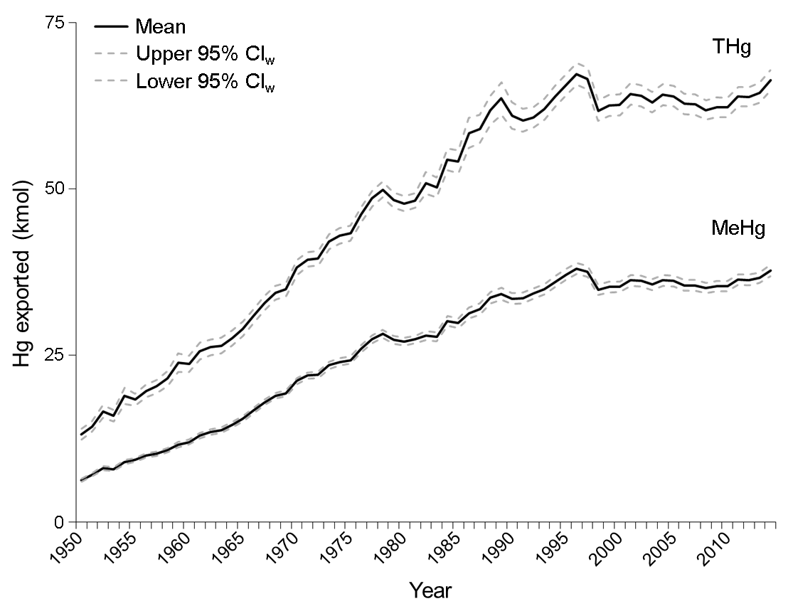Supplementary Figure 1 | Temporal trends (1950‒2014) of Hg exported from the entire ocean resulting from marine fisheries. Average (full line) with lower and upper 95% confidence intervals weighted for sample size (CI_{w}; dashed lines) are shown.

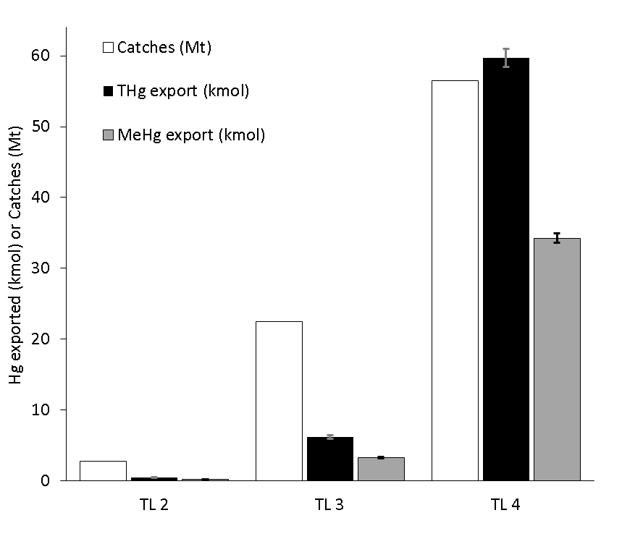
Supplementary Figure 2 | Catches (white) and total mercury (THg; black) and methylmercury (MeHg; grey) exported from the entire ocean resulting from marine fisheries in 2014 by trophic level (TL). Averages with lower and upper 95% confidence intervals weighted for sample size (CI_{w}; error bars) are shown for Hg export.

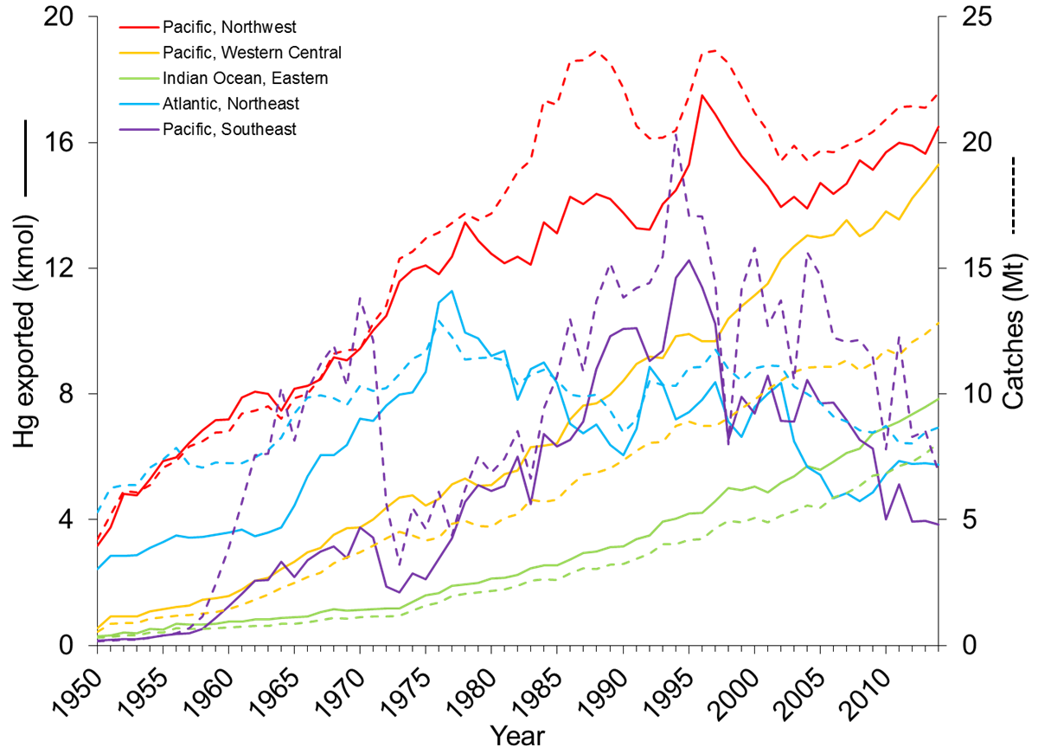
Supplementary Figure 3 | Temporal trends (1950‒2014) of catches (dashed lines) and Hg exported (full lines). Northwest Pacific (#61; red), Western Central Pacific (#71; orange), Eastern Indian Ocean (#57; green), Northeast Atlantic (#27; blue), and Southeast Pacific (#87; purple).

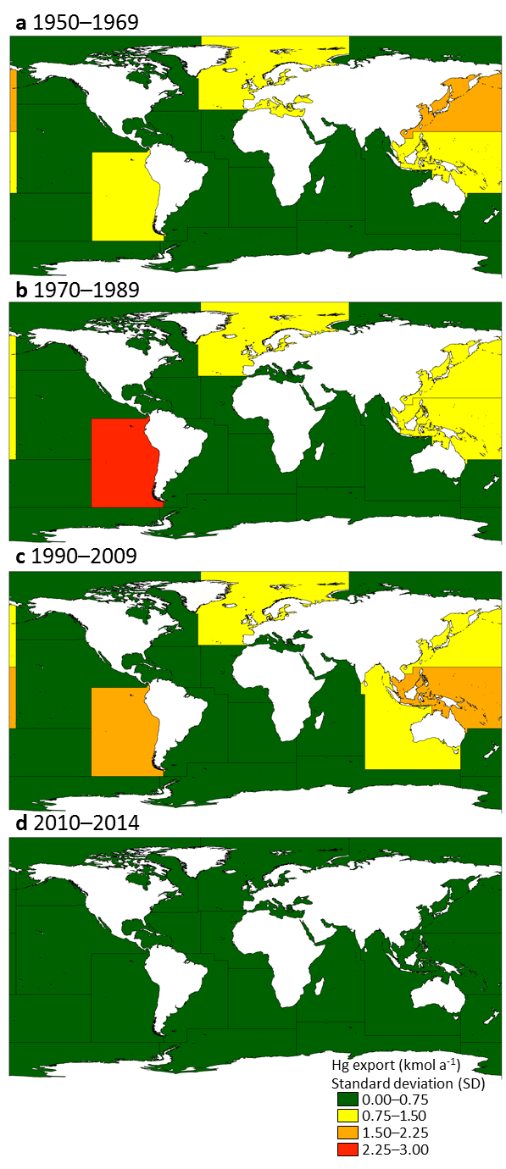
Supplementary Figure 4 | Hg export from the ocean. Standard deviations of mean total Hg export data in a, 1950–1969, b, 1970–1989, c, 1990–2009, and d, 2010–2014 resulting from catches of fishes, molluscs, crustaceans, reptiles, and mammals for each Major Fishing Areas (MFA). MFA numbers are provided in panel a and corresponding MFA names are found in Supplementary Table 7. Means for each period are found in Fig. 2. Maps were created in ArcGIS version 10.3.1 (http://desktop.arcgis.com/).
References
1 Froese, R. & Pauly, D. FishBase. http://fishbase.org. (2016).
2 Lavoie, R. A. et al. Trophic structure and mercury distribution in a Gulf of St. Lawrence (Canada) food web using stable isotope analysis. Sci. Total Environ. 408, 5529-5539, doi:10.1016/j.scitotenv.2010.07.053 (2010).
3 Bilandzic, N. et al. Concentration of mercury and selenium in tissues of five cetacean species from Croatian coastal waters. Arch. Biol. Sci. 67, 1377-1389, doi:10.2298/abs140215116b (2015).
4 Dehn, L. A. et al. Trophic relationships in an Arctic food web and implications for trace metal transfer. Sci. Total Environ. 362, 103-123, doi:10.1016/j.scitotenv.2005.11.012 (2006).
5 Riget, F. et al. Transfer of mercury in the marine food web of West Greenland. J. Environ. Monit. 9, 877-883, doi:10.1039/b704796g (2007).
6 Born, E. W. et al. Population substructure of North Atlantic minke whales (Balaenoptera acutorostrata) inferred from regional variation of elemental and stable isotopic signatures in tissues. J. Mar. Syst. 43, 1-17, doi:10.1016/s0924-7963(03)00085-x (2003).
7 Hansen, A. M. K., Bryan, C. E., West, K. & Jensen, B. A. Trace Element Concentrations in Liver of 16 Species of Cetaceans Stranded on Pacific Islands from 1997 through 2013. Arch. Environ. Contam. Toxicol. 70, 75-95, doi:10.1007/s00244-015-0204-1 (2016).
8 Tilbury, K. L. et al. Chemical contaminants in juvenile gray whales (Eschrichtius robustus) from a subsistence harvest in Arctic feeding grounds. Chemosphere 47, 555-564, doi:10.1016/s0045-6535(02)00061-9 (2002).
9 Karimi, R., Fitzgerald, T. P. & Fisher, N. S. A quantitative synthesis of mercury in commercial seafood and implications for exposure in the United States. Environ. Health Perspect. 120, 1512-1519, doi:10.1289/ehp.1205122 (2012).
10 Atwell, L., Hobson, K. A. & Welch, H. E. Biomagnification and bioaccumulation of mercury in an Arctic marine food web: insights from stable nitrogen isotope analysis. Can. J. Fish. Aquat. Sci. 55, 1114-1121, doi:10.1139/f98-001 (1998).
11 Jarman, W. M., Hobson, K. A., Sydeman, W. J., Bacon, C. E. & McLaren, E. B. Influence of trophic position and feeding location on contaminant levels in the Gulf of the Farallones food web revealed by stable isotope analysis. Environ. Sci. Technol. 30, 654-660, doi:10.1021/es950392n (1996).
12 Yamamoto, Y., Honda, K., Hidaka, H. & Tatsukawa, R. Tissue distribution of heavy-metals in Weddell Seals (Leptonychotes weddellii). Mar. Pollut. Bull. 18, 164-169, doi:10.1016/0025-326x(87)90240-2 (1987).
13 Wagemann, R., Innes, S. & Richard, P. R. Overview and regional and temporal differences of heavy metals in Arctic whales and ringed seals in the Canadian Arctic. Sci. Total Environ. 186, 41-66, doi:10.1016/0048-9697(96)05085-1 (1996).
14 Warburton, J. & Seagars, D. J. Metal concentrations in liver and kidney tissues of Pacific walrus: continuation of a baseline study. (Marine Mammals Management, U.S. Fish and Wildlife Service, 1993).
15 Bustamante, P., Morales, C. F., Mikkelsen, B., Dam, M. & Caurant, F. Trace element bioaccumulation in grey seals Halichoerus grypus from the Faroe Islands. Mar. Ecol. Prog. Ser. 267, 291-301, doi:10.3354/meps267291 (2004).
16 Dietz, R., Riget, F. & Johansen, P. Lead, cadmium, mercury and selenium in Greenland marine animals. Sci. Total Environ. 186, 67-93, doi:10.1016/0048-9697(96)05086-3 (1996).
17 Julshamn, K. & Grahl-Nielsen, O. Trace element levels in harp seal (Pagophilus groenlandicus) and hooded seal (Cystophora cristata) from the Greenland Sea. A multivariate approach. Sci. Total Environ. 250, 123-133, doi:10.1016/s0048-9697(00)00371-5 (2000).
18 Kretzmann, M., Rohrbach, L., Durham, K., DiGiovanni, R. & Sanudo-Wilhelmy, S. Trace metal burdens in stranded seals from Long Island, New York: potential evidence for species differences in foraging. Aquat. Mamm. 36, 178-187, doi:10.1578/am.36.2.2010.178 (2010).
19 Medvedev, N., Panichev, N. & Hyvarinen, H. Levels of heavy metals in seals of Lake Ladoga and the White Sea. Sci. Total Environ. 206, 95-105, doi:10.1016/S0048-9697(97)80001-0 (1997).
20 Miles, A. K., Calkins, D. G. & Coon, N. C. Toxic elements and organochlorines in harbor seals (Phoca vitulina richardsi), Kodiak, Alaska, USA. Bull. Environ. Contam. Toxicol. 48, 727-732 (1992).
21 Smith, T. G. & Armstrong, F. A. J. Mercury and selenium in ringed and bearded seal tissues from Arctic Canada. Arctic 31, 75-84 (1978).
22 Taylor, D. L., Schliebe, S. & Metsker, H. Contaminants in blubber, liver and kidney tissue of Pacific walruses. Mar. Pollut. Bull. 20, 465-468, doi:10.1016/0025-326x(89)90069-6 (1989).
23 Wagemann, R. & Stewart, R. E. A. Concentrations of heavy metals and selenium in tissues and some foods of Walrus (Odobenus rosmarus rosmarus) from the eastern Canadian Arctic and Sub-Arctic, and associations between metals, age, and gender. Can. J. Fish. Aquat. Sci. 51, 426-436, doi:10.1139/f94-044 (1994).
24 Wagemann, R., Stewart, R. E. A., Lockhart, W. L., Stewart, B. E. & Povoledo, M. Trace metals and methyl mercury: associations and transfer in harp seal (Phoca groenlandica) mothers and their pups. Mar. Mamm. Sci. 4, 339-355, doi:10.1111/j.1748-7692.1988.tb00542.x (1988).
25 Fliedner, A. et al. Spatial and temporal trends of metals and arsenic in German freshwater compartments. Environ. Sci. Pollut. Res. 21, 5521-5536, doi:10.1007/s11356-013-2487-y (2014).
26 Kidd, K. A. et al. Biomagnification of mercury through lake trout (Salvelinus namaycush) food webs of lakes with different physical, chemical and biological characteristics. Sci. Total Environ. 438, 135-143, doi:10.1016/j.scitotenv.2012.08.057 (2012).
27 Burger, J., Dixon, C., Shukla, T., Tsipoura, N. & Gochfeld, M. Metal levels in horseshoe crabs (Limulus polyphemus) from Maine to Florida. Environ. Res. 90, 227-236, doi:10.1016/s0013-9351(02)00027-0 (2002).
28 Burger, J. et al. Metals in horseshoe crabs from Delaware Bay. Arch. Environ. Contam. Toxicol. 44, 36-42, doi:10.1007/s00244-002-2002-9 (2003).
29 Al-Reasi, H. A., Ababneh, F. A. & Lean, D. R. Evaluating mercury biomagnification in fish from a tropical marine environment using stable isotopes (delta C-13 and delta N-15). Environ. Toxicol. Chem. 26, 1572-1581, doi:10.1897/06-359R.1 (2007).
30 Agusa, T., Kunito, T., Tanabe, S., Pourkazemi, M. & Aubrey, D. G. Concentrations of trace elements in muscle of sturgeons in the Caspian Sea. Mar. Pollut. Bull. 49, 789-800, doi:10.1016/j.marpolbul.2004.06.008 (2004).
31 Greenfield, B. K. et al. Seasonal, interannual, and long-term variation in sport fish contamination, San Francisco Bay. Sci. Total Environ. 336, 25-43, doi:10.1016/j.scitotenv.2004.05.023 (2005).
32 Becker, P. R. Concentration of chlorinated hydrocarbons and heavy metals in Alaska Arctic marine mammals. Mar. Pollut. Bull. 40, 819-829, doi:10.1016/s0025-326x(00)00076-x (2000).
33 Becker, P. R. et al. Relationship of silver with selenium and mercury in the liver of two species of toothed whales (odontocetes). Mar. Pollut. Bull. 30, 262-271, doi:10.1016/0025-326x(94)00176-a (1995).
34 Ferreira, M. et al. Biological variables and health status affecting inorganic element concentrations in harbour porpoises (Phocoena phocoena) from Portugal (western Iberian Peninsula). Environ. Pollut. 210, 293-302, doi:10.1016/j.envpol.2016.01.027 (2016).
35 Frodello, J. P., Romeo, M. & Viale, D. Distribution of mercury in the organs and tissues of five toothed-whale species of the Mediterranean. Environ. Pollut. 108, 447-452, doi:10.1016/s0269-7491(99)00221-3 (2000).
36 Hansen, C. T., Nielsen, C. O., Dietz, R. & Hansen, M. M. Zinc, cadmium, mercury and selenium in minke whales, belugas and narwhals from West Greenland. Polar Biol. 10, 529-539, doi:10.1007/BF0023370 (1990).
37 Itano, K., Kawai, S., Miyazaki, N., Tatsukawa, R. & Fujiyama, T. Mercury and selenium levels in striped dolphins caught off the Pacific Coast of Japan. Agric. Biol. Chem. 48, 1109-1116, doi:10.1271/bbb1961.48.1109 (1984).
38 Kehrig, H. A., Hauser-Davis, R. A., Seixas, T. G., Pinheiro, A. B. & Di Beneditto, A. P. M. Mercury species, selenium, metallothioneins and glutathione in two dolphins from the southeastern Brazilian coast: mercury detoxification and physiological differences in diving capacity. Environ. Pollut. 213, 785-792, doi:10.1016/j.envpol.2016.03.041 (2016).
39 Wagemann, R., Stewart, R. E. A., Béland, P. & Desjardins, C. Heavy metals in tissues of beluga whales from various locations in the Canadian Arctic and the St. Lawrence River. Can. Bull. Fish. Aquat. Sci./Bull. Can. Sci. Halieut. Aquat. 224, 191-206 (1990).
40 Wagemann, R., Trebacz, E., Boila, G. & Lockhart, W. L. Methylmercury and total mercury in tissues of arctic marine mammals. Sci. Total Environ. 218, 19-31, doi:10.1016/s0048-9697(98)00192-2 (1998).
41 Paludan-Muller, P., Agger, C. T., Dietz, R. & Kinze, C. C. Mercury, cadmium, zinc, copper and selenium in harbour porpoise (Phocoena phocoena) from West Greenland. Polar Biol. 13, 311-320, doi:10.1007/BF0023835 (1993).
42 Bezerra, M. F., Lacerda, L. D., Lima, E. & Melo, M. T. D. Monitoring mercury in green sea turtles using keratinized carapace fragments (scutes). Mar. Pollut. Bull. 77, 424-427, doi:10.1016/j.marpolbul.2013.09.020 (2013).
43 Faust, D. R. et al. Inorganic elements in green sea turtles (Chelonia mydas): Relationships among external and internal tissues. Environ. Toxicol. Chem. 33, 2020-2027, doi:10.1002/etc.2650 (2014).
44 Peterson, S. A., Van Sickle, J., Herlihy, A. T. & Hughes, R. M. Mercury concentration in fish from streams and rivers throughout the western united states. Environ. Sci. Technol. 41, 58-65, doi:10.1021/es061070u (2007).
45 Gingerich, P. D. Body Weight and Relative Brain Size (Encephalization) in Eocene Archaeoceti (Cetacea). J. Mamm. Evol. 23, 17-31, doi:10.1007/s10914-015-9304-y (2016).
46 Crile, G. & Quiring, D. P. A record of the body weight and certain organ and gland weights of 3690 animals. The Ohio Journal of Science 40, 219-259 (1940).
47 Kastelein, R. & Vaughan, N. Food consumption, body measurements and weight changes of a female killer whale (Orcinus orca). Aquat. Mamm. 15, 18-21 (1989).
48 Lockyer, C. Body weights of some species of large whales. ICES J. Mar. Sci. 36, 259-273, doi:10.1093/icesjms/36.3.259 (1976).
49 Gallo-Reynoso, J. P. & Figueroa-Carranza, A. L. Size and weight of Guadalupe fur seals. Mar. Mamm. Sci. 12, 318-321, doi:10.1111/j.1748-7692.1996.tb00584.x (1996).
50 Godsell, J. The relative influence of age and weight on the reproductive behaviour of male grey seals Halichoerus grypus. J. Zool. 224, 537-551, doi:10.1111/j.1469-7998.1991.tb03784.x (1991).
51 Hamilton, J. E. Weight, etc., of elephant seal. Nature 163, 536-536, doi:10.1038/163536b0 (1949).
52 FAO. Food and Agriculture Organization of the United Nation (FAO). FAOSTAT statistics database. Available online at http://fao.org/faostat. (2017).

