Supplementary Information

Ultrafast magnetization modulation induced by the electric field component of a terahertz pulse in a ferromagnetic-semiconductor thin film

Tomoaki Ishii¹, Hiromichi Yamakawa², Toshiki Kanaki¹, Tatsuya Miyamoto², Noriaki Kida², Hiroshi Okamoto², Masaaki Tanaka^{1,3} and Shinobu Ohya^{1,3,4}

¹Department of Electrical Engineering and Information Systems, The University of Tokyo, 7-3-1 Hongo, Bunkyo-ku, Tokyo 113-8656, Japan
²Department of Advanced Materials Science, Graduate School of Frontier Sciences, The University of Tokyo, Chiba 277-8561, Japan
³Center for Spintronics Research Network, Graduate School of Engineering, The University of Tokyo, 7-3-1 Hongo, Bunkyo-ku, Tokyo 113-8656, Japan
⁴Institute of Engineering Innovation, Graduate School of Engineering, The University of Tokyo, 7-3-1 Hongo, Bunkyo-ku, Tokyo 113-8656, Japan

A. Differential reflectivity of the GaAs:Be sample
To check that the Franz-Keldysh effect (FKE) occurs in our system, we measured the pump-power dependence of the maximum value of –ΔR/R in its time evolution [defined as (–ΔR/R)_{max}] (Fig. S1a) for GaAs:Be. Here, ΔR is the change in reflectivity R. We see that (–ΔR/R)_{max} increases and then saturates with an increase in the pump power (Fig. S1b). In Fig. S1b, in the high intensity regime (i.e. when the maximum terahertz electric field E_{THz} is larger than 240 kV/cm), the strong electric field enables the electronic bands of GaAs to adiabatically follow the terahertz electric field and the quasi-static FKE appears. In this case, ΔR scales with E_{THz}. Indeed, in our experimental data (solid circles in Fig. S1b), (–ΔR/R)_{max} shows a square root dependence on the maximum of E_{THz}² (see the black solid curve). Meanwhile, (–ΔR/R)_{max} shows an almost linear dependence on the pump power when the maximum terahertz electric field E_{THz} is less than 240 kV/cm (see the dotted line in Fig. S1b), because carriers can dynamically follow the terahertz electric field but the bands cannot adiabatically follow the terahertz electric field in this regime^{S1}, which is called the dynamical FKE regime. These are characteristic features of the FKE, which have been well understood in previous studies of the FKE in GaAs using terahertz pump-probe measurements^{S}. The above-mentioned results are evidence that the FKE actually occurs in the GaAs:Be sample used in our study.
The time evolution of –ΔR/R (Fig. S1a) can be understood as follows. In the dynamical FKE regime (blue circles in Fig. S1a), the observed peaks (t = –0.4, 0.3 ps) of –ΔR/R are located at the positions of the dips of the |E_{THz}| – t curve (green dotted curve). In this regime, the optical response is governed by the ponderomotive energy^{S1} U_{p} (t), which is defined as the average kinetic energy of the oscillatory motion of charged particles,
$$U_{p}\left(t\right)=\frac{e^{2}}{2m}〈\overline{{\left(\int_{-∞}^{t}{E_{THZ}\left(t^{'}\right)dt'}\right)}^{2}}〉, (S1)$$
where, e is the elementary charge, m is the mass and indicates the time average. The integral function of E_{THz} indicates that U_{p} has peaks at E_{THz}=0. The expected peak positions are consistent with the observed peak positions (t = –0.4, 0.3 ps), as shown by the blue circles in Fig. S1a. Meanwhile, in the quasi-static FKE regime (red circles in Fig. S1a), since the conduction and valence bands of GaAs are modulated by acquiring energy eE_{THz}y (y//E_{THz}) without any delay, peaks of the optical response (–ΔR/R) are expected to approach the peak positions of E_{THz}. Indeed, we observed the peaks of –ΔR/R at t ~ 0 and 0.5 ps (red circles) are located fairly close to the peaks of |E_{THz}|–t (green dotted curve). This behavior in the time evolution gives another evidence of the FKE.

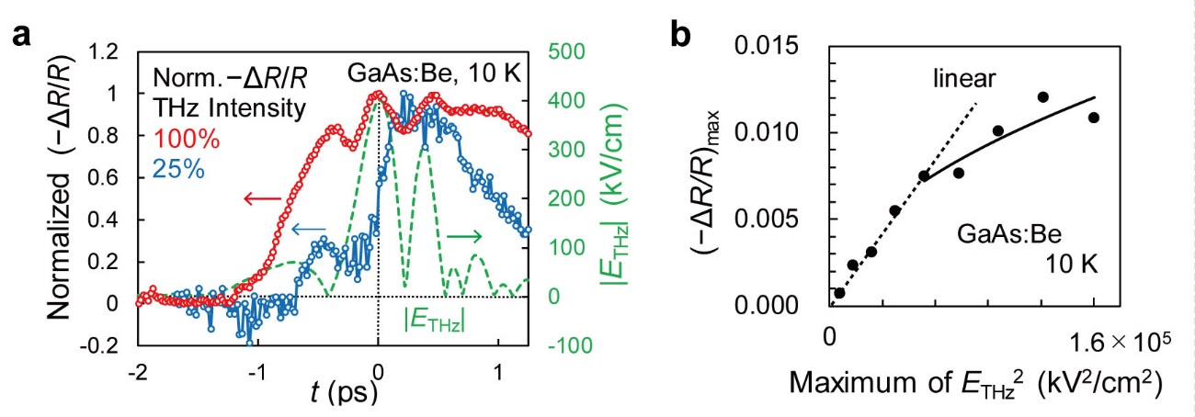
Figure S1 | Differential reflectivity for the GaAs:Be sample. a, Red circles show the time evolution of the change (ΔR) in the reflectivity (R) measured at 10 K for GaAs:Be when the electric field E_{THz} of the terahertz pulse expressed by the green dotted curve is applied to the sample. Here, −ΔR/R is normalized by its maximum value. Blue solid circles show –ΔR/R when the intensity E_{THz}² of the terahertz pump pulse is 25% of the green dotted curve (i.e. the maximum E_{THz} is 200 kV/cm). The angle between the electric field E_{probe} of the probe pulse and E_{THz} is set at 30º. b, (–ΔR/R)_{max} obtained for GaAs:Be plotted as a function of E_{THz}² at 10 K when the angle between E_{probe} and E_{THz} is 30º.

B. Derivation of Δθ_{MLD} and ΔM_{in}
The polarization rotation θ of the probe pulse before the pump irradiation (in-plane magnetization M_{in}=0) is given by^{S}
$$θ\left(t≪0\right)=-\frac{ε_{xy}+s_{1}\sin{2α}}{ \left(1-ε_{a}\right)\sqrt{ε_{a}}}, (S2)$$
where α is the angle between the incident probe polarization and the y axis (see Fig. S2), and
$$ε_{a}=\frac{1}{2}\left(ε_{xx}+ε_{yy}\right), ε_{s}=\frac{1}{2}\left(ε_{xx}-ε_{yy}\right)≅s_{1}+s_{2}M_{in}^{2}, (S3)$$
where ε_{xx} (ε_{xx} =12 for GaAs and GaMnAs), ε_{yy} (=12 for GaAs and GaMnAs) and ε_{xy} are the elements of the dielectric tensor (see equation (1) in the main text), and s₁ and s₂ are constants. In the last term of equation (S3), from the Onsager equation, ε_{s} is expanded using a power series of the squared in-plane (x-y plane) magnetization M_{in}². Note that before the terahertz-pump pulse irradiation, M_{in}²=0.
By the terahertz-pump pulse irradiation, the dielectric tensor is modulated; ε_{xy}, ε_{a} and ε_{s} are changed to ε_{xy}+Δε_{xy}, ε_{a}+Δε_{a} and s₁+Δs₁+ s₂ΔM_{in}², respectively, where Δε_{xy}, Δε_{a}, Δs₁ and ΔM_{in} are the changes in ε_{xy}, ε_{a}, s₁ and M_{in}, respectively. In the following, using Δε_{xy}, Δε_{a}, Δs₁ and ΔM_{in}, we express the change Δθ_{MOKE} in the magneto-optical polar Kerr rotation, the change Δθ_{bir} in the polarization rotation induced by the birefringence and the change (Δθ_{MLD}) in the polarization rotation by the magnetic linear dichroism as follows.
$$Δθ_{MOKE}=-\frac{ε_{xy}+Δε_{xy}}{ \left(1-ε_{a}-{Δε}_{a}\right)\sqrt{ε_{a}+Δε_{a}}}+\frac{ε_{xy}}{ \left(1-ε_{a}\right)\sqrt{ε_{a}}} ,$$
$$Δθ_{bir}=-\frac{\left(s_{1}+Δs_{1}\right)\sin{2α}}{ \left(1-ε_{a}-{Δε}_{a}\right)\sqrt{ε_{a}+Δε_{a}}}+\frac{s_{1}\sin{2α}}{ \left(1-ε_{a}\right)\sqrt{ε_{a}}} , (S4)$$
$$Δθ_{MLD}=-\frac{s_{2}ΔM_{in}^{2}\sin{2α^{'}}}{ \left(1-ε_{a}-{Δε}_{a}\right)\sqrt{ε_{a}+Δε_{a}}} ,$$
where $α'$ is the angle between the incident probe polarization and the direction of M_{in} (Fig. S3). We derived $ΔM_{in}^{2}$ from Δθ_{MLD} (the derivation of Δθ_{MLD} is explained below). We cannot determine $α'$ from our experimental results; however, for the analysis of the data measured with E_{probe}//E_{THz}, we take $\sin{2α'}=1$, i.e. $α'$= 45° or 225°, which corresponds to a typical easy magnetization axis (i.e. one of the <100> axes). The obtained $ΔM_{in}^{2}$ is shown in Fig. 3b in the main text. Note that we use arbitrary unit for $ΔM_{in}^{2}$.
In our optical alignment of E_{probe}//E_{THz}, Δθ_{bir} is still remaining due to the small deviation from the ideal condition α=0°. For the analysis of the magnetization dynamics, we have excluded Δθ_{bir} from the observed Δθ as follows. We measured the time evolution of ΔR/R at 10 K for GaMnAs (Fig. S4a). Using the experimental ΔR/R, Δε_{a} and Δε_{s} (change in ε_{s}) are estimated by the following equations,
$$Δn ≅-\frac{n^{2}-1}{4}\left(-\frac{ΔR}{R}\right){\left(1+\frac{n-1}{2}\left(-\frac{ΔR}{R}\right)\right)}^{-1},$$
$$Δε_{yy}={\left(n+Δn\right)}^{2}-ε_{yy}, n^{2}=ε_{yy}, (S5)$$
$$Δε_{a}=\frac{1}{2}Δε_{yy}, Δε_{s}=-\frac{1}{2}Δε_{yy},$$
where Δn is the change in refractive index n. Generally, the influence of ΔM_{in} on ΔR is negligible^{S}. This is because the higher-order terms such as $s_{2}ΔM_{in}^{2}$ are much smaller than the zeroth order term $Δs_{1}$ in the Taylor expansion of ε_{s}. Hence, we can use $Δε_{s}$=$Δs_{1}+s_{2}ΔM_{in}^{2}≅Δs_{1}$ when we analyze ΔR. Note that in the Δθ measurements, which are much more sensitive to the change in the dielectric tensor, we cannot use this approximation. In fact, Δθ signals due to the term $s_{2}ΔM_{in}^{2}$ are observed in GaMnAs^{S3}. Therefore, Δθ_{bir} can be approximated by,
$$Δθ_{bir}=-\frac{\left(s_{1}+Δs_{1}\right)\sin{2α}}{ \left(1-ε_{a}-{Δε}_{a}\right)\sqrt{ε_{a}+Δε_{a}}}+\frac{s_{1}\sin{2α}}{ \left(1-ε_{a}\right)\sqrt{ε_{a}}}$$
$$≅-\frac{\left(ε_{s}+Δε_{s}\right)\sin{2α}}{ \left(1-ε_{a}-{Δε}_{a}\right)\sqrt{ε_{a}+Δε_{a}}}+\frac{ε_{s}\sin{2α}}{ \left(1-ε_{a}\right)\sqrt{ε_{a}}}. (S6)$$
Using these equations, we can obtain Δθ_{bir} if we can obtain the real value of sin 2α. Using this Δθ_{bir}, Δθ_{MLD} is obtained by Δθ_{sum} − Δθ_{bir}, where Δθ_{sum} = $(Δθ_{M//[001]}+Δθ_{M//[00\overline{1}]})/2$ (violet squares in Fig. S4b). ΔM_{in}² is derived by equation (S4) using the obtained Δθ_{MLD}. Here, to obtain Δθ_{bir}, we determined sin 2α (=0.044, i.e. α=2.5°) so that ΔM_{in}² becomes positive and its minimum value becomes zero. The obtained Δθ_{MLD} and Δθ_{bir} are shown as the blue triangles and the red circles in Fig. S4b, respectively. As a reference, the obtained Δθ_{MOKE} is also shown as the dark blue open circles in Fig. S4b. From Δθ_{MLD} as shown in the blue triangles in Fig. S4b, we derived ΔM_{in}² (Fig. 3b in the main text) using equations (S4) and (S5).
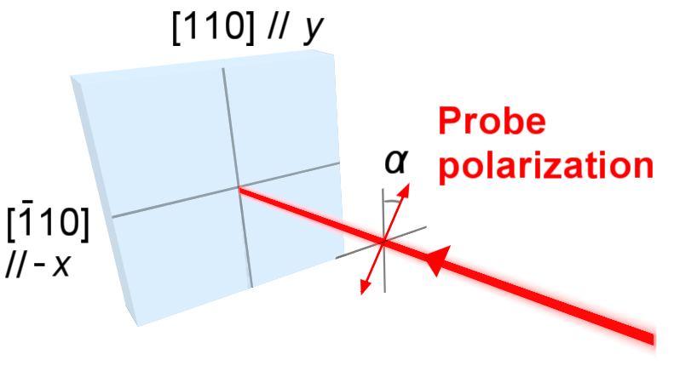
Figure S2 | Definition of α. α is the angle between the incident probe polarization and the y axis (//[110]).
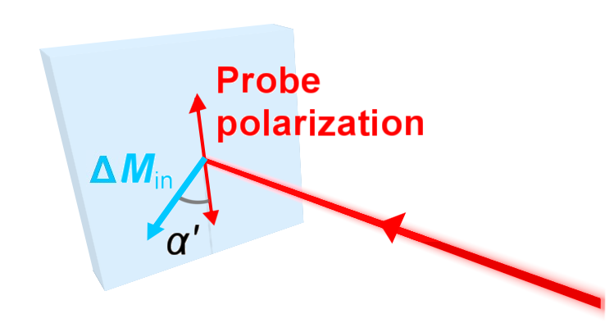
Figure S3 | Definition of $α'$. $α'$ is the angle between the incident probe polarization and ΔM_{in}.
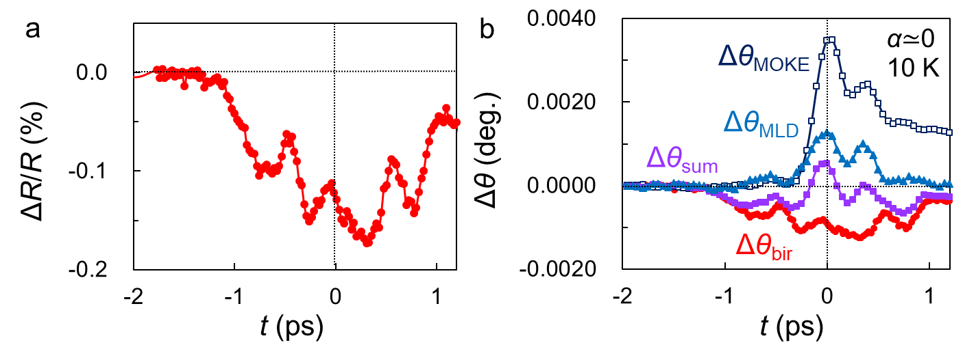
Figure S4 | Differential reflectivity for GaMnAs. a,Time evolution of the change (ΔR) in the reflectivity (R) measured at 10 K for GaMnAs when the terahertz pulse is applied to the sample. The angle between E_{probe} and E_{THz} is 30º. b, Time evolution of Δθ_{bir} (red circles) derived from ΔR/R using sin 2α=0.044, that of Δθ_{MLD} (= Δθ_{sum} − Δθ_{bir}, blue triangles), that of Δθ_{MOKE} (dark blue open squares) and that of Δθ_{sum} (violet squares), where Δθ_{sum} = $(Δθ_{M//[001]}+Δθ_{M//[00\overline{1}]})/2$.

C. Relationship between ΔM_{perp} and ΔM_{in}
When the magnetization direction is tilted by an angle β from the initial magnetization direction (//[001], black dotted arrow in Fig. S5), the change ΔM_{perp} in perpendicular magnetization M_{perp} and ΔM_{in} are given by
−ΔM_{perp} = ΔM sin β/2,
ΔM_{in} = ΔM cos β/2,
where ΔM is the change in magnetization M (see the red solid arrow in Fig. S5). ΔM_{in} is also written by,
ΔM_{in} = M sin β.
Because the tilt angle of M is small (i.e. β<<1),
−ΔM_{perp} $≅$ ΔM β/2,
ΔM_{in} $≅$ ΔM,
ΔM_{in} = M β.
Therefore,
−ΔM_{perp} = ΔM_{in} β/2 = (ΔM_{in})²/ (2M). (S7)
Equation (S7) indicates that −ΔM_{perp} ($∝$−Δε_{xy}) is proportional to (ΔM_{in})².

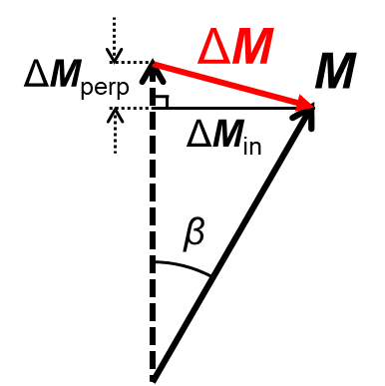
−
Figure S5 | Derivation of the relationship between ΔM_{perp} and ΔM_{in}. The magnetization direction, the initial magnetization direction and the change in the magnetization direction are shown by the black dotted arrow, black solid arrow and red solid arrow, respectively.

D. Landau-Lifshitz-Gilbert (LLG) simulation
We performed the LLG simulation for GaMnAs using the well-known software OOMMF. The time evolution of $-Δ$M_{perp} divided by the saturation magnetization (M_{s}) is shown by red solid curve in Fig. S6a. M_{perp} is modulated by up to 0.001% in the LLG simulation. As a reference, the time evolution of $-Δε_{xy}/ε_{xy}$ is also shown by the dark blue plots (same data as that shown in Fig. 3a in the manuscript) in Fig. S6b. The experimental $-Δε_{xy}/ε_{xy}$-t curve shows that M_{perp} is modulated by up to 1%, which is three orders of magnitude larger than that calculated by the LLG-torque model. Hence, we concluded that the terahertz modulation of the magnetization is not caused by the magnetic field of the terahertz pulse.

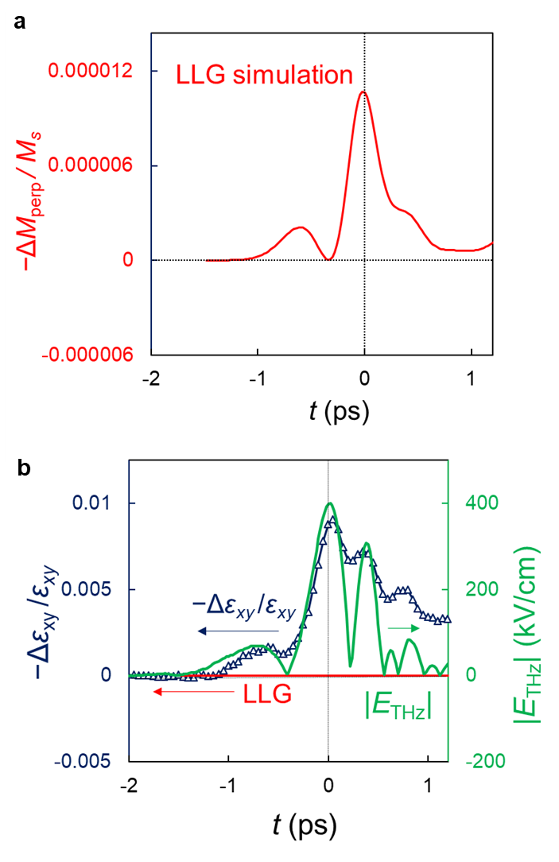
Figure S6 | LLG simulation of the time evolution of the magnetization in the GaMnAs thin film using the micro-magnetics simulation package OOMMF. a, Perpendicular magnetization dynamics derived from the LLG simulation for GaMnAs. b, Comparison between our experimental results shown by the dark blue plots (same data as that shown in Fig. 3a in the manuscript) and the LLG simulation shown by the red solid curve. |E_{THz}| is shown by the green solid curve.

References

S. Novelli, F., Fausti, D., Giusti, F., Parmigiani, F. & Hoffmann, M. Mixed regime of light-matter interaction revealed by phase sensitive measurements of the dynamical Franz-Keldysh effect. Sci. Rep. 3, 1227 (2013).
S. Kahn, F. J., Pershan, P. S. & Remeika, J. P. Ultraviolet magneto-optical properties of single-crystal orthoferrites, garnets, and other ferric oxide compounds. Phys. Rev. 186, 891 (1969).
S. Matsuda, T. & Munekata, H. Mechanism of photoexcited precession of magnetization in (Ga,Mn)As on the basis of time-resolved spectroscopy, Phys. Rev. B 93, 075202 (2016).

