Supporting Information

Probiotic Lactobacillus fermentum strain JDFM216 stimulates the longevity and immune response of Caenorhabditis elegans through a nuclear hormone receptor

Mi Ri Park¹, Sangdon Ryu¹, Brighton E. Maburutse¹, Nam Su Oh², Sae Hun Kim³, Sejong Oh⁴, Seong-Yeop Jeong⁵, Do-Youn Jeong⁵, Sangnam Oh^{6†}, and Younghoon Kim^{1†}

¹Department of Animal Science and Institute of Milk Genomics, Chonbuk National University, Jeonju, 54896, Korea
²R&D Center, Seoul Dairy Cooperative, Ansan, Gyeonggi 15407, South Korea
³Department of Biotechnology, College of Life Sciences and Biotechnology, Korea University, Seoul 02841, South Korea
⁴Department of Animal Science, Chonnam National University, Gwangju 61186, Korea
⁵Microbial Institute for Fermentation Industry, Sunchang, Jeonbuk 56048, Republic of Korea
⁶Department of Functional Food and Biotechnology, Jeonju University, Jeonju 55069, Republic of Korea

Supplementary Figures.
Supplementary Figure S1.
Supplementary Figure S2.
Supplementary Figure S3.

Supplementary Table
Supplementary Table S1.

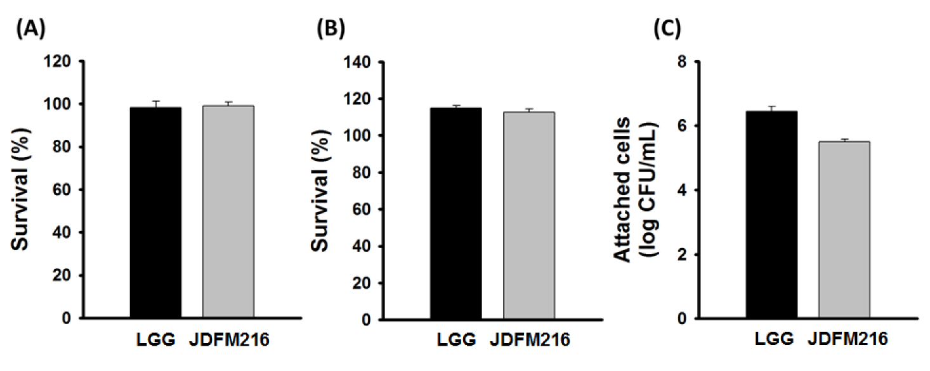

Figure S1. Conventional in vitro assay results for Lactobacillus fermentum strain JDFM216. Susceptibility of JDFM216 to (A) synthetic gastric juice (pH 2.5) and (B) bile conditions with 0.5% oxgall as well as their ability for (C) attachment on a mucus layer in vitro. Values represent the mean of three independent experiments with standard error of the mean (SEM). LGG = Lactobacillus rhamnosus strain GG.

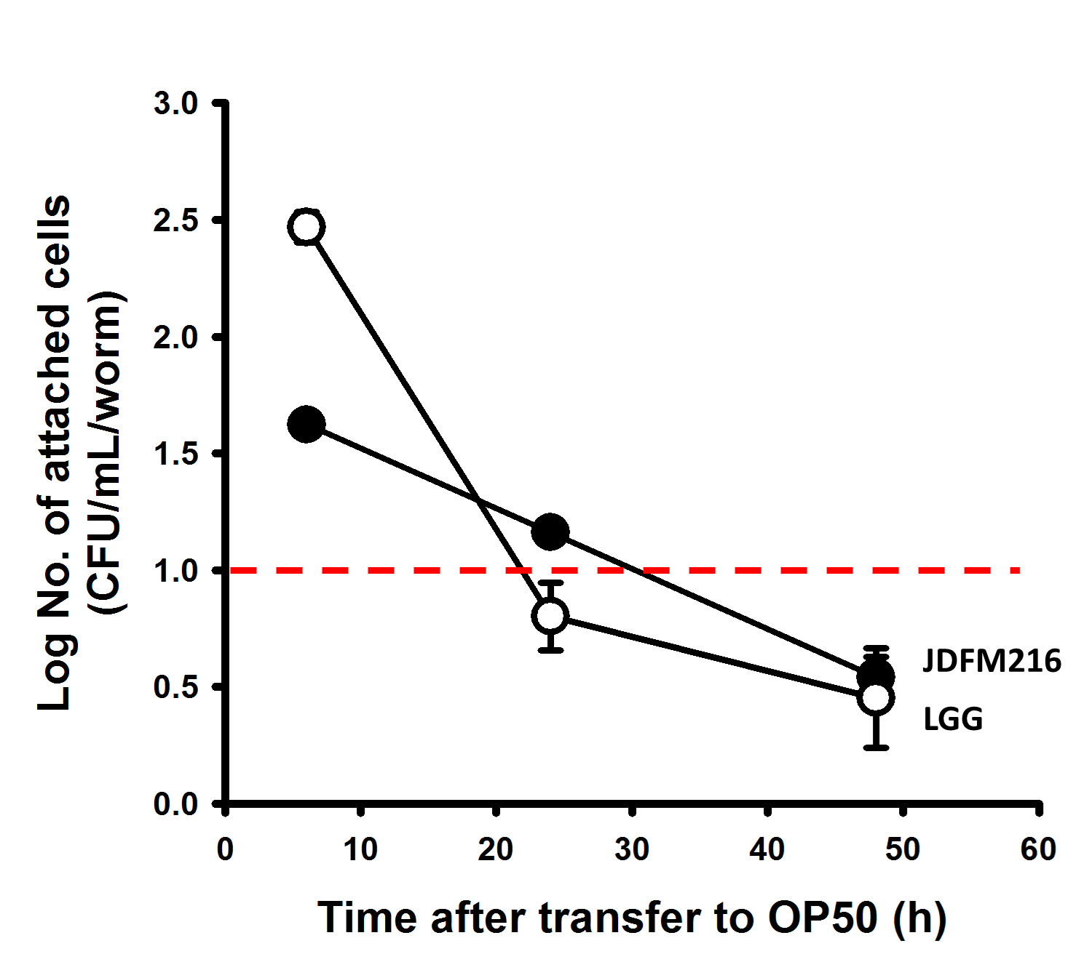

Figure S2. Quantification of intestinal Lactobacillus fermentum strain JDFM216 obtained by disruption of worms feeding on OP50 at 6, 24, and 48 h after 24 h of feeding on JDFM216. Values represent the mean of three independent experiments with standard error of the mean (SEM). LGG = Lactobacillus rhamnosus strain GG.
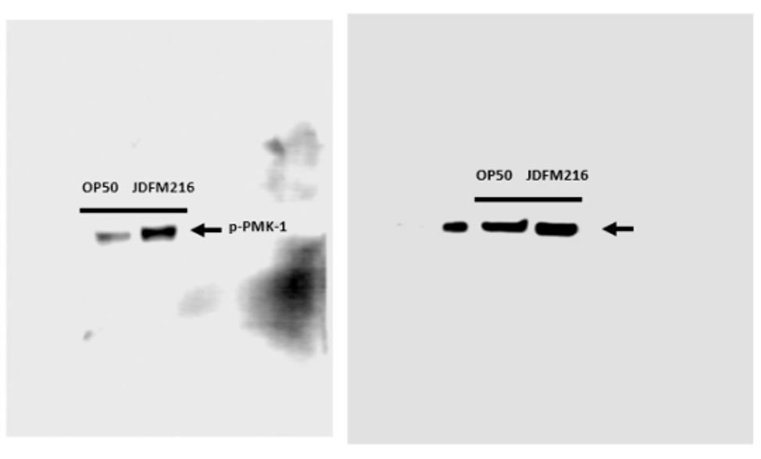
Fig. S3. Uncropped images of western blot for all panels shown in Fig. 3D.

Table S1. Antimicrobial activities of Lactobacillus fermentum strain JDFM216 on four foodborne pathogens.

Pathogenic strains | Diameter of inhibition zone (mm)
E. coli O157: H7 EDL 933 | 26.71±1.14 (++)
Salmonella Typhimurium SL1344 | 28.05±1.57 (++)
Listeria monocytogens EGD-e | 23.52±3.31 (+)
Listeria monocytogens Scott A | 24.71±1.76 (+)

Inhibition zone: 0 mm no activity, <5 mm: 5-20 mm: Weak (±), 20-25 mm: Moderate (+), ≥25 mm: Strong (++), Mean values with standard deviation (n = 3).

