Supplemental Information

Ion–ion interactions in the denatured state contribute to the stabilization of CutA1 proteins
Katsuhide Yutani^{1,*}, Yoshinori Matsuura¹, Hisashi Naitow¹, and Yasumasa Joti²,

¹RIKEN SPring-8 Center, 1-1-1 Kouto, Sayo, Hyogo 679-5148, Japan
²Japan Synchrotron Radiation Research Institute, 1-1-1, Kouto, Sayo, Hyogo 679-5198 Japan

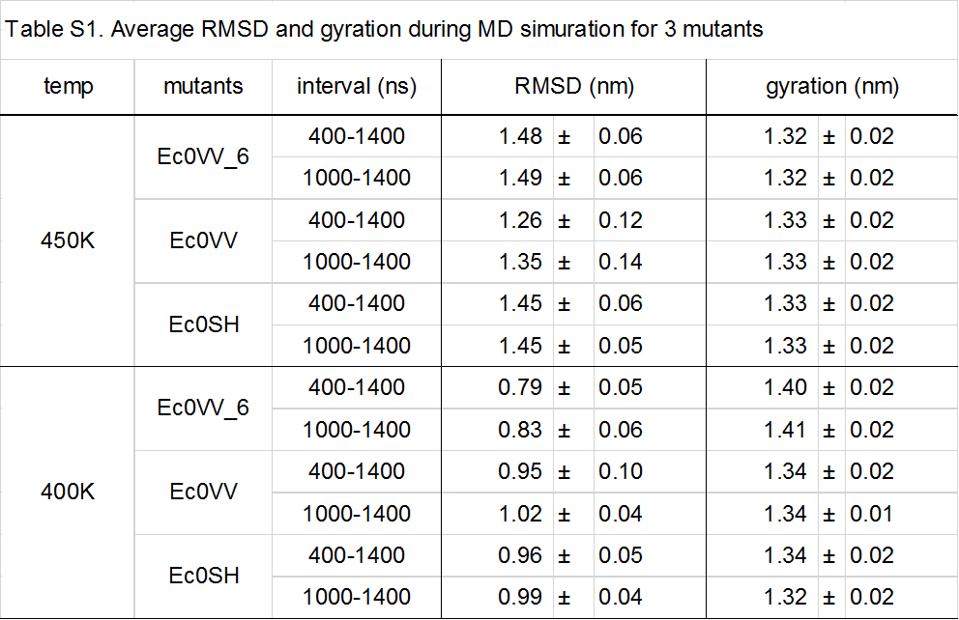

Supplementary figure legends

Figure S1. Trajectories of changes in secondary structures of three subunits during MD simulations
- α-helical residues for three mutants at 450 K MD. Red, blue, and black represent Ec0VV_6, Ec0VV, and Ec0SH, respectively. The values are an average of all three subunits.
- Structural residues (= β-sheet + α-helix + β-bridge + turn) for three mutants at 450 K MD. Red, blue, and black represent Ec0VV_6, Ec0VV, and Ec0SH, respectively. The values are an average of all three subunits.
- α-helical residues for 3 mutants at 400 K MD. Red, blue, and black represent Ec0VV_6, Ec0VV, and Ec0SH, respectively. The values are an average of all three subunits.
- Structural residues (= β-sheet + α-helix + β-bridge + turn) for three mutants at 400 K MD. Red, blue, and black represent Ec0VV_6, Ec0VV, and Ec0SH, respectively. The values are an average of all three subunits.

Figure S2. Trajectories of changes in the distance of major salt bridges of Lys87 in Ec0VV_6A during 1400 ns at 450 K
- Lys87–Asp20 (black)
- Lys87–Asp26 (magenta)
- Lys87–Asp39 (green)
- Lys87–Glu21 (blue)
- Lys87–Glu57 (red)
- Lys87–Glu59 (cyan)

Figure S3. Trajectories of changes in the distance of major salt bridges of Arg88 in Ec0VV_6A during 1400 ns at 450 K
- Arg88–Asp20 (cyan)
- Arg88–Glu21 (red)
- Arg88–Asp26 (blue)
- Arg88–Asp39 (green)
- Arg88–Glu90 (black)

