Ballasting by cryogenic gypsum enhances carbon export in a Phaeocystis under-ice bloom Wollenburg, J.E.^{1*}; Katlein, C.¹; Nehrke, G.¹; Nöthig, E.-M.¹; Matthiessen, J.¹; Wolf-Gladrow, D.A.¹; Nikolopoulos, A. ²; Gázquez-Sanchez, F. ³; Rossmann, L.¹; Assmy, P.⁴; Babin, M.⁵; Bruyant F.⁵; Beaulieu, M.⁶; Dybwad, C.⁷; Peeken, I.¹.

Supplementary Data

Supplementary Video 1: Example video sequences from the MUC cast at station PS92/47 showing the Phaeocystis export event at depths of 50 m, 300 m, 600 m, 1000 m, 1300 m, 1600 m, 1900 m and seafloor. Shackle width is approximately 4 cm diameter.

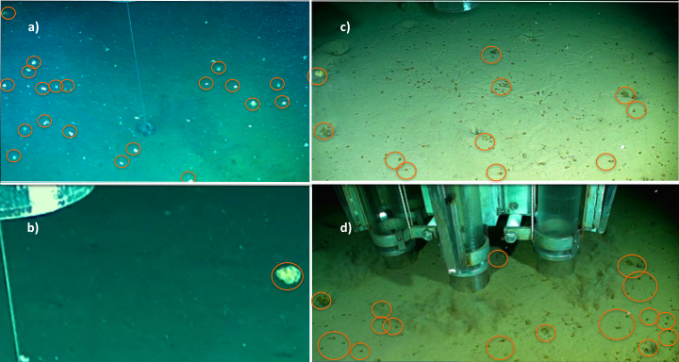
Supplementary Fig. S1: Photos from TV-MUC cast 2 m (a & b), and 0.2 m (c) above seafloor, and during coring (d). Large aggregates or accumulations of aggregates are indicated by orange circle. The whitish appearance of aggregates in the water column (a & b) results from the bright searchlights directed bottomwards. A more correct colour reproduction can be achieved close to the seafloor because the light is scattered by the sediments there (Figs. 3c & 3d). Photos are frame captures from the video recording of the TV-MUC system taken by Jutta Wollenburg.

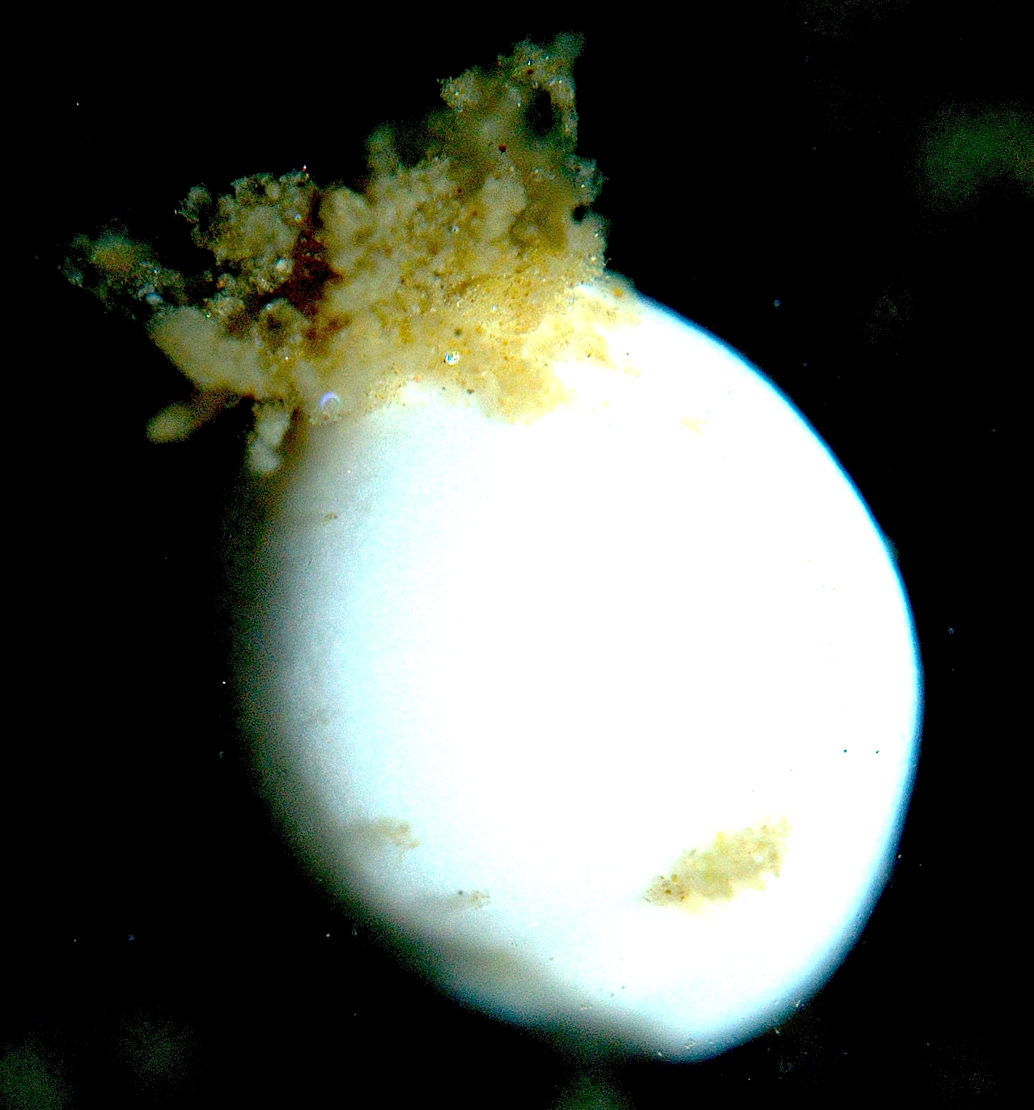
1 mm
Supplementary Fig. S2: Colonial strands of Phaeocystis just being ingested by deep-sea foraminifera Pyrgo rotalaria.

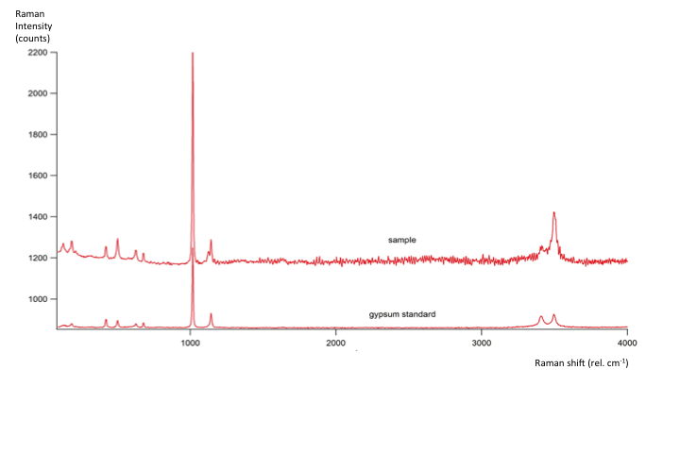Supplementary Fig. S3: Raman spectrum of gypsum crystals isolated from Phaeocystis aggregates pipetted from the sediment surface at station PS92/47.

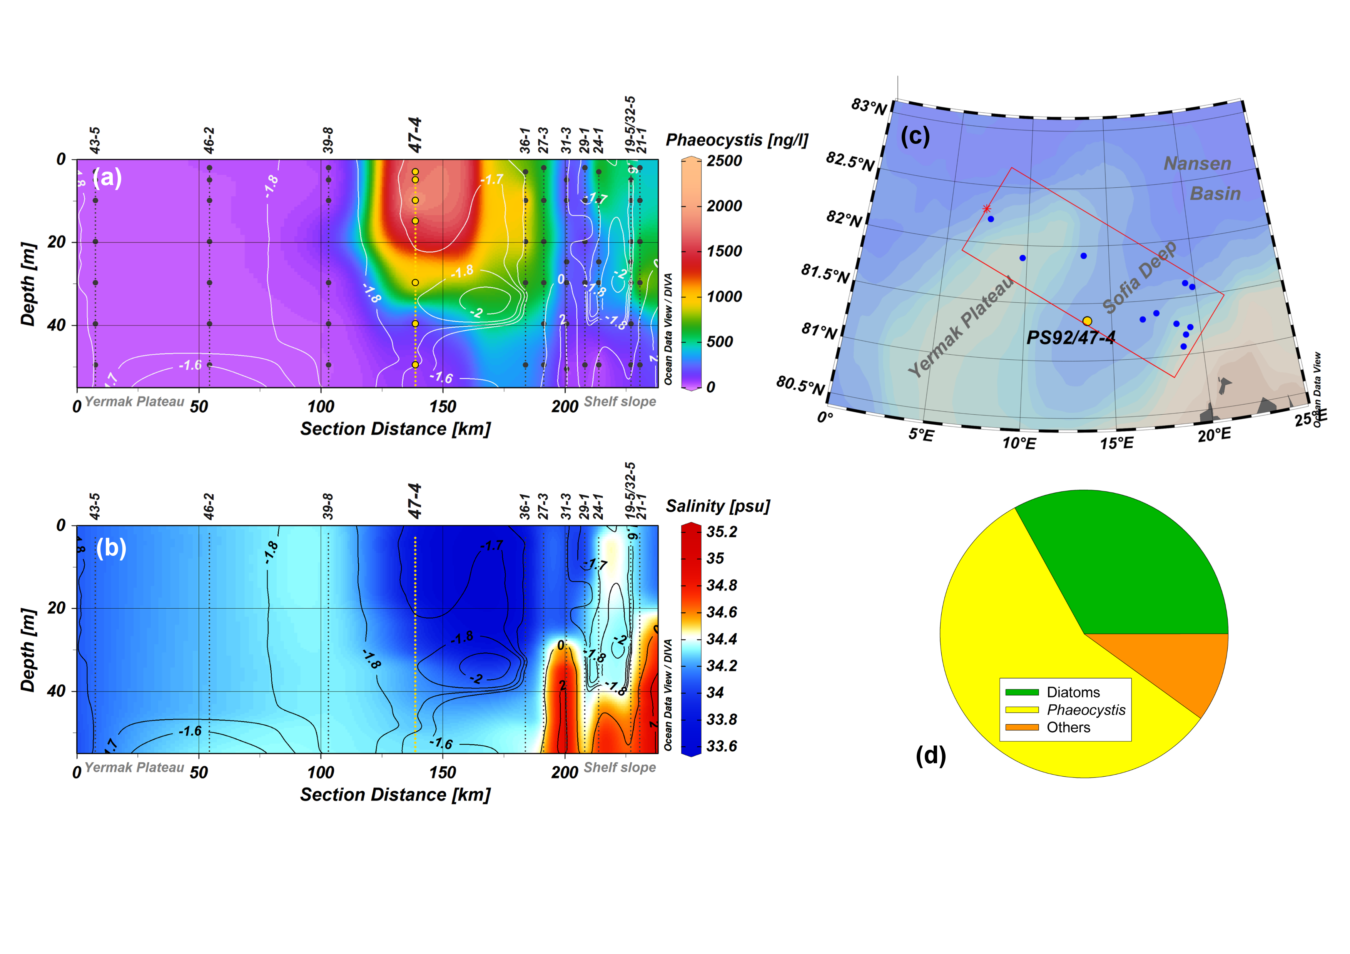Supplementary Fig. 3: Section plots for the upper 50 metres of (a) distribution of Phaeocystis Chl-a, and (b) salinity. Both plots are overlaid by contours of potential temperature (in °C; a, solid white; b, black lines). Black dots (yellow for station PS92/47) indicate the sample depths at each station. All section plots comprise data from PS92 stations within the red rectangle shown in the map (c). The section stretches from the Yermak Plateau in the north-west to the Barents Sea continental shelf in the south-east. The yellow dot marks station PS92/47 in the Sophia Deep while the red star indicates the beginning (0 km) of the section over the Yermak Plateau. Note that the displayed order in the section is not always in consecutive order of time. Data are plotted with Ocean Data View software, v4.7.6⁶¹. (d) Pie chart showing the composition of the autotroph biomass at station PS92/47 (10 m water depth) in carbon per litre based on microscopic counts. Others are mainly consisting of the phototrophic dinoflagellate Polarella glacialis and the ciliate Myrionecta rubra.

Supplementary Table 1: Carbon flux in the Arctic Ocean; selection of data obtained by means of sediment traps, ²³⁴Th-derived, nitrogen budget calculated, and taken from the review of Harada et al.⁹. Values are given as annual flux (g C m⁻² yr⁻¹) and daily flux rates (g C m⁻² d⁻¹). For comparison, the here described carbon export event was estimated to be between 0.81 - 6.18 g C m⁻² for this single event, depending on the Phaeocystis contribution of 12-92%¹³.

Method/Region | Annual flux | Daily flux ranges | References
 | g C m⁻² yr⁻¹ | g C m⁻² d⁻¹
Long-term trap deployments
150 - 300 m water depth
Lomonosov Ridge | 1.5 | 0.0003 – 0.02 | Fahl and Nöthig, 2007⁷
Northern Laptev Sea | 6.6 | ~ 0.002 – 0.28 | Lalande et al., 2009^{S1}
Fram Strait HAUSGARTEN | 2.5 | 0.0007 – 0.045 | Bauerfeind et al., 2009^{S2};  Lalande et al., 2013^{S3}; 2016^{S4}
2500 m
Fram Strait HAUSGARTEN | 3.3 | 0.002 – 0.014 | Lalande et al., 2016^{S4}
Short-term trap deployments
5 - 25 m water depth
Northern Laptev Sea |  | 0.03 – 0.38 | Lalande et al., 2014²⁰
Yermak Plateau |  | 0.017 – 0.06 | Lalande et al., 2014²⁰
Central Arctic Ocean |  | 0.005 – 0.11 | Lalande et al., 2014²⁰
300 - 500 m
Fram Strait HAUSGARTEN |  | 0.002 – 0.015 | Lalande et al., 2011⁴⁰
²³⁴Th-derived POC flux
2 - 200 m water depth
Nansen/Amundsen Basin |  | 0 – 0.12 | Roca-Marti et al., 2016¹⁰
High Arctic | 0.9 |  | Cai et al., 2010^{S5}
Nitrate flux estimation
from nitrate budget calculated export production | 1.5 - 3.0 |  | Randelhoff and Guthrie, 2016⁴³
> 1000 m water depth
High Arctic | 0.17 – 1.05 |  | Review by Harada, 2016 and references therein⁹

Supplementary Table 2: Potential carbon budget; estimation for the Phaeocystis blooming event of about 28 days integrated for the upper 50 m water column. Particulate organic carbon (POC) standing stock, the contribution of Phaeocystis biomass in carbon units to the entire phytoplankton community (PPC, phytoplankton carbon) for station PS92/47 and for the N-ICE 2015 expedition (calculated averages, AVG), integrated Phaeocystis standing stocks and primary production rates (50 m). The estimated potential carbon export is based on the daily primary production of Phaeocystis for this study and the average daily carbon export rates at 100 m derived from short term sediment traps deployed under the ice for NICE 2015 multiplied by the duration of the bloom (28 days). ± indicate method error.

 | POC standing stock  (g C m⁻²) | Phaeocystis  contribution to PPC  (%) | Phaeocystis  standing stock (PPC)  (g C m⁻²) | Phaeocystis  primary production  (g C m⁻² d⁻¹) | Phaeocystis  estimated potential carbon export for 28days  (g C m⁻²) | Reference
PS92/47 | 9.4±0.5 | 56% | 1.6±0.1 | 0.13±0.02 | 3.8±0.2 | This study
AVG  NICE 2015 | 11.14 | 74% | 1.3 | - | 4.5 | Calculated  from  Assmy et. al., 2017¹³

Supplementary References

S1. Lalande, C., Belanger, S. & Fortier, L. Impact of a decreasing sea ice cover on the vertical export of particulate organic carbon in the northern Laptev Sea, Siberian Arctic Ocean. Geophys. Res. Lett 36, L21604, (2009).
S2. Bauerfeind, E. et al. Particle sedimentation patterns in the eastern Fram Strait during 2000-2005: Results from the Arctic long-term observatory HAUSGARTEN. Deep Sea Res. I 56, 1471-1487, (2009).
S3. Lalande, C., Bauerfeind, E., Nöthig, E.-M. & Beszczynska-Möller, A. Impact of a warm anomaly on export fluxes of biogenic matter in the eastern Fram Strait. Progr. Oceanogr. 109, 70-77, (2013).
S4. Lalande, C. et al. Lateral supply and downward export of particulate matter from upper waters to the seafloor in the deep eastern Fram Strait, Deep Sea Res. I 114, 78-89, (2016).
S5. Cai, P. et al. Low export flux of particulate organic carbon in the central Arctic Ocean as revealed by 234Th:238U disequilibrium, J. Geophys. Res 115, (2010).

