Network-guided genomic and metagenomic analysis of the faecal microbiota of the critically endangered kakapo

David W. Waite^{1,2}*, Melissa Dsouza^{3,4}, Yuji Sekiguchi⁵, Philip Hugenholtz², Michael W. Taylor^{1,6}

¹School of Biological Sciences, University of Auckland, Auckland, New Zealand
²Australian Centre for Ecogenomics, School of Chemistry and Molecular Biosciences, The University of Queensland, Brisbane, Australia
³Department of Surgery, University of Chicago, Chicago, IL, USA
⁴Marine Biological Laboratory, Woods Hole, MA, USA
⁵Bio-Measurement Research Group, Biomedical Research Institute, National Institute of Advanced Industrial Science and Technology, Ibaraki, Japan
⁶Maurice Wilkins Centre for Molecular Biodiscovery, University of Auckland, Auckland, New Zealand

*Corresponding Author
David W. Waite
School of Chemistry and Molecular Biosciences
University of Queensland
d.waite@uq.edu.au

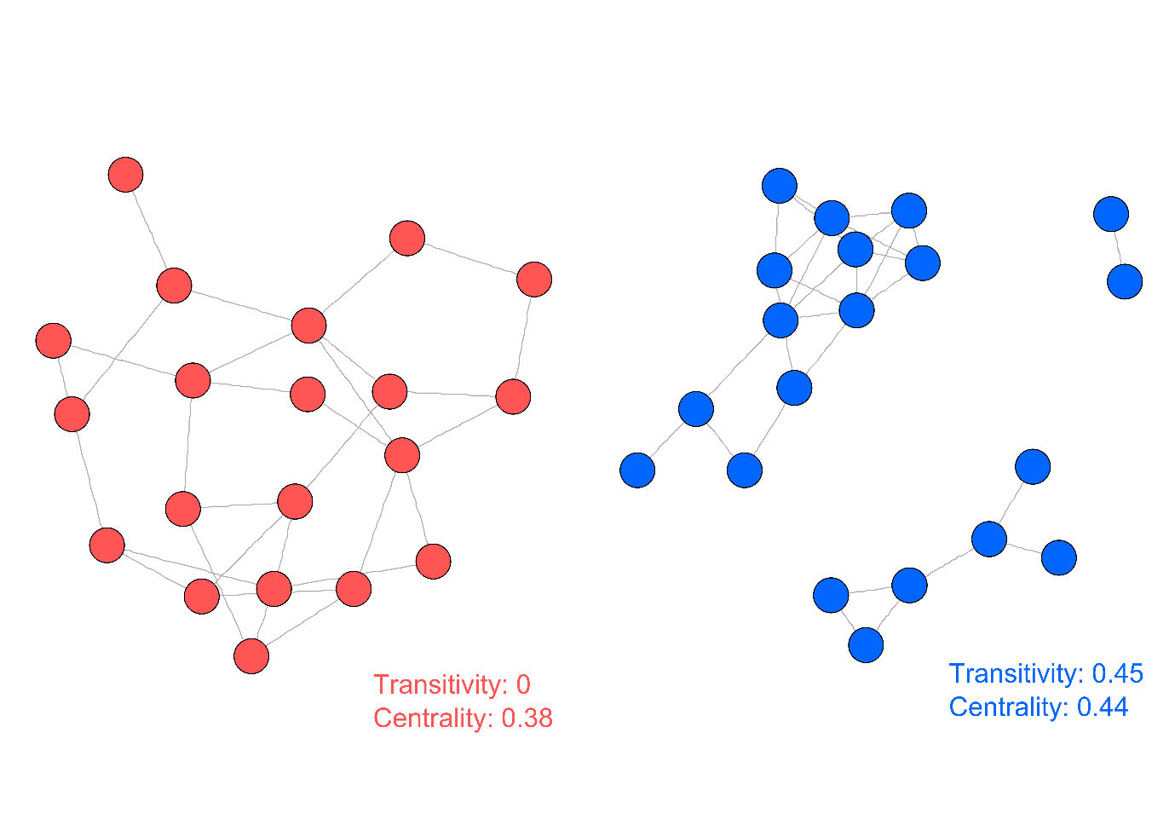
Supplemental Figure S1. Comparison of networks displaying low and high modularity
Randomly constructed graphs of 20 nodes and 30 edges (connections) were constructed in R using the erdos.renyi.game function of the igraph package. 10,000 graphs were randomly constructed and those with the lowest (red) and highest (blue) transitivity value were retained. Both graphs are constructed from the same number of nodes and connections, but stochastic placement of the connections drastically alters the topology of the network and associated statistics. Such differences in topology have ecological significance in the interpretation of the interactions represented within the network.

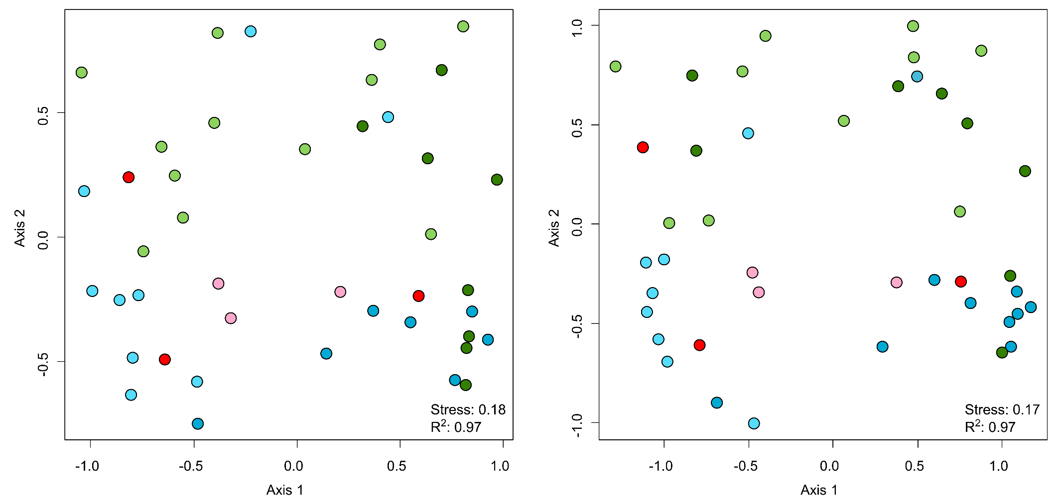
Supplemental Figure S2. Non-metric multidimensional scaling plot of the kakapo 16S rRNA gene OTU data
Ordination was performed using the Bray-Curtis distance with the full data set (left) and as subsampled for network analysis (right). Samples from kakapo chicks (green) and adults (blue) are coloured by year sampled (pale = 2011, dark = 2012). Samples used for metagenomic sequencing are marked in pink (chick) and red (adult), and show no consistent difference from other samples used in network construction.

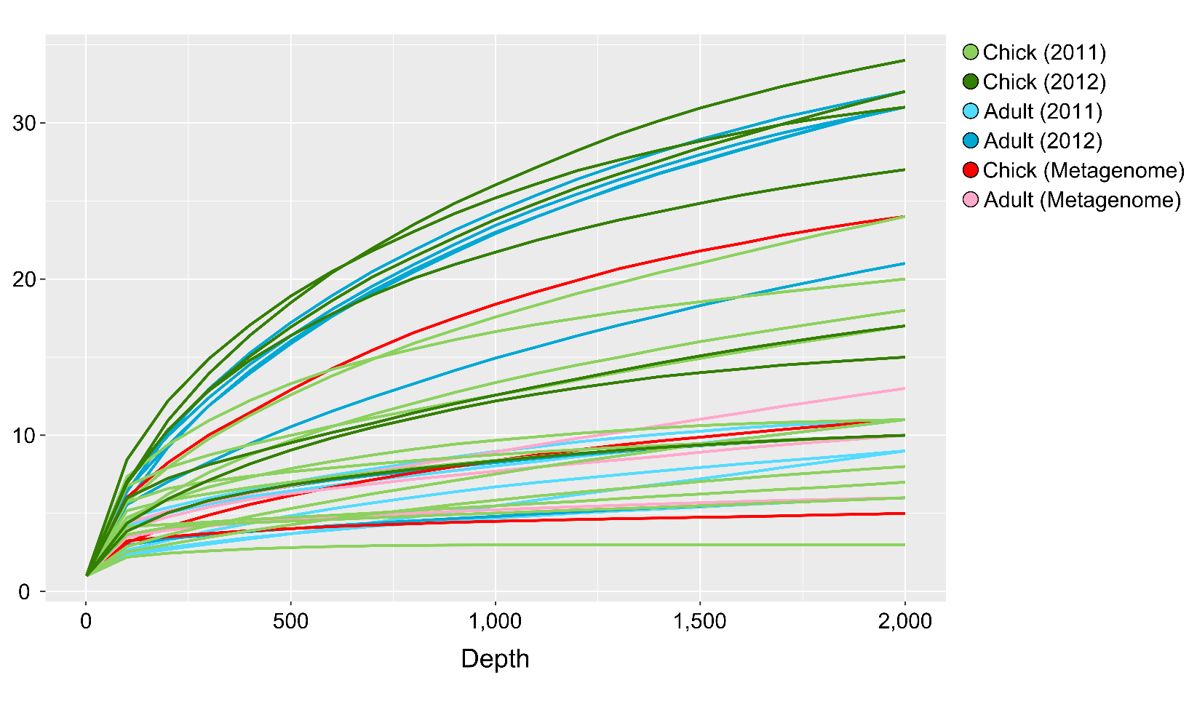
Supplemental Figure S3. Rarefaction analysis of subsampled OTU table

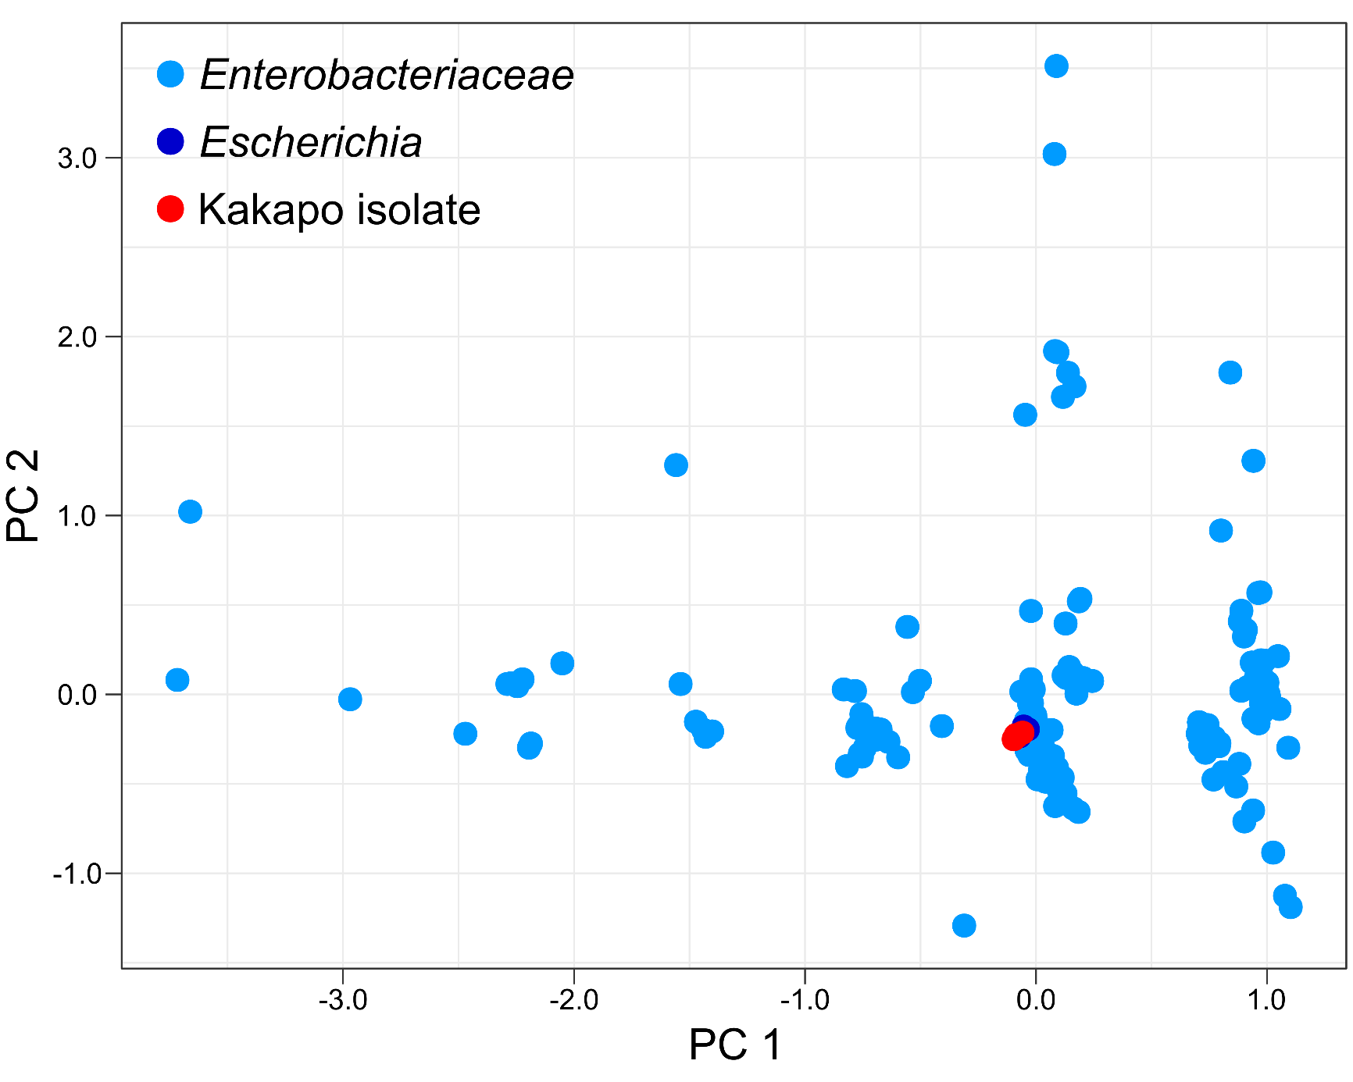
Supplemental Figure S4. PCA ordination of KEGG-annotated Enterobacteriaceae genomes

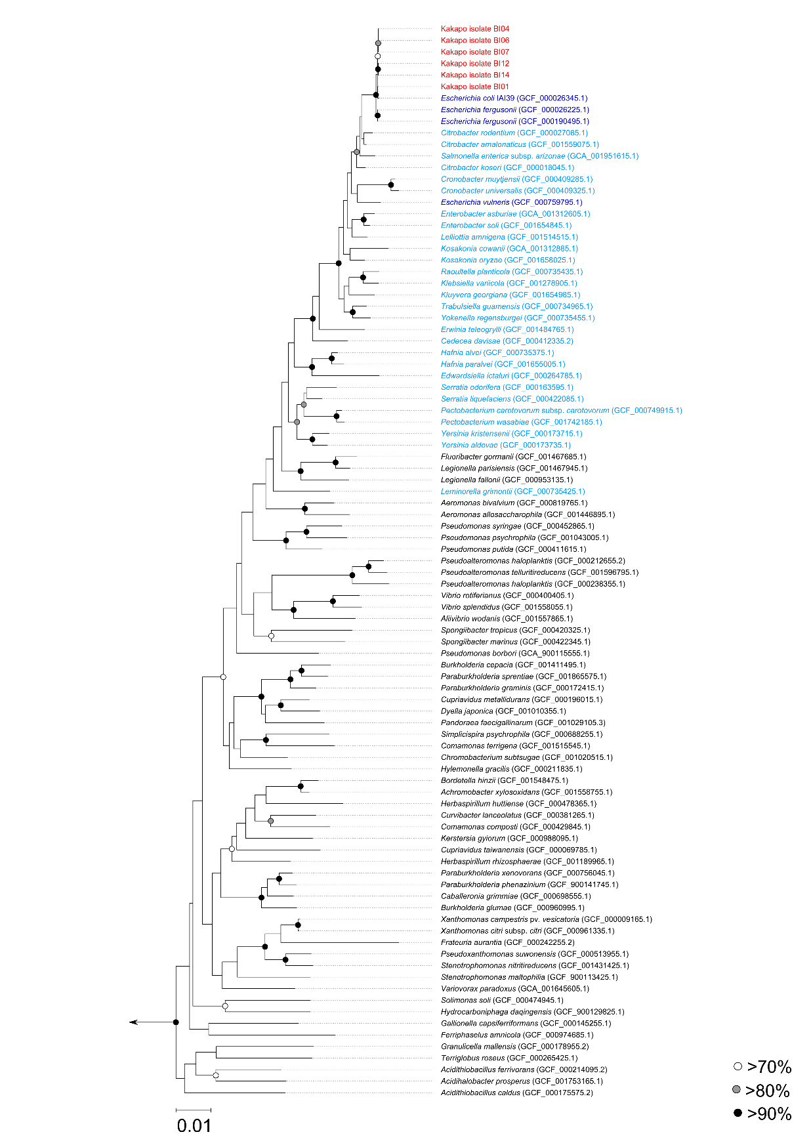

Supplemental Figure S5. Phylogenetic inference of beta-1,4-endoglucan hydrolase sequences from Proteobacteria
Kakapo isolate sequences are marked in red, with Escherichia in dark blue and other Enterobacteriaceae sequences in pale blue. Bootstrap support was determined through 100 resamplings.
Table S1. Overview of the relationship between samples utilised for amplicon and metagenomic sequencing
Individual | Timepoint 1 | Metagenomic sampling | Timepoint 3 | Timepoint 4
Chick_1 |  |  |  | +
Chick_2 | + |  | + | +
Chick_3 | + |  | +
Chick_4 | + |  |  | +
Chick_5 | + |  |  | +
Chick_6 | + | + |  | +
Chick_7 | + | + |  | +
Chick_8 |  |  | +
Chick_9 | + | + | + | +
Chick_10 |  |  | + | +
Adult_1 | + | + |  | +
Adult_2 | + | + |  | +
Adult_3 | + |  |  | +
Adult_4 |  | + |  | +
Adult_5 | + |  |  | +
Adult_6 | + |  |  | +
Adult_7 | + |  |  | +
Adult_8 | +
Adult_9 | +
Adult_10 | +

Columns labelled as Timepoint 1, 3 and 4 refer to sampling periods during the study design in (Waite et al., 2014), following the exclusion of the hand-rearing phase (Timepoint 2 in original study). Additional sampling was performed for six individuals from which amplicon and metagenomic samples were generated.

Table S2. Bacterial isolates used for genome sequencing
SampleID | Isolation conditions | Banding Pattern | Closest BLAST Match
BI01 | LB (aerobic) | 1 | Escherichia fergusonii
BI02 |  | 2 | Escherichia fergusonii
BI03 |  | 3 | Escherichia coli
BI04 | BHI (aerobic) | 2 | Escherichia fergusonii
BI05 |  | 3 | Escherichia fergusonii
BI06 | LB (anaerobic) | 2 | Escherichia fergusonii
BI07 |  | 3 | Escherichia fergusonii
BI08 | BHI (anaerobic) | 2 | Escherichia fergusonii
BI09 |  | 3 | Escherichia fergusonii
BI10 | M17 (anaerobic) | 2 | Escherichia fergusonii
BI11 |  | 3 | Escherichia fergusonii
BI12 | MRS (anaerobic) | 2 | Escherichia fergusonii
BI13 |  | 3 | Escherichia fergusonii
BI14 |  | 4 | Streptococcus gallolyticus
BI15 |  | 5 | Streptococcus gallolyticus

List of bacterial isolates previously obtained from a previous cultivation experiment (Waite et al., 2013). Table layout is modified from original publication and highlighted isolates were used for genome sequencing in this study. The kakapo from which these isolates were obtained was also included in the metagenomic cohort (Table S1, Adult_4).

Table S3. Quality control and assembly statistics for genome and metagenome samples
Sample | Raw reads (paired) | High quality reads (paired) | High quality reads (orphaned) | Assembled bases (MB) | Contigs | N50 | Predicted genes
BI01 (E. fergusonii) | 1,506,091 | 1,434,660 | 44,228 | 4.75 | 67 | 183,225 | 4,493
BI02 (E. fergusonii) | 2,231,990 | 2,044,394 | 126,152 | 4.73 | 71 | 435,364 | 4,408
BI04 (E. fergusonii) | 1,447,296 | 1,413,427 | 32,210 | 4.70 | 52 | 362,224 | 4,383
BI06 (E. fergusonii) | 1,691,620 | 1,661,742 | 24,717 | 4.75 | 67 | 275,438 | 4,458
BI07 (E. fergusonii) | 2,055,721 | 1,986,430 | 35,034 | 5.23 | 93 | 201,913 | 5,117
BI12 (E. fergusonii) | 1,442,568 | 1,363,285 | 67,635 | 5.43 | 379 | 66,601 | 5,599
BI14 (S. gallolyticus) | 1,725,202 | 1,667,360 | 54,060 | 2.18 | 121 | 34,542 | 2,236
BI15 (S. gallolyticus) | 3,148,699 | 2,963,285 | 143,425 | 2.16 | 133 | 33,976 | 2,217
Chick_6 | 3,236,242 | 3,096,959 | 135,783 | - | - | - | -
Chick_7 | 2,741,807 | 2,706,660 | 34,488 | - | - | - | -
Chick_9 | 2,890,590 | 2,857,683 | 31,822 | - | - | - | -
Adult_1 | 3,493,113 | 3,415,822 | 74,202 | - | - | - | -
Adult_2 | 2,334,971 | 2,288,253 | 45,279 | - | - | - | -
Adult_4 | 3,574,059 | 3,512,475 | 60,786 | - | - | - | -
Metagenomic assembly | 18,270,782 | 17,877,852 | 382,360 | 17.4 | 6,869 | 7,922 | 257,679

Reads used for metagenomics assembly (raw and quality filtered) are the sum of individual metagenomics samples.

