SUPPLEMENTARY INFORMATION
Correspondence and requests for materials should be addressed to J.H (jphong@hanyang.ac.kr)

Exploring oxygen-affinity-controlled TaN electrodes for thermally advanced TaO_{x} bipolar resistive switching

Tae Yoon Kim,¹ Gwang Ho Baek,² Seung Mo Yang, ¹ Jung Yup Yang³, Kap Soo Yoon¹, Soo Gil Kim⁴, Jae Yeon Lee⁴, Hyun Sik Im,⁵ and Jin Pyo Hong^{1,2,*}

1. Cumulative probabilities of as-grown Samples A and C.
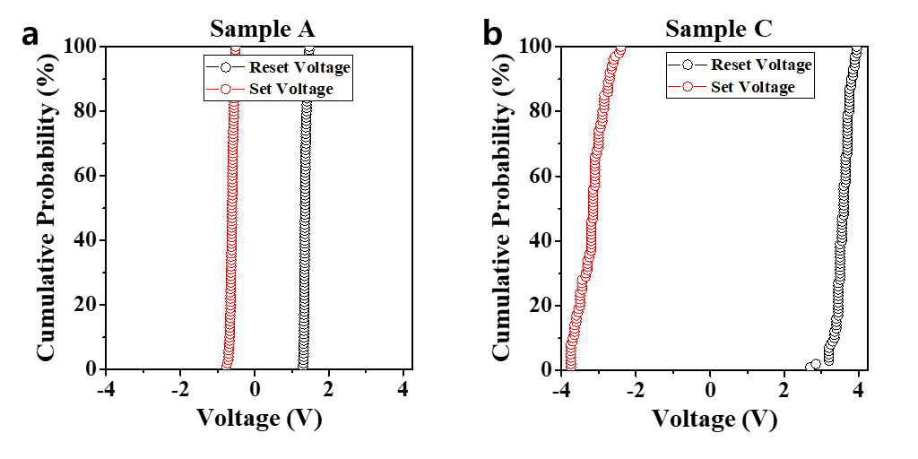

Figure S1 Distributions of set/reset voltages for (a) Sample A and (b) Sample C during 100 consecutive switching cycles. Sample A had a narrow distribution of set/reset voltages, while Sample C had a relatively wide distribution of set/reset voltages, along with a stable resistive switching response.

2. Comparison of endurance and retention features of Samples A and C.

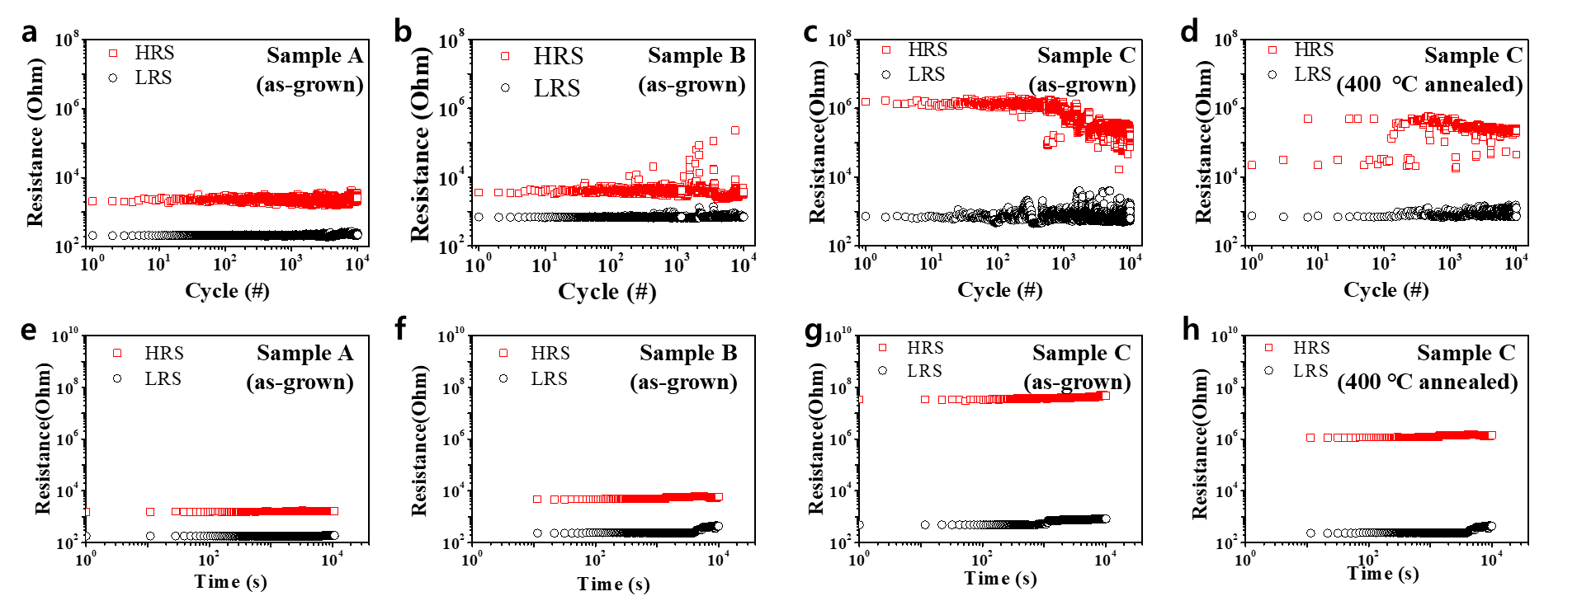
Figure S2 Switching endurance analyses of (a) Sample A (as-grown), (b) Sample B (as-grown), (c) Sample C (as-grown), and (d) Sample C (annealed at 400°C) for 10⁴ operation cycles. Retention characteristics of (e) Sample A (as-grown), (f) Sample B (as-grown), (g) Sample C (as-grown), and (h) Sample C (annealed at 400°C) for 10⁴ s; the slight fluctuation in output for annealed Sample C indicates that more optimization work is required.

3. Resistive switching behaviors of Samples A and C after the post-annealing process.
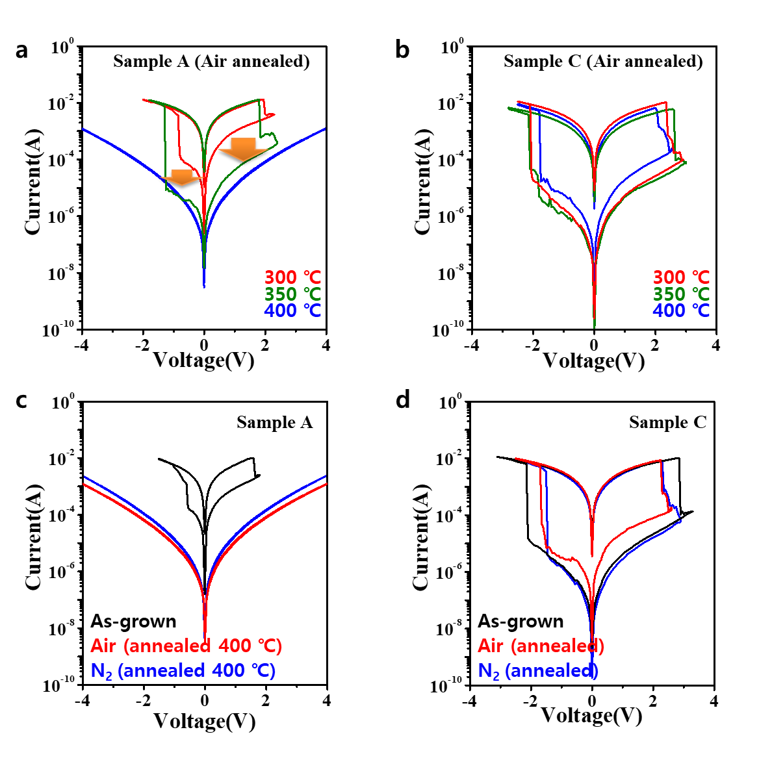
Figure S3 Resistive switching characteristics of I-V curves for Samples A and C under two different conditions. First, Samples A (a) and C (b) were annealed in an air environment at various temperatures. Second, Samples A (c) and C (d) were annealed at 400 °C in air and N₂ environments. Heat treatment was carried out at each temperature for 1 hour. Resistive switching behavior was absent in annealed Sample A. In contrast, the resistive switching behavior of Sample C was mostly unchanged, even after 400°C post-annealing, regardless of the annealing atmosphere.

