A single cell high content assay detects mitochondrial dysfunction in iPSC-derived neurons with mutations in SNCA

Daniel Little¹*, Christin Luft¹, Olukunbi Mosaku¹, Maëlle Lorvellec¹, Zhi Yao², Sébastien Paillusson³, Janos Kriston-Vizi¹, Sonia Gandhi², Andrey Y Abramov², Robin Ketteler¹, Michael J. Devine^{1,4,5}, Paul Gissen^{1,4,5}

¹ MRC Laboratory for Molecular Cell Biology, University College London, Gower Street, London, United Kingdom
² Department of Molecular Neuroscience, University College London, Institute of Neurology, Queen Square, London, United Kingdom
³ Institute of Psychiatry, Psychology and Neuroscience, King’s College London, De Crespigny Park, London, United Kingdom
⁴ Department of Neuroscience, Physiology and Pharmacology, University College London, Gower Street, London, United Kingdom
⁵ These authors contributed equally
* Corresponding Author
Correspondence: d.little@ucl.ac.uk

Supplementary Information

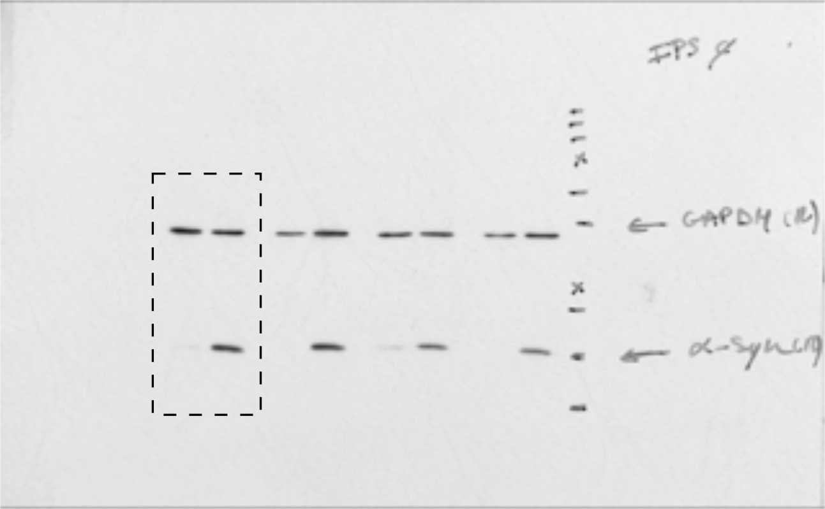

Supplementary Figure 1. Uncropped version of immunoblot blot shown in figure 1, dashed rectangle represents area shown in figure 1.

Basal | Control 1 - Patient 1 | Control 1 - Patient 2 | Control 2 - Patient 1 | Control 2 - Patient 2
Cell Intensity | 71 | 73 | 47 | 48
Mitochondria Intensity | 82 | 84 | 68 | 69
Mean Area | 70 | 75 | 46 | 49
Total Area | 79 | 83 | 56 | 59
Aspect Ratio | 99 | 99 | 97 | 96
Major Axis Length | 92 | 94 | 94 | 97
Oligomcyin
Cell Intensity | 54 | 46 | 40 | 35
Mitochondria Intensity | 70 | 60 | 62 | 53
Mean Area | 52 | 36 | 36 | 25
Total Area | 53 | 39 | 40 | 29
Aspect Ratio | 103 | 104 | 98 | 100
Major Axis Length | 81 | 75 | 76 | 71
Rotenone
Cell Intensity | 82 | 76 | 62 | 59
Mitochondria Intensity | 96 | 95 | 80 | 79
Mean Area | 88 | 64 | 73 | 53
Total Area | 89 | 78 | 67 | 59
Aspect Ratio | 100 | 101 | 96 | 97
Major Axis Length | 90 | 80 | 85 | 73

Supplementary Table 1. Median difference between controls and patients (% of control) by different measures for each condition (basal, oligomycin and rotenone).

 | Control 1 |  | Control 2 |  | Patient 1 |  | Patient 2
 | Images | Cells | Images | Cells | Images | Cells | Images | Cells
Basal | 95 | 1809 | 82 | 2581 | 98 | 1260 | 97 | 1383
CCCP | 96 | 1638 | 95 | 2601 | 96 | 1067 | 91 | 1293
Oligomcyin | 88 | 1383 | 72 | 2043 | 86 | 877 | 74 | 869
Rotenone | 89 | 1245 | 70 | 1131 | 75 | 994 | 77 | 946

Supplementary Table 2. Table displaying the total number of images and cells analysed for each cell line under each condition (basal, CCCP, oligomycin and rotenone).

