Supporting Information

Electrochemical properties of novel FeV₂O₄ as an anode for Na-ion batteries

Irish Valerie B. Maggay,^{1†} Lyn Marie Z. De Juan,^{2†} Jeng-Shin Lu,^{1†} Mai Thanh Nguyen,² Tetsu Yonezawa,² Ting-Shan Chan,³ and Wei-Ren Liu^{1*}

¹Department of Chemical Engineering, Chung Yuan Christian University, Taoyuan City, Chungli 32023, Taiwan, R.O.C.
*E-mail: WRLiu1203@gmail.com
Tel:+886 3-265-4140; fax: +886 3-265-4199

²Division of Materials Science and Engineering, Faculty of Engineering, Hokkaido University
Kita 13 Nishi 8, Kita-ku, Sapporo, Hokkaido 060-8628, Japan

³National Synchrotron Radiation Research Center (NSRRC), Hsinchu, 30076, Hsinchu, Taiwan

Fig. S1. (a) Lattice parameters and (b) cell volume of FeV₂O₄ with their corresponding error bars.

Fig. S2. Comparison of FeV₂O₄ calcined at 400°C with different XRD scan rate.

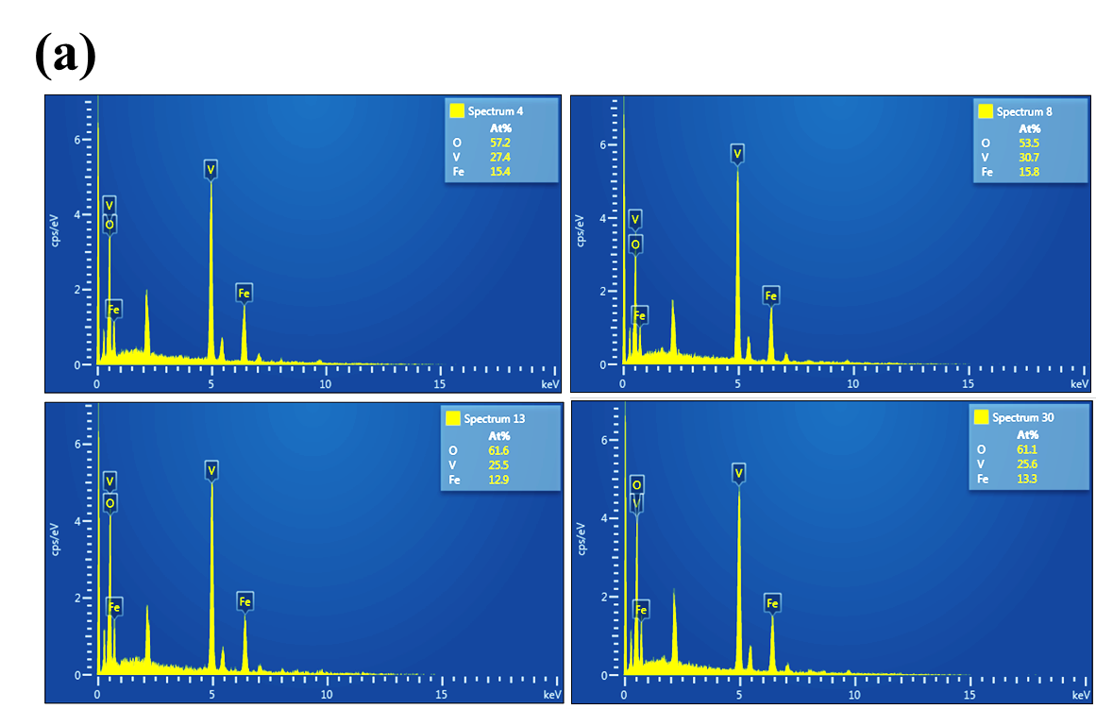
Fig. S2 (a) EDS spectra of FeV₂O₄ and (b) its error bar.
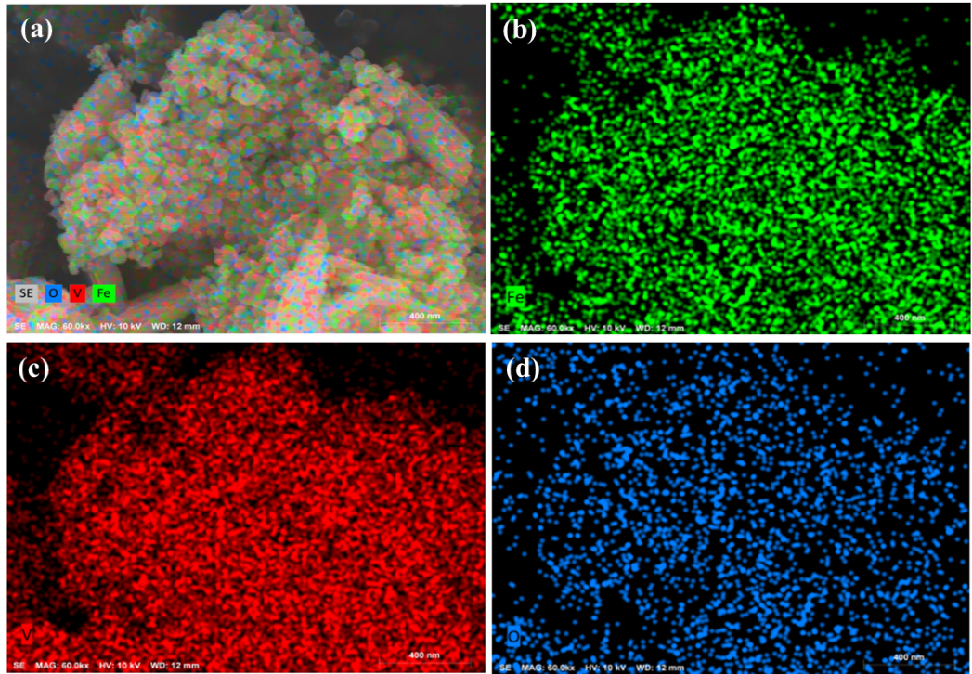

Fig. S3. Elemental mapping of FeV₂O₄.

Fig. S4. (a) X-ray absorption near edge (XANES) spectra of V K-edge and the (b) zoomed in graph of the edge energies.

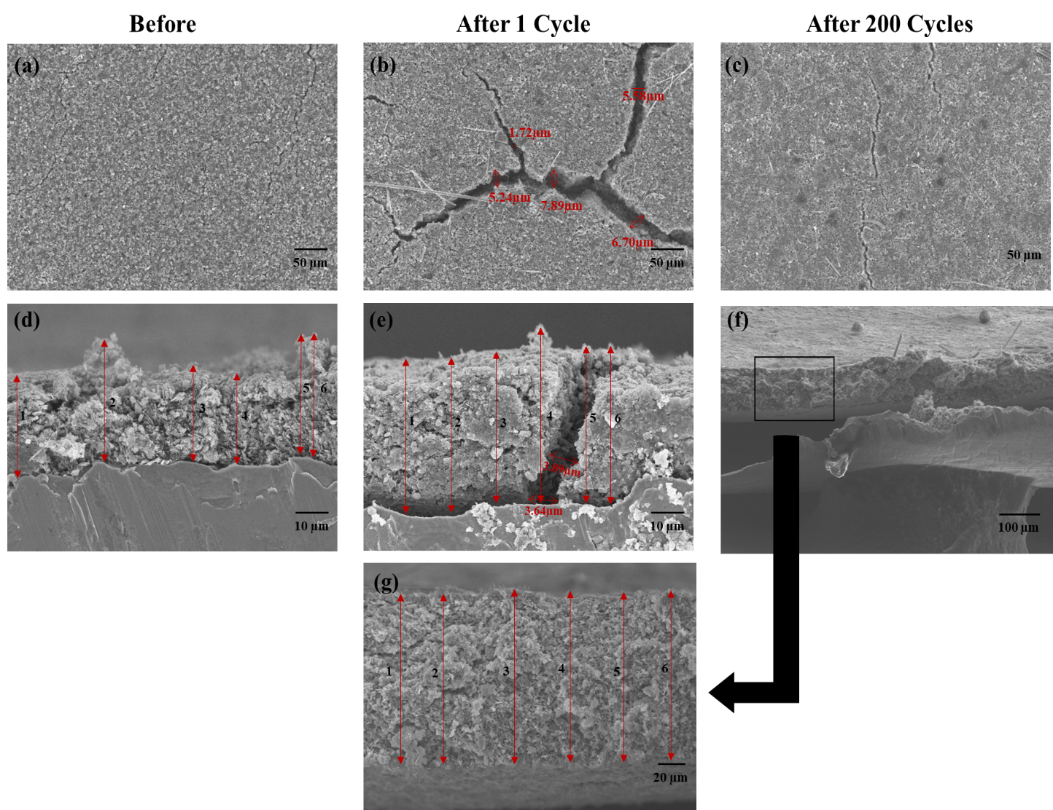

Fig. S5. Ex-situ SEM images of FVO-PVdF electrodes (a) before, after the (b) 1st and (c) 200th charge/discharge cycle. Cross-section SEM images of (d) before, (e) after the 1st, and (f) low and (g) high magnification of the electrode after the 200th cycle.

Table 1. Measured thickness of FVO-PVdF electrode before and after charge/discharge cycle.
FVO-PVdF | Before  (µm) | After 1st C/D Cycle (µm) | After 200th C/D Cycle (µm)
D₁ | 11.00 | 15.82 | 34.64
D₂ | 13.08 | 15.03 | 34.43
D₃ | 9.14 | 15.36 | 34.65
D₄ | 9.93 | 17.66 | 34.10
D₅ | 12.34 | 15.76 | 33.44
D₆ | 12.45 | 15.70 | 33.55
D_{ave} | 11.32 | 15.88 | 34.14
Expansion: 201%

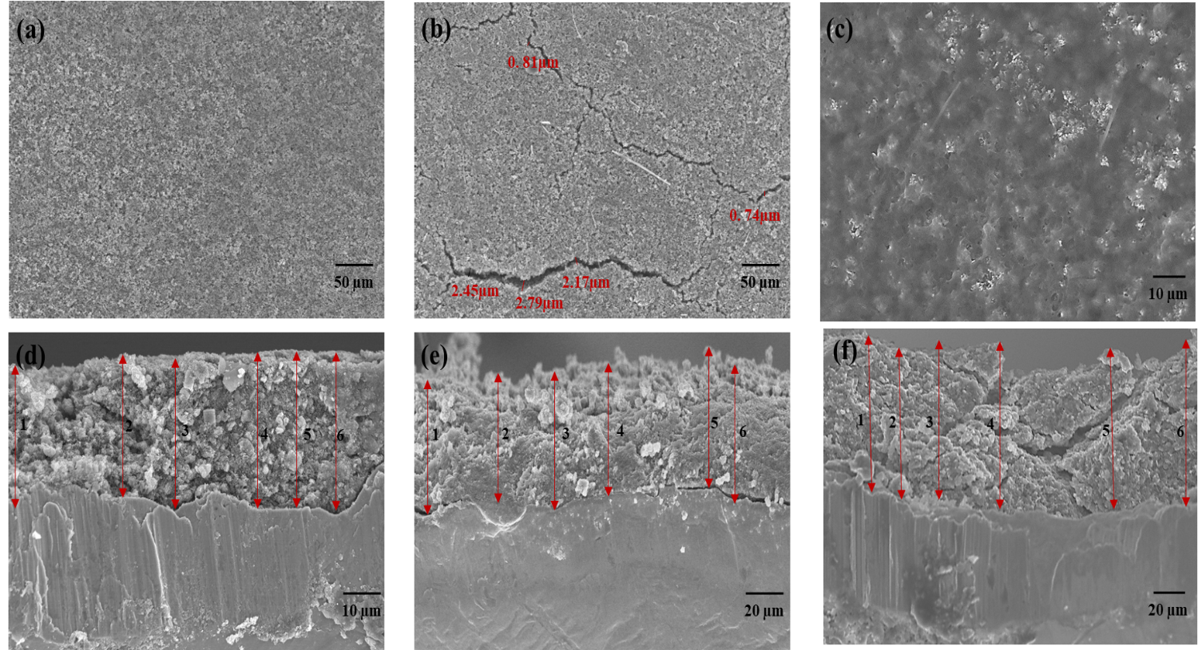

Fig. S6. Ex-situ SEM images of FVO-CMC/SBR electrodes (a) before, after the (b) 1st and (c) 200th charge/discharge cycle. Cross-section SEM images of (d) before, after the (e) 1st and (f) 200th charge/discharge cycle.

Table 2. Measured thickness of FVO-CMC/SBR electrode before and after charge/discharge cycle.
FVO-CMC/SBR | Before  (µm) | After 1st C/D Cycle (µm) | After 200th C/D Cycle (µm)
D₁ | 11.07 | 13.72 | 21.46
D₂ | 11.22 | 13.43 | 21.45
D₃ | 12.11 | 14.35 | 22.96
D₄ | 12.31 | 13.72 | 23.49
D₅ | 12.12 | 14.56 | 22.51
D₆ | 12.73 | 14.44 | 22.53
D_{ave} | 11.93 | 14.04 | 22.40
Expansion: 88%

(a)

(b)
(c)

Fig. S7. Molecular structures of (a) PVdF, (b) CMC¹, and (c) SBR.

1 Biswal, D. & Singh, R. Characterisation of carboxymethyl cellulose and polyacrylamide graft copolymer. Carbohydr. Polym. 57, 379-387 (2004).

Fig. S8. CV profiles of FVO-CMC/SBR at a scan rate of 0.1 mV·s⁻¹ from 0.01 – 3.0V.

