Supplementary Information

Interleukin-6/STAT3 signalling regulates adipocyte induced epithelial-mesenchymal transition in breast cancer cells.
¹Jones Gyamfi, ¹ Yun-Hee Lee, ²Minseob Eom ¹Junjeong Choi
¹ College of Pharmacy, Yonsei Institute of Pharmaceutical Sciences, Yonsei University, Incheon, Korea
² Department of Pathology, Yonsei University Wonju College of Medicine, Wonju, Korea

Corresponding author:
Junjeong Choi M.D., Ph. D.
College of Pharmacy, Yonsei Institute of Pharmaceutical Sciences, Yonsei University, Incheon, Korea
Veritas Hall D 306, 85 Songdogwahak-ro,
Incheon, 21983, Republic of Korea
Phone: +82-32-749-4521
Fax: +82-32-749-4105
E-mail: junjeong@yonsei.ac.kr

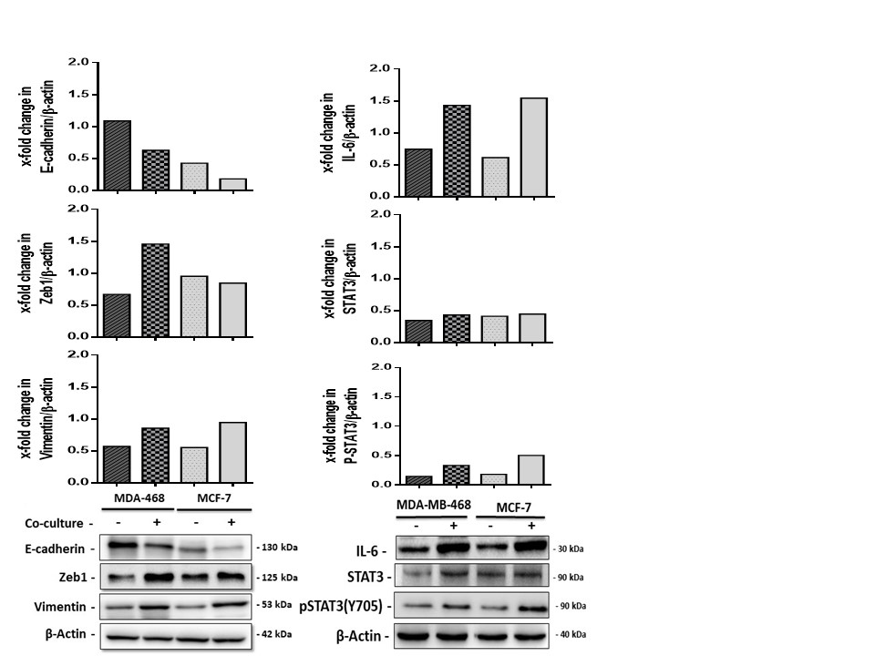

Supplementary Figure 1: Adipocytes induces an EMT-phenotype in co-cultured breast cancer cells.
Representative Western blot and quantification showing levels of E-cadherin, Zeb1 and vimentin in co-cultured breast cancer cells.

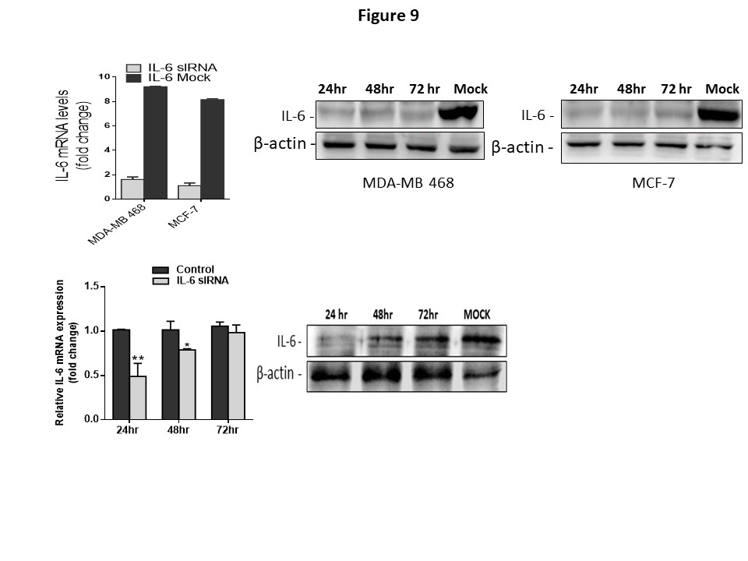
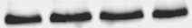
Supplementary Figure 2: Inhibition of IL-6R by siRNA in breast cancer cells and in differentiated human adipocytes.
MCF-7
MDA-MB 468
IL-6 -
24hr 48hr 72 hr Mock
24hr 48hr 72 hr Mock
QT-PCR quantification and Western blot analyses of IL-6 expression in breast cancer cells and differentiated human adipocytes after treatment with IL-6R siRNA. Expected band size for IL-6 is 30kDa, blots show inhibition of IL-6 over 96 hours after treatment with siRNA in breast cancer cells. Inhibition of IL-6R in human adipocytes was effective within 24 hours. Beta-actin expected molecular weight/size is 42 kDa. Relative IL-6 mRNA expression was normalized to GADPH (Data indicate mean ± SEM; ***p < 0,001; **p < 0.01; *p < 0.05).

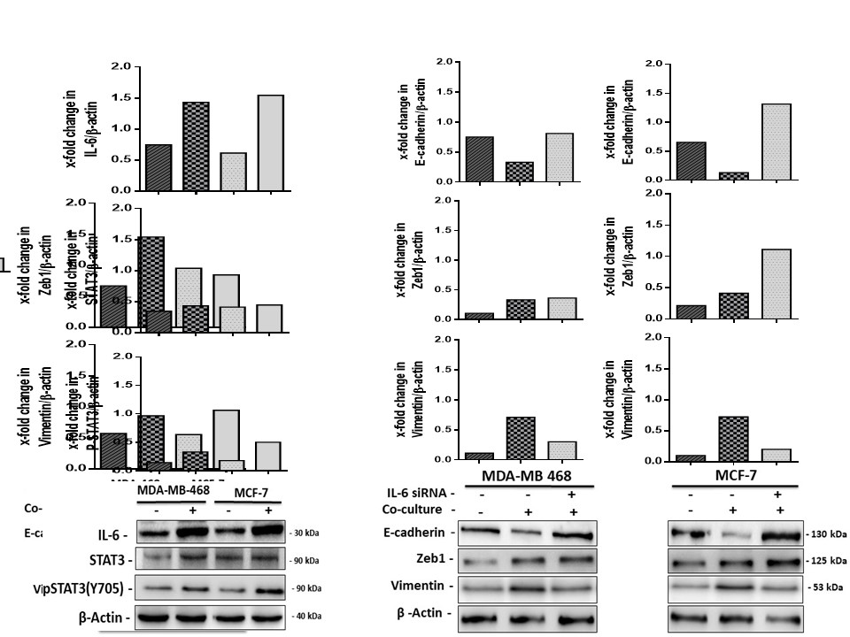

Supplementary Figure 3: Adipocytes induces an EMT-phenotype in co-cultured breast cancer cells is reversed by IL-6 blockage.
Representative Western blot and quantification showing levels of E-cadherin, Zeb1 and vimentin in co-cultured breast cancer cells.

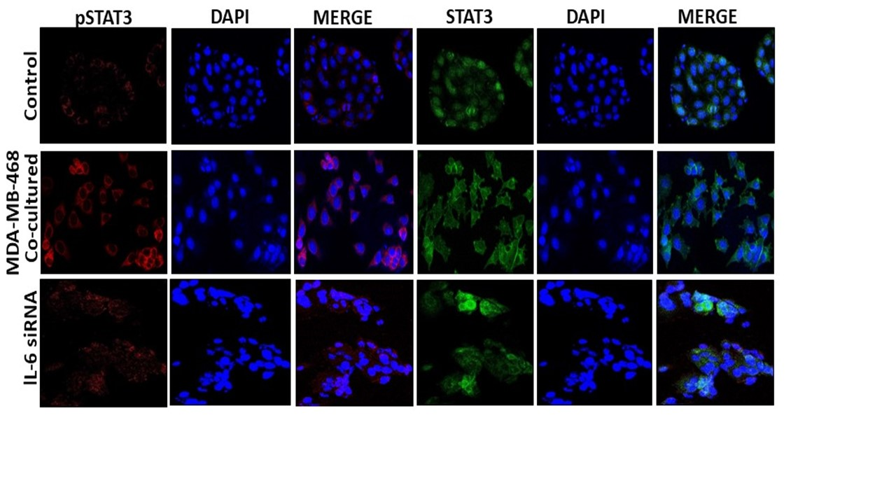
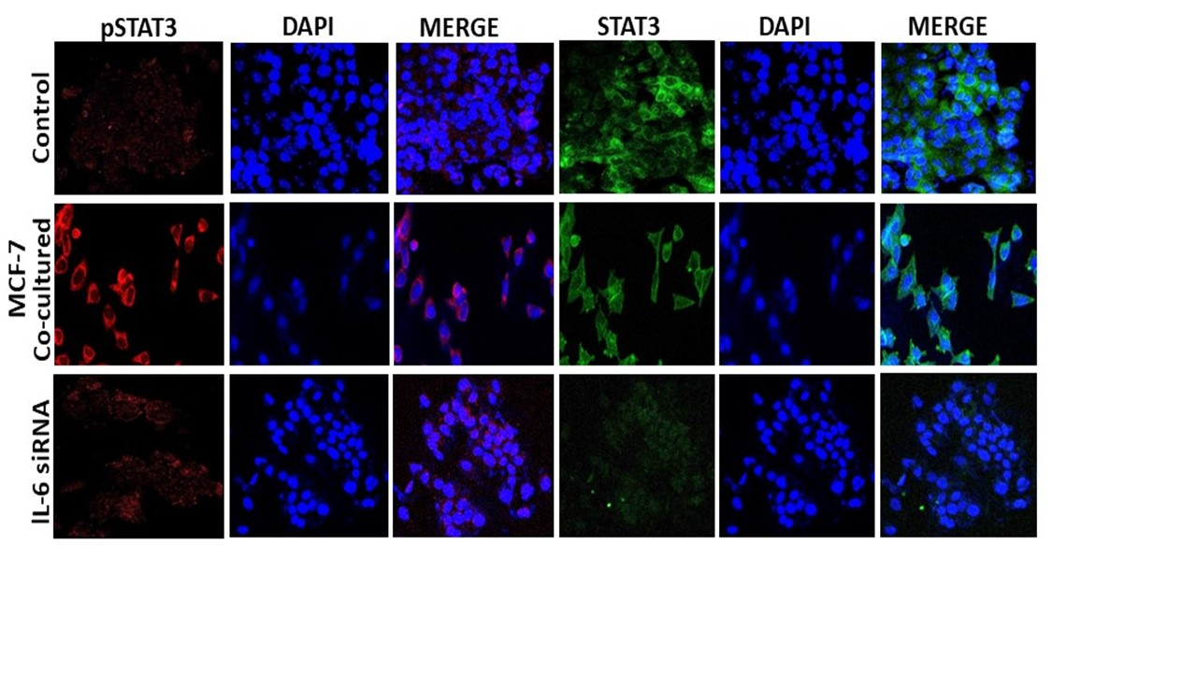
Supplementary Figure 4: Nuclear localization of pSTAT3 after co-culture of breast cancer cells with human adipocytes.
Representative confocal images of immunofluorescent stainings of STAT3 (green) and P-STAT3 (red) co-stained with nuclear marker DAPI (blue) in breast cancer cells cultured with adipocytes.

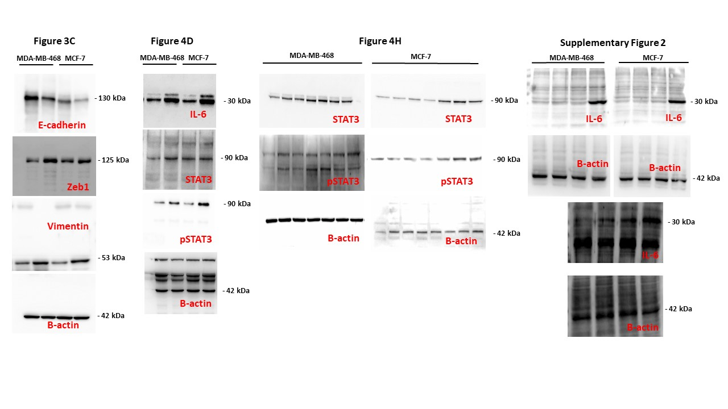
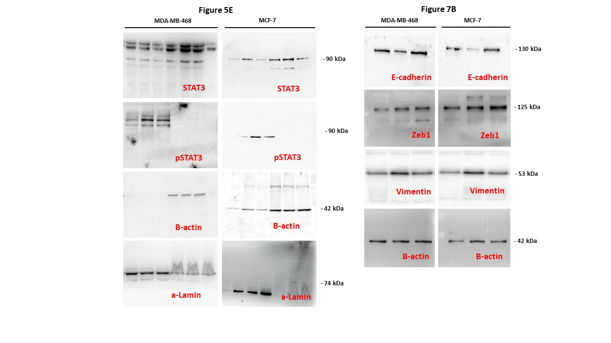
Supplementary Figure 5: Uncropped scans of western blot displayed in Fig. 3C, 4D, 4H 5E, 7B and supplementary fig 2.

