SUPPLEMENTARY INFORMATION

The effects of printing orientation on the electrochemical behaviour of 3D printed acrylonitrile butadiene styrene (ABS) / carbon black electrodes

Hairul Hisham Bin Hamzah^{1†}, Oliver Keattch^{2†}, Derek Covill² & Bhavik Anil Patel^{1,*}
¹School of Pharmacy and Biomolecular Sciences and
²School of Computing, Engineering and Mathematics, University of Brighton, Brighton, East Sussex, UK

† Joint first authors
* Correspondence to: b.a.patel@brighton.ac.uk

Figure S1. Voltammograms for acrylonitrile butadiene styrene (ABS) / carbon black print filament material utilised for development of 3D printed electrodes. Responses are shown in 1 mM ferrocene carboxylic acid in 0.1 M sodium hydroxide at a scan rate of 100 mV/s. Electrode diameter and thickness is 3 mm.

Figure S2. Voltammograms for vertical, horizontal smooth and horizontal rough 3D printed electrodes in 1 M KCl, showcasing the background potential window, which is similar for all three electrodes. Experiments carried out at scan rates of 100 mV/s

Figure S3. Additional responses of performance parameters on 1 mM ferrocene carboxylic acid. (A) Comparison of the ratio of i_{pa}/i_{pc} on gassy carbon (GG), vertical printed (VP) electrode, horizontal printed smooth surface (HPSS) and horizontal printed rough surface (HPRS). (B) shows a comparison of the anodic and cathodic peak separation (ΔE_{p}). Statistical analyses were performed using one-way ANOVA followed by a post-hoc Tukey test. Data shown as mean ± S.D., n = 4, and *P < 0.05, **P < 0.01 and ***P < 0.001.

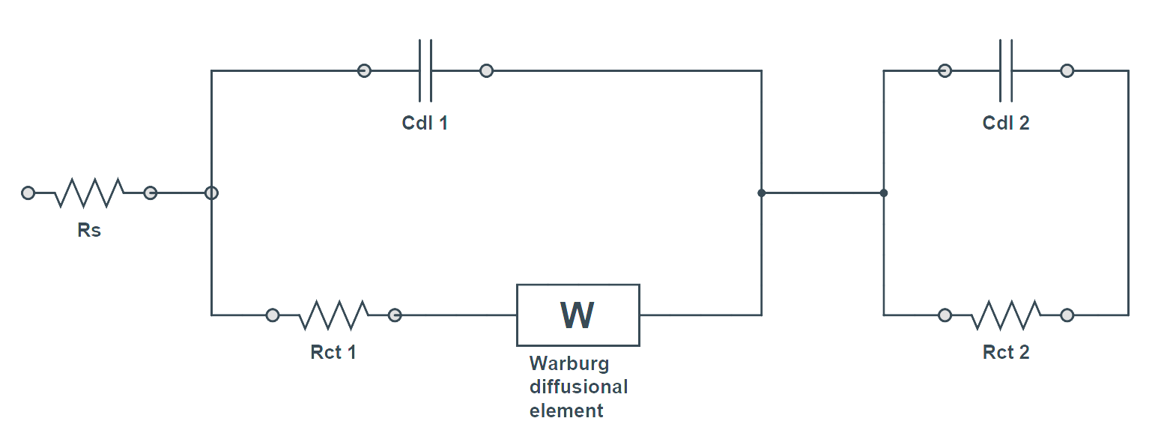
Figure S4. The best equivalent circuit used to fit the experimental data shown in Figures 3D-3F. R_{s} is the uncompensated solution resistance, C_{dl} 1 and 2 are the double layer capacitances, R_{ct} 1 and R_{ct} 2 are the charge transfer resistances and W is the Warburg diffusional element. W was used in the circuit in order the obtain the best-fitted data with the smallest error of fitting. The presence of W in the circuit may correspond to the diffusion process of protons and electrolyte ions to the electrode surface from the 1 M KCl solution in the diffuse layer.

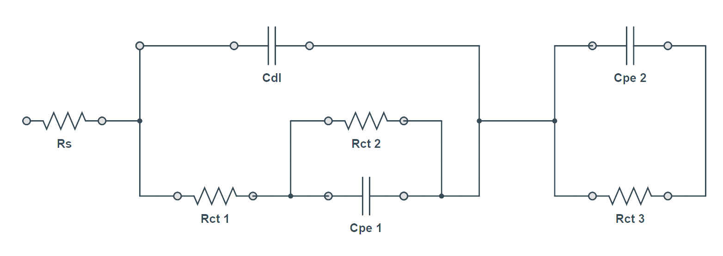

Figure S5. The best equivalent circuit used to fit the data shown in Figure 4a to the Faradaic impedance measurements in 10 mM of ferricyanide/ ferrocyanide solution (black lines). R_{s} is the uncompensated solution resistances, C_{dl} is the double layer capacitances, R_{ct} 1, R_{ct} 2 and R_{ct} 3 are the charge transfer resistances. CPE 1 and 2 are the constant phase elements.

