Low circulating chemerin levels correlate with hepatic dysfunction and increased mortality in decompensated liver cirrhosis
Paul Horn*^{1,2}; Christian von Loeffelholz^{1,3}; Franziska Forkert²; Sven Stengel²; Philipp Reuken²; René Aschenbach⁴, Andreas Stallmach^{1,2}; Tony Bruns^{1,2}
¹Integrated Research and Treatment Center, Center for Sepsis Control and Care (CSCC), Jena University Hospital, Jena, Germany
²Department of Internal Medicine IV, Gastroenterology, Hepatology and Infectious Diseases, Jena University Hospital, Jena, Germany
³Department of Anesthesiology and Intensive Care Medicine, Jena University Hospital, Jena, Germany
⁴Institute for Diagnostic and Interventional Radiology, Jena University Hospital, Jena, Germany

Supplementary Information
Supplementary Figures
Figure Legends
Supplementary Figure 1
Analysis of chemerin concentration in ascitic fluid showing a correlation with serum chemerin (r=0.627. p<0.001) (A), a lower concentration as compared to serum concentrations (p<0.001) (B) and a higher chemerin/albumin ratio in ascitic fluid as compared to serum (p=0.008) (C). Chemerin levels in ascitic fluid were not different in patients with SBP or other infections compared to patients without infection (p>0.05) (D). Asterisk indicate p<0.05 in paired Wilcoxon test.

Supplementary Figure 2
Kaplan-Meier analysis of 28-days transplant-free survival for patients stratified for serum chemerin concentration tertiles (overall p=0.003 in log-rank Test).

Supplementary Figure 3
Kaplan-Meier analysis of overall survival (right censored at transplantation) (A), and time free from liver transplantation (B) for patients stratified for serum chemerin concentration (<87 ng/ml versus ≥87 ng/ml) and MELD score (<18 versus ≥18) (overall p<0.001, p=0.016 and p<0.001, respectively in log-rank test) and overall survival (C) and time free from liver transplantation (D) for patients stratified for status of infection (no infection versus infection) and serum chemerin concentration (<87 ng/ml versus ≥87 ng/ml) (overall p<0.001, p=0.001 and p<0.001, respectively in log-rank test).

Supplementary Figure 1
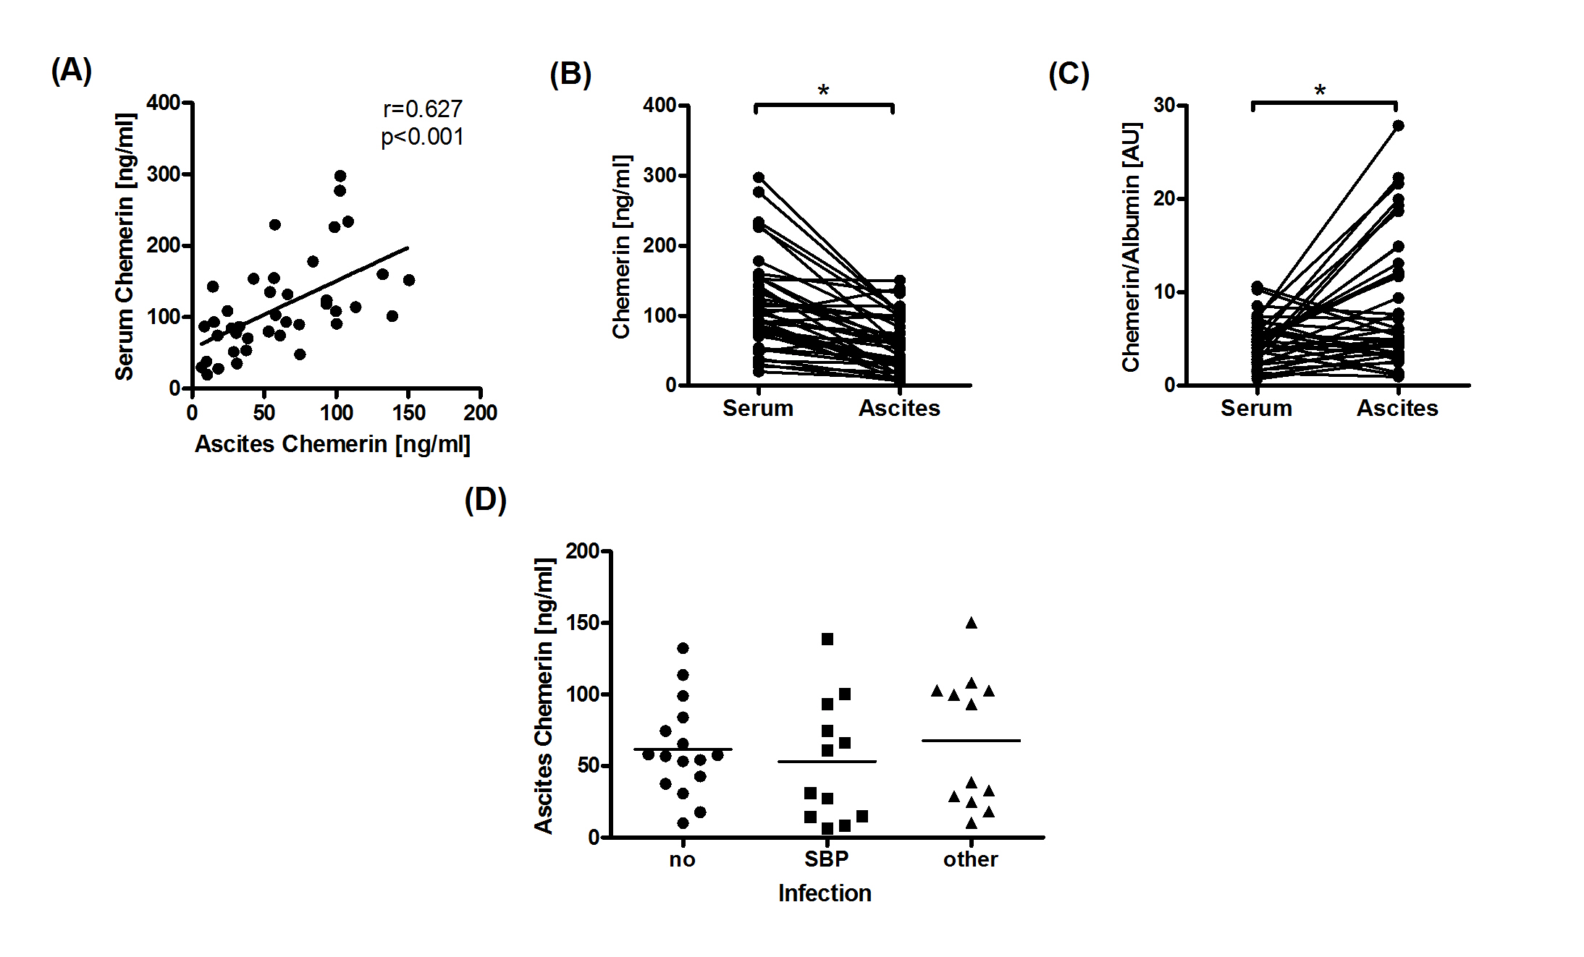

Supplementary Figure 2
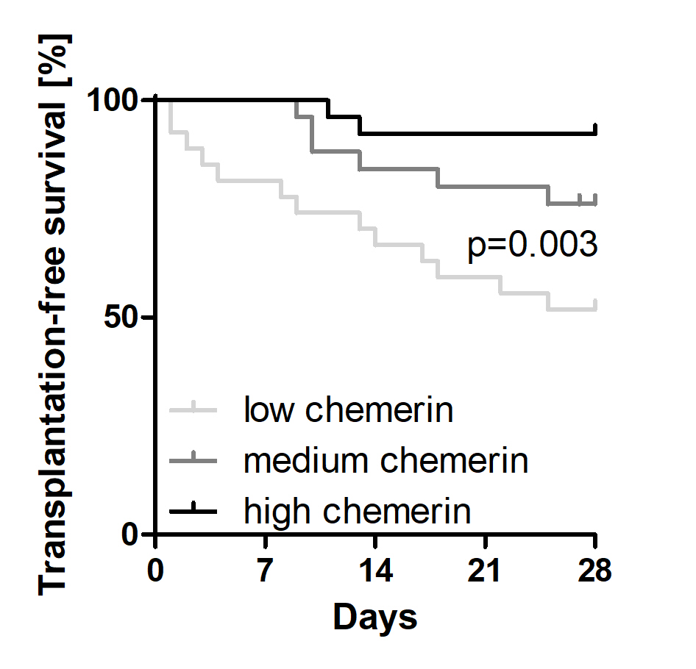

Supplementary Figure 3