Attenuation of inflammatory responses by (+)-syringaresinol via MAP-Kinase-mediated suppression of NF-κB signaling in vitro and in vivo

Vivek K. Bajpai¹, Md Badrul Alam², Khong Trong Quan³, Mi-Kyoung Ju², Rajib Majumder^{4,5}, Shruti Shukla¹, Yun Suk Huh⁶, MinKyun Na^{3,*}, Sang Han Lee^{2,*} & Young-Kyu Han^{1,*}
¹Department of Energy and Materials Engineering, Dongguk University-Seoul, Seoul 04620, Republic of Korea
²Departments of Food Science and Biotechnology, Graduate School, Kyungpook National University, Daegu 41566, Republic of Korea
³College of Pharmacy, Chungnam National University, Daejeon 34134, Republic of Korea
⁴Department of Biological Sciences, Macquarie University, Sydney, NSW 2109, Australia
⁵Elizabeth Macarthur Agricultural Institute (EMAI), NSW Department of Primary Industries, Menangle, NSW 2567, Australia
⁶Department of Biological Engineering, Inha University, 100 Inha-ro, Nam-gu, Incheon 22212, Republic of Korea

Running head: Attenuation of inflammatory responses by a lignan

Corresponding authors:

Dr. Young-Kyu Han; E-mail: ykenergy@dongguk.edu; Dr. MinKyun Na; E-mail: mkna@cnu.ac.kr; Dr. Sang Han Lee; E-mail: sang@knu.ac.kr

Table S1. List of the primer sets used in this study.
Gene name |  | Sequences
iNOS | forward | GGCTGTCAGAGCCTCGTGGCTTTGG
iNOS | reverse | CCCTTCCGAAGTTTCTGGCAGCAGC
COX2 | forward | AACACAGCTACGAAAACC
COX2 | reverse | CACAGTATGATGTAACAGTCC
TNFα | forward | GGCAGGTCTACTTTGGAGTCATTGC
TNFα | reverse | ACATTCGAGGCTCCAGTGAATTCGG
IL-1β | forward | ATGGCAACTGTTCCTGAACTCAACT
IL-1β | reverse | CAGGACAGGTATAGATTCTTTCCTT
IL6 | forward | GAGGATACCACTCCCAACAGA
IL6 | reverse | AAGTGCATCATCGTTGTTCATACA
GAPDH | Forward | TTGTGATGGGTGTGAACCAC
GAPDH | reverse | ACACATTGGGGGTAGGAACA

Fig. S1. ¹H NMR spectrum of (+)-syringaresinol (300 MHz, MeOD).

Fig. S2. ¹³C NMR spectrum of (+)-syringaresinol (75 MHz, MeOD).

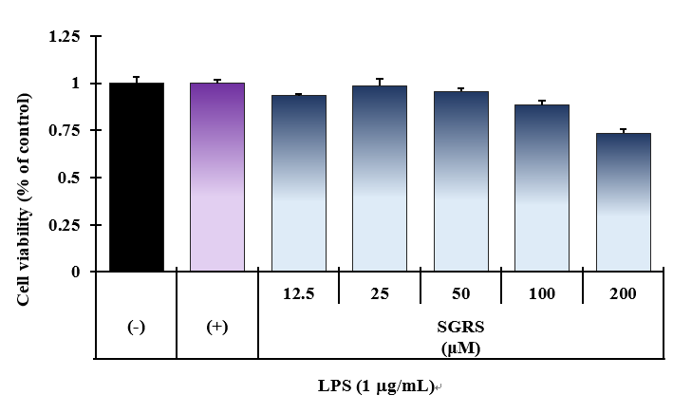
Fig. S3. Effect of (+)-syringaresinol (SGRS) on the viability of RAW 264.7 cells. Cells were treated with SGRS for 24 h at the indicated concentrations and cell viability was determined by MTT assay. Values are expressed as the mean ± SD (n=3).

Original gel images
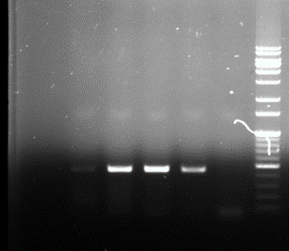

iNOS

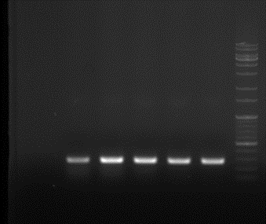

COX-2

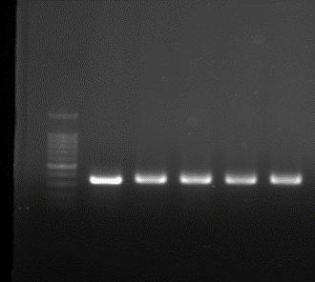

GAPDH

Figure 2C (Uncropped original blots)

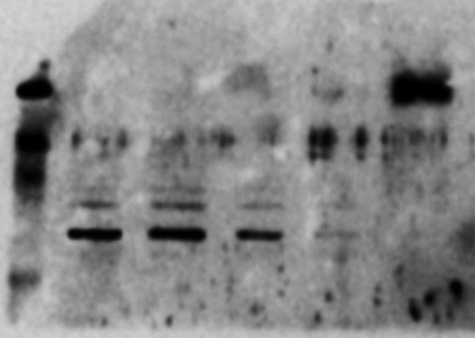
iNOS

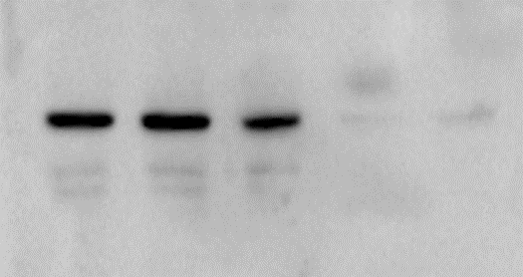
COX-2

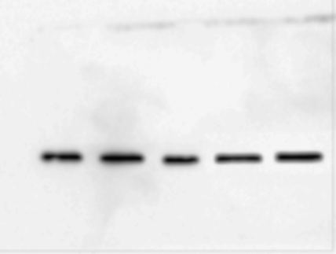

β-actin

Figure 2D (Uncropped original blots)

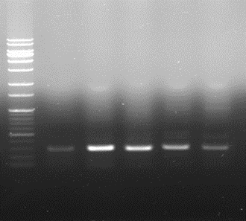

TNF-α

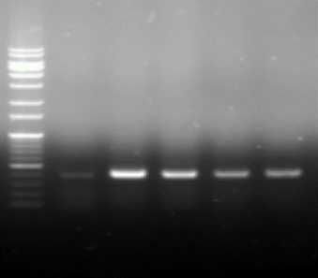

IL-1β

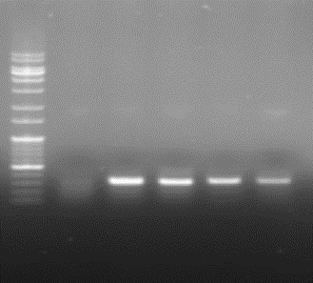

IL-6

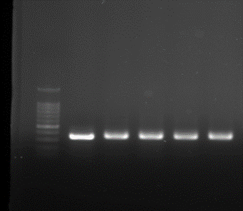

GAPDH

Figure 3D (Uncropped original blots)

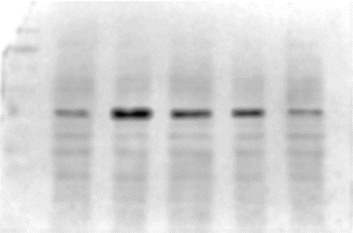

p-IκB

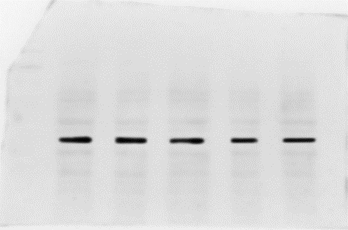

IκB

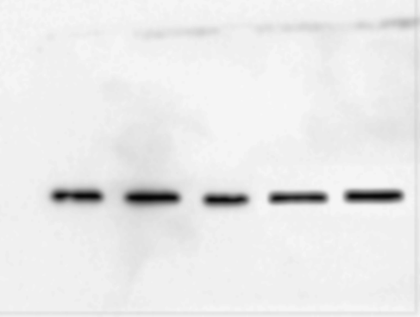

β-actin

Figure 4A (Uncropped original blots)

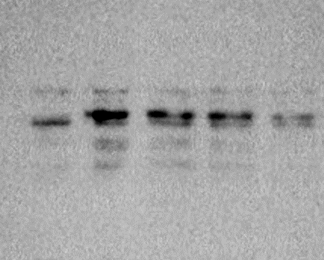

NF-κB

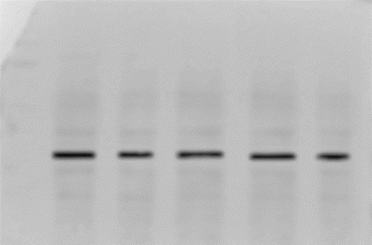

Lamin B

Figure 4B (Uncropped original blots)

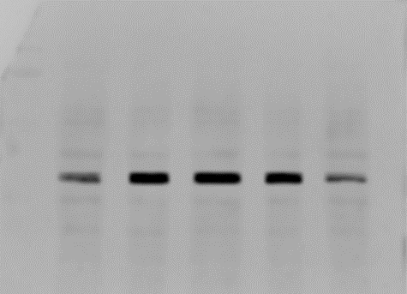

p-p38

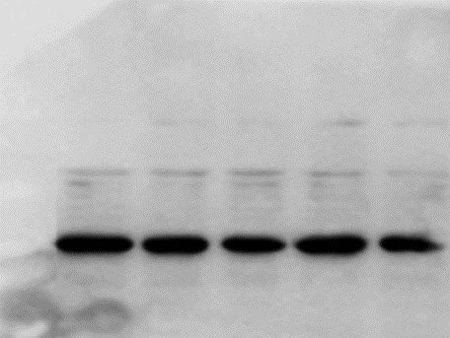

p38

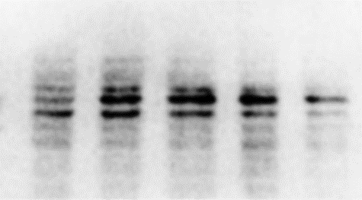

p-JNK

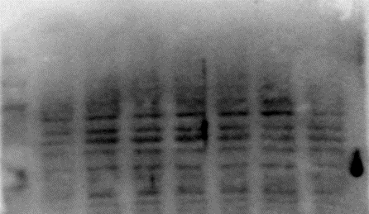

JNK

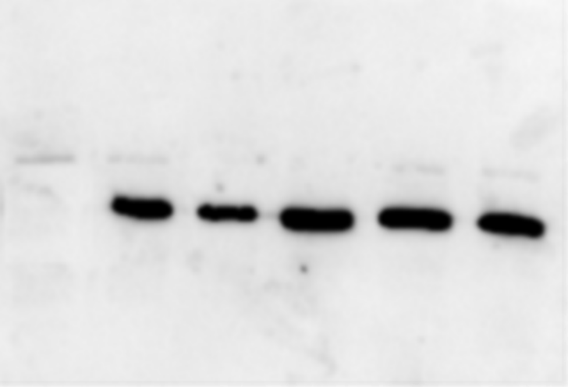

β-actin

Figure 4D (Uncropped original blots)

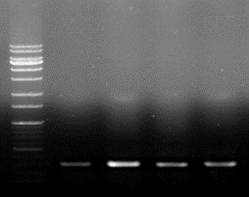

iNOS
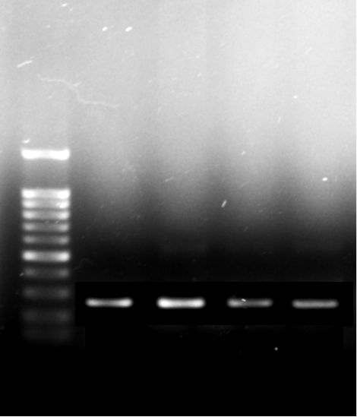

COX-2

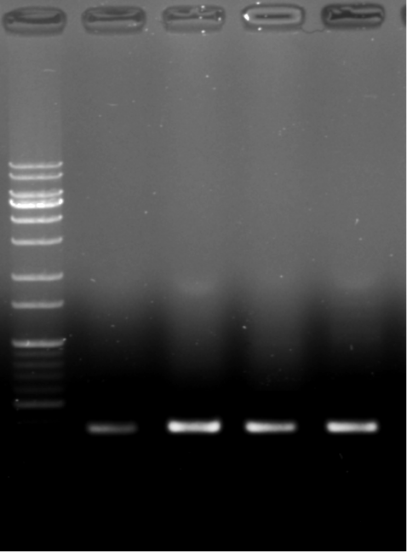

TNF-α

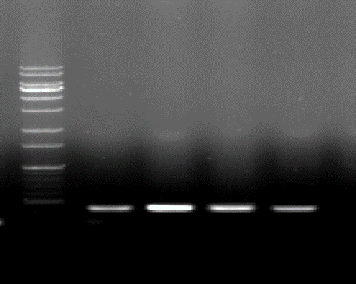

IL-1β

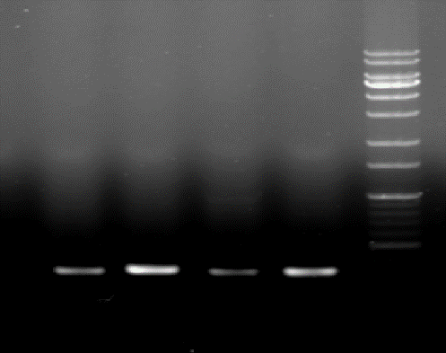

IL-6
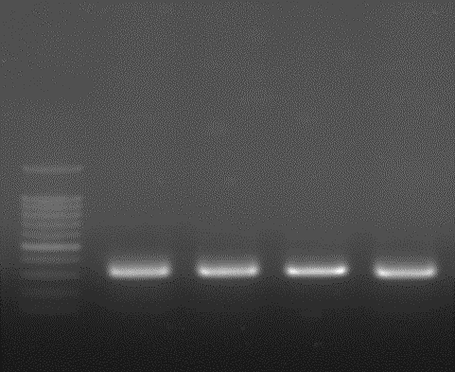

GAPDH

Figure 5B (Uncropped original blots)

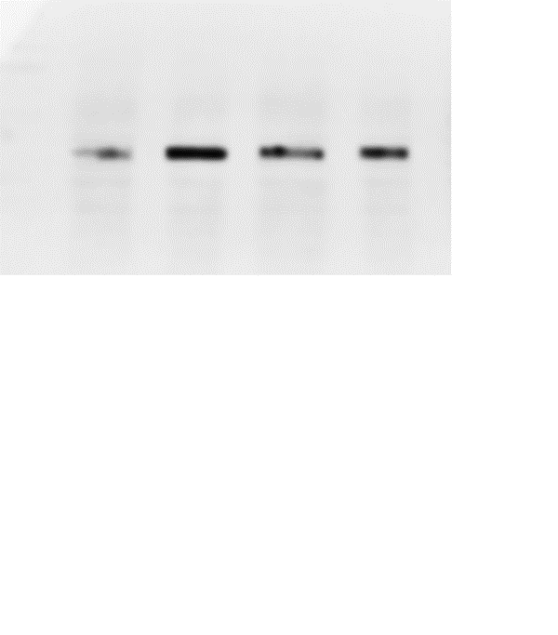
COX-2

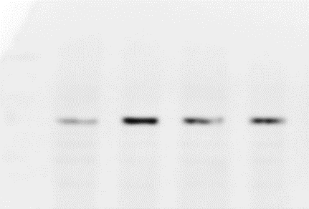

NF-κB

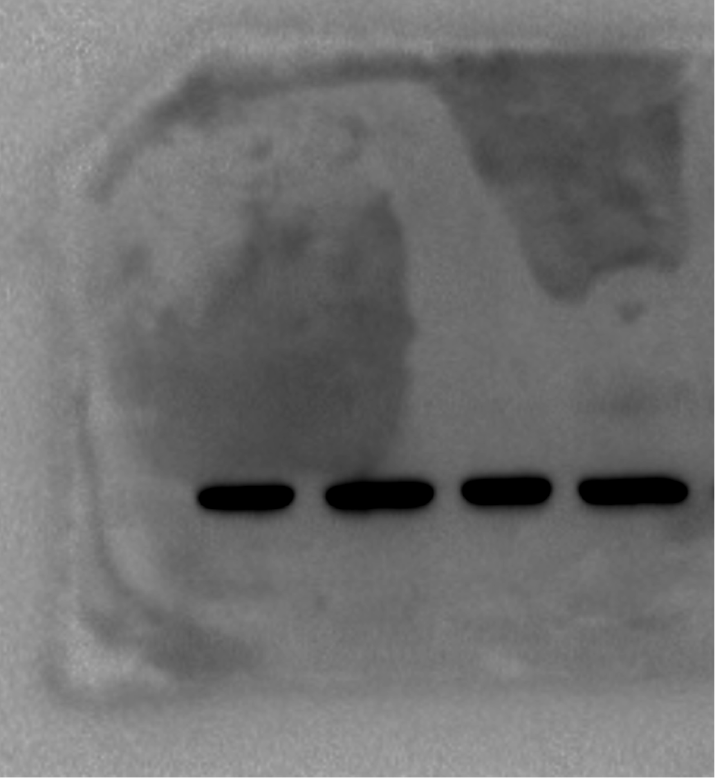

β-actin

Figure 5C (Uncropped original blots)

