Linear Cyclodextrin Polymer Prodrugs as Novel Therapeutics for Niemann-Pick Type C1 Disorder
Aditya Kulkarni,^{1*} Paola Caporali,² Atul Dolas,¹ Soniya Johny,¹ Sandeep Goyal,¹ Jessica Dragotto,² Alberto Macone,³ Ramesh Jayaraman⁴ and Maria Teresa Fiorenza^{2,5}

¹Aten Porus Lifesciences, Bangalore 560068, India.
²Department of Psychology, Division of Neuroscience, Sapienza University, Rome, Italy.
³Department of Biochemical Sciences "A. Rossi Fanelli", Sapienza University of Rome Rome, Italy.
⁴TheraIndx Lifesciences Pvt Ltd, Bangalore 562123, India.
⁵IRCCS Fondazione Santa Lucia, Via del Fosso Fiorano 64, 00179 Rome, Italy.

*To whom correspondence should be addressed: aditya@atenporus.com

Supplementary Information

Synthesis of ORX-301
Materials and Methods
All the reagents were obtained from commercial sources and used as such without further purification if not specified. All solvents used for synthesis were of analytical grade and used without any further purification. IR spectra were measured with a Perkin Elmer Spectrum One Fourier transform infrared spectrometer as KBr pellets. ¹H NMR spectra were recorded on a 400 MHz Bruker spectrometer using TMS as an internal standard. The chemical shifts (δ) for ¹H are given in ppm relative to residual signals of the solvent. Coupling constants are given in Hz. The following abbreviations are used to indicate the multiplicity: s, singlet; d, doublet; t, triplet; q, quartet; m, multiplet; brs, broad singlet.

Synthesis and Characterization
Synthesis of 6^{A}, 6^{D}-diazido 6^{A}, 6^{D}-dideoxy β-cyclodextrin (3)
To a solution of 6^{A}, 6^{D}-diiodo 6^{A}, 6^{D}-dideoxy β-CD(8 g, 5.9 mmol, 1 equiv.) in anhydrous dimethylformamide (70.0 mL),NaN₃ (2.3 g, 35.4 mmol, 6 equiv.) was added. The resulting solution was stirred at 80 °C for 14 h under nitrogen atmosphere. The solution was concentrated to remove DMF and the residue was dissolved in minimum amount of water and loaded on silica gel. The compound was then purified through column chromatography using ACN:water (95:5) as the eluent system. The appropriate fractions were combined together and evaporated to remove acetonitrile. The aqueous solution was then lyophilized to afford desired product as a white solid (Yield: 5.6 g, 80%). FT–IR (KBr, cm⁻¹): 3366, 2037; ¹HNMR (400 MHz, D₂O) δ =5.04 (d, J = 3.6 Hz, 7H), 3.77-4.00 (m, 28H), 3.53-3.65 (m, 14H), 2.83 (s, 2H), 3.98 (s, 2H).

Synthesis of difunctionalized ketal linker (4)
To a solution of acetone (1.43 mL, 19.5 mmol, 1 equiv.) and (propargyloxy)trimethylsilane (5 gm, 38.9 mmol, 2.0 equiv.) in dry dichloromethane under inert atmosphere at -78 °C, trimethylsilyl trifluoromethanesulphonate (0.86 gm, 20 mol%) was added slowly. The reaction mixture was allowed to stir at same temperature for an additional 2.5 h. Progress of the reaction was monitored by TLC. Pyridine (0.6 mL) was added to the reaction mixture and allowed to stir for further 15 min. After completion of the reaction, the reaction mixture was poured in to the solution of saturated sodium bicarbonate and was extracted with diethyl ether. The collective organic layer was washed with brine and evaporated to dryness under reduced pressure. The crude residue was purified through column chromatography using hexane/EtOAc (95:05) as the eluent system to afford Compound 4 (2.2 g, 76%) as a colourless oil. ¹HNMR (400 MHz, CDCl₃):δ = 4.16 (d, J = 2.7 Hz, 4H), 2.41 (t, J = 2.4 Hz, 2H), 1.43 (s, 6H); ¹³C NMR (100 MHz, CDCl₃):δ = 101.51, 80.46, 73.46, 49.36, 24.62.

Synthesis of polymer (ORX-301)
To a degassed solution of 3 (1 g, 0.84 mmol, 1 equiv.) in dimethylformamide (0.2 M), 4(128 mg, 0.84 mmol, 1 equiv.) and Cu(PPh₃)₃Br (39 mg, 0.042 mmol, 0.05 equiv.) were added. The solution was stirred with heating at 60°C for 24 h. The viscous solution was poured into a large excess of ethyl acetate (10x of reaction volume) and washed with hexane. The resulting precipitate was filtered through Buchner funnel. The solid product obtained was dissolved in minimum amount of water and lyophilized to afford desired polymer (ORX-301).¹H NMR (400 MHz, D₂O) δ = 7.88 (s, 1H), 5.01 (d, J = 3.6 Hz, 7H), 3.53-3.93 (m, 47H), 2.96 (s, 3H), 2.80 (s, 3H). The molecular weight of the polymer is determined by gel permeation chromatography (GPC) in DMF. ORX-301 has a molecular weight peak (Mp) of ~ 33,000 Da and a polydispersity index (PDI) of 1.021. The purity of the ORX-301 was determined by HPLC.

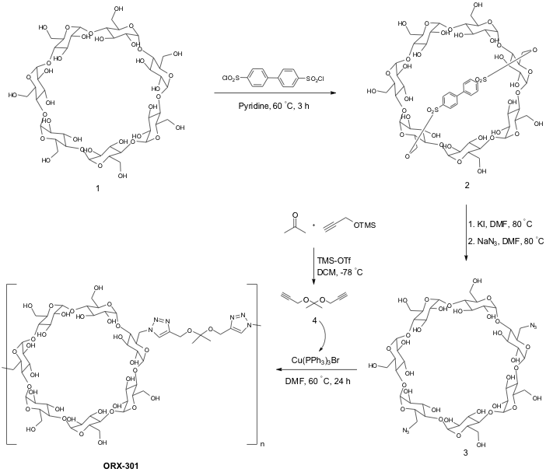

Scheme 1. Synthesis of β-cyclodextrin click polymer (ORX-301)

Table 1A: Individual Animal Body Weight- Males

Group No  Dose  (mg/kg b.w) | Animal  ID | Day 1 | Day 7
G1  0 | M001  M002  M003 | 18.60  20.51  19.92 | 19.88  20.38  20.34
G2  2000 | M004  M005  M006 | 20.00  19.04  18.67 | 19.35  19.90  19.78
G3  3000 | M007  M008  M009 | 20.59  19.69  19.87 | Dead  19.70  19.09

Table 1B: Individual Animal Body Weight- Females

Group No  Dose  (mg/kg b.w) | Animal  ID | Day 1 | Day 7
G1  0 | M013  M014  M015 | 17.96  18.65  18.13 | 17.99  18.78  18.90
G2  2000 | M016  M017  M018 | 17.62  18.20  16.05 | 17.99  18.38  16.18
G3  3000 | M019  M020  M021 | 18.13  17.84  19.37 | 18.10  17.75  Dead

Table 2: Statistical analyses of the body weight of adult wt mice of increasing age

Post-natal  week | Mean bodyweight |  | Mann-Whitney U tests  adult ORX-301- vs. sham-treated wt mice
Post-natal  week | adult sham-treated  wt mice | adult ORX-301-treated  wt mice
8 | 20.46 ± 0.83 g | 20.35 ± 0.65 g | U = 35.5, p = 0.70
9 | 20.83 ± 0.72 g | 20.91 ± 0.52 g | U = 33.5, p = 0.57
10 | 21.89 ± 0.82 g | 21.71 ± 0.68 g | U = 38, p = 0.90
11 | 21.98 ± 0.74 g | 22.07 ± 0.56 g | U = 33, p = 0.57
12 | 23.79 ± 0.84 g | 23.72 ± 0.61 g | U = 36, p = 0.76
13 | 24.34 ± 0.91 g | 24.58 ± 0.49 g | U = 37.5, p = 0.83
14 | 24.59 ± 0.85 g | 24.78 ± 0.47 g | U = 38, p = 0.90
15 | 25.23 ± 0.83 g | 25.18 ± 0.45 g | U = 34.5, p = 0.63
16 | 25.19 ± 0.83 g | 25.20 ± 0.41 g | U = 28, p = 0.31
17 | 25.40 ± 0.96 g | 25.65 ± 0.43 g | U = 33, p = 0.57
18 | 25.29 ± 0.89 g | 25.14 ± 0.53 g | U = 34.5, p = 0.63
19 | 25.92 ± 0.93 g | 26.21 ± 0.36 g | U = 37, p = 0.83
20 | 26.19 ± 0.85 g | 25.82 ± 0.55 g | U = 34, p = 0.63
21 | 25.87 ± 1.09 g | 26.33 ± 0.50 g | U = 38, p = 0.90

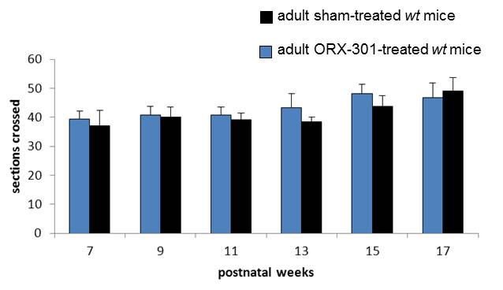
Figure 1. The administration of the ORX-301 prodrug has no effect on the neurobehavioral phenotype of adult wt mice. Histograms indicate the number of sections crossed by experimental group mice of increasing age in the balance beam test. Data are expressed as mean ± SEM.

Table 3: Statistical analyses of the neurobehavioral performance of adult wt mice of increasing age

Post-natal  week | Student’s t test  adult ORX-301- vs. sham-treated wt mice
7 | t₁₆ = - 0.36, p = 0.73
9 | t₁₆ = - 0.18, p = 0.86
11 | t₁₆ = - 0.45, p = 0.61
13 | t₁₆ = - 1.04, p = 0.31
15 | t₁₆ = - 0.86, p = 0.40
17 | t₁₆ = 0.34, p = 0.74

Table 4: Statistical analyses of the body weight loss variation of adult Npc1^{nmf164} mice of increasing age.

Post-natal  week | Mann-Whitney U tests  adult ORX-301- vs. sham-treated Npc1^{nmf164} mice
11 | U = 27.5, p = 0.47
12 | U = 8, p = 0.007
13 | U = 8, p = 0.007
14 | U = 13, p = 0.03
15 | U = 15.5, p = 0.06

Table 5: Statistical analyses of the neurobehavioral performance of adult mice of increasing age

Post-natal  week | Statistical analyses
7 | one-way ANOVAs | F_{(2,32)} = 1.48, p = 0.24 | post hoc | ------
9 | one-way ANOVAs | F_{(2,32)} = 14.60, p = 0.00003 | post hoc | adult wt vs. sham-treated Npc1^{nmf164} mice: p = 0.00003
 |  |  |  | adult wt vs. ORX-301-treated Npc1^{nmf164} mice: p = 1
 |  |  |  | adult ORX-301- vs. sham-treated Npc1^{nmf164} mice: p = 0.001
11 | one-way ANOVAs | F_{(2,32)} = 25.12, p < 0.00001 | post hoc | adult wt vs. sham-treated Npc1^{nmf164} mice: p < 0.00001
 |  |  |  | adult wt vs. ORX-301-treated Npc1^{nmf164} mice: p = 0.06
 |  |  |  | adult ORX-301- vs. sham-treated Npc1^{nmf164} mice: p = 0.005
13 | one-way ANOVAs | F_{(2,32)} = 58.17, p < 0.00001 | post hoc | adult wt vs. sham-treated Npc1^{nmf164} mice: p < 0.00001
 |  |  |  | adult wt vs. ORX-301-treated Npc1^{nmf164} mice: p = 0.00001
 |  |  |  | adult ORX-301- vs. sham-treated Npc1^{nmf164} mice: p = 0.005
15 | Mann-Whitney U | adult wt vs. ORX-301-treated Npc1^{nmf164} mice: U = 0, p < 0.00001
17 | Mann-Whitney U | adult wt vs. ORX-301-treated Npc1^{nmf164} mice: U = 0, p < 0.00001

Table 6: Statistical analyses of the body weight of wt mice of increasing age

Post-natal  week | Mean bodyweight |  | Mann-Whitney U test  ORX-301- vs. sham-treated wt mice
Post-natal  week | sham-treated  wt mice | ORX-301-treated  wt mice | Mann-Whitney U test  ORX-301- vs. sham-treated wt mice
2 | 7.89 ± 0.27 g | 7.35 ± 0.16 g | U = 30, p = 0.18
3 | 10.94 ± 0.24 g | 10.57 ± 0.26 g | U = 32, p = 0.24
4 | 13.99 ± 0.27 g | 13.78 ± 0.49 g | U = 43.5, p = 0.73
5 | 17.05 ± 0.35 g | 17.00 ± 0.74 g | U = 46.5, p = 0.91
6 | 19.15 ± 0.59 g | 18.60 ± 0.68 g | U = 37, p = 0.43
7 | 20.32 ± 0.67 g | 19.41 ± 0.86 g | U = 35, p = 0.34
8 | 21.36 ± 0.77 g | 20.23 ± 0.88 g | U = 32, p = 0.24
9 | 21.85 ± 0.76 g | 21.14 ± 0.95 g | U = 39, p = 0.52
10 | 22.78 ± 0.78 g | 21.46 ± 0.74 g | U = 33.5, p = 0.27
11 | 22.94 ± 0.84 g | 22.58 ± 0.85 g | U = 42, p = 0.68
12 | 23.34 ± 0.80 g | 22.89 ± 1.05 g | U = 37, p = 0.43
13 | 24.04 ± 0.79 g | 22.65 ± 1.12 g | U = 28, p = 0.14
14 | 24.75 ± 0.78 g | 23.02 ± 1.07 g | U = 27, p = 0.11
15 | 24.80 ± 0.56 g | 23.81 ± 0.62 g | U = 35, p = 0.34
16 | 24.95 ± 0.75 g | 24.73 ± 0.93 g | U = 44, p = 0.79
17 | 24.99 ± 0.89 g | 23.92 ± 0.95 g | U = 32, p = 0.24
18 | 25.10 ± 0.68 g | 24.61 ± 0.32 g | U = 41, p = 0.62
19 | 25.56 ± 0.74 g | 24.35 ± 0.98 g | U = 39, p = 0.52
20 | 25.16 ± 0.98 g | 25.43 ±1.10 g | U = 44, p = 0.79
21 | 25.31 ± 0.78 g | 25.83 ± 0.81 g | U = 40, p = 0.57
22 | 25.56 ± 0.61 g | 26.01 ± 0.78 g | U = 41, p = 0.62
23 | 25.78 ± 0.59 g | 26.35 ± 0.28 g | U = 32, p = 0.24
24 | 25.89 ± 1.01 g | 26.50 ± 0.55 g | U = 30, p = 0.18
25 | 25.91 ± 0.59 g | 26.58 ± 0.80 g | U = 30, p = 0.18
26 | 25.58 ± 0.63 g | 26.45 ±1.15 g | U = 30, p = 0.18
27 | 25.99 ± 0.77 g | 26.51 ± 0.95 g | U = 30, p = 0.18
28 | 26.16 ± 0.66 g | 26.60 ± 1.02 g | U = 30, p = 0.18

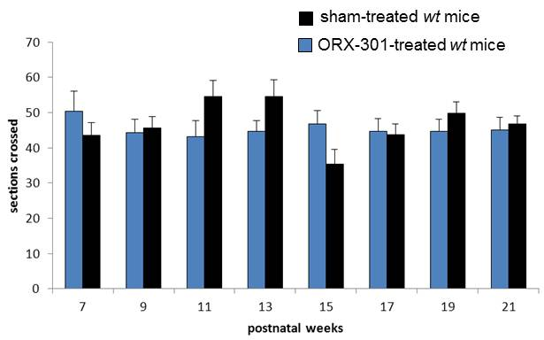

Figure 2: The administration of the ORX-301 prodrug has no effect on the neurobehavioral phenotype of wt mice. Histograms indicate the number of sections crossed by experimental group mice of increasing age in the balance beam test. Data are expressed as mean ± SEM.

Table 7: Statistical analyses of the neurobehavioral performance of wt mice of increasing age

Post-natal  week | Student’s t test  ORX-301- vs. sham-treated wt mice
7 | t₁₈ = 1.06, p = 0.31
9 | t₁₈ = - 0.24, p = 0.82
11 | t₁₈ = - 1.70, p = 0.11
13 | t₁₈ = - 1.56, p = 0.17
15 | t₁₈ = 1.93, p = 0.07
17 | t₁₈ = 0.17, p = 0.88
19 | t₁₈ = - 1.05, p = 0.31
21 | t₁₈ = - 0.43, p = 0.67

Table 8: Statistical analyses of the body weight of Npc1^{nmf164} mice of increasing age

Post-natal  week | Mean bodyweight |  |  | Kruskal-Wallis’s  test
Post-natal  week | sham-treated  Npc1^{nmf164} mice | HPβCD-treated  Npc1^{nmf164} mice | ORX-301-treated  Npc1^{nmf164} mice | Kruskal-Wallis’s  test
2 | 7.31 ± 0.20 g | 7.43 ± 0.30 g | 7.53 ± 0.21 g | H = 0.13, p = 0.94
3 | 10.44 ± 0.17 g | 10.37 ± 0.33 g | 10.02 ± 0.44 g | H = 0.98, p = 0.60
4 | 13.57 ± 0.33 g | 13.31 ± 0.53 g | 12.52 ± 0.34 g | H = 4.26, p = 0.12
5 | 16.48 ± 0.32 g | 17.24 ± 0.65 g | 15.76 ± 0.66 g | H = 1.40, p = 0.50
6 | 17.32 ± 0.37 g | 18.58 ± 0.75 g | 18.49 ± 0.64 g | H = 3.08, p = 0.21
7 | 18.09 ± 0.48 g | 20.25 ± 0.84 g | 19.97 ± 0.58 g | H = 0.93, p = 0.23
8 | 18.93 ± 0.59 g | 20.85 ± 0.94 g | 20.73 ± 0.37 g | H = 0.95, p = 0.48
9 | 19.94 ± 0.55 g | 20.55 ± 1.03 g | 19.96 ± 0.61 g | H = 0.21, p = 0.90
10 | 19.63 ± 0.67 g | 19.92 ± 0.81 g | 19.38 ± 0.55 g | H = 0.17, p = 0.92

Table 9: Statistical analyses of the body weight loss variation of Npc1^{nmf164} mice of increasing age

Post-natal  week | Kruskal-Wallis’s  test | Mann-Whitney U test
11 | H = 2.28, p = 0.32 | --------------------
12 | H = 17.93, p = 0.0001 | ORX-301- vs. sham-treated Npc1^{nmf164} mice | U = 22, p = 0.0001
12 | H = 17.93, p = 0.0001 | HPβCD- vs. sham-treated Npc1^{nmf164} mice | U = 34, p = 0.09
12 | H = 17.93, p = 0.0001 | ORX-301- vs. HPβCD-treated Npc1^{nmf164} mice | U = 58, p = 0.13
13 | H = 15.02, p = 0.0005 | ORX-301- vs. sham-treated Npc1^{nmf164} mice | U = 42.5, p = 0.004
13 | H = 15.02, p = 0.0005 | HPβCD- vs. sham-treated Npc1^{nmf164} mice | U = 7.5, p = 0.0001
13 | H = 15.02, p = 0.0005 | ORX-301- vs. HPβCD-treated Npc1^{nmf164} mice | U = 66, p = 0.26
14 | H = 20.61, p < 0.00001 | ORX-301- vs. sham-treated Npc1^{nmf164} mice | U = 16, p = 0.0002
14 | H = 20.61, p < 0.00001 | HPβCD- vs. sham-treated Npc1^{nmf164} mice | U = 5.5, p = 0.00006
14 | H = 20.61, p < 0.00001 | ORX-301- vs. HPβCD-treated Npc1^{nmf164} mice | U = 70.5, p = 0.36
15 | H = 25.70, p < 0.00001 | ORX-301- vs. sham-treated Npc1^{nmf164} mice | U = 0, p < 0.00001
15 | H = 25.70, p < 0.00001 | HPβCD- vs. sham-treated Npc1^{nmf164} mice | U = 0, p < 0.00001
15 | H = 25.70, p < 0.00001 | ORX-301- vs. HPβCD-treated Npc1^{nmf164} mice | U = 78, p = 0.59
16 | ----- | ORX-301- vs. HPβCD-treated Npc1^{nmf164} mice | U = 84.5, p = 0.80
17 | ----- | ORX-301- vs. HPβCD-treated Npc1^{nmf164} mice | U = 68.5, p = 0.31
18 | ----- | ORX-301- vs. HPβCD-treated Npc1^{nmf164} mice | U = 53.5, p = 0.08
19 | ----- | ORX-301- vs. HPβCD-treated Npc1^{nmf164} mice | U = 89.5, p = 0.98
Table 10: Statistical analyses of the body weight loss variation of Npc1^{nmf164} mice of increasing age

 |  | Npc1^{nmf164} mice
 |  | sham-treated | HPβCD-treated | ORX-301-treated
Friedman’s Test |  | χ² = 44.28, p < 0.00001 | χ² = 38.14, p = 0.00001 | χ² = 161.51, p < 0.00001
Wilcoxon’s test | post-natal weeks 11 vs. 12 | Z = 2.80, p = 0.005 | Z = 0.67, p = 0.50 | Z = 0.91, p = 0.36
Wilcoxon’s test | post-natal weeks 12 vs. 13 | Z = 2.40, p = 0.02 | Z = 1.09, p = 0.27 | Z = 2.67, p = 0.008
Wilcoxon’s test | post-natal weeks 13 vs. 14 | Z = 2.52, p = 0.01 | Z = 1.28, p = 0.20 | Z = 1.78, p = 0.07
Wilcoxon’s test | post-natal weeks 14 vs. 15 | Z = 2.67, p = 0.008 | Z = 0.67, p = 0.50 | Z = 0.05, p = 0.96
Wilcoxon’s test | post-natal weeks 15 vs. 16 | ------ | Z = 0.94, p = 0.34 | Z = 0.05, p = 0.96
Wilcoxon’s test | post-natal weeks 16 vs. 17 | ------ | Z = 1.18, p = 0.24 | Z = 2.86, p = 0.004
Wilcoxon’s test | post-natal weeks 17 vs. 18 | ------ | Z = 0.52, p = 0.60 | Z = 2.45, p = 0.01
Wilcoxon’s test | post-natal weeks 18 vs. 19 | ------ | Z = 2.52, p = 0.01 | Z = 0, p = 1
Wilcoxon’s test | post-natal weeks 19 vs. 20 | ------ | ------ | Z = 1.83, p = 0.07
Wilcoxon’s test | post-natal weeks 20 vs. 21 | ------ | ------ | Z = 2.03, p = 0.04
Wilcoxon’s test | post-natal weeks 21 vs. 22 | ------ | ------ | Z = 0.36, p = 0.72

Table 11: Statistical analyses of the neurobehavioral performance of mice of increasing age

Postnatal  week | Kruskal-Wallis’s  test | Mann-Whitney U test
7 | H = 13.35,  p = 0.004 | wt vs. sham-treated Npc1^{nmf164} mice | U = 33, p = 0.0004
7 | H = 13.35,  p = 0.004 | wt vs. ORX-301-treated Npc1^{nmf164} mice | U = 83, p = 0.004
7 | H = 13.35,  p = 0.004 | wt vs. HPβCD-treated Npc1^{nmf164} mice | U = 85, p = 0.53
7 | H = 13.35,  p = 0.004 | ORX-301- vs. sham-treated Npc1^{nmf164} mice | U = 94.5, p = 0.57
7 | H = 13.35,  p = 0.004 | HPβCD- vs. sham-treated Npc1^{nmf164} mice | U =34, p = 0.09
7 | H = 13.35,  p = 0.004 | ORX-301- vs. HPβCD-treated Npc1^{nmf164} mice | U = 68, p = 0.31
9 | H = 28.83,  p < 0.00001 | wt vs. sham-treated Npc1^{nmf164} mice | U = 9.5, p < 0.00001
9 | H = 28.83,  p < 0.00001 | wt vs. ORX-301-treated Npc1^{nmf164} mice | U = 47.5, p = 0.00004
9 | H = 28.83,  p < 0.00001 | wt vs. HPβCD-treated Npc1^{nmf164} mice | U = 35, p = 0.004
9 | H = 28.83,  p < 0.00001 | ORX-301- vs. sham-treated Npc1^{nmf164} mice | U = 61, p = 0.04
9 | H = 28.83,  p < 0.00001 | HPβCD- vs. sham-treated Npc1^{nmf164} mice | U = 21.5, p = 0.009
9 | H = 28.83,  p < 0.00001 | ORX-301- vs. HPβCD-treated Npc1^{nmf164} mice | U = 59.5, p = 0.15
11 | H = 35.06,  p < 0.00001 | wt vs. sham-treated Npc1^{nmf164} mice | U = 4.5, p < 0.00001
11 | H = 35.06,  p < 0.00001 | wt vs. ORX-301-treated Npc1^{nmf164} mice | U = 35.5, p < 0.00001
11 | H = 35.06,  p < 0.00001 | wt vs. HPβCD-treated Npc1^{nmf164} mice | U = 4, p < 0.00001
11 | H = 35.06,  p < 0.00001 | ORX-301- vs. sham-treated Npc1^{nmf164} mice | U = 52.5, p = 0.02
11 | H = 35.06,  p < 0.00001 | HPβCD- vs. sham-treated Npc1^{nmf164} mice | U =49, p = 0.50
11 | H = 35.06,  p < 0.00001 | ORX-301- vs. HPβCD-treated Npc1^{nmf164} mice | U = 57.5, p = 0.12
13 | H = 48.28,  p = 0.004 | wt vs. sham-treated Npc1^{nmf164} mice | U = 0, p < 0.00001
13 | H = 48.28,  p = 0.004 | wt vs. ORX-301-treated Npc1^{nmf164} mice | U = 10, p < 0.00001
13 | H = 48.28,  p = 0.004 | wt vs. HPβCD-treated Npc1^{nmf164} mice | U = 0, p < 0.00001
13 | H = 48.28,  p = 0.004 | ORX-301- vs. sham-treated Npc1^{nmf164} mice | U = 5.5, p < 0.00001
13 | H = 48.28,  p = 0.004 | HPβCD- vs. sham-treated Npc1^{nmf164} mice | U =31.5, p = 0.06
13 | H = 48.28,  p = 0.004 | ORX-301- vs. HPβCD-treated Npc1^{nmf164} mice | U = 26, p = 0.001
15 | H = 34.01,  p < 0.00001 | wt vs. ORX-301-treated Npc1^{nmf164} mice | U = 26.5, p < 0.00001
15 | H = 34.01,  p < 0.00001 | wt vs. HPβCD-treated Npc1^{nmf164} mice | U = 1, p < 0.00001
15 | H = 34.01,  p < 0.00001 | ORX-301- vs. HPβCD-treated Npc1^{nmf164} mice | U = 12, p = 0.00004
17 | H = 40.49,  p < 0.00001 | wt vs. ORX-301-treated Npc1^{nmf164} mice | U = 0, p < 0.00001
17 | H = 40.49,  p < 0.00001 | wt vs. HPβCD-treated Npc1^{nmf164} mice | U = 0, p < 0.00001
17 | H = 40.49,  p < 0.00001 | ORX-301- vs. HPβCD-treated Npc1^{nmf164} mice | U = 2, p < 0.00001
19 | H = 40.87,  p < 0.00001 | wt vs. ORX-301-treated Npc1^{nmf164} mice | U = 0, p < 0.00001
19 | H = 40.87,  p < 0.00001 | wt vs. HPβCD-treated Npc1^{nmf164} mice | U = 0, p < 0.00001
19 | H = 40.87,  p < 0.00001 | ORX-301- vs. HPβCD-treated Npc1^{nmf164} mice | U = 0, p < 0.00001
21 | ---- | wt vs. ORX-301-treated Npc1^{nmf164} mice | U = 0, p < 0.00001
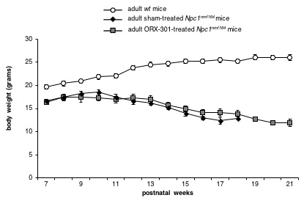
Figure 3: Administration of ORX-301 prodrug delays body weight loss of adult pre-symptomatic (late-intervention study) Npc1^{nmf164} mice. Line graph indicates the body weight of experimental group mice of increasing age. Data are expressed as mean ± SEM. Please note that the end point of each plot corresponds to the post-natal age at which all animals of each experimental group were still alive.

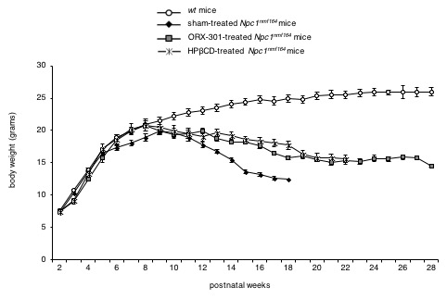

Figure 4: ORX-301 and HPßCD treatments started at PN14 delay the progression of body weight loss of Npc1^{nmf164} mice at different rates. Line graph indicates the body weight of experimental group mice of increasing age. Data are expressed as mean ± SEM . See Table 6 and 8 for raw data and statistical analyses. Please note that the end point of each plot corresponds to the post-natal age at which all animals of each experimental group were alive.

