Quantitative proteomic analysis using iTRAQ to identify salt-responsive proteins during the germination stage of two Medicago species

Ruicai Long^{1,*}, Yanli Gao^{1,*}, Hao Sun¹, Tiejun Zhang¹, Xiao Li¹, Mingna Li², Yan Sun², Junmei Kang¹, Zhen Wang¹, Wang Ding¹, Qingchuan Yang¹

¹ Institute of Animal Sciences, Chinese Academy of Agricultural Sciences, Beijing 100193, People’s Republic of China.
² College of Animal Science and Technology, China Agricultural University, Beijing 100193, People’s Republic of China.

Supplementary information
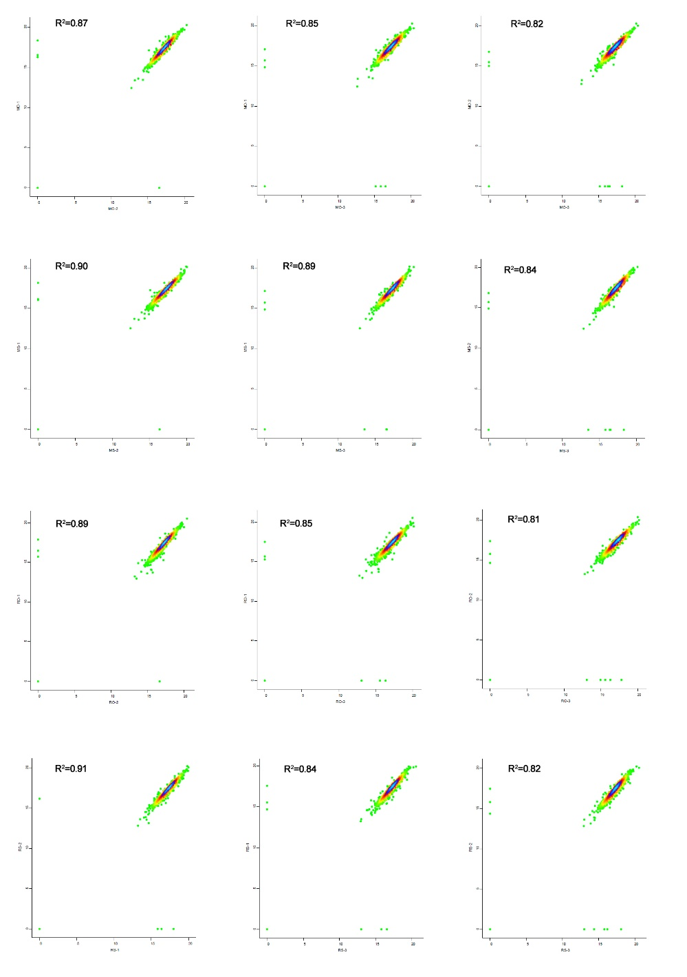
Supplementary Fig. 1 The correlation analysis of iTRAQ replicates.
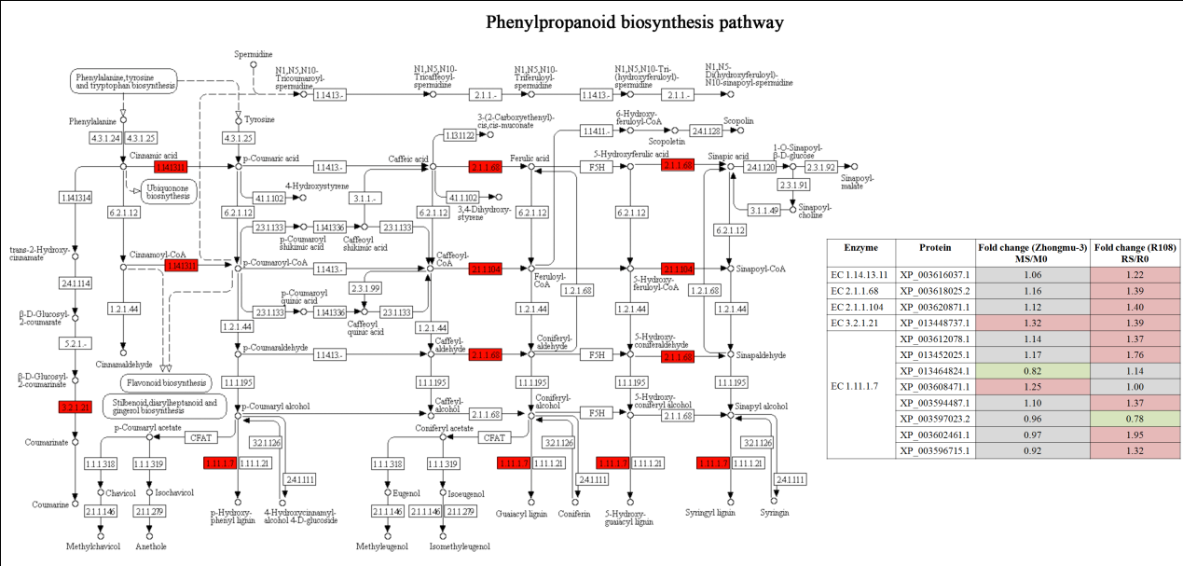
Supplementary Fig. 2 Differentially changed proteins involved in the phenylpropanoid biosynthesis pathway affecting lignin biosynthesis ⁵⁷⁻⁵⁹.

Supplementary Table 1 Zhongmu-3 and R108 proteins identified by iTRAQ.
Supplementary Table 2 Differentially changed proteins in Zhongmu-3 seedlings (fold change ratio > 1.20 or < 0.83).
Supplementary Table 3 Differentially changed proteins in R108 seedlings (fold change ratio > 1.20 or < 0.83).
Supplementary Table 4 Gene ontology classifications of differentially changed proteins and the results of an enrichment analysis.
Supplementary Table 5 KEGG pathways associated with the identified differentially changed proteins.
Supplementary Table 6 The fold changes of protein and transcript abundances of 15 identified proteins by iTRAQ.
Supplementary Table 7 Details regarding the qRT-PCR primers used in this study.

