Supplementary Figures

Neuroepithelial control of mucosal inflammation in acute cystitis

Daniel S.C. Butler¹, Ines Ambite¹, Karoly Nagy^{1,2}, Caterina Cafaro¹, Abdulla Ahmed¹, Aftab Nadeem¹, Nina Filenko¹, Thi Hien Tran¹, Karl-Erik Andersson^{3,4} Björn Wullt¹, Manoj Puthia¹, Catharina Svanborg^{1*}

¹Department of Microbiology, Immunology and Glycobiology, Institute of Laboratory Medicine, Lund University, Lund, S-223 62, Sweden
² Jahn Ferenc (South Pest) Teaching Hospital, 1204 Budapest, Hungary
³ Institute for Regenerative Medicine, Wake Forest University School of Medicine, Winston Salem, NC, USA
⁴ Institute of Clinical Medicine, Department of Obstetrics and Gynecology, Aarhus University, Aarhus Denmark)

Correspondence: Catharina Svanborg
Email: Catharina.Svanborg@med.lu.se Phone: +46 709-426549

Fig S1. NK1R and SP responses to acute cystitis isolate CY-17.

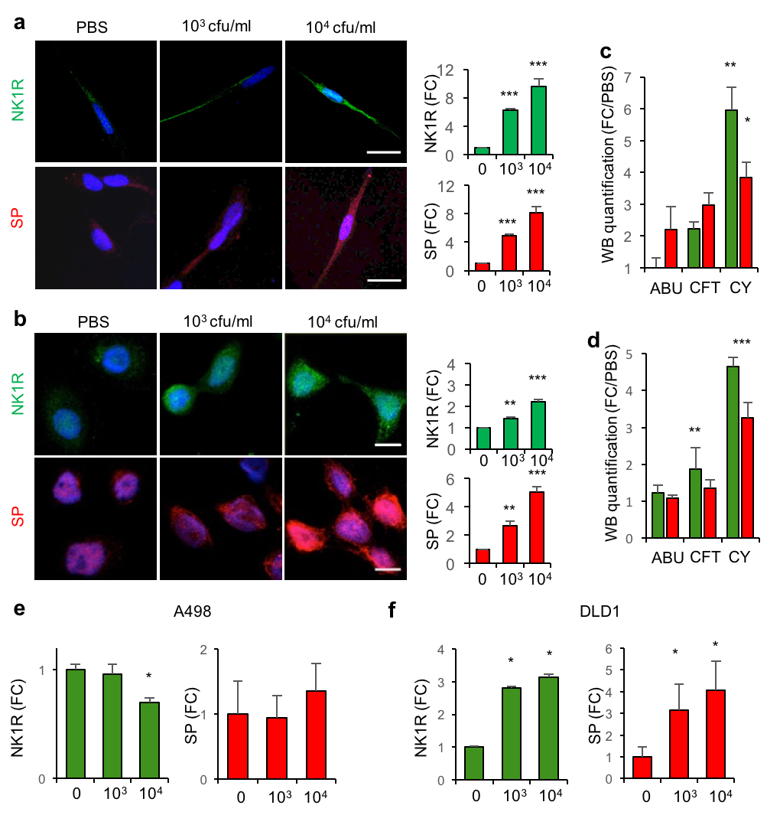

Dose dependent NK1R and SP response to CY-17 infection (10³ - 10⁴ CFU/ml, MOI = 0.005 – 0.05, 4 hours) in SH-SY5Y nerve cells and HTB-9 bladder epithelial cells. (a) Confocal imaging of the NK1R (green) and SP (red) response in nerve cells with inserted quantification (FC to PBS control) (b) Confocal imaging of the NK1R (green) and SP (red) response in bladder epithelial cells. Scale bar = 20 µm. (c-d) Quantification of Western blots (n = 4) from Fig 1d (c) and Fig 1h (d). (e) SP and NK1R response in A498 kidney epithelial cells. (f) SP and NK1R response in DLD1 colon epithelial cells. Data is presented as means + SD of 3 experiments, 5 cells per condition. * = P < 0.05 ** = P < 0.01, *** = P < 0.001

Fig S2. Response of nerve cells and bladder epithelial cells to acute cystitis- or and ABU isolates.

ABU
CY
ABU
CY
SP
NK1R
CY
ABU
ABU
CY
SP
NK1R
a
b
P = 0.012
P = 0.026
P < 0.001
P = 0.027

Nerve cells and bladder epithelial cells were infected with a defined pediatric acute cystitis isolates or pediatric ABU isolates (MOI = 0.05, 4 hours). (A) NK1R (green) and SP (red) staining in SH-SY5Y nerve cells infected with cystitis isolates or ABU isolates. Fold change compared to PBS control. (B) NK1R (green) and SP (red) staining in HTB-9 bladder epithelial cells infected with cystitis isolates or ABU isolates, Fold change compared to PBS control. Mean of three experiments, 50 cells per sample, Mann-Whitney U-test. * = P 0.05, ** = P < 0.01, *** = P < 0.001.

Fig S3. localization of NK1R and SP.

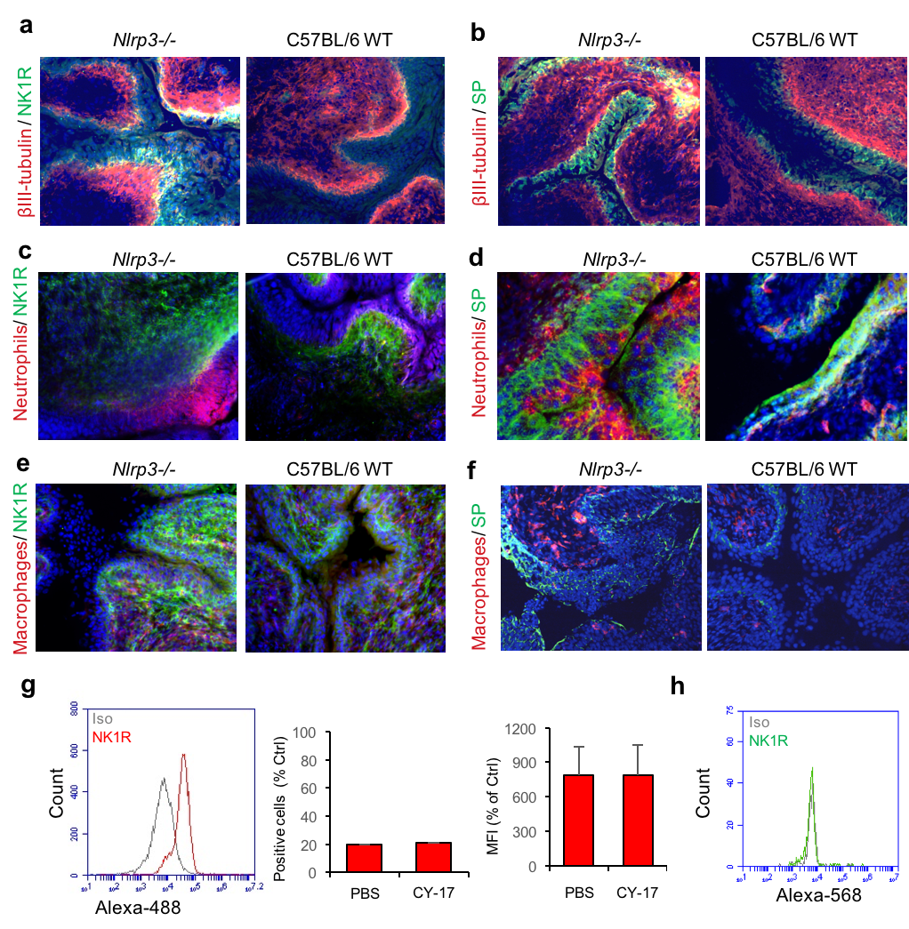

Tissue sections from Nlrp3^{-/-} and C57BL/6 WT mice (n = 4 mice per group) were infected with CY-17 for 7 days and stained for NK1R or SP. The nerve marker βIII tubulin, the neutrophil marker LY6G or the macrophage marker RM0029-11H3, were used. (a) Co-localization of NK1R (green) with βIII tubulin (red). (b) Co-localization of SP (green) with βIII tubulin (red). (c) No co-localization of NK1R (green) with Neutrophils (red). (d) No co-localization of SP (green) with Neutrophils (red). (e) N No co-localization of K1R (green) with macrophages (red). (f) No co-localization of SP (green) with macrophages (red). White arrowheads indicate co-localization. Scale Bars =100 µm. (g-h) The lack of PMNs and CD14+ PBMC contribution to this response was confirmed in vitro by stimulating isolated PMNs (g) or PBMCs (h) from healthy controls (n = 5) with supernatants from CY-17 infected bladder epithelial cells (1 hour).

Fig S4. Protected phenotype of infected Tlr4-/- and Il1b-/- mice.

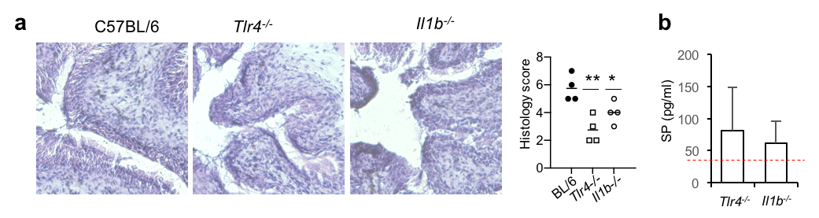

(a) H&E stained bladder tissue sections from Tlr4^{-/-} and Il1b^{-/-} mice and tissue pathology score, compared to infected WT mice after CY-17 infection for 7 days (n = 4 mice per infection group, Mann-Whitney test). (b) Urine SP levels in CY-17 infected Tlr4^{-/-} and Il1b^{-/-} mice (n = 4 mice per infection group compared to uninfected controls).

Fig S5. Effect of SR140333 treatment in Nlrp3^{-/-} mice and C57BL/6 WT mice
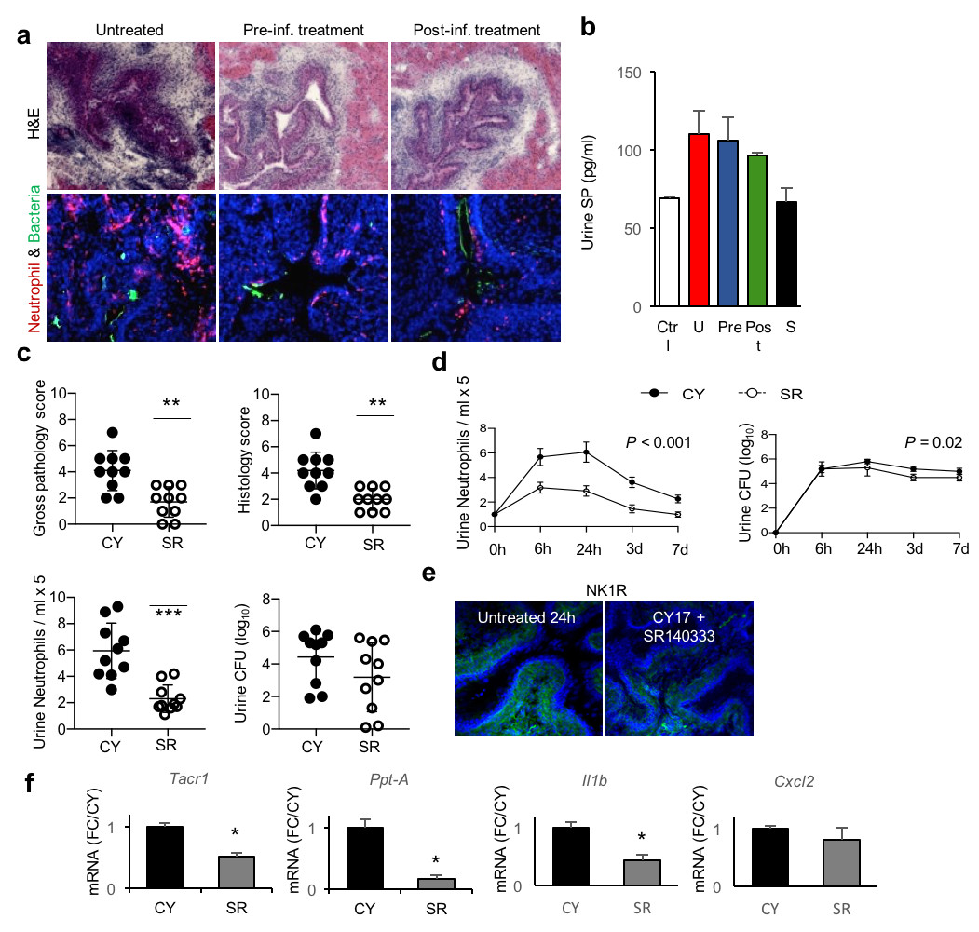
(a) Evidence of acute cystitis in bladder tissue sections from CY-17 infected Nlrp3^{-/-} mice. Rescue after treatment with the NK1R inhibitor SR140333 (H&E staining, Nlrp3^{-/-} mice, 24 hours after infection, Scale bar = 100 µm). (b) SP ELISA from urine of infected Nlrp3^{-/-} mice treated with SR140333 or left untreated (24 hours). No change in SP release by SR140333, either by the pre- or post-treatment regime (n = 10 mice per group except sham and uninfected where n = 4). (c) Protective effect in C57BL/6 WT mice, treated with SR140333 (1 mg/kg i.p.1 hour after infection with CY-17), compared to untreated control mice. Decrease in gross pathology score, histology score and urine neutrophil counts. The inhibitor did not change bacterial counts in urine (means ± SEMs, n = 10 mice per group, 2 experiments). (d) Kinetics of urine neutrophil recruitment and urine bacterial counts in C57BL/6 WT mice infected with CY-17. SR140333 treated C57BL/6 WT mice are compared to untreated, infected WT mice (means + SEMs, n = 6 per group, two experiments). (e) NK1R staining in C57BL/6 WT mice infected with CY-17 for 24h compared to C57BL/6 WT mice infected with CY-17 and treated with SR140333. (f) Effect of SR14033 on Tacr1, Ppt-A, Il1b and Cxcl2 gene expression in C57BL/6 WT mice infected with CY-17 compared to untreated infected controls. Data is presented as means + SEMs, Mann Whitney tests for all except kinetics where AUC analysis with Welch’s t-test was performed. * = P < 0.05, ** = P < 0.01

Fig S6. NK1R inhibition in vitro

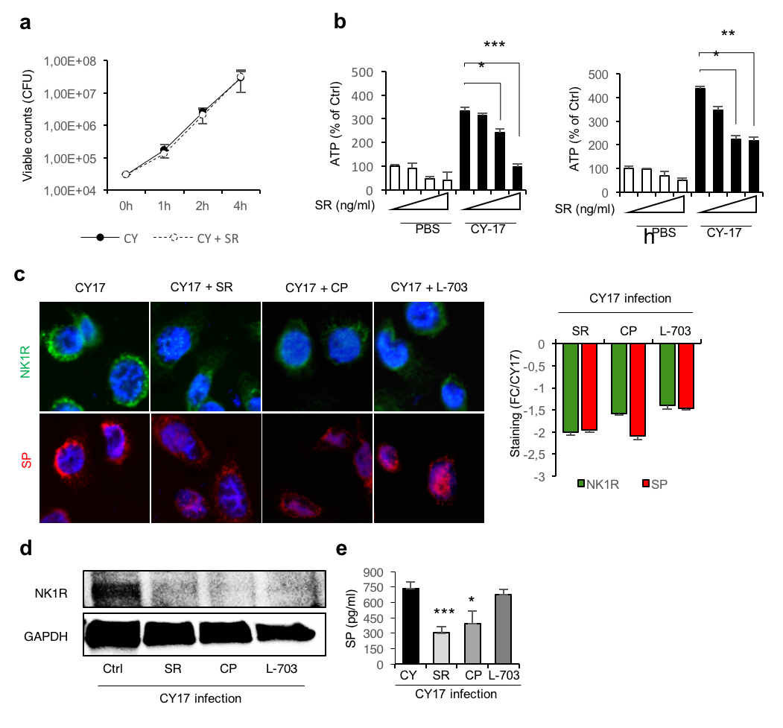

(a) CY-17 was grown in LB broth with the addition of vehicle (DMSO) or SR140333 to show whether there are bactericidal effects of SR140333. (b) downstream effects of SR140333 on ATP release in nerve- and bladder epithelial cells showing dose dependent decrease (5-500 ng/ml) of ATP release in both cell lines. (c) Additional NK1R antagonists were investigated in HTB-9 bladder epithelial cells by confocal microscopy (histogram inset shows NK1R and SP staining compared to CY-17 infected cells). (d) Western blot analysis confirming (c). (e) SP release in bladder epithelial cells confirming (c).

Fig S7. Genes regulated by NK1R inhibition in infected Nlrp3^{-/-} mice.

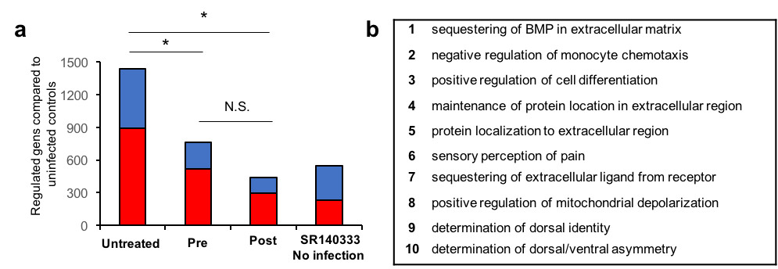

(a) Number of regulated genes (up = red, down = blue) in Nlrp3^{-/-} mice treated with SR140333 compared to infected controls without treatment or uninfected controls (n = 2 per group, Chi²-test). (b) Top 10 biological functions Inhibited by SR140333 treatment post CY-17 infection compared to untreated, infected controls. * = P < 0.05.

Fig S8. Inflammasome control of mucosal neurokinin control

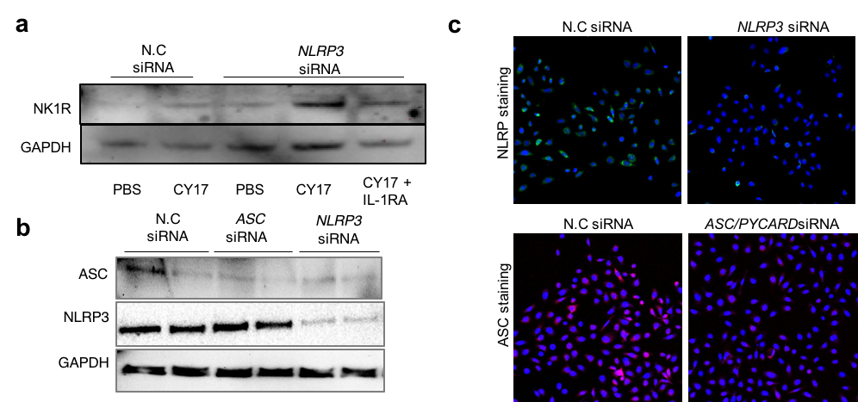

(a) As a specificity control to exclude the involvement of IL-1β, cells were pre-treated with IL-1RA (Anakinra, 500 ng/ml, 30 minutes) and the change in NK1R expression was quantified by western blot analysis. (b) Suppression of NLRP3 and ASC expression by siRNA treatment (control for Fig 6d). (c) Suppression of NLRP3 and ASC expression by siRNA treatment (control for Fig 6a). Data is presented as Means + SEMs, n = 3 experiments, one-way ANOVA, Bonferroni or two-tailed t-test.

Fig S9. The IL-1β and SP loop.
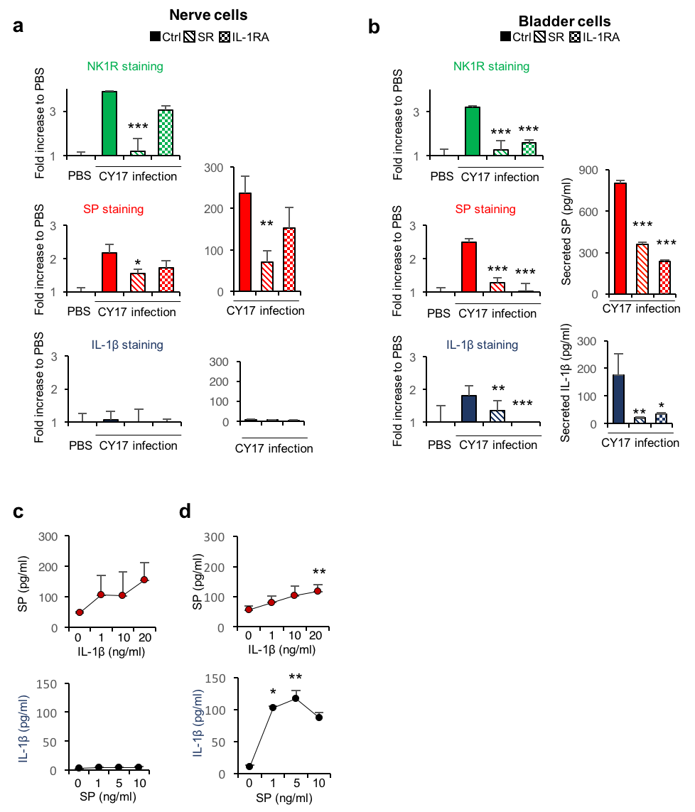

To understand the link between SP/NK1R signaling and IL-1β, nerve cells and bladder epithelial cells were pre-treated with SR140333 or IL-1RA (500 ng/ml) 30 minutes prior to CY-17 infection before examining the changes in SP, NK1R and IL-1β expression. (a) Pre-treatment with SR104333 reduced NK1R and SP expression in nerve cells. As nerve cells neither produced or secreted IL-1β, there was no significant effect of IL-1RA on SP/NK1R expression (50 cells per condition). (b) In bladder cells, NK1R, SP and IL-1β expression were reduced by both SR140333 and IL-1RA (50 cells per condition). (c) Nerve cells were treated with exogenous IL-1β (1-20 ng/ml) or recombinant (1-10 ng/ml) for four hours before investigating secreted IL-1β or SP. Exogenous IL-1β triggered SP secretion, but recombinant SP were not able to trigger IL-1β secretion (n = 5 samples per condition). (d) The effect of exogenous treatment with IL-1β or SP were also performed in bladder epithelial cells. Exogenous IL-1β triggered SP secretion and recombinant SP triggered IL-1β secretion (n = 6 samples per condition). Data is presented as means + SEMs from three experiments and analyzed using two tailed t-test or Mann-Whitney U-test (c-d), * = 0.05, ** = P < 0.01, *** = P < 0.001,
Fig S10. Antibody controls for tissue- and cellular stainings.

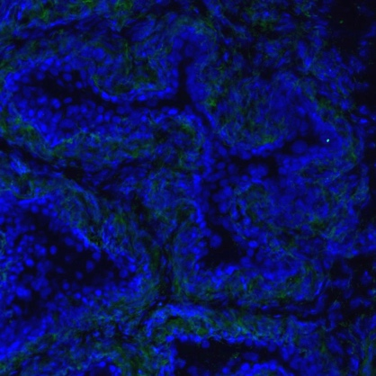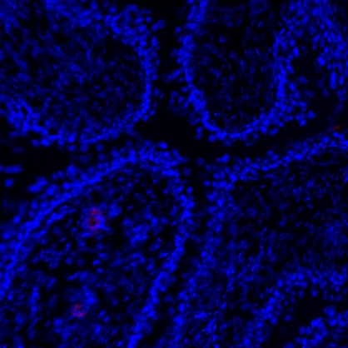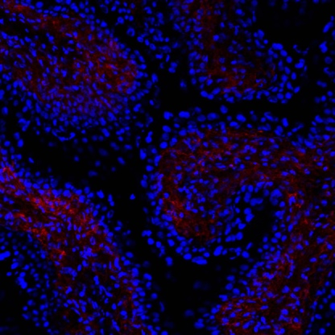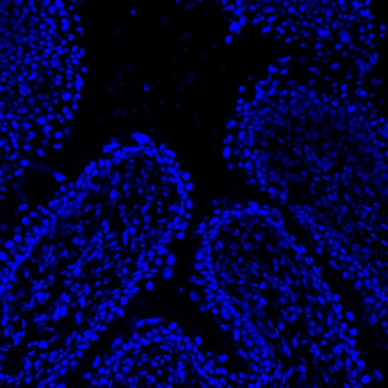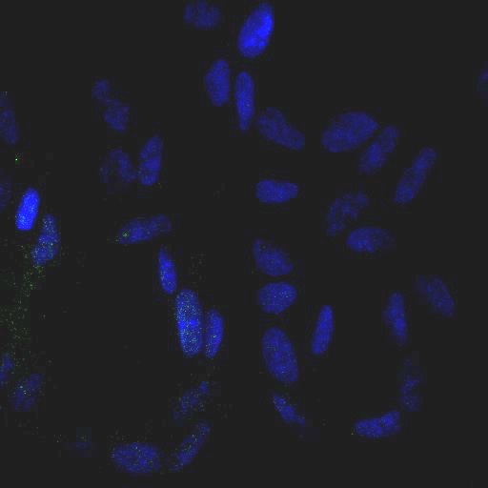
c
b
a
AF 488 Goat anti-mouse
AF 568 Goat anti-rabbit
βIII tubulin absorption control
NK1R & SP absorption control
AF 488 Goat anti-mouse
AF 568 Goat anti-rabbit

(a) Alexa fluor (AF) 488 (goat anti-mouse) and 568 (goat anti-rabbit) conjugated secondary antibody controls. Nerve cells and bladder epithelial cell were stained. (b) AF 488 (goat anti-mouse) and AF 568 (goat anti rabbit) conjugated secondary antibody controls. Tissue sections from uninfected C57BL/6 WT mice were stained. (c) Antibody specificity control. Antibodies to SP, NK1R and βIII tubulin were mixed with peptides corresponding to each antigen at a 5:1 ratio.

Fig S11. Western blots from main figures.

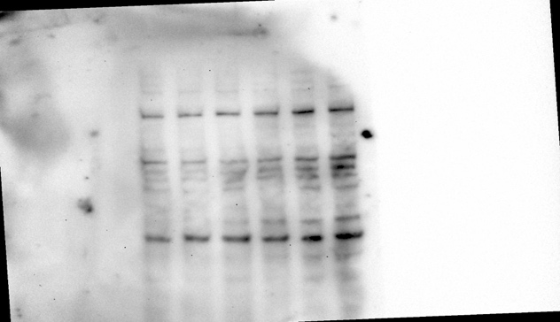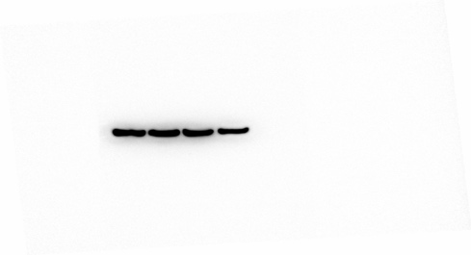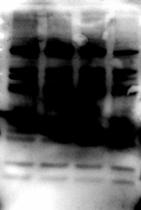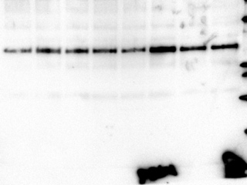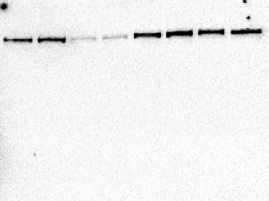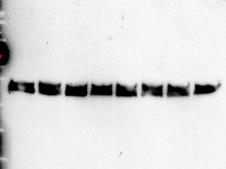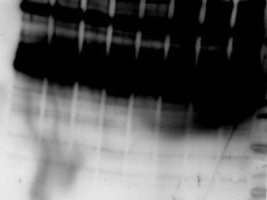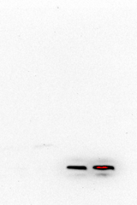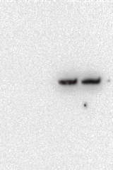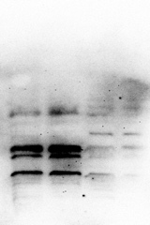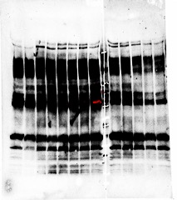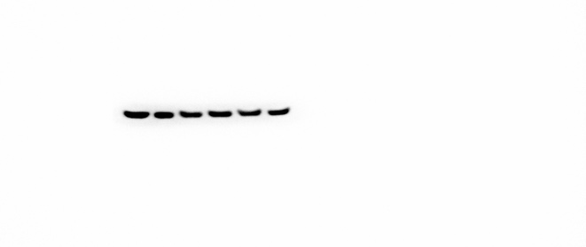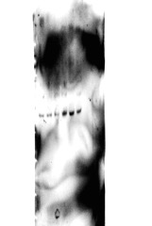
β-actin
SP
NK1R
40-50
KDa
14 KDa
20 KDa
46 KDa
74 KDa
a
74 KDa
100-110
KDa
NK1R
NLRP3
ASC
GAPDH
18 KDa
30-40
KDa
NLRP3
GAPDH
HHH3
15 KDa
30-40
KDa
100-110
KDa
b
d
e
46 KDa
74 KDa
30-40
KDa
NK1R
GAPDH
c
40 -50
KDa
14 KDa
74 KDa
SP
NK1R
β-actin

(a) Showing full blots from figure 1d. (b) Showing full blots from figure 1h. (c) Showing full blots from figure 4h. (d) showing full blots from figure 6d and controls in Supplementary Fig S7. (e) Blots from Supplementary fig S8.

Supplementary Table S1. Top biological processes inhibited by SR140333 treatment compared to untreated mice, both 24 hours after infection with CY-17.
GO: Biological Process Name | p-value | q-value Bonferroni | q-value FDR B&H | q-value FDR B&Y | Hit Count in Query List | Hit Count in Genome | Hit in Query List
Inflammatory response | 1.40E-13 | 5.91E-10 | 5.91E-10 | 5.27E-09 | 32 | 714 | Il18, Hmgb2, Hmox1, Chi3l1, Ptgs2, Ffar4, Gja1, Hp, Vnn1, Ngfr, Ccr1, C3ar1, Ccr5, Plscr1, Cnr1, Pglyrp1, Ffar2, Casp4, Birc3, Relb, Cxcl2, Cxcl3, Ednrb, Slc11a1, Cd14, Serpine1, Cd44, Tnfaip3, Il1b, Il1rn, Clcf1, Il4r
Regulation of response to stress | 2.27E-12 | 9.58E-09 | 2.23E-09 | 1.99E-08 | 46 | 1585 | Lgmn, Il18, Nek6, Hmgb2, Wnt4, Hmox1, Ptgs2, Ffar4, Ceacam1, Gja1, Clu, Hp, Vnn1, Nfkbia, Nup210, Ccr1, Plat, C3ar1, Ccr5, Mmp3, Plek, Parpbp, Plscr1, Hspa8, Cnr1, Foxm1, Pglyrp1, Ffar2, Agr2, Casp4, Birc3, Relb, Cxcl2, Ednrb, Ndc1, Cd14, Lmnb1, Clec4d, Mtm1, Serpine1, Cd44, Tnfaip3, Ltf, Il1b, Il1rn, Clcf1
Positive regulation of multicellular organismal process | 6.41E-11 | 2.71E-07 | 4.51E-08 | 4.03E-07 | 44 | 1616 | Hcar2, Il18, Tnfsf9, Hmgb2, Wnt4, Bcl3, Hmox1, Chi3l1, Lrg1, Ptgs2, Cd84, Gja1, Jun, Clu, Vnn1, Angpt4, Aspm, Ngfr, Ccr1, Plat, C3ar1, Ccr5, Plek, Cnr1, Ffar2, Vtcn1, Casp4, Birc3, Apoc2, Ect2, Cxcl2, Ednrb, Slc11a1, Gpihbp1, Cd14, Mtm1, Serpine1, Tnfaip3, Ltf, Cdc20, Il1b, Tmem100, Clcf1, Il4r
Cytokine production | 8.94E-11 | 3.77E-07 | 4.72E-08 | 4.21E-07 | 28 | 703 | Pcsk5, Il18, Tnfsf9, Hmgb2, Bcl3, Hmox1, Chi3l1, Ptgs2, Ffar4, Ceacam1, Cd84, Clu, C3ar1, Ccr5, Pglyrp1, Ffar2, Vtcn1, Casp4, Birc3, Relb, Lcp2, Slc11a1, Cd14, Serpine1, Tnfaip3, Ltf, Il1b, Il4r
Apoptotic process | 1.82E-09 | 7.66E-06 | 4.51E-07 | 4.02E-06 | 46 | 1934 | Lgmn, Hcar2, Il18, Hk2, Nek6, Dapl1, Tnfsf9, Hmgb2, Wnt4, Bcl3, Hmox1, Nr4a1, Pak6, Chi3l1, Ptgs2, Ffar4, Ceacam1, Gja1, Jun, Aldh1a2, Clu, Vnn1, Angpt4, Nfkbia, Bub1b, Ngfr, Ccr5, Plscr1, Hspa8, Cnr1, Pglyrp1, Casp4, Birc3, St6gal1, Ect2, Ednrb, Cd14, Timp1, Serpine1, Cd44, Tnfaip3, Ltf, Ckap2, Il1b, Il1rn, Clcf1
Fever generation | 2.90E-09 | 1.22E-05 | 6.49E-07 | 5.79E-06 | 6 | 15 | Ptgs2, Ccr5, Cnr1, Ednrb, Il1b, Il1rn
Cell cycle | 3.89E-09 | 1.64E-05 | 7.97E-07 | 7.11E-06 | 43 | 1771 | Cdkn3, Cenpw, Cenpn, Nek6, Cenpe, Kif4a, Nubp1, Hmmr, Wnt4, Nr4a1, Pak6, Ptgs2, Jun, Ncapg, Nup210, Bub1b, Aspm, Sgo2, Cdt1, Dna2, Hspa8, Kif11, Knl1, Kif22, Foxm1, Kif23, Rbl1, Birc3, Gas7, Ect2, Kif20a, Ndc1, Lmnb1, Fanci, Racgap1, Avpi1, Tnfaip3, Ckap2, Cdc20, Il1b, Rspo1, Tmprss11a, Bora
I-kappaB kinase/NF-kappaB signaling | 2.78E-07 | 1.17E-03 | 2.22E-05 | 1.98E-04 | 14 | 271 | Il18, Nek6, Bcl3, Hmox1, Ptgs2, Gja1, Nfkbia, Birc3, Relb, Ect2, Cd14, Tnfaip3, Ltf, Il1b
Adaptive immune response | 2.88E-07 | 1.21E-03 | 2.25E-05 | 2.01E-04 | 17 | 406 | Il18, Bcl3, Ceacam1, Cd84, Clu, C3ar1, Hspa8, Lilrb4, Vtcn1, Relb, Slc11a1, Clec4d, Cd44, Tnfaip3, Il1b, Clcf1, Il4r

Supplementary Table S2. Antibodies used for immunocytochemistry (ICC), Western blot (WB), Immunohistochemistry (IHC) and flow cytometry (FACS).

Antibodies | ICC | WB | IHC | FACS
Mouse anti-NK1R  sc-514453, Santa Cruz | 1:50 | 1:100 | 1:50 | -
Rabbit anti-NK1R  sc-15323 , Santa Cruz | - | - | 1:50 | 1:50
Rabbit anti-Substance P  ORB11399, Biorbyt | 1:200 | 1:500 | 1:100 | -
Mouse anti-NLRP-3  AG-20B-0014-C100, AdipoGene | 1:200 | 1:1000 | - | -
Rabbit anti-ASC  sc-22514, Santa Cruz | 1:50 | 1:100 | - | -
Rabbit anti-Il1b  ab9722, Abcam | 1:200 | - | - | -
Mouse anti-bIII tubulin  MAB1195, R&D system | 1:400 | - | 1:400 | -
Rabbit anti-NeuN  mabn140, Millipore | 1:200 | - | - | -
Rat anti-neutrophil  ab2557, Abcam | - | - | 1:200 | -
Rat anti-macrophage  sc-101447, Santa cruz | - | - | 1:50 | -
Mouse ani-b-actin  Sigma-Aldrich, A1978 | - | 1:4000 | - | -
FITC labeled Mouse anti-CD14  345785, BD | - | - | - | 1:100
HRP-linked GAPDH  sc-25778, Santa Cruz | - | 1:4000 | - | -
Alexa488 labeled Goat anti-rabbit  A-11008, Thermo Fischer | 1:400 | - | 1:200 | 1:100
Alexa568 labeled goat anti-rabbit,  A-11011, Thermo Fischer | - | - | - | 1:100
Alexa568 labeled Goat anti-mouse  A-11004, Thermo Fischer | 1:400 | - | 1:200 | -
Alexa568 labeled Goat anti-rat  A-11077, Thermo Fischer | - | - | 1:200 | -
HRP-linked Goat anti-rabbit  Cell signaling | - | 1:4000 | - | -
HRP-linked goat anti-mouse  Cell Signaling | - | 1:4000 | - | -

Supplementary Table S3. Murine Primer sequences used for analysis of Tacr1, Ppt-1, Cxcl2 and Il1b gene expression from whole bladder tissue mRNA in uninfected, CY-17 infected C57BL/6 WT, Tlr4^{-/-}, Il1b^{-/-}, Asc^{-/-} and Nlrp3^{-/-} mice, as well as SR140333 treated Nlrp3 and C57BL/6 WT mice (From Figures 2, 3, 4, and Supplementary Fig S5).
Gene | Primer sequences | Size (bp) |  | location
Tacr1 | Forward: 5′-CTTGCCTTTTGGAACCGTGTG-3′,  Reverse: 5′-CACTGTCCTCATTCTCTTGTGGG-3′ | 501 | 6
Ppt-A | Forward: 5′-GCCAATGCAGAACTACGAAA-3′  Reverse: 5′-GCTTGGACAGCTCCTTCATC-3′ | 282 | 6
Cxcl2 | Quiagen, QT00113253 | - | 5
Il1b | Origene, MP206724 | - | 2

PCR reactions were performed using the following specifications: Thermal cycling, 95°C, 3 min, followed by 40 cycles comprising a denaturation (95°C, 30 s), annealing (59°C, 30 s), and extension (72°C, 30 s) steps, and a final extension at 72°C, for 6 min.

