SUPPLEMENTARY DATA

Targeting a Reticulocyte Binding Protein and Duffy Binding Protein to Inhibit Reticulocyte Invasion by Plasmodium vivax

Sonal Gupta^{1,2}, Shailja Singh^{2,3,4}, Jean Popovici⁵, Camille Roesch⁵,
Ahmed Rushdi Shakri¹, Micheline Guillotte-Blisnick⁴, Christèle Huon⁴,
Didier Menard^{4,5} and Chetan E. Chitnis^{1,4,*}

¹International Centre for Genetic Engineering and Biotechnology (ICGEB), New Delhi, India,²Special Centre for Molecular Medicine, Jawaharlal Nehru University, New Delhi, India,³Shiv Nadar University, Gautam Buddha Nagar, India, ⁴Institut Pasteur, Paris, France, ⁵Institut Pasteur of Cambodia, Phnom Penh, Cambodia

Supplementary Figure Legends
Supplementary Figure S1: Reticulocyte enrichment from normal human blood by immunomagnetic separation. (A) Reticulocytes were stained with new methylene blue. The percentage of reticulocytes in normal human adult blood comprises ~1% of total blood cells. After enrichment by magnetic separation the percentage of reticulocytes increased to 50-60%. Reticulocytes can be differentiated from mature erythrocytes by presence of blue black intracytoplasmic granules. (B) Analysis of blood before (blue) and after (red) reticulocyte enrichment by flow cytometry. Reticulocyte enriched blood stained with mouse anti-CD71 IgG conjugated to phycoerythrhin (anti-CD71 PE) showed ~51% CD71 positive reticulocytes (R2) after enrichment.

Supplementary Figure S2: Mapping of a 30kDa reticulocyte binding domain of PvRBP1 (PvRBP1a₃₀), chosen on the basis of homology with erythrocyte binding domain of PfRH4. ClustalW alignment of PfRH4 (GenBank accession no. AF432854.1) dark grey and PvRBP1 (GenBank accession no. Q00798) light grey. *, identical residues; :, conserved substitutions; ., semiconserved substitutions.

Supplementary Figure S3: Immunogenicity of recombinant PvRBP1a₃₀ protein. (A) End point titer of rabbit serum raised against PvRBP1a₃₀ protein was determined by standardized ELISA. Sera were collected at Day 14, Day 42 and Day 74. ELISA reactivity (mean + SD) of all sera are shown at different dilutions. End point titer of Day 74 sera was observed to be 1:160,000. (B) Day 74 anti-PvRBP1a₃₀ rabbit sera reacts with 30kDa protein band of recombinant PvRBP1a₃₀ by Western blotting.

Supplementary Figure S1.
a
Before Enrichment After Enrichment
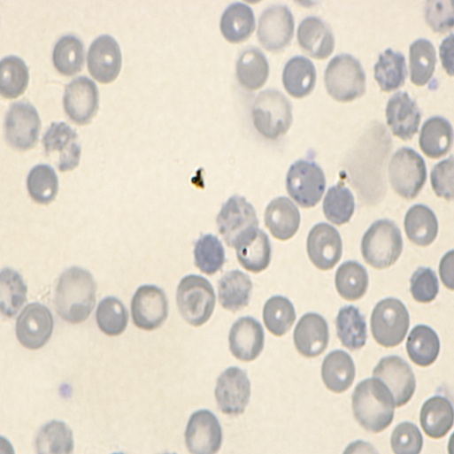
~ 60% reticulocytes
~ 1% reticulocytes

b
FL2 (Anti CD71 PE)
Count
After enrichment
Before enrichment

Supplementary Figure S2.

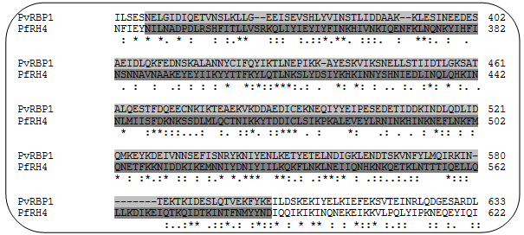

Supplementary Figure S3.
a
Optical Density at 492 nM (OD
Sera Dilutions
b
Anti-RBP1a₃₀ Day 74
Prebleed

30 kDa
72
55
34
25

