Supplementary Material

Crystal structure and substrate binding mode of ectonucleotide phosphodiesterase/pyrophosphatase-3 (NPP3)

Christoph Döhler, Matthias Zebisch, Norbert Sträter

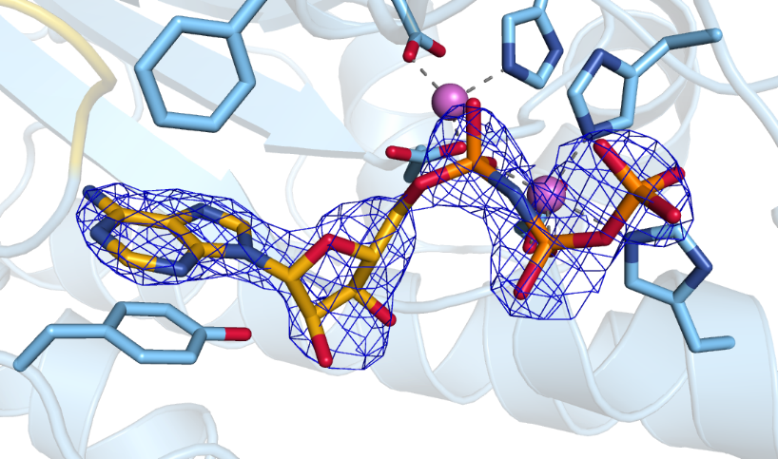

Supplementary Figure S1: Electron density map of AMPNPP bound to the active site of NPP3. The feature enhanced map (2mF_{o}-F_{c}) is contoured at 2.2 σ.

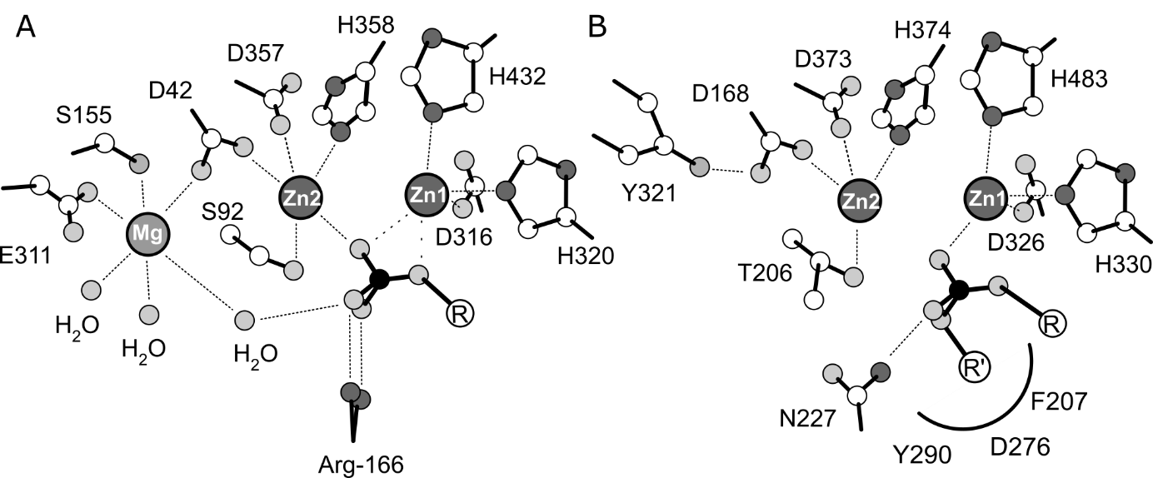
Supplementary Figure S2: Comparison of substrate binding modes and active site structure of human alkaline phosphatase (a) and rat NPP3 (b).
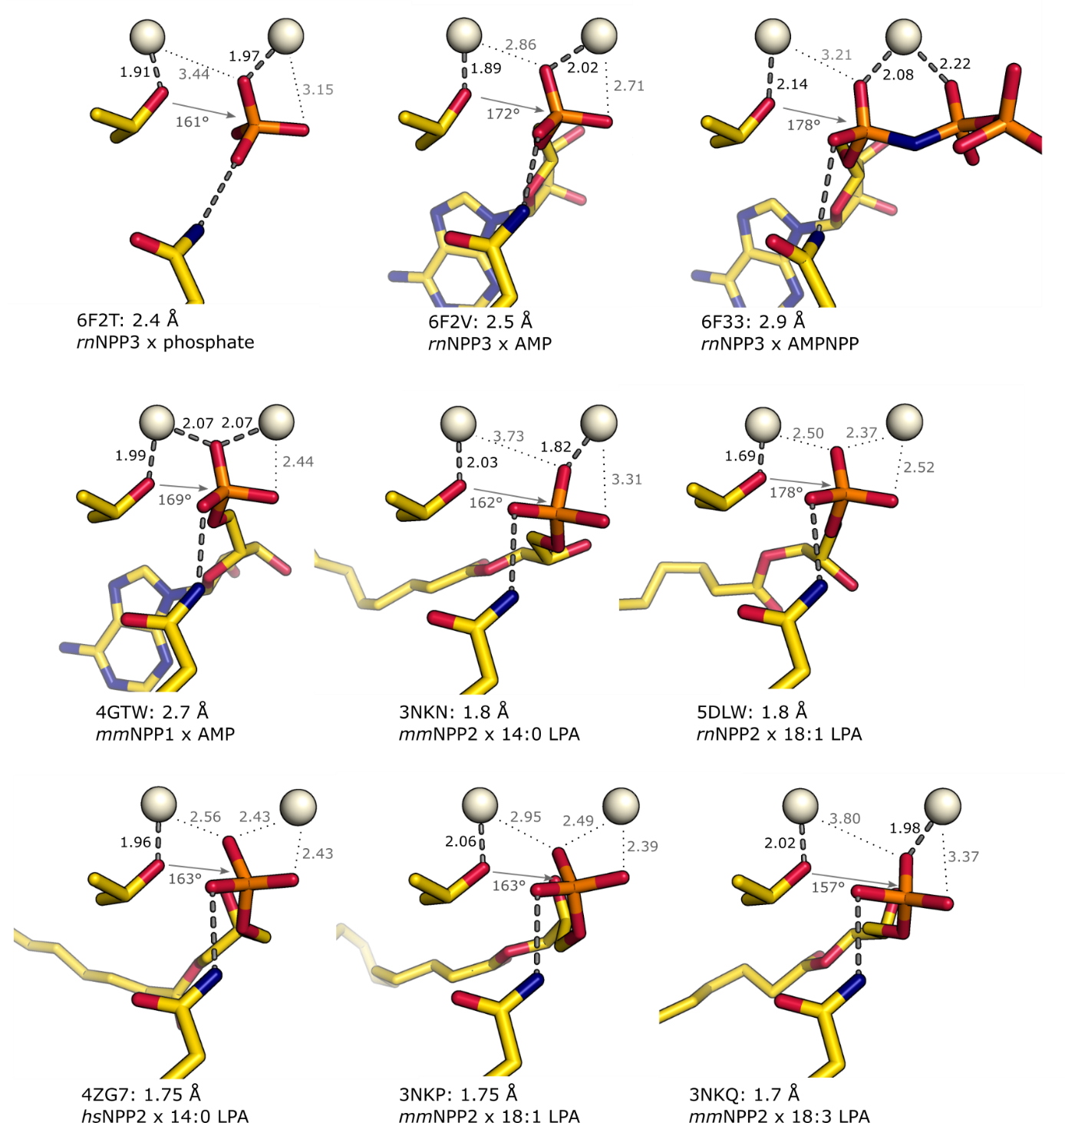
Supplementary Figure S3: Comparison of binding modes of the phosphate groups in various product complex structures to the dizinc center of NPP1-3.

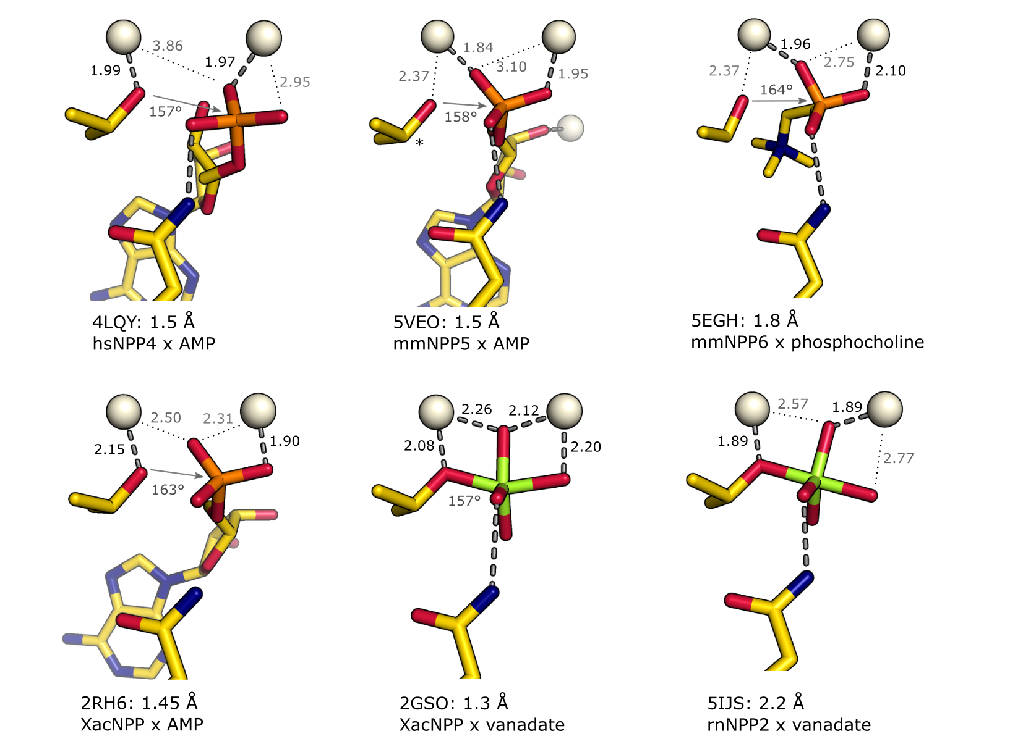
Supplementary Figure S4: Comparison of the binding mode of phosphate groups in various product complex structures and vanadate to the dizinc center of NPP4-6. In the structure of mmNPP5 (pdb id 5VEO) the Thr72 nucleophile (*) is modeled in a low energy conformer for the generation of this figure. For structure analysis, a T72A mutant was used. The structure pdb id 2RH6 of XacNPP is a higher resolution structure of this complex analyzed by the same authors earlier at 2.0 Å as PDB id 2GSU (Zalatan et al. 2006). 2RH6 differs in the phosphate group coordination from 2GSU, in which the AMP has only 60 % occupancy in monomer A and close contacts in monomer B of the asymmetric unit. 2RH6 appears to have no associated publication. The cocrystal structure of hsNPP7 in complex with phosphocholine is not included here because the phosphate group is not in a productive binding mode for phosphoryl transfer in this complex.

Supplementary Table S1: Molar reaction enthalpies of nucleotide hydrolysis in 50 mM Tris/HCl, 25 mM NaCl, 0.1 mM ZnCl₂, (pH 9.5).
Reaction | ΔH_{t} [kcal/mol] | ΔH_{d} [kcal/mol] | ΔH_{r} [kcal/mol]
ATP → AMP + PPi | -16.22 ± 0.74 | 0.66 ± 0.08 | -15.66
UTP → AMP + PPi | -17.17 ± 1.52 | 0.71 ± 0.09 | -16.45
GTP → AMP + PPi | -22.41 ± 3.47 | 0.16 ± 0.02 | -22.26
CTP → AMP + PPi | -19.85 ± 0.89 | 1.11 ± 0.02 | -18.74
Ap3A → AMP + ADP | -26.73 ± 0.01 | 0.50 ± 0.08 | -26.23
Ap4A → AMP + ATP | -38.66 ± 0.32 | 0.29 ± 0.14 | -38.36
Ap4A → 2 AMP + PPi | — | — | -22.70
UDPGlc → UMP + PGlc | -29.89 ± 2.26 | -0.05 ± 0.01 | -29.53
UDPGlcNAc → UMP + PGlncNAc | -36.22 ± 0.42 | -0.03 ± 0.01 | -36.25
NAD⁺ → AMP + NMP | -27.38 ± 0.44 | 0.14 ± 0.05 | -27.24

Supplementary Table S2: Overview of the primers for the generation of NPP3 mutants
Mutation site | Primers
K205A | 5’-GAGAGCAGTGTATCCCACCGCAACCTTTCCAAATCATTATACC-3’  3’-CTCTCGTCACATAGGGTGGCGTTGGAAAGGTTTAGTAATATGG-5’
S237A | 5’-CCGATGCTGCGGGGCACAAGAGTGGA-3’  3’-ATACACCTTCTCGGGCGGCTAC-3’
T379V | 5’-CCAGGTCTCTTGTGACAGAGTGGAATAC-3’  3’-CTAGTACCTTACCTGGTCCAGAGAAC
G480A, G481A, G484A | 5’-GGGAGTTCCAACTGCGAAGCCGCCACACACGCTTACAACAATGAATTTAAAAG-3’  3’-CCCTCAAGGTTGACGCTTCGGCGGTGTGTGCGAATGTTGTTACTTAAATTTTC-5’
T482V | 5’-CGGGGTACACGGTTACAACAATGAA-3’  3’-AAGGTTGACGCTTCCGCCCCATGTGCC-5’

