Quad-mode functional and molecular photoacoustic microscopy

Wei Liu,¹ Daria M. Shcherbakova,^{2,3} Neel Kurupassery,¹ Yang Li,⁵ Qifa Zhou,⁴ Vladislav V. Verkhusha^{2,3,5,*}, Junjie Yao^{1,*}

¹Department of Biomedical Engineering,100 Science Drive, Duke University, Durham, NC 27708, USA
²Department of Anatomy and Structural Biology, Albert Einstein College of Medicine, Bronx, New York, USA
³Gruss-Lipper Biophotonics Center, Albert Einstein College of Medicine, Bronx, New York, USA. ⁴⁵Department of Biomedical Engineering, University of Southern California, Los Angeles, CA 90089, USA
⁵Medicum, Faculty of Medicine, University of Helsinki, Helsinki, Finland

*Corresponding authors: junjie.yao@duke.edu and vladislav.verkhusha@einstein.yu.edu

The axial resolutions of the high-frequency (HF) and low-frequency (LF) transducer elements were quantified by measuring the lateral full-width at half-maximum (FWHM) of the axial line spread function (LSF) of the PA signals, from a thin bar of the USAF test chart (58-198, Edmund Optics, Barrington, NJ, USA). Fig. S1 shows the axial resolution measurement results. The axial resolutions of the HF and LF transducer elements were 36 µm and 72 µm, respectively.
Figure S1
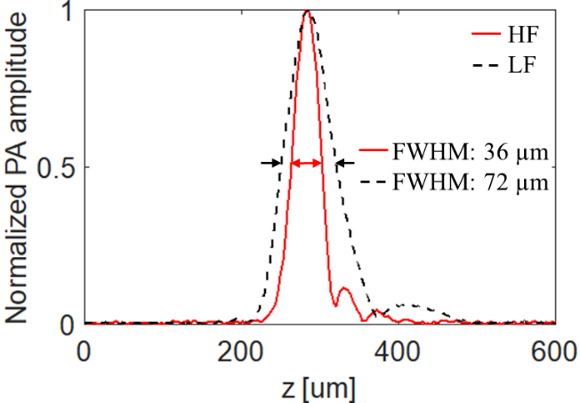
Supplementary Fig. S1. The axial resolution measurement results of the HF and LF transducer elements.

The lateral resolutions of the proposed QM-PAM were quantified by measuring the lateral FWHMs of the line spread functions (LSFs) of a sharp edge of the USAF test chart. The raster scanning of the sharp edge was performed with a step size of 1.25 μm for the OR modes and 5 μm for the AR modes. The measurement results for both elements under the two optical modes are shown in Fig. S2. For OR-HF and OR-LF modes, the FWHM of the LSFs were 6.9 μm, as shown in Fig. S2(a)-(d). For AR-HF and AR-LF modes, the lateral FWHMs of the LSFs were both 76.3 μm, as shown in Fig. S2(e)-(h).

Figure S2
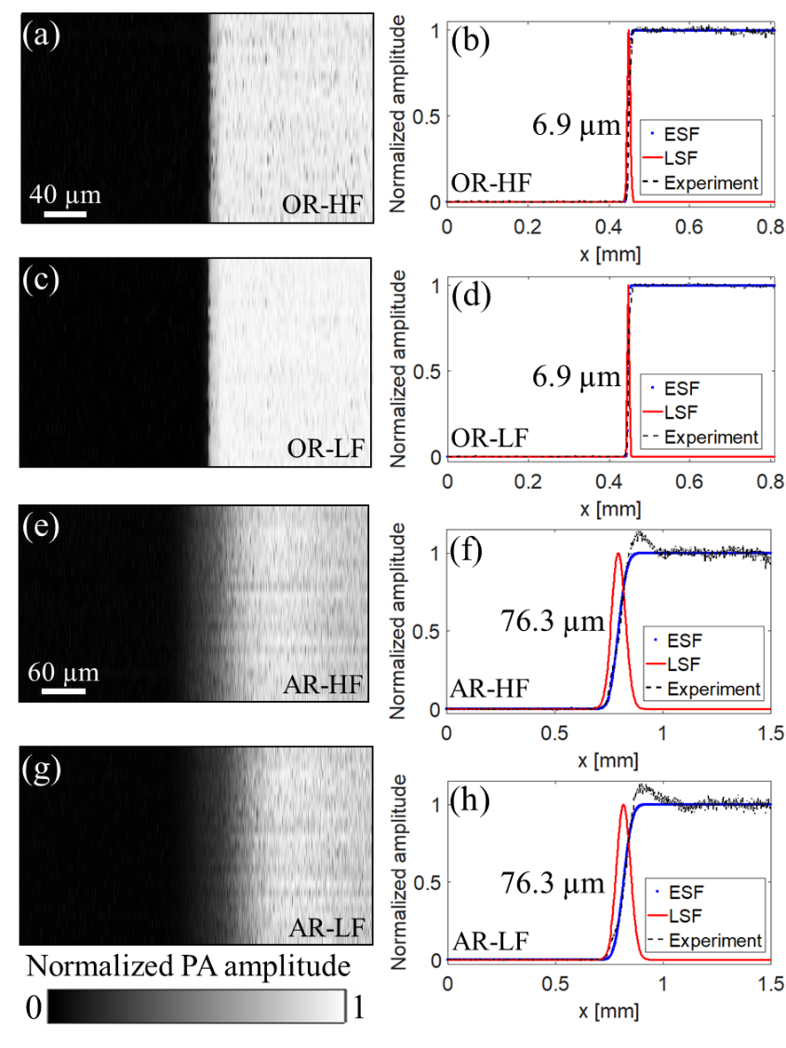
Supplementary Fig. S2. The lateral resolutions of four imaging modes of the QM-PAM. (a)-(d) The MAP images of the USAF chart’s sharp edge and the corresponding LSFs for the OR-LF and OR-HF modes. (e)-(h) The MAP images of the USAF chart’s sharp edge and the corresponding LSFs for the AR-LF and AR-HF modes.

