Ocean acidification drives community shifts towards simplified non-calcified habitats in a subtropical−temperate transition zone

Supplementary Information

Sylvain Agostini^{1,*}, Ben P. Harvey¹, Shigeki Wada¹, Koetsu Kon¹, Marco Milazzo², Kazuo Inaba¹ and Jason M. Hall-Spencer^{1,3}

¹ Shimoda Marine Research Center, University of Tsukuba, 5-10-1 Shimoda, Shizuoka 415-0025, Japan
² Dipartimento di Scienze della Terra e del Mare, University of Palermo, CoNISMa, via Archirafi 28, 90123 Palermo, Italy
³ Marine Biology and Ecology Research Centre, University of Plymouth, Plymouth PL4 8AA, UK.
* Email address: agostini.sylvain@shimoda.tsukuba.ac.jp (S. Agostini), Tel: (+81) 0558-22-6697

Supplementary Figures

Fig S1: Water chemistry of intertidal waters taken as continuous measurements (every minute, except for the station 1800 µatm, every 10 min) for up to a 24-hours on Shikine Island, Japan taken at different stations representative of the different pCO₂ zones: ‘300 µatm’ (June 22nd 2015), ‘400 µatm’ (June 17th 2015), ‘1100 µatm’ (June 21st 2015), ‘1800 µatm’ (November 11th 2016). Dissolved oxygen probe was not available during the collection of the ‘1800 µatm’ data.

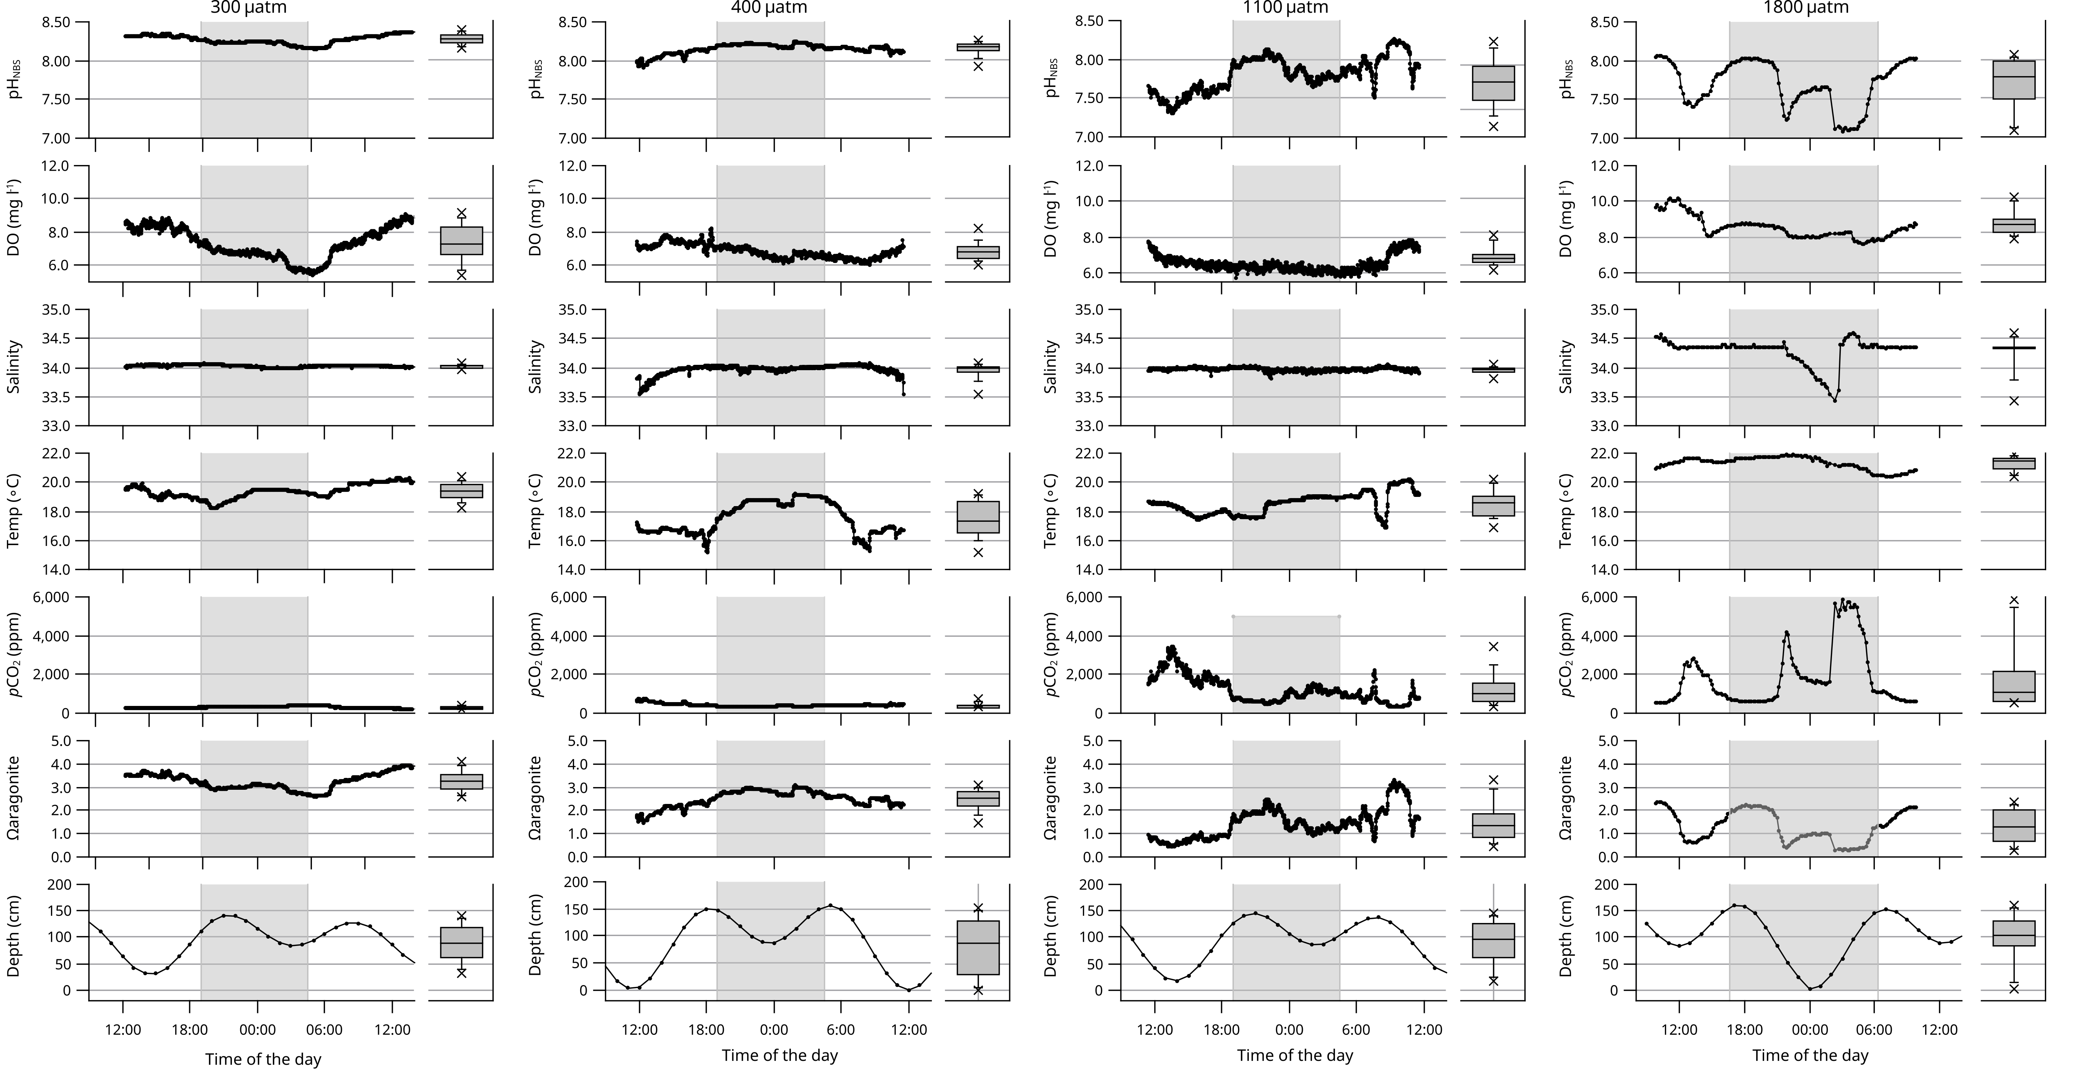
Fig. S2: Water chemistry of subtidal waters at ‘1500 µatm’ station as continuous measurements (every 5 minutes) for up to 24-hours off Shikine Island, Japan on the June 22nd 2015.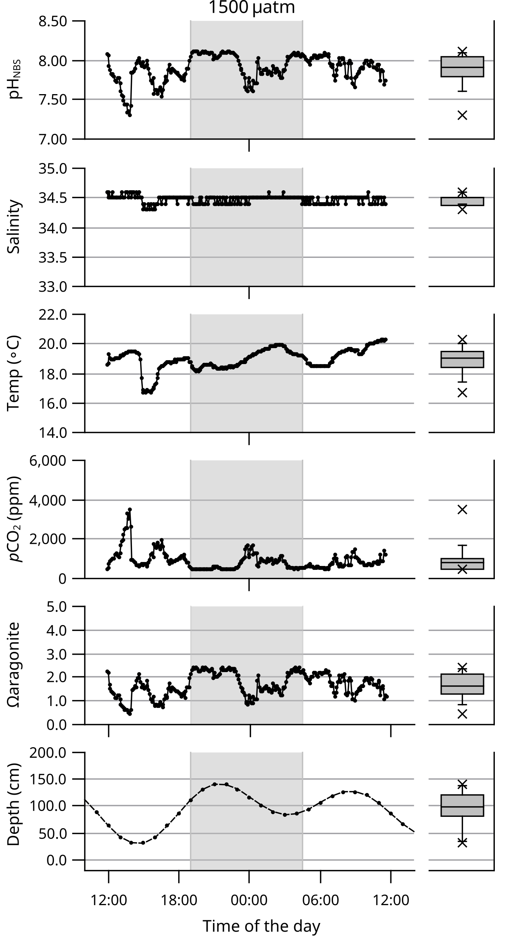

Fig. S3: Long term variation in water chemistry at a ‘300 μatm’ (black line) and ‘900 μatm’ (grey line) subtidal stations over the month of June 2016 (May 26th 2016 to July 5th 2016)

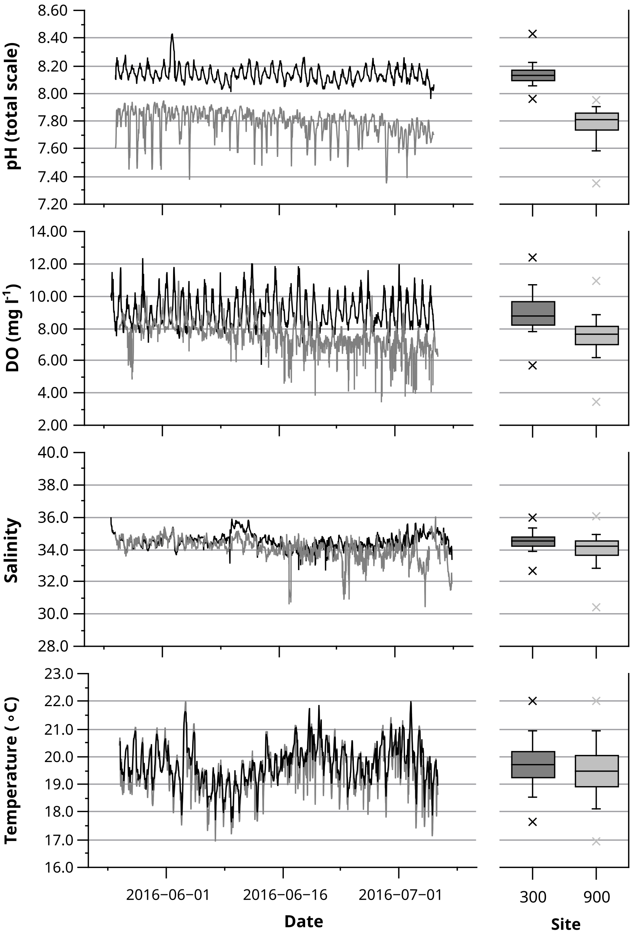

Fig. S4: Variation in percent cover (%) of different Taxonomic groups in the intertidal zone at stations along the CO₂ gradient stations off Shikine Island, Japan between June 17th and June 22nd 2015. Letters above indicate statistical groups after multiple comparison using Kruskal-Wallis (Bonferroni-adjusted), the absence of letters signifies that the overall effect was non-significant.
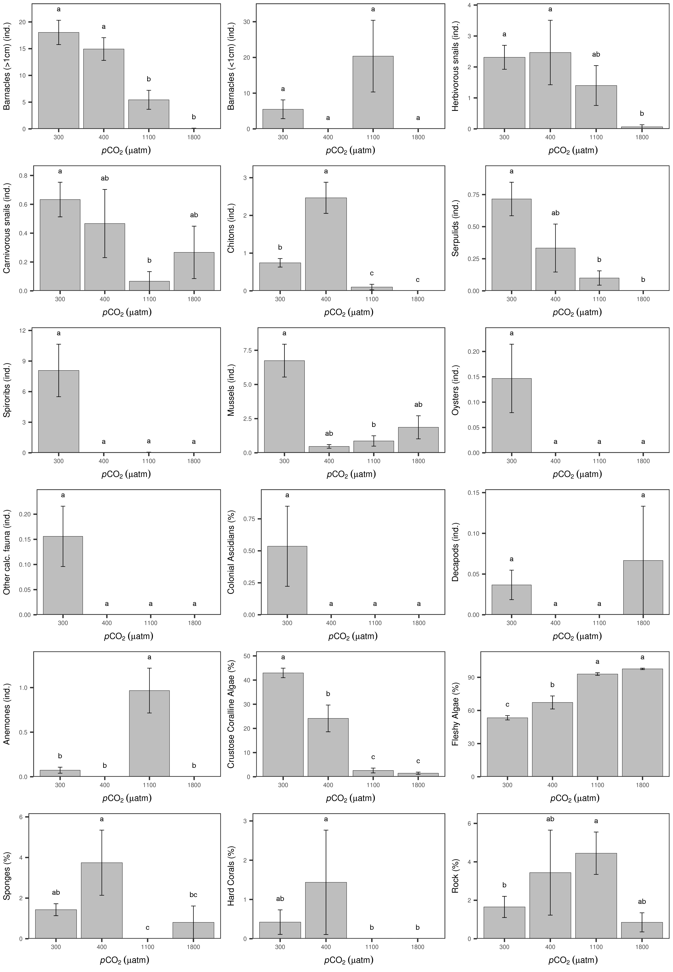

Fig. S5: Variation in percentage of coverage of different Taxonomic groups in the subtidal zone at stations along the CO₂ gradient stations off Shikine Island, Japan on 1st May 2015 with the exception of ‘700 µatm’ which was surveyed later on the 7th July 2016. Letters above indicate statistical groups after multiple comparison using Kruskal-Wallis (Bonferroni-adjusted), the absence of letters signifies that the overall effect was non-significant (Kruskal-Wallis, p > 0.05). In addition to the data presented in the figure below, one holothurid and one sponge were counted at ‘300 µatm’ and 4 Aplysia kurodai were counted at the ‘1800 µatm’ site.
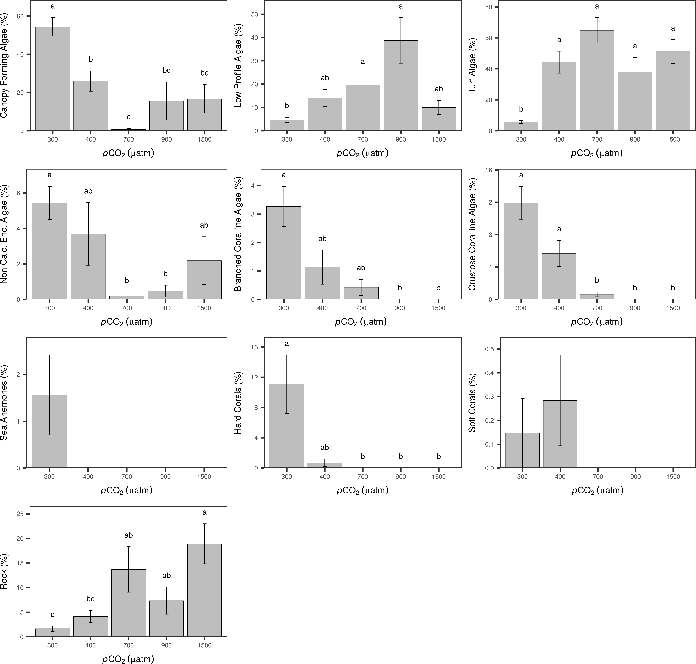

Table S1: Macroalgal and macrofaunal presence (dots) during a 30 min search at both 300 µatm and 1100 µatm in the intertidal at Shikine Island, Japan in June 2015. Heavily-calcified organisms are shown in bold. Total numbers of taxa at each station are given at the end of the Table.
Taxa |  | Taxonomic Group | ‘300 µatm’ | ‘1100 µatm’
Chlorophyta | Chaetomorpha spiralis (Okamura, 1903) | fleshy algae |  | ●
 | Ulva (Linnaeus, 1753) sp. | fleshy algae |  | ●
 | Ulva conglobata (Kjellman, 1897) | fleshy algae | ●
Rhodophyta | Ahnfeltiopsis concinna ((J.Agardh) P.C. Silva & DeCew, 1992) | fleshy algae |  | ●
 | Chondracanthus intermedius ((Suringar) Hommersand, 1993) | fleshy algae | ●
 | Chondrophycus undulatus ((Yamada) Garbary & Harper, 1998) | fleshy algae | ●
 | Chondrus verrucosa (Mikami, 1965) | fleshy algae | ●
 | Corallinaceae (Lamouroux, 1812) sp. 1 | Coralline algae | ● | ●
 | Corallinaceae (Lamouroux, 1812) sp. 2 | Coralline algae | ● | ●
 | Gracilaria textorii ((Suringar) De Toni, 1895) | fleshy algae | ●
 | Grateloupia chiangii (S.Kawaguchi & H.W. Wang, 2001) | fleshy algae | ●
 | Grateloupia crispata ((Okamura) Y.-P. Lee, 2008) | fleshy algae | ● | ●
 | Grateloupia crispata ((Okamura) Y.-P. Lee, 2008) | fleshy algae |  | ●
 | Grateloupia sparsa ((Okamura) Chiang, 1970) | fleshy algae | ●
 | Grateloupia turuturu (Yamada, 1941) | fleshy algae | ●
 | Hypnea variabilis (Okamura, 1909) | fleshy algae | ●
 | Laurencia saitoi (L.P. Perestenko, 1980) | fleshy algae | ●
 | Lomentaria hakodatensis (Yendo, 1920) | fleshy algae | ●
 | Mastocarpus stellatus ((Stackhouse) Guiry, 1984) | fleshy algae | ●
 | Peyssonneliaceae (Denizot, 1968) sp. | Encrusting non-calcareous algae |  | ●
 | Polyopes prolifer ((Hariot) Kawaguchi & Wang, 2002) | fleshy algae |  | ●
 | Pterocladiella capillacea ((S.G. Gmelin) Santelices & Hommersand, 1997) | fleshy algae | ●
 | Sarcodia montagneana ((J.D. Hooker & Harvey) J.Agardh, 1852) | fleshy algae | ●
Ochrophyta | Ishige okamurae (Yendo, 1907) | fleshy algae | ●
 | Total number of algal taxa |  | 18 | 8

Table S1 continued

Taxa |  | Taxonomic Group | ‘300 µatm’ | ‘1100 µatm’
Demospongiae | Halichondria (Halichondria) okadai (Kadota, 1922) | Sponges | ● | ●
Anthozoa | Actinia equina (Linnaeus, 1758) | Anemones |  | ●
 | Sphenopidae (Hertwig, 1882) | Other colonial organisms |  | ●
 | Tubastraea coccinea (Lesson, 1829) | Hard corals | ●
Polychaeta | Spirorbinae (Chamberlin, 1919) | Spirobids | ● | ●
 | Serpulidae (Rafinesque, 1815) | Serpulids | ● | ●
Polyplacophora | Acanthochitona achates (Gould, 1859) | Chitons | ● | ●
 | Liolophura japonica (Lischke, 1873) | Chitons | ● | ●
 | Onithochiton hirasei (Pilsbry, 1901) | Chitons | ●
Gastropoda | Patelloida saccharina (Linnaeus, 1758) | Herbivorous gastropods | ● | ●
 | Patelloida saccharina lanx (Reeve, 1855) | Herbivorous gastropods | ● | ●
 | Cellana grata (Gould, 1859) | Herbivorous gastropods | ● | ●
 | Cellana toreuma (Reeve, 1854) | Herbivorous gastropods | ● | ●
 | Lottia kogamogai (Sasaki & Okutani, 1994) | Herbivorous gastropods | ●
 | Scutellastra flexuosa (Quoy & Gaimard, 1834) | Herbivorous gastropods |  | ●
 | Siphonaria signa (Reeve, 1846) | Herbivorous gastropods |  | ●
 | Siphonaria japonica (Donovan, 1824) | Herbivorous gastropods | ● | ●
 | Siphonaria sirius (Pilsbry, 1894) | Herbivorous gastropods | ● | ●
 | Sabia conica (Schumacher, 1817) | Herbivorous gastropods |  | ●
 | Pictodiloma suavis (Philippi, 1850) | Herbivorous gastropods |  | ●
 | Drupa ricinus lischkei (Hidalgo, 1904) | Carnivorous gastropods | ●
 | Ergalatax contracta (Reeve, 1846) | Carnivorous gastropods | ●
 | Turrilatirus nagasakiensis (E.A. Smith, 1880) | Carnivorous gastropods | ●
 | Mancinella echinata (Blainville, 1832) | Carnivorous gastropods |  | ●
 | Mitrella burchardi (Dunker, 1877) | Carnivorous gastropods |  | ●
 | Tenguella granulata (Duclos, 1832) | Carnivorous gastropods | ●
 | Morula iostoma (Reeve, 1844) | Carnivorous gastropods | ●
 | Tenguella musiva (Kiener, 1835) | Carnivorous gastropods |  | ●
 | Morula uva (Röding, 1798) | Carnivorous gastropods | ●
 | Muricidae (Rafinesque, 1815) | Carnivorous gastropods | ●
 | Monoplex parthenopeus (Salis Marschlins, 1793) | Carnivorous gastropods |  | ●
 | Purpura panama (Röding, 1798) | Carnivorous gastropods | ● | ●
 | Reishia clavigera (Küster, 1860) | Carnivorous gastropods | ● | ●
 | Strigatella scutulata (Gmelin, 1791) | Carnivorous gastropods | ●
 | Reishia bronni (Dunker, 1860) | Carnivorous gastropods |  | ●
 | Reishia luteostoma (Holten, 1803) | Carnivorous gastropods |  | ●
 | Thalessa virgata (Dillwyn, 1817) | Carnivorous gastropods | ●
 | Trochus rota (Dunker, 1860) | Herbivorous gastropods | ●
 | Turbo stenogyrus (P.Fischer, 1873) | Herbivorous gastropods | ●
 | Hespererato scabriuscula (Gray, 1832) | Herbivorous gastropods |  | ●
Bivalvia | Brachidontes mutabilis (Gould, 1861) | Mussels |  | ●
 | Saccostrea kegaki (Torigoe & Inaba, 1981) | Oysters |  | ●
 | Saccostrea scyphophilla (Peron & Lesueur, 1807) | Oysters | ●
Maxillopoda | Capitulum mitella (Linnaeus, 1758) | Large barnacles (> 1cm) | ● | ●
 | Chthamalus challengeri krakatauensis (Broch, 1931) | Small barnacles (< 1cm) | ● | ●
 | Megabalanus rosa (Pilsbry, 1916) | Large barnacles (> 1cm) | ● | ●
 | Megabalanus volcano (Pilsbry, 1916) | Large barnacles (> 1cm) | ●
 | Tetraclita japonica (Pilsbry, 1916) | Large barnacles (> 1cm) | ● | ●
 | Total number of faunal taxa |  | 33 | 32

Table S2: Macroalgal and benthic macrofaunal presence (dots) during the photo quadrat survey at the 300 µatm, 400 µatm, 900 µatm in the subtidal at Shikine Island, Japan in June 2015. Heavily-calcified organisms are shown in bold. Total numbers of taxa at each station are given at the end of the table.
Taxa |  | Taxonomic Group |  | ‘300 µatm’ |  | ‘400 µatm’ |  | ‘900 µatm’
Chlorophyta | Codium (Stackhouse, 1797) spp. | Encrusting non-calcareous algae |  | ● |  | ●
 | Codium coactum (Okamura, 1902) | Encrusting non-calcareous algae |  | ● |  |  |  | ●
 | Caulerpa chemnitzia ((Esper) J.V.Lamououx, 1809) | Low-profile algae |  |  |  | ● |  | ●
 | Ulva (Linnaeus, 1753) spp. | Low-profile algae |  |  |  |  |  | ●
Rhodophyta | Asparagopsis taxiformis ((Delile) Trevisan de Saint-Léon, 1845) | Canopy-forming algae |  | ● |  | ●
 | Amphiroa (J.V. Lamouroux, 1812) sp. | Branching Coralline Algae |  | ● |  | ●
 | Callophyllis crispata (Okamura, 1896) | Canopy-forming algae |  | ●
 | Chondracanthus tenellus ((Harvey) Hommersand, 1993) | Canopy-forming algae |  | ●
 | Chondria ryukyuensis (Yamada, 1935) | Canopy-forming algae |  | ●
 | Corallinaceae (Lamouroux, 1812) | Crustose coralline algae |  | ● |  |  |  | ●
 | Delisea pulchra ((Greville) Montagne, 1844) | Canopy-forming algae |  | ● |  |  |  | ●
 | Eucheuma serra ((J.Agardh) J.Agardh, 1847) | Canopy-forming algae |  | ●
 | Gelidium elegans (Kützing, 1868) | Canopy-forming algae |  | ●
 | Grateloupia angusta ((Okamura) S.Kawaguchi & H.W.Wang, 2001) | Canopy-forming algae |  | ●
 | Grateloupia (C.Agardh, 1822) sp. | Canopy-forming algae |  | ● |  |  |  | ●
 | Lithophyllum okamurae f. japonicum (Foslie) | Crustose coralline algae |  | ● |  | ●
 | Martensia jejuensis (Y. Lee, 2004) | Canopy-forming algae |  | ●
 | Meristotheca papulosa ((Montagne) J.Agardh, 1872) | Canopy-forming algae |  | ● |  | ●
 | Peyssonneliaceae (Denizot, 1968) | Non calc. encrusting algae |  | ● |  | ●
 | Pterocladiella capillacea ((S.G. Gmelin) Santelices & Hommersand, 1997) | Canopy-forming algae |  |  |  |  |  | ●
 | Ptilophora subcostata ((Okamura) R.E.Norris, 1987) | Canopy-forming algae |  | ●
 | Sarcodia ceylanica (Harvey ex Kützing, 1869) |  |  | ● |  | ●
 | Tricleocarpa cylindrica ((J.Ellis & Solander) Huisman & Borowitzka, 1990) | Branched coralline algae |  | ●
Ochrophyta | Dictyopteris undulata (Holmes, 1896) |  | Canopy-forming algae |  |  |  | ● |  | ●
 | Dictyota dichotoma ((Hudson) J.V. Lamouroux, 1809) |  | Canopy-forming algae |  |  |  |  |  | ●
 | Distromium decumbens ((Okamura) Levring, 1940) |  | Low-profile algae |  | ● |  | ●
 | Lobophora variegata ((J.V. Lamouroux) Womersley ex E.C. Oliveira, 1977) |  | Low-profile algae |  |  |  |  |  | ●
 | Padina arborescens (Holmes, 1896) |  | Canopy-forming algae |  | ●
 | Rugulopteryx okamurae ((E.Y. Dawson) I.K. Hwang, W.J. Lee & H.S. Kim, 2009) |  | Canopy-forming algae |  | ●
 | Number of taxa |  |  |  | 23 |  | 10 |  | 10

Table S2 continued

Taxa |  | Taxonomic Group | ‘300 µatm’ | ‘400 µatm’ | ‘900 µatm’
Demospongiae | Demospongiae (Sollas, 1885) | Other invertebrates | ● | ●
Scleractinia | Acropora solitaryensis (Veron & Wallace, 1984) | Hard corals | ●
 | Alveopora japonica (Eguchi, (1968)) | Hard corals | ●
 | Cyphastrea (Milne Edwards & Haime, 1848) sp. | Hard corals | ● | ●
 | Dipsastraea speciosa (Dana, 1846) | Hard corals | ● | ●
 | Goniastrea complex (Milne Edwards & Haime, 1848) sp 1 | Hard corals | ●
 | Hydnophora exesa (Pallas, 1766) | Hard corals | ●
 | Montipora turgescens (Bernard, 1897) | Hard corals | ●
 | Paragoniastrea australensis (Milne Edwards, 1857) | Hard corals | ●
 | Porites heronensis (Veron, 1985) | Hard corals | ●
Actinidae | Entacmaea quadricolor (Leuckart in Rüppell & Leuckart, 1828) | Sea Anemone | ●
Nephtheidae | Dendronephthya (Kuekenthal, 1905) sp. | Soft corals | ● | ●
Zoanthidae | Zoanthus (Lamarck, 1801) sp. | Soft corals |  |  | ●
Phymanthidae | Phymanthidae (Andres, 1883) sp. | Sea Anemone |  | ●
Polychaeta | Serpulidae (Rafinesque, 1815) | Serpulids | ● | ●
Gastropoda | Tegulidae (Kuroda, Habe & Oyama, 1971) | Herbivorous gatropods | ●
 | Trochidae (Rafinesque, 1815) | Herbivorous gatropods | ●
 | Muricidae (Rafinesque, 1815) sp. 1 | Carnivorous gastropods | ●
 | Muricidae (Rafinesque, 1815) sp. 2 | Carnivorous gastropods | ●
 | Muricidae (Rafinesque, 1815) sp. 3 | Carnivorous gastropods | ●
 | Columbellidae (Swainson, 1840) sp. 1 | Carnivorous gastropods | ● | ●
 | Columbellidae (Swainson, 1840) sp. 2 | Carnivorous gastropods | ● | ●
 | Columbellidae (Swainson, 1840) sp. 3 | Carnivorous gastropods | ● | ●
 | Mitridae (Swainson, 1831) sp. 1 | Carnivorous gastropods | ●
 | Mitridae (Swainson, 1831) sp. 2 | Carnivorous gastropods | ●
 | Neogastropoda (Wenz, 1938) sp. 1 | Carnivorous gastropods | ●
 | Neogastropoda (Wenz, 1938) sp. 2 | Carnivorous gastropods |  |  | ●
 | Aplysia kurodai. (Linnaeus, 1767) | Not attributed |  |  | ●
Maxillopoda | Balanomorpha (Pilsbry, 1916) sp. | Not attributed | ●
Malacostraca | Decapoda (Latreille, 1802) sp. | Not attributed |  | ●
Holothuroidea | Holothuria (Stauropora) pervicax (Selenka, 1867) | Not attributed | ●
Actinopterygii | Gobiidae (Cuvier, 1816) sp. | Fishes |  |  | ●
 | Number of taxa |  | 26 | 10 | 4

Table S3: Summary table of overall pCO₂ effects on organisms recorded on the rocky shores of Shikine island, Japan, including statistical analysis results (Kruskal-Wallis, p-value Bonferroni-corrected; *** p < 0.001, ** p < 0.01, *, p < 0.05). Direction of response between ‘Pre-industrial’ and ‘RCP.5’ is indicated by either an increase ‘+’, decrease ‘-’, or non-significant change ‘n.s.’. Complexity factor (scale 1 to 5) attributed to each category for calculation of the habitat complexity score shown in Figure 5.

 | Categories | Direction | Kruskal Wallis H | Complexity factor
Intertidal | Coralline Algae | - | 99.21 (***) | 2
 | Fleshy Algae | + | 47.57 (***) | 2
 | Non-Calcareous Encrusting Algae | + | 16.77 (***) | 0
 | Sponges | - | 19.27 (***) | 2
 | Colonial Ascidians | - | 9.64 (*) | 1
 | Biofilm on Flat Rock | + | 11.46 (**) | 0
 | Hard Corals | - | 9.81 (*) | 5
 | Anemones | + | 53.39 (***) | 2
 | Barnacles (> 1 cm) | - | 33.42 (***) | 4
 | Barnacles (< 1 cm) | n.s. | 6.76 | 1
 | Decapods | n.s. | 2.27 | 0
 | Mussels | - | 20.80 (***) | 4
 | Oysters | n.s. | 3.99 | 3
 | Carnivorous Gastropods | - | 10.76 (*) | 0
 | Herbivorous Gastropods | - | 12.50 (**) | 0
 | Chitons | - | 42.11 (***) | 0
 | Serpulids | - | 16.39 (***) | 2
 | Spirorbids | - | 9.53 (*) | 1
Subtidal | Hard Corals | - | 19.67 (***) | 5
 | Soft Corals | n.s. | 6.32 | 2
 | Anemones | n.s. | 5.09 | 2
 | Turf algae | + | 44.81 (***) | 2
 | Branched Coralline Algae | - | 20.96 (***) | 3
 | Crustose Coralline Algae | - | 42.09 (***) | 2
 | Low-Profile Algae | + | 50.13 (***) | 2
 | Canopy-Forming Algae | - | 35.71 (***) | 4
 | Non-Calcareous Encrusting Algae | - | 19.73 (**) | 0
 | Biofilm on Flat Rock | + | 32.88 (***) | 0

