Endocervical and vaginal microbiota in South African adolescents with asymptomatic Chlamydia trachomatis infection

Christina Balle, Katie Lennard, Smritee Dabee, Shaun L. Barnabas, Shameem Z. Jaumdally, Melanie A. Gasper, Venessa Maseko, Zizipho ZA. Mbulawa, Anna-Lise Williamson, Linda-Gail Bekker, David A. Lewis, Jo-Ann S Passmore, Heather B Jaspan

Supplementary material: Supplementary Figure 1.

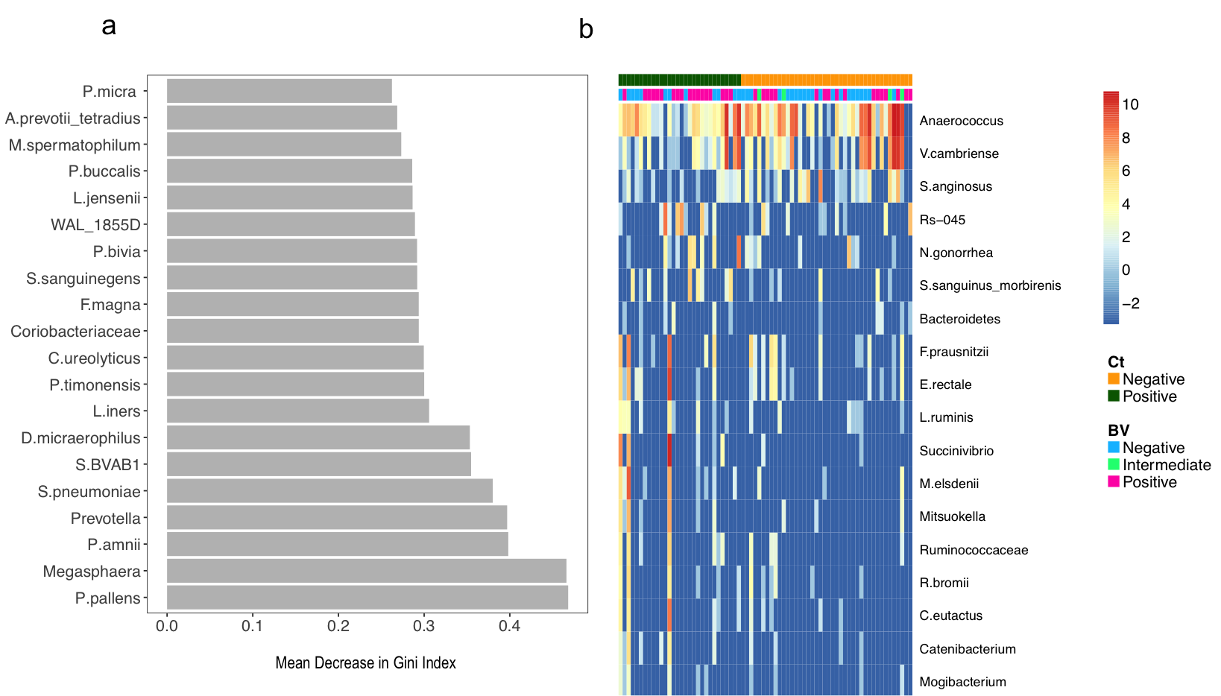

Supplementary Figure 1
- The top 20 most influential taxa by Random Forest analysis. The x-axis indicates the mean decrease in Gini Index (length of bar represents predictive ability of each taxon).
- Taxa significantly differentially abundant and/or frequent by C. trachomatis category in the vaginal lateral wall (LW) microbiota by metagenomeSeq (FDR ≤ 0.05, coefficient ≥ 1.25, taxa present in ≥ 20% of samples in at least one of the two groups being compared). Unsupervised clustering of samples (columns) by Bray-Curtis distance; heat map scale: log2-transformed standardized counts. The OTU assigned C. trachomatis taxonomy was excluded for this analysis.

