Hormetic dose response to _{L}-ascorbic acid as an anti-cancer drug in colorectal cancer cell lines according to SVCT-2 expression
Sungrae Cho¹, Jin Sung Chae², Hocheol Shin¹, Yujeong Shin³, Haeun Song³, Youngwook Kim⁴, Byong Chul Yoo⁵, Kangsan Roh¹, Seungchan Cho¹, Eui-joon Kil¹, Hee-seong Byun¹, Sang-ho Cho¹, Seyeon Park³, Sukchan Lee^{1*} and Chang-Hwan Yeom^{2*}

¹Department of Genetic Engineering, Sungkyunkwan University, Suwon, 16419, Republic of Korea
²Yeom Chang-Hwan hospital, Seoul, 06605, Republic of Korea
³Department of Applied Chemistry, Dongduk Women’s University, Seoul, 02748, Republic of Korea
⁴Department of Health Sciences and Technology, Samsung Advanced Institute for Health Sciences and Technology, Sungkyunkwan University, Seoul, 06351, Republic of Korea
⁵Colorectal Cancer Branch, Division of Translational and Clinical Research, Research Institute, National Cancer Center, Goyang, 10408, Republic of Korea

Corresponding author: Chang-Hwan Yeom, Sukchan Lee

Chang-Hwan Yeom
Yeom Chang-Hwan hospital, Seoul, 06605, Republic of Korea
Tel: +82-2-514-1249; e-mail: lymphych@hanmail.net

Sukchan Lee
Dept. of Genetic Engineering, Sungkyunkwan University, Suwon, 16419, Korea
Tel: +82-31-290-7866; FAX: +82-31-290-7870; e-mail: cell4u@skku.edu
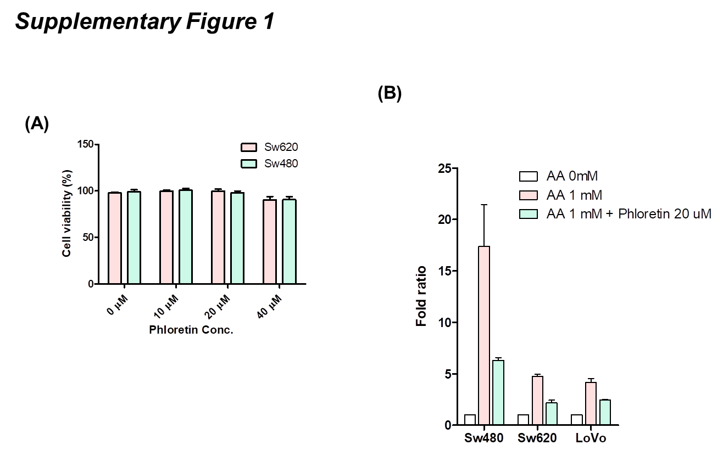
Supplementary Figure 1. A. Cell viability assay for phloretin in Sw620 and Sw480 cell lines. Cell cytotoxicity was not observed with 20 μM phloretin treatment in both cell lines. B. _{L}-Ascorbic acid uptake in cancer cells was analyzed by HPLC. Treatment with phloretin inhibited _{L}-ascorbic acid uptake.

Supplementary Figure 2. Co-staining of cyclin D1 and CDK4 by immunocytochemistry in DLD-1 cell line. Cyclin D1 and CDK4 were co-localized in nucleus and cytosol after treatment with 10 μM _{L}-ascorbic acid.

Supplementary Figure 3. Cyclin D1 and CDK4 localization was analyzed in HCT15 cells by confocal microscopy. Co-localization of Cyclin D1 and CDK4 was observed in nuclei and cytosol after treatment with 10 μM _{L}-ascorbic acid.

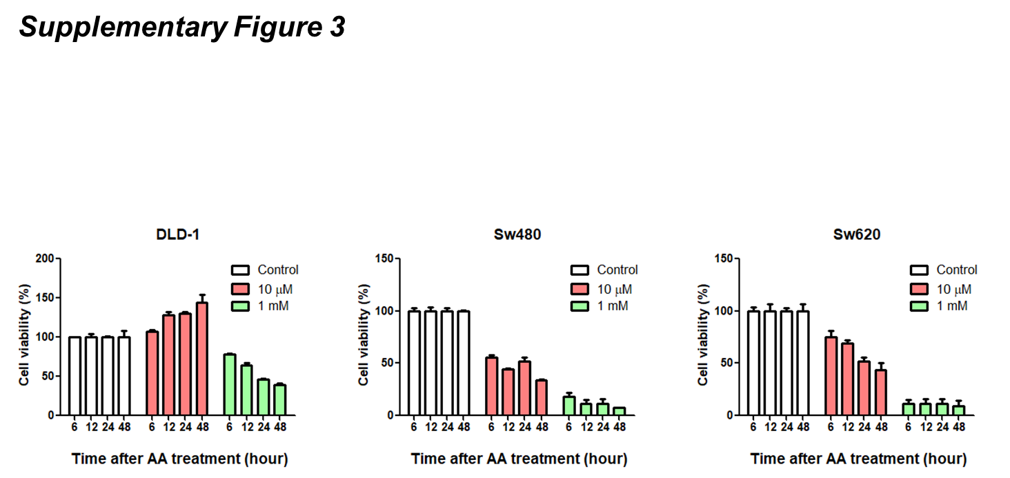

Supplementary Figure 4. Time-course cell viability assay was analyzed in DLD-1, Sw620 and Sw480 cell line. 10 μM and 1mM _{L}-ascorbic acid was treated. Hormetic proliferation response was observed after 12 hr with 10 μM of _{L}-ascorbic acid treatment.

