Supplementary Materials

Title: Estrogen Action in the Epithelial Cells of the Mouse Vagina Regulates Neutrophil Infiltration and Vaginal Tissue Integrity

Authors: Shuai Li, Gerardo G. Herrera, Keila K. Tam, Jacob S. Lizarraga, My-Thanh Beedle, Wipawee Winuthayanon

Supplemental Figures
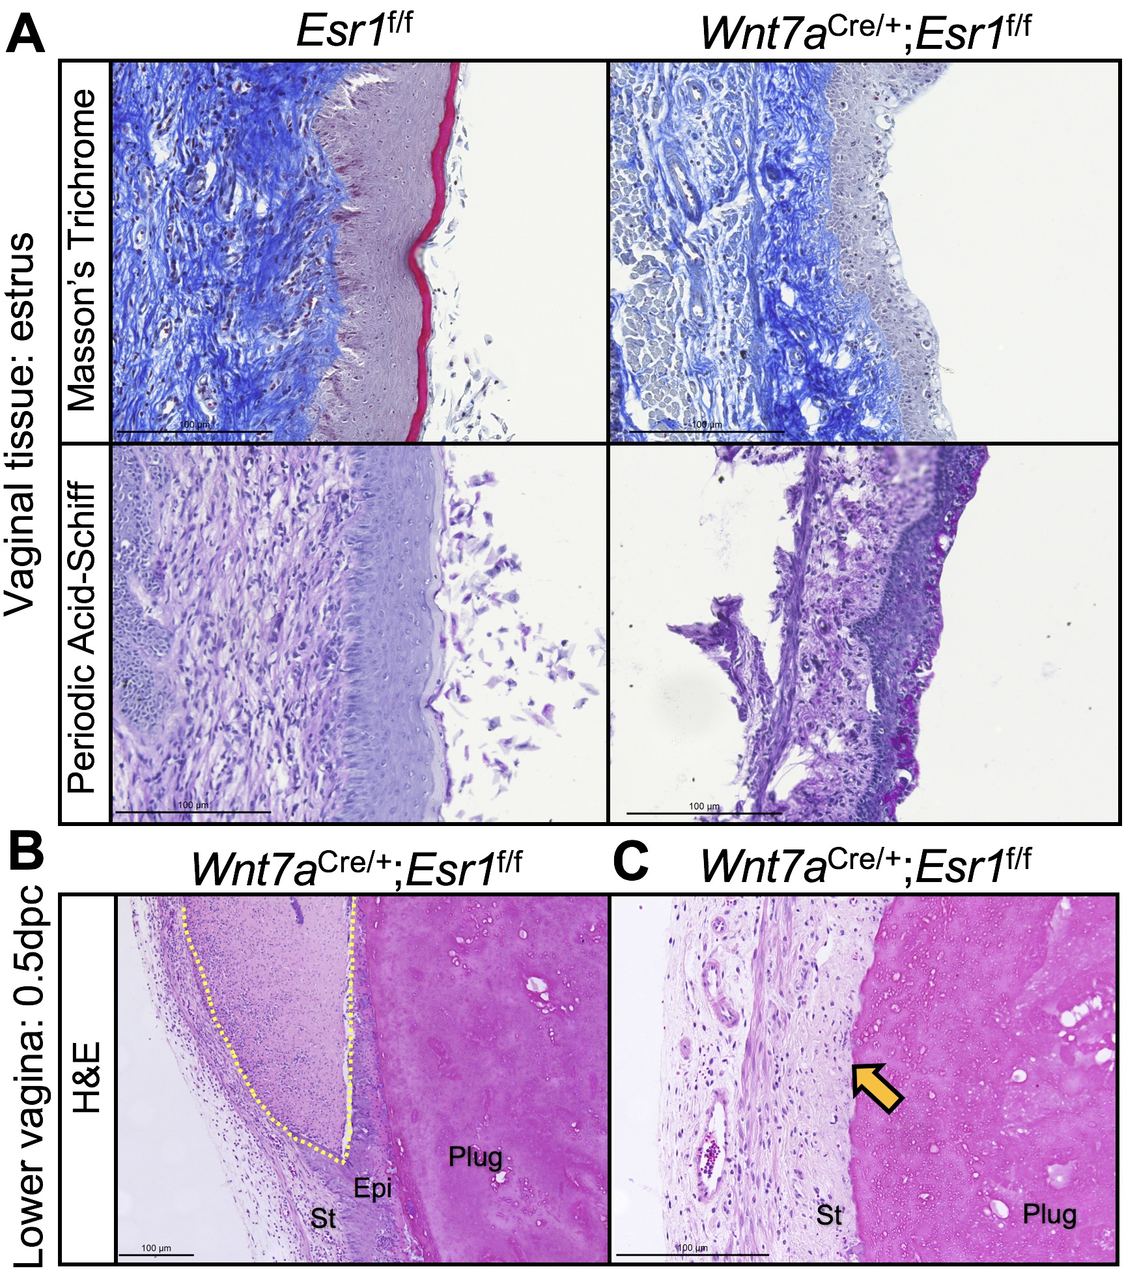
Figure S1. Representative images of H&E staining shows severe lesions of Wnt7a^{cre/+};Esr1^{f/f} animals. A) Masson’s Trichrome staining and PAS staining of the vaginal tract at estrus in Esr1^{f/f} and Wnt7a^{cre/+};Esr1^{f/f} animals. B) Mating induced lesion created a cavity allowing semen to fill between the upper and the lower layers of Wnt7a^{cre/+};Esr1^{f/f} epithelium (yellow dotted lines outline the cavity). C) An area with complete removal of the epithelium (arrow denotes where the vaginal plug adheres to the stromal cells). Scale bars are 100µm.
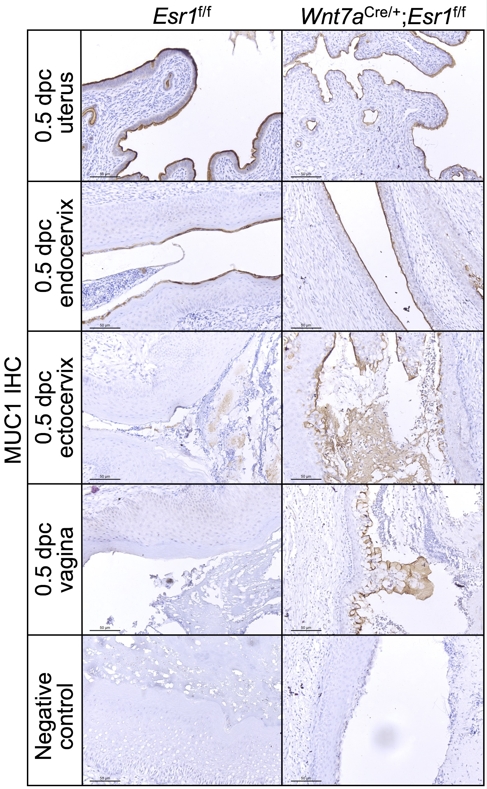
Figure S2. Representative images of MUC1 IHC staining of the female reproductive tract. The top panel: MUC1 IHC demonstrates a strong positive staining at the apical layer of the uterine epithelial cells in both Esr1^{f/f} and Wnt7a^{Cre/+};Esr1^{f/f} animals. The second panel: MUC1 was present at the apical surface of endocervix region in both Esr1^{f/f} and Wnt7a^{Cre/+};Esr1^{f/f} animals. The third and fourth panels: MUC1 IHC staining was not detected at the ectocervix or the vagina in Esr1^{f/f} animals, but the intense signal was observed at the ectocervix and the upper to middle vaginal tract of Wnt7a^{Cre/+};Esr1^{f/f} animals. Bottom panel: negative controls omitting primary antibody. Scale bars are 50µm.
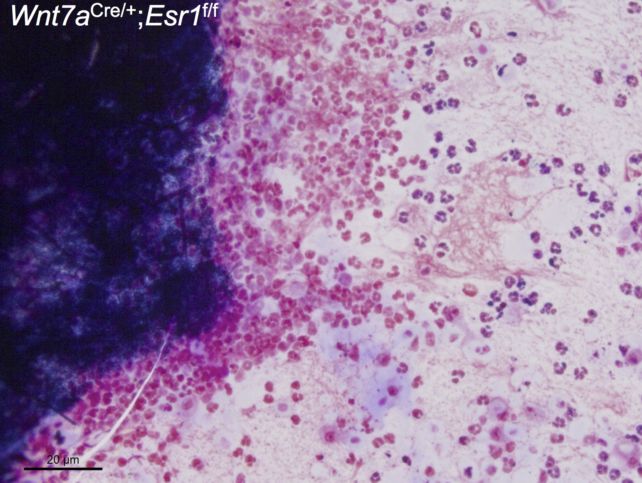
Figure S3. An example of a leukocyte cluster that was commonly found in the vaginal smears of Wnt7a^{cre/+};Esr1^{f/f} animals Scale bar is 20µm.

Figure S4. Original zymography images. Images were not altered by any image processing software. Fig. 6A and 6B were cropped from the representative areas of above images and were rearranged to improve the clarity of the paper.
Supplementary Table
Table S1. Primers used for qRT-PCR.
Gene names | Primer sequences
mMuc1 | F: CCCCTATGAGGAGGTTTCGG  R: CAGATCAGAGTGCAGGGGTC
mMuc4 | F: GACCAGATGGCTCTGAACCTA  R: TGCATTGGCCTCCATTGTGA
mKrt6a | F: TTCGTGACCCTGAAGAAGGAT  R:TTGCATCTGAGACAGTTCTGCTT
mKrt6b | F: GAAAAAGGATGTAGATGCTGCC  R: AGGAAGTTGATCTCGTCTGCAA
mKrt10 | F: CAGCTGGCCCTGAAACAATC  R: AGTTGTTGGTACTCGGCGTT
mKrt13 | F: AGAGCGGGACTACAGTGCTT  R:AGCTCATTTTCGTACTTGAGCCTG
mKrt16 | F: ATGGCGAGAATATCCACAGCTC  R: GCTGGTTGAACCTTGCTCCT
mMmp9 | F: GCCGACTTTTGTGGTCTTCC  R: GGTACAAGTATGCCTCTGCCA
mMmp2 | F: AACGGTCGGGAATACAGGAG  R: GGTAAACAAGGCTTCATGGGG
mEef2 | F: CGCTACCTGGCCGAAAAGTA  R: GTACTGCACACCCTTGGTGA
mElk1 | F: CCTGCAGGTTATCCTAACCCC  R: GCCCTTGCAGCTTCCAATTC
mlkka | F: AACATCCTCTGACATGTGTGGT  R:CCAACTCCAATCAAGACTCATCA
mIl1a | F: CGTGTTGCTGAAGGAGTTGC  R: GGTGCACCCGACTTTGTTCT
mIl1b | F: AGCTTCCTTGTGCAAGTGTC  R: TGGGGTCCGTCAACTTCAAA
mIl6 | F: CCTCTCTGCAAGAGACTTCCAT  R: ACAGGTCTGTTGGGAGTGGT
mIl8 | F: GGAAGTGATAGCAGTCCCAAA  R: AATTGGGCCAACAGTAGCCT
mTlr2 | F: AACCTCAGACAAAGCGTCAA  R: TCCTGAGCAGAACAGCGTTT
mTlr6 | F: GCTGTTTTGGGCCAACCTTAG  R: ATGAGAGCCCAGGTTGACAGT
mTnfa | F: ACTGAACTTCGGGGTGATCG  R: GGTGGTTTGTGAGTGTGAGG
mKlk1 | F: GCCCACTGATCTGTGATGGT  R: TCTGGTGTAGATACCCGGCA
mKlk4 | F: GCTGCTGTATGACCCTGTGT  R: CAGAGTCCCCATTGCAGGAG
mKlk1b3 | F: TCCCTAGGAGGGATTGATGCT  R: CACATGCCAGGGTTGGGAAT
mKlk1b5 | F: ACCCGTCATATACGAACCCG  R: GGGCTTTGACACAGTCCTCA
mKlk1b24 | F: CAACGTGAACCCTCTGCTCA  R: CCTTAGGTTGCGGGATGTCA

