Supplementary material for

Decadal erosion of coral assemblages by multiple disturbances in the Palm Islands, central Great Barrier Reef
Gergely Torda^{1, 2, 3*}, Katie Sambrook^{1, 2*}, Peter Cross¹, Yui Sato³, David G. Bourne^{1, 3}, Vimoksalehi Lukoschek², Tess Hill¹, Georgina Torras Jorda¹, Aurelie Moya², Bette L. Willis^{1, 2}
* equal contribution
1. College of Science and Engineering, James Cook University, Townsville, QLD 4811, Australia
2. Australian Research Council Centre of Excellence for Coral Reef Studies, James Cook University, Townsville, QLD 4811, Australia
3. Australian Institute of Marine Science, PMB 3, Townsville MC, QLD 4810, Australia

Email: gergely.torda@jcu.edu.au

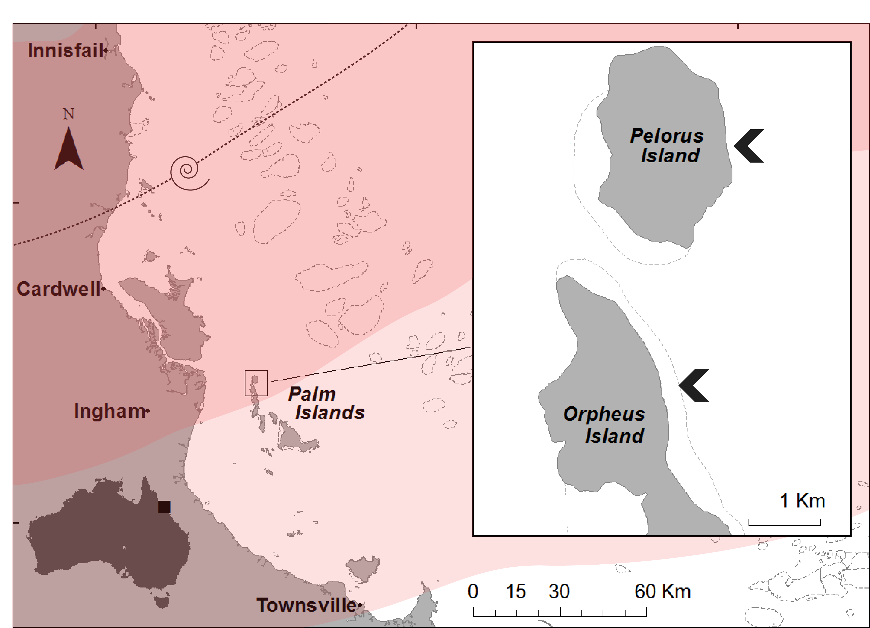
Fig. S1 Map showing the location of survey sites and the track of Category 5 Tropical Cyclone Yasi (dashed line) as it travelled past the Palm Islands Group, in the central Great Barrier Reef, on 2 February 2011. Strong pink shading indicates boundaries of very destructive winds with gusts exceeding 280 km/h; light pink shading indicates boundaries of destructive winds with gusts between 125 and 280 km/h. Map created in ArcGIS 10, cyclone track data extracted from http://www.bom.gov.au/cyclone/history/yasi.shtml.

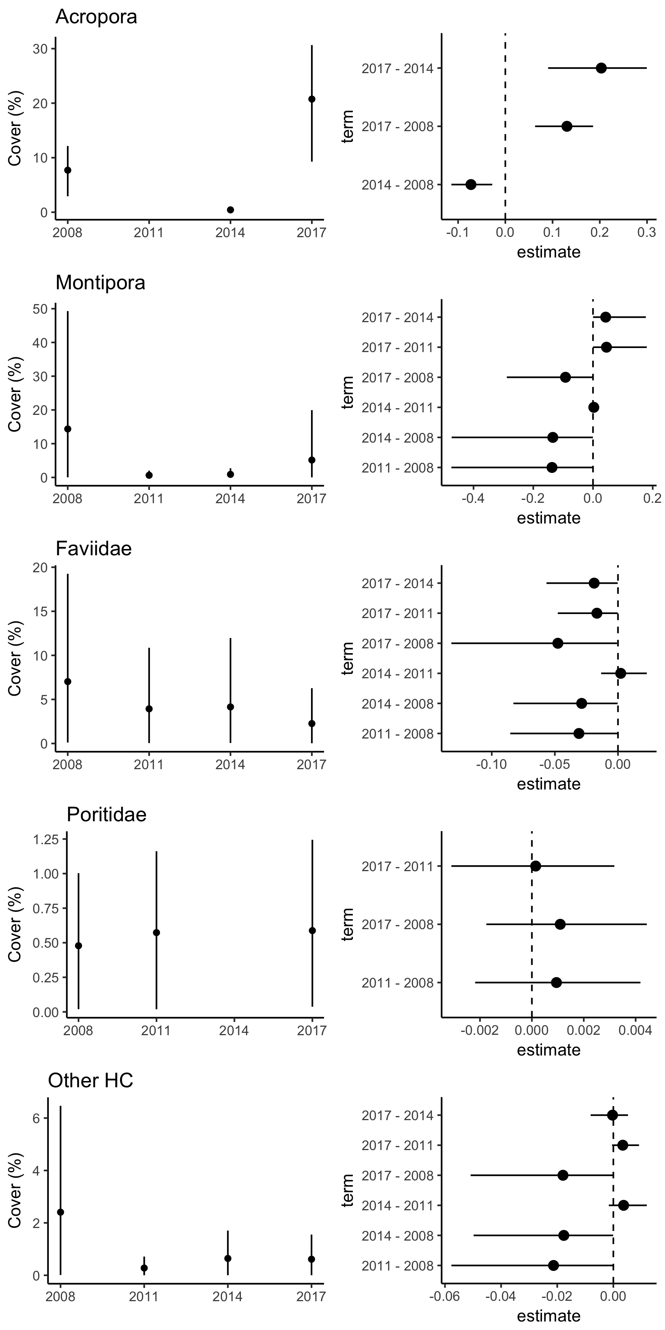
Fig. S2 Means and 95% credibility intervals of modeled coral cover for five coral groups obtained from Bayesian generalized linear mixed effects models using binomial distibuiton. Years with only zero values were omitted (2011 for Acropora and 2014 for Poritidae). Corresponding butterfly-plots indicate the 95% prediction intervals of pairwise comparisons of timepoints, where zero represents no change.

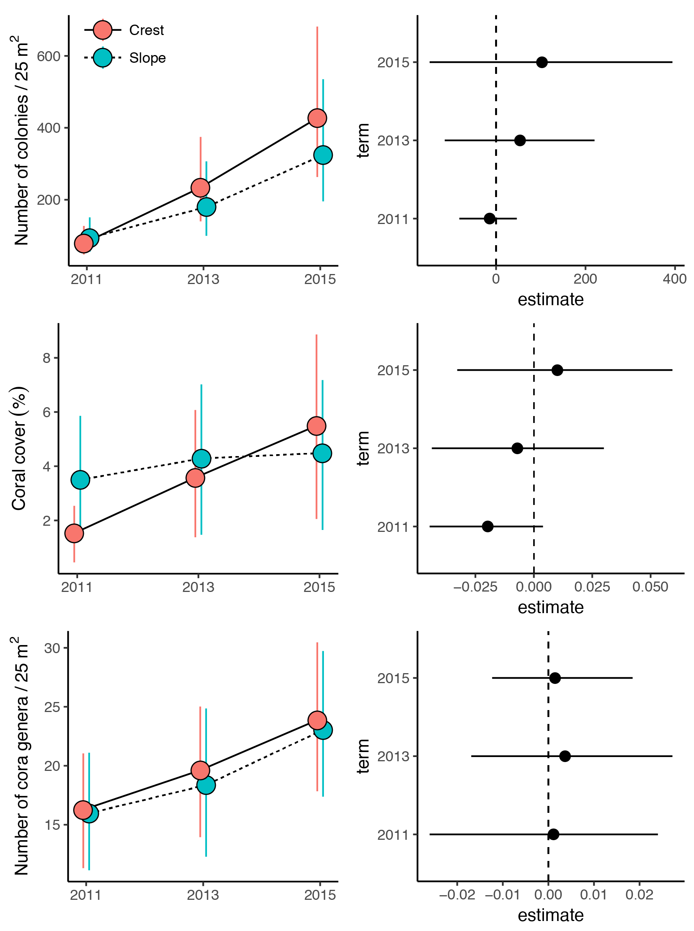
Fig. S3 . Modeled mean +- 95% credibility interval of colony density (a), coral cover (b), and genus diversity (c) by depth and year on the exposed fringing reef of Orpheus Island, central GBR. Data obtained from three replicate 5 x 5 m quadrats per depth zone per time-point (bar the slope in 2013, when only two quadrats were surveyed for logistical constraints). The Bayesian generalized linear mixed effects models used negative binomial (a), binomial (b), and poisson (c) distributions, respectively. Corresponding caterpillar-plots indicate the 95% credibility intervals of comparisons between the crest and slope data at each time-point, where zero represents no difference.
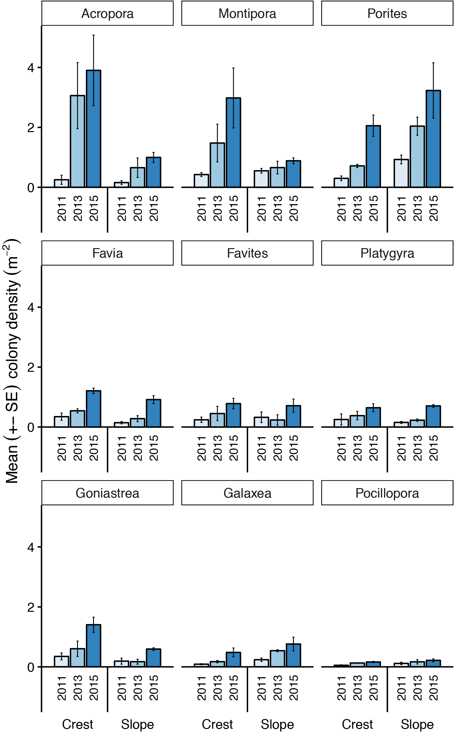

Fig. S4 Mean (± SE) density of the most common coral genera (per m²) by depth and year at E Orpheus, central GBR. All colonies ≥1 cm mean diameter. n=3 quadrats per zone, except in 2013 when only two quadrats were surveyed on the lower slope.

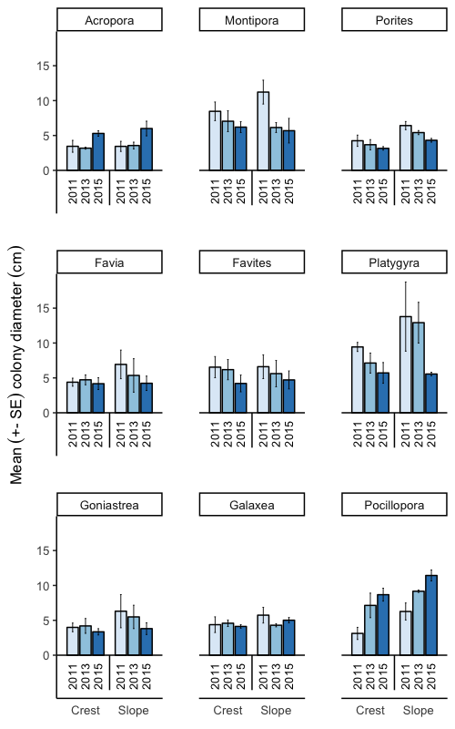
Fig. S5 Mean (± SE) colony area of the most common coral genera by depth and year at E Orpheus, central GBR. All colonies ≥1 cm mean diameter. n=3 quadrats per zone, except in 2013 when only two quadrats were surveyed on the lower slope.

Table S1. Re-classification of taxonomically resolved data from post-2008 into the broad morphological groups of Gralton⁴⁶; following Veron⁴⁷.

Branching/Arborescent
Acropora: bushy, branching, staghorn, columnar; Hydnophora, Isopora, Tubastrea
Corymbose/Plating
Acropora: bottlebrush, clumping, digitate, tabular, corymbose; Pocilloporidae; Turbinaria; Pachyseris; Merulina; Echinopora; Leptoseris; Pavona
Encrusting
Montipora; Cyphastrea; Leptastrea; Galaxea; Echinophyllia; Mycedium; Scolymia; Trachiphyllia; Oxypora; Trachyphyllia
Massive
Acanthastrea; Alveopora; Astreopora; Caulastrea; Coeloseris; Diploastrea; Favia; Favites; Goniastrea; Goniopora; Leptoria; Lobophyllia; Montastrea; Oulophyllia; Pectinia; Platygyra; Plerogyra; Symphyllia; Physogyra; Gardineroseris; Psammocora; Coscinarea

Table S2. List of R packages and functions used for data analysis.
data manipulation and graphing
tidyverse
ggplot2

Bayesian analyses
rstanarm::: stan_glmer
broom::: tidyMCMC
multcomp::: contrMat

nMDS
vegan:::metaMDS

Pairwise permutational MANOVA
RVAideMemoire:::pairwise.perm.manova

Table S3. Bayesian models and their parameter estimates. ‘rhat’ vales are a measure of the efficiency of the model. Values under 1.05 indicate that the model was appropriately parameterised.

A) Changes in overall coral cover on transects
coral.stanT = stan_glmer(cbind(Cover, 2000-Cover)~Year +(1|Site),
data=coral,
family='binomial',
prior = normal(1, 10),
prior_intercept = normal(0,10),
chains = 3,
iter = 3000, thin=4, warmup=1000)

term | estimate | std.error | cred.low | cred.high
(Intercept) | -0.94856112 | 0.4082642 | -1.922812678 | -0.10053666
Year2011 | -2.20535691 | 0.07220537 | -2.346679446 | -2.06186103
Year2014 | -3.16564342 | 0.10602803 | -3.367243835 | -2.97421398
Year2017 | -0.03860928 | 0.04046906 | -0.115015432 | 0.04117919
b[(Intercept) Site:EP] | 0.10641447 | 0.40641207 | -0.744402644 | 1.07174884
b[(Intercept) Site:NEO] | -0.12518173 | 0.40784124 | -0.99404826 | 0.81902606
Sigma[Site:(Intercept),(Intercept)] | 0.44405262 | 0.96773289 | 0.002350304 | 1.91124043

B) Changes in coral abundance among years and reef zones
dens.stan1 <- stan_glmer(CC~Year*Depth + (1|Quadrat), data=dens,
family='neg_binomial_2',
prior=normal(0,1),
prior_intercept=normal(0,10),
prior_aux=cauchy(0,5),
chains=3, iter=5000, warmup=2000, thin=4)

term | estimate | std.error | conf.low | conf.high | rhat
(Intercept) | 4.35E+00 | 0.2542796 | 3.85E+00 | 4.8527152 | 1.0026229
Year2013 | 1.07E+00 | 0.2933655 | 5.33E-01 | 1.665035 | 0.9997379
Year2015 | 1.67E+00 | 0.2872341 | 1.05E+00 | 2.2145798 | 1.0000198
DepthSlope | 1.43E-01 | 0.3638069 | -6.55E-01 | 0.8480183 | 1.0000571
Year2013:DepthSlope | -4.13E-01 | 0.4418997 | -1.24E+00 | 0.5119869 | 0.9990064
Year2015:DepthSlope | -4.10E-01 | 0.3917385 | -1.18E+00 | 0.3893049 | 1.0000369
b[(Intercept) Quadrat:1] | -5.31E-02 | 0.1759101 | -4.51E-01 | 0.2581093 | 1.0012044
b[(Intercept) Quadrat:2] | 7.73E-02 | 0.1894509 | -2.13E-01 | 0.5148563 | 1.0025465
b[(Intercept) Quadrat:3] | -1.10E-02 | 0.1716177 | -3.65E-01 | 0.3457381 | 0.9997093
b[(Intercept) Quadrat:4] | 1.18E-02 | 0.1769059 | -3.54E-01 | 0.3972622 | 0.9993536
b[(Intercept) Quadrat:6] | 3.43E-02 | 0.1907699 | -2.88E-01 | 0.4763067 | 1.0003544
b[(Intercept) Quadrat:9] | -2.05E-02 | 0.1784199 | -4.43E-01 | 0.314905 | 0.9987874
b[(Intercept) Quadrat:_NEW_Quadrat] | 4.91E-03 | 0.2539132 | -4.64E-01 | 0.4908148 | 1.001211
reciprocal_dispersion | 1.15E+01 | 6.2110491 | 2.61E+00 | 24.0338409 | 1.0006269
Sigma[Quadrat:(Intercept),(Intercept)] | 6.92E-02 | 0.259267 | 2.24E-09 | 0.2640563 | 1.0017004
mean_PPD | 2.25E+02 | 34.5886975 | 1.69E+02 | 291.5294118 | 1.0002843
log-posterior | -1.16E+02 | 3.514065 | -1.23E+02 | -109.6424875 | 0.999666
C) Changes in coral cover among years and reef zones
cover.stan = stan_glmer(cbind(CC, 1000-CC)~Year*Depth +(1|Quadrat),
data=cover,
family='binomial',
prior = normal(0, 10),
prior_intercept = normal(0,10),
chains = 3,
iter = 3000, thin=4, warmup=1000)

term | estimate | std.error | conf.low | conf.high | rhat
(Intercept) | -4.253653148 | 0.3504178 | -4.94732088 | -3.5317404 | 1.0028663
Year2013 | 0.885273661 | 0.1806585 | 0.54277565 | 1.259852 | 1.0020156
Year2015 | 1.335273718 | 0.1713245 | 1.01380649 | 1.6756316 | 1.0024984
DepthSlope | 0.873523098 | 0.497188 | -0.01628691 | 1.8942532 | 1.0004419
Year2013:DepthSlope | -0.686107496 | 0.2489251 | -1.19797363 | -0.2588738 | 1.0037702
Year2015:DepthSlope | -1.075006261 | 0.2146682 | -1.48558823 | -0.6638505 | 1.0061448
b[(Intercept) Quadrat:1] | 0.078678448 | 0.3278945 | -0.62432573 | 0.7284098 | 1.0007688
b[(Intercept) Quadrat:2] | 0.259704181 | 0.3311325 | -0.47547221 | 0.8964124 | 1.0012467
b[(Intercept) Quadrat:3] | -0.305878599 | 0.3270715 | -0.89268127 | 0.4324411 | 1.0001768
b[(Intercept) Quadrat:4] | 0.016394632 | 0.3377735 | -0.68049439 | 0.6912069 | 1.0004737
b[(Intercept) Quadrat:6] | 0.448051355 | 0.3447756 | -0.19358245 | 1.1958758 | 1.0007091
b[(Intercept) Quadrat:9] | -0.445433133 | 0.337766 | -1.1676513 | 0.1669979 | 0.9996634
b[(Intercept) Quadrat:_NEW_Quadrat] | -0.006251365 | 0.5651388 | -1.03546093 | 1.241419 | 1.0019836
Sigma[Quadrat:(Intercept),(Intercept)] | 0.317864507 | 0.367289 | 0.02633018 | 0.9392281 | 0.9988992
mean_PPD | 36.32537255 | 2.0180732 | 32.52941176 | 40.2941176 | 1.0013888
log-posterior | -80.73876931 | 2.9715087 | -86.42252669 | -75.4395687 | 0.9988674
D) Changes in coral genus diversity among years and reef zones
div.stan2 <- stan_glmer(CDr~Year*Depth + (1|Quadrat), data=div,
family='poisson',
prior=normal(0,1),
prior_intercept=normal(0,10),
#prior_aux=cauchy(0,5),
chains=3, iter=6000, warmup=3000, thin=4)

term | estimate | std.error | conf.low | conf.high | rhat
(Intercept) | 2.77E+00 | 0.15531502 | 2.46E+00 | 3.06136854 | 1.0003544
Year2013 | 1.92E-01 | 0.17999236 | -1.80E-01 | 0.52301218 | 1.0001002
Year2015 | 3.95E-01 | 0.17568832 | 4.70E-02 | 0.74393642 | 0.9992088
DepthSlope | -7.63E-03 | 0.21859844 | -4.33E-01 | 0.41201869 | 1.0018669
Year2013:DepthSlope | -5.54E-02 | 0.2748104 | -6.07E-01 | 0.48469759 | 1.002348
Year2015:DepthSlope | -3.32E-02 | 0.24881388 | -5.23E-01 | 0.45165847 | 1.0003331
b[(Intercept) Quadrat:1] | 4.57E-02 | 0.11041394 | -1.54E-01 | 0.27577874 | 1.0005919
b[(Intercept) Quadrat:2] | -3.21E-02 | 0.10422715 | -2.79E-01 | 0.14930766 | 1.0000252
b[(Intercept) Quadrat:3] | -8.59E-03 | 0.10177788 | -2.29E-01 | 0.19054738 | 1.0004375
b[(Intercept) Quadrat:4] | 2.10E-02 | 0.10371422 | -1.70E-01 | 0.25853089 | 0.9991245
b[(Intercept) Quadrat:6] | -3.61E-03 | 0.10466807 | -2.26E-01 | 0.2152257 | 1.0004727
b[(Intercept) Quadrat:9] | -1.11E-02 | 0.10097461 | -2.39E-01 | 0.20233279 | 0.9998637
b[(Intercept) Quadrat:_NEW_Quadrat] | 5.26E-04 | 0.14040876 | -2.94E-01 | 0.29270519 | 1.0013108
Sigma[Quadrat:(Intercept),(Intercept)] | 2.10E-02 | 0.06352247 | 4.01E-10 | 0.08072529 | 1.0006273
mean_PPD | 1.96E+01 | 1.48946599 | 1.65E+01 | 22.35294118 | 1.0010502
log-posterior | -6.61E+01 | 2.9062787 | -7.15E+01 | -60.77491693 | 0.9999412

Table S4. Modeled mean density, coral cover and genus diversity on crest and slope at exposed reefs of Orpheus Island.
Colony density

Year | Zone | Mean density | 95% credibility interval | Probability
2011 | Crest | 79.02919 | 47.96-127.1 | P_{crest>slope} = 0.29
2013 | Crest | 234.04376 | 139.79-374.41 | P_{crest>slope} = 0.79
2015 | Crest | 427.16075 | 263.31-681.38 | P_{crest>slope} = 0.81
2011 | Slope | 93.57426 | 55.72-150.97 | P_{slope>crest} = 0.71
2013 | Slope | 179.91308 | 99.83-306.58 | P_{slope>crest} = 0.21
2015 | Slope | 324.79258 | 195.39-535.08 | P_{slope>crest} = 0.19
Coral cover

Year | Zone | Mean cover | 95% credibility interval | Probability
2011 | Crest | 1.529514 | 0.45-2.54 | P_{crest>slope} = 0.04
2013 | Crest | 3.579925 | 1.38-6.07 | P_{crest>slope} = 0.32
2015 | Crest | 5.495453 | 2.05-8.86 | P_{crest>slope} = 0.71
2011 | Slope | 3.498884 | 1.62-5.86 | P_{slope>crest} = 0.96
2013 | Slope | 4.286865 | 1.47-7.02 | P_{slope>crest} = 0.68
2015 | Slope | 4.48815 | 1.65-7.18 | P_{slope>crest} = 0.29
Genus diversity

Year | Zone | Mean # of genera | 95% credibility interval | Probability
2011 | Crest | 2.505468 | 11.32-21.05 | P_{crest>slope} = 0.53
2013 | Crest | 2.864307 | 13.95-25.02 | P_{crest>slope} = 0.62
2015 | Crest | 3.25602 | 17.84-30.46 | P_{crest>slope} = 0.57
2011 | Slope | 2.597438 | 11.15-21.1 | P_{slope>crest} = 0.47
2013 | Slope | 3.233413 | 12.29-24.85 | P_{slope>crest} = 0.38
2015 | Slope | 3.198327 | 17.38-29.73 | P_{slope>crest} = 0.43

Table S5. Names of data contributors to the study and details of data supplied
Name | Initials | Year | Data collection method | Details
Bette Willis | BW | 1998  1999  2001 | Line intercept transects | Coral composition / cover
Cathie Page | CP | 1999 | Line intercept transects | Coral composition / cover
Charlotte Gralton | CG | 2001 | Line intercept transects | Coral composition / cover
Yui Sato | YS | 2008 | Line intercept transects | Coral composition / cover
David Bourne | DB | 2008 | Line intercept transects | Coral composition / cover
Vimoksalehi Lukoschek | VL | 2011 | Line intercept transects  Belt transects | Coral composition / benthic cover
Peter Cross | PC | 2011 | Permanent quadrats | Taxonomic identity, abundance and colony size
Gergely Torda | GT | 2011  2013  2015  2014, 2017 | Permanent quadrats  Line intercept transects  Belt transects | Taxonomic identity, abundance and colony size, structural complexity  Coral composition / benthic cover
Katie Sambrook | KS | 2015  2014 | Permanent quadrats  Line intercept transects  Belt transects | Taxonomic identity, abundance and colony size  Coral composition / benthic cover

R Scripts

library(rstanarm)
library(rstan)
library(broom)
library(tidyverse)
library(ggplot2)
library(gridExtra)
library(ggfortify)
library(sjPlot)
library(MuMIn)
library(stringr)

df <- read.csv('LIT.csv', strip.white = T)
SE <- function(x) sd(x)/sqrt(length(x))

##Graphs
### Stacked bar graph

coralcover <- df %>%
filter(Category != 'Soft corals') %>%
unite(SiTr, c(Site, Transect), sep = '-') %>%
group_by(Year, SiTr, Category) %>%
summarise(percent.cover=sum(LIT)/20) %>%
group_by(Year, SiTr) %>%
mutate(Cov.Tot = sum(percent.cover), Cov.Prop = 100*percent.cover/Cov.Tot) %>%
group_by(Year, Category) %>%
summarise(Cov.Mean=mean(percent.cover), Cov.SE=SE(percent.cover),
Cov.Prop.Mean = mean(Cov.Prop), Cov.Prop.SE=SE(Cov.Prop))

coralcover$Category <- factor(coralcover$Category, levels = c("Acropora", "Montipora", "Pocilloporidae", "Faviidae", "Poritidae", "Other HC"))

ggplot(coralcover, aes(y=Cov.Mean, x=Year, fill=Category, color = Category)) +
geom_bar(stat='identity', position = 'stack', alpha = 0.2, width = 1) +
theme_classic(12) +
theme(axis.text.x = element_text(angle = 45, hjust = 1)) +
theme(axis.line.x = element_line(color='black', size=0.5)) +
theme(axis.line.y = element_line(color='black', size=0.5)) +
scale_y_continuous(expression(Mean~'%'~coral~cover)) +
theme(legend.position='right') +
scale_x_continuous(expression(), breaks=c(2008, 2011, 2014, 2017)) +
theme(legend.title=element_blank()) +
theme(strip.text.x = element_blank()) +
annotate("segment", x=-Inf, xend=Inf, y=-Inf, yend=-Inf, size = 1)+
annotate("segment", x=-Inf, xend=-Inf, y=-Inf, yend=Inf, size = 1) +
theme(panel.margin = unit(2, "lines"))

### Pointrange graphs per Genus

coralcover2 <- df %>%
filter(Category != 'Soft corals') %>%
group_by(Year, Site, Transect, Category) %>%
summarise(percent.cover=sum(LIT)/20) %>%
group_by(Year, Site, Transect) %>%
mutate(Cov.Tot = sum(percent.cover), Cov.Prop = 100*percent.cover/Cov.Tot) %>%
group_by(Year, Site, Category) %>%
summarise(Cov.Mean=mean(percent.cover), Cov.SE=SE(percent.cover),
Cov.Prop.Mean = mean(Cov.Prop), Cov.Prop.SE=SE(Cov.Prop))

coralcover2$Category <- factor(coralcover2$Category, levels = c("Acropora", "Montipora", "Pocilloporidae", "Faviidae", "Poritidae", "Other HC"))

ggplot(coralcover2, aes(y=Cov.Mean, x=Year, color = Category, shape = Site)) +
geom_pointrange(aes(ymax = Cov.Mean + Cov.SE, ymin = Cov.Mean - Cov.SE),
size=0.5, position = position_dodge(1.1)) +
geom_line(aes(linetype = Site), alpha = 0.5, position = position_dodge(1.1))+
facet_wrap(~Category, nrow = 2, ncol = 3, scales = 'free') +
theme_classic(12) +
theme(axis.text.x = element_text(angle = 45, hjust = 1)) +
theme(axis.line.x = element_line(color='black', size=0.1)) +
theme(axis.line.y = element_line(color='black', size=0.1)) +
scale_y_continuous(expression(Mean~'%'~coral~cover)) +
theme(legend.position='right') +
scale_x_continuous(expression(), breaks=c(2008, 2011, 2014, 2017)) +
theme(legend.title=element_blank()) +
scale_shape_manual(values = c(15,16)) +
scale_linetype_manual(values = c('dashed', 'dotted'))

###historical outlook, stacked bars

historical <- read.csv('historical.csv', header=T, strip.white=T)

df$Morphology[df$Sp %in% c('bushy', 'branching', 'staghorn', 'columnar')] <- 'Branching/Arborescent'
df$Morphology[df$Genus %in% c('Hydnophora', 'Isopora', 'Tubastrea')] <- 'Branching/Arborescent'
df$Morphology[df$Family %in% c('Pocilloporidae')] <- 'Corymbose/Plating'
df$Morphology[df$Sp %in% c('bottlebrush', 'clumping', 'digitate', 'tabular', 'corymbose')] <- 'Corymbose/Plating'
df$Morphology[df$Genus %in% c('Turbinaria', 'Pachyseris', 'Merulina', 'Echinopora', 'Leptoseris', 'Pavona')] <- 'Corymbose/Plating'
df$Morphology[df$Sp %in% c('encrusting')] <- 'Encrusting'
df$Morphology[df$Genus %in% c('Montipora', 'Cyphastrea', 'Leptastrea', 'Galaxea', 'Echinophyllia', 'Mycedium', 'Scolymia', 'Trachiphyllia', 'Oxypora', 'Styloco/Palaus/Madrac', 'Trachyphyllia')] <- 'Encrusting'
df$Morphology[df$Genus %in% c('Acanthastrea', 'Alveopora', 'Astreopora', 'Caulastrea', 'Coeloseris', 'Diploastrea', 'Favia', 'Favites', 'Goniastrea', 'Goniopora', 'Leptoria', 'Lobophyllia', 'Montastrea', 'Oulophyllia', 'Pectinia', 'Platygyra', 'Plerogyra', 'Faviidae', 'Symphyllia', 'Physogyra', 'Gardineroseris','Psammocora','Coscinarea')] <- 'Massive'
df$Morphology[df$Sp %in% c('massive')] <- 'Massive'

coralcover3 <- df %>%
filter(Category != 'Soft corals') %>%
filter(Morphology != 'NA') %>%
unite(SiTr, c(Site, Transect), sep = '-') %>%
group_by(Year, SiTr, Morphology) %>%
summarise(percent.cover=sum(LIT)/20) %>%
group_by(Year, SiTr) %>%
mutate(Cov.Tot = sum(percent.cover), Cov.Prop = 100*percent.cover/Cov.Tot) %>%
group_by(Year, Morphology) %>%
summarise(Cov.Mean=mean(percent.cover), Cov.SE=SE(percent.cover)) %>%
as.data.frame()

final <-rbind(historical, coralcover3)
final$Morphology <- as.factor(final$Morphology)
final$Morphology <- factor(final$Morphology, levels = rev(c("Branching/Arborescent", "Corymbose/Plating", "Encrusting", "Massive")))

ggplot(final, aes(y=Cov.Mean, x=Year, fill=Morphology)) +
geom_bar(stat='identity', position = 'stack', alpha = 0.2, color = 'gray') +
theme_classic(12) +
theme(axis.text.x = element_text(angle = 45, hjust = 1)) +
theme(axis.line.x = element_line(color='black', size=0.5)) +
theme(axis.line.y = element_line(color='black', size=0.5)) +
scale_y_continuous(expression(Mean~'%'~coral~cover)) +
#theme(legend.position='bottom') +
theme(legend.position = c(1,1), legend.justification = c(1,1)) +
scale_x_continuous(expression(), breaks=c(1998, 1999, 2001, 2008, 2011, 2014, 2017)) +
theme(legend.title=element_blank()) +
#scale_color_brewer(palette = 'Greys') +
scale_fill_brewer(palette = 'Greys') +
guides(colour = guide_legend(reverse=T), fill= guide_legend(reverse=T))

###historical outlook, pointrange graphs per morphology

final$Morphology <- factor(final$Morphology, levels = c("Branching/Arborescent", "Corymbose/Plating", "Encrusting", "Massive"))
ggplot(final, aes(y=Cov.Mean, x=Year)) +
geom_pointrange(aes(ymax = Cov.Mean + Cov.SE, ymin = Cov.Mean - Cov.SE), size=0.3) +
geom_line(alpha = 0.3, linetype = 'dotted')+
facet_wrap(~Morphology, nrow = 4, ncol = 2, scales = 'free') +
theme_classic(12) +
theme(axis.text.x = element_text(angle = 45, hjust = 1)) +
theme(axis.line.x = element_line(color='black', size=0.5)) +
theme(axis.line.y = element_line(color='black', size=0.5)) +
scale_y_continuous(expression(Mean~'%'~coral~cover)) +
theme(legend.position='bottom') +
scale_x_continuous(expression(), breaks=c(1998, 1999, 2001, 2008, 2011, 2014, 2017)) +
theme(legend.title=element_blank()) +
theme(strip.background = element_rect(fill="#CCCCFF"))

#### some basic descriptive stats for the paper

#stats for paper
dstat <- final %>%
group_by(Year) %>%
summarise(total = sum(Cov.Mean))
#decrease:
1-dstat[7,'total']/dstat[1,'total']
#recovery rate:
(dstat[4,'total']-dstat[2,'total'])/(dstat[4,'Year']-dstat[2,'Year'])
(dstat[7,'total']-dstat[6,'total'])/(dstat[7,'Year']-dstat[6,'Year'])

(dstat[3,'total']-dstat[2,'total'])/(dstat[3,'Year']-dstat[2,'Year'])
(dstat[4,'total']-dstat[3,'total'])/(dstat[4,'Year']-dstat[3,'Year'])

#descriptive stats decreases by morphology
mstat <- final %>%
group_by(Year, Morphology) %>%
summarise(total = sum(Cov.Mean))
1-mstat[5,'total']/mstat[1,'total']
1-mstat[6,'total']/mstat[2,'total']
1-mstat[7,'total']/mstat[3,'total']
1-mstat[8,'total']/mstat[4,'total']

1-mstat[17,'total']/mstat[13,'total']
1-mstat[18,'total']/mstat[14,'total']
1-mstat[19,'total']/mstat[15,'total']
1-mstat[20,'total']/mstat[16,'total']

1-mstat[13,'total']/mstat[9,'total']
1-mstat[16,'total']/mstat[12,'total']

dom <- mstat %>%
group_by(Year) %>%
summarise(dom = max(total)/sum(total))

#decreases by category after Yasi
CatStat <- df %>%
filter(Morphology != 'NA') %>%
unite(SiTr, c(Site, Transect), sep = '-') %>%
group_by(Year, SiTr, Category) %>%
summarise(percent.cover=sum(LIT)/20)

###NMDS plot and associated stats

library(vegan)

nmds <- df %>%
filter(Category != 'Other HC') %>%
mutate(Cat = factor(ifelse(Genus == 'Acropora', paste0(Genus, ' (', Sp, ')'), as.character(Genus)))) %>%
dplyr:::select(Year, Site, Transect, Cat, LIT) %>%
group_by(Year, Site, Transect, Cat) %>%
summarise(sumLIT = sum(LIT)) %>%
spread(Cat, sumLIT)
nmds[is.na(nmds)] <- 0

nmds.stnd <- nmds %>% ungroup() %>%
mutate(Transect = as.factor(Transect)) %>%
mutate_if(is.numeric, funs(decostand(.^0.25, MARGIN = 2, 'max')))

franko.mds <- metaMDS(nmds.stnd[, c(-1:-3)], k = 2, autotransform = FALSE)

#stressplot(franko.mds)
#plot(franko.mds)
franko.site.scores <- as.data.frame(scores(franko.mds, display = 'sites'))
franko.site.scores <- data.frame(franko.site.scores, nmds) #so that we have the original names
franko.species.scores <- as.data.frame(scores(franko.mds, display = 'species'))
franko.species.scores$Species <- rownames(franko.species.scores)
#head(franko.species.scores)
#head(franko.site.scores)
franko.site.scores$Year <- as.factor(franko.site.scores$Year)
hjust <- ifelse(franko.species.scores$NMDS1>0, 0, 1)
vjust <- ifelse(franko.species.scores$NMDS2>0, 0, 1)

g <- ggplot() +
geom_segment(data = NULL, aes(y=-Inf, x = 0, yend = Inf, xend = 0), linetype = 'dotted') +
geom_segment(data = NULL, aes(y=0, x = -Inf, yend = 0, xend = Inf), linetype = 'dotted') +
geom_point(data = franko.site.scores, aes(y = NMDS2, x = NMDS1, color = Year), size = 2) +
geom_segment(data = franko.species.scores, aes(y = 0, x = 0, yend = NMDS2, xend = NMDS1), arrow = arrow(length = unit(0.3, 'lines')), alpha = 0.2) +
geom_text(data = franko.species.scores, aes(y = NMDS2, x = NMDS1, label = Species, hjust = hjust, vjust = vjust), show.legend = F, size = 3, color = 'gray') +
theme_classic() +
scale_y_continuous(expression()) +
scale_x_continuous(expression()) +
coord_equal(xlim = c(-1.3, 1.5), ylim = c(-1, 1)) +
theme(legend.position = c(0.15, 1), legend.justification = c(1,1))
g

franko.hull <- franko.site.scores %>% group_by(Year) %>%
do({
x = .
x[chull(x$NMDS1, x$NMDS2),] #function chull creates a convex hull for xy coordinates
})
g <- g + geom_polygon(data = franko.hull, aes(y=NMDS2, x=NMDS1, fill = Year), alpha = 0.2)
g
#ggsave('nmds.pdf', g, width = 7, height = 7, units = 'in')

#simper
ComMat <- nmds %>% ungroup() %>% dplyr:::select(-1:-3)
nmds <- nmds %>% ungroup() %>% mutate(Year = as.factor(Year))
nmds.sim <- simper(ComMat, nmds$Year)
summary(nmds.sim)

#permanova
library(RVAideMemoire)
nmds.dist <- vegdist(nmds.stnd[, -1:-3], 'bray')
pairwise.perm.manova(nmds.dist, nmds$Year)

##Bayesian models

sp <- 'Acropora'
coral <- df %>%
filter(Category == sp) %>%
#unite(SiTr, c(Site, Transect), sep = '-') %>%
group_by(Year, Site, Transect, Category) %>%
summarise(Cover=sum(LIT)) %>% #the 'number of 'success' for each taxon out of 2000 'trials'
ungroup() %>%
mutate(Year = as.factor(Year), Transect = as.factor(Transect))

coral
levels(coral$Year)
ggplot(coral, aes(Year, Cover/20, fill = Site)) + geom_boxplot() #divide by 20 to get the % cover on 20 m
coral <- coral %>%
group_by(Year, Site) %>%
mutate(dropit = SE(Cover) == 0) %>%
filter(dropit != 'TRUE') %>%
droplevels()
table(coral$Cover ==0)
levels(coral$Year)
#leave out no-variance timepoints, as stats cannot be calculated on no vairance. use % instead of proportions, cause bayesian bionmial won't run on non-integers. Keep sites as random effects, otherwise its pseudo-repliaction (transects don't represent the reef, they represent the sites, and the sites represent the reef).
#bayesian:
coral.stanA = stan_glmer(cbind(Cover, 2000-Cover)~Year +(1|Site), #Cover is success, 2000-Cover is failure.
data=coral,
family='binomial',
prior = normal(1, 10),
prior_intercept = normal(0,10),
chains = 3,
iter = 6000, thin=6, warmup=2000)

stan_trace(coral.stanA)
stan_ac(coral.stanA)
posterior_vs_prior(coral.stanA, group_by_parameter = TRUE, facet_args = list(scales = "free_y"),prob = .95)

tidyMCMC(coral.stanA, conf.int = T, conf.method = 'HPDinterval')

newdata = with(coral, expand.grid(Year = levels(Year)))
Xmat = model.matrix(~Year, newdata)
coefs = as.data.frame(coral.stanA) %>% dplyr:::select(starts_with('(Intercept)'), starts_with('Year')) %>% as.matrix()
fit = binomial()$linkinv(coefs %*% t(Xmat))
newdata = newdata %>% cbind(tidyMCMC(fit, conf.int = T, conf.method = 'HPDinterval')) %>%
mutate_if(is.numeric, funs(.*100)) %>%
mutate(Year = as.numeric(as.character(Year)))
summary(newdata)

(assign(paste0(sp, 'Plot'), ggplot(newdata, aes(y=estimate, x=Year)) +
geom_linerange(aes(ymin = conf.low, ymax = conf.high)) +
geom_point() +
theme_classic()+
scale_y_continuous('Cover (%)') +
scale_x_continuous('', breaks = c(2008, 2011, 2014, 2017)) +
ggtitle(sp)
))

#Tukey's comparisons
library(multcomp)
library(coda)
newdata = with(coral, expand.grid(Year = levels(Year)))
Xmat = model.matrix(~Year, newdata)
coefs = as.data.frame(coral.stanA) %>% dplyr:::select(starts_with('(Intercept)'), starts_with('Year')) %>% as.matrix()
fit = binomial()$linkinv(coefs %*% t(Xmat))
tuk.mat <- contrMat(n=table(newdata$Year), type='Tukey')
fit = fit %*% t(tuk.mat)
head(fit)
colMeans(fit)
comp <- tidyMCMC(as.mcmc(fit), conf.int=TRUE,conf.method='HPDinterval')
(AcroporaButterfly <- ggplot(comp, aes(y=estimate, x=term)) +
geom_pointrange(aes(ymin=conf.low, ymax=conf.high)) +
geom_hline(yintercept=0, linetype='dashed') +
#scale_x_continuous(breaks = c(0.5, 1, 1.5))
coord_flip() +
theme_classic() +
ggtitle(''))

#Specific questions:
newdata = with(coral, expand.grid(Year = levels(Year)))
Xmat = model.matrix(~Year, newdata)
coefs = as.data.frame(coral.stanA) %>% dplyr:::select(starts_with('(Intercept)'), starts_with('Year')) %>% as.matrix()
fit = binomial()$linkinv(coefs %*% t(Xmat))
newdata = newdata %>% cbind(tidyMCMC(fit, conf.int = T, conf.method = 'HPDinterval'))
head(newdata)
colnames(fit)
Diff.abs <- fit[, 3] - fit[,1]
sum(Diff.abs>0)/length(Diff.abs)
tidyMCMC(as.mcmc(Diff.abs), conf.int = T, conf.method = 'HPDinterval')
Diff.perc <- (fit[,3]-fit[,1])/fit[,1]
tidyMCMC(as.mcmc(Diff.perc), conf.int = T, conf.method = 'HPDinterval')
colMeans(fit)

##################
sp <- 'Montipora'
coral <- df %>%
filter(Category == sp) %>%
#unite(SiTr, c(Site, Transect), sep = '-') %>%
group_by(Year, Site, Transect, Category) %>%
summarise(Cover=sum(LIT)) %>%
ungroup() %>%
mutate(Year = as.factor(Year), Transect = as.factor(Transect))
coral
levels(coral$Year)
ggplot(coral, aes(Year, Cover/20, fill = Site)) + geom_boxplot()
coral <- coral %>%
group_by(Year, Site) %>%
mutate(dropit = SE(Cover) == 0) %>%
filter(dropit != 'TRUE') %>%
droplevels()
table(coral$Cover ==0)
levels(coral$Year)

coral.stanM = stan_glmer(cbind(Cover, 2000-Cover)~Year +(1|Site),
data=coral,
family='binomial',
prior = normal(1, 10),
prior_intercept = normal(0,10),
chains = 3,
iter = 3000, thin=4, warmup=1000)

stan_trace(coral.stanM)
stan_ac(coral.stanM)
posterior_vs_prior(coral.stanM, group_by_parameter = TRUE, facet_args = list(scales = "free_y"),prob = .95)

tidyMCMC(coral.stanM, conf.int = T, conf.method = 'HPDinterval')

newdata = with(coral, expand.grid(Year = levels(Year)))
Xmat = model.matrix(~Year, newdata)
coefs = as.data.frame(coral.stanM) %>% dplyr:::select(starts_with('(Intercept)'), starts_with('Year')) %>% as.matrix()
fit = binomial()$linkinv(coefs %*% t(Xmat))
newdata = newdata %>% cbind(tidyMCMC(fit, conf.int = T, conf.method = 'HPDinterval')) %>%
mutate_if(is.numeric, funs(.*100)) %>%
mutate(Year = as.numeric(as.character(Year)))
summary(newdata)

(assign(paste0(sp, 'Plot'), ggplot(newdata, aes(y=estimate, x=Year)) +
geom_linerange(aes(ymin = conf.low, ymax = conf.high)) +
geom_point() +
theme_classic()+
scale_y_continuous('Cover (%)') +
scale_x_continuous('', breaks = c(2008, 2011, 2014, 2017)) +
ggtitle(sp)
))

#Tukey's comparisons
newdata = with(coral, expand.grid(Year = levels(Year)))
Xmat = model.matrix(~Year, newdata)
coefs = as.data.frame(coral.stanM) %>% dplyr:::select(starts_with('(Intercept)'), starts_with('Year')) %>% as.matrix()
fit = binomial()$linkinv(coefs %*% t(Xmat))
tuk.mat <- contrMat(n=table(newdata$Year), type='Tukey')
fit = fit %*% t(tuk.mat)
head(fit)
colMeans(fit)
comp <- tidyMCMC(as.mcmc(fit), conf.int=TRUE,conf.method='HPDinterval')
(MontiporaButterfly <- ggplot(comp, aes(y=estimate, x=term)) +
geom_pointrange(aes(ymin=conf.low, ymax=conf.high)) +
geom_hline(yintercept=0, linetype='dashed') +
#scale_x_continuous(breaks = c(0.5, 1, 1.5))
coord_flip() +
theme_classic()+
ggtitle(''))

#Specific questions:
newdata = with(coral, expand.grid(Year = levels(Year)))
Xmat = model.matrix(~Year, newdata)
coefs = as.data.frame(coral.stanM) %>% dplyr:::select(starts_with('(Intercept)'), starts_with('Year')) %>% as.matrix()
fit = binomial()$linkinv(coefs %*% t(Xmat))
newdata = newdata %>% cbind(tidyMCMC(fit, conf.int = T, conf.method = 'HPDinterval'))
head(newdata)
colnames(fit)
Diff.abs <- fit[, 3] - fit[,1]
sum(Diff.abs>0)/length(Diff.abs)
tidyMCMC(as.mcmc(Diff.abs), conf.int = T, conf.method = 'HPDinterval')
Diff.perc <- (fit[,3]-fit[,1])/fit[,1]
tidyMCMC(as.mcmc(Diff.perc), conf.int = T, conf.method = 'HPDinterval')
colMeans(fit)

##################
sp <- 'Poritidae'
coral <- df %>%
filter(Category == sp) %>%
#unite(SiTr, c(Site, Transect), sep = '-') %>%
group_by(Year, Site, Transect, Category) %>%
summarise(Cover=sum(LIT)) %>%
ungroup() %>%
mutate(Year = as.factor(Year), Transect = as.factor(Transect))
coral
levels(coral$Year)
ggplot(coral, aes(Year, Cover/20, fill = Site)) + geom_boxplot()
coral <- coral %>%
group_by(Year, Site) %>%
mutate(dropit = SE(Cover) == 0) %>%
filter(dropit != 'TRUE') %>%
droplevels()
table(coral$Cover ==0)
levels(coral$Year)

coral.stanP = stan_glmer(cbind(Cover, 2000-Cover)~Year +(1|Site),
data=coral,
family='binomial',
prior = normal(1, 10),
prior_intercept = normal(0,10),
chains = 3,
iter = 3000, thin=4, warmup=1000)

stan_trace(coral.stanP)
stan_ac(coral.stanP)
posterior_vs_prior(coral.stanP, group_by_parameter = TRUE, facet_args = list(scales = "free_y"),prob = .95)

tidyMCMC(coral.stanP, conf.int = T, conf.method = 'HPDinterval')

newdata = with(coral, expand.grid(Year = levels(Year)))
Xmat = model.matrix(~Year, newdata)
coefs = as.data.frame(coral.stanP) %>% dplyr:::select(starts_with('(Intercept)'), starts_with('Year')) %>% as.matrix()
fit = binomial()$linkinv(coefs %*% t(Xmat))
newdata = newdata %>% cbind(tidyMCMC(fit, conf.int = T, conf.method = 'HPDinterval')) %>%
mutate_if(is.numeric, funs(.*100)) %>%
mutate(Year = as.numeric(as.character(Year)))
summary(newdata)

(assign(paste0(sp, 'Plot'), ggplot(newdata, aes(y=estimate, x=Year)) +
geom_linerange(aes(ymin = conf.low, ymax = conf.high)) +
geom_point() +
theme_classic()+
scale_y_continuous('Cover (%)') +
scale_x_continuous('', breaks = c(2008, 2011, 2014, 2017)) +
ggtitle(sp)
))

#Tukey's comparisons
newdata = with(coral, expand.grid(Year = levels(Year)))
Xmat = model.matrix(~Year, newdata)
coefs = as.data.frame(coral.stanP) %>% dplyr:::select(starts_with('(Intercept)'), starts_with('Year')) %>% as.matrix()
fit = binomial()$linkinv(coefs %*% t(Xmat))
tuk.mat <- contrMat(n=table(newdata$Year), type='Tukey')
fit = fit %*% t(tuk.mat)
head(fit)
colMeans(fit)
comp <- tidyMCMC(as.mcmc(fit), conf.int=TRUE,conf.method='HPDinterval')
(PoritidaeButterfly <- ggplot(comp, aes(y=estimate, x=term)) +
geom_pointrange(aes(ymin=conf.low, ymax=conf.high)) +
geom_hline(yintercept=0, linetype='dashed') +
#scale_x_continuous(breaks = c(0.5, 1, 1.5))
coord_flip() +
theme_classic()+
ggtitle(''))

#Specific questions:
newdata = with(coral, expand.grid(Year = levels(Year)))
Xmat = model.matrix(~Year, newdata)
coefs = as.data.frame(coral.stanP) %>% dplyr:::select(starts_with('(Intercept)'), starts_with('Year')) %>% as.matrix()
fit = binomial()$linkinv(coefs %*% t(Xmat))
newdata = newdata %>% cbind(tidyMCMC(fit, conf.int = T, conf.method = 'HPDinterval'))
head(newdata)
colnames(fit)
Diff.abs <- fit[, 3] - fit[,1]
sum(Diff.abs>0)/length(Diff.abs)
tidyMCMC(as.mcmc(Diff.abs), conf.int = T, conf.method = 'HPDinterval')
Diff.perc <- (fit[,3]-fit[,1])/fit[,1]
tidyMCMC(as.mcmc(Diff.perc), conf.int = T, conf.method = 'HPDinterval')
colMeans(fit)

#################
sp <- 'Faviidae'
coral <- df %>%
filter(Category == sp) %>%
#unite(SiTr, c(Site, Transect), sep = '-') %>%
group_by(Year, Site, Transect, Category) %>%
summarise(Cover=sum(LIT)) %>%
ungroup() %>%
mutate(Year = as.factor(Year), Transect = as.factor(Transect))
coral
levels(coral$Year)
ggplot(coral, aes(Year, Cover/20, fill = Site)) + geom_boxplot()
coral <- coral %>%
group_by(Year, Site) %>%
mutate(dropit = SE(Cover) == 0) %>%
filter(dropit != 'TRUE') %>%
droplevels()
table(coral$Cover ==0)
levels(coral$Year)

coral.stanF = stan_glmer(cbind(Cover, 2000-Cover)~Year +(1|Site),
data=coral,
family='binomial',
prior = normal(1, 10),
prior_intercept = normal(0,10),
chains = 3,
iter = 3000, thin=4, warmup=1000)

stan_trace(coral.stanF)
stan_ac(coral.stanF)
posterior_vs_prior(coral.stanF, group_by_parameter = TRUE, facet_args = list(scales = "free_y"),prob = .95)

tidyMCMC(coral.stanF, conf.int = T, conf.method = 'HPDinterval')

newdata = with(coral, expand.grid(Year = levels(Year)))
Xmat = model.matrix(~Year, newdata)
coefs = as.data.frame(coral.stanF) %>% dplyr:::select(starts_with('(Intercept)'), starts_with('Year')) %>% as.matrix()
fit = binomial()$linkinv(coefs %*% t(Xmat))
newdata = newdata %>% cbind(tidyMCMC(fit, conf.int = T, conf.method = 'HPDinterval')) %>%
mutate_if(is.numeric, funs(.*100)) %>%
mutate(Year = as.numeric(as.character(Year)))
summary(newdata)

(assign(paste0(sp, 'Plot'), ggplot(newdata, aes(y=estimate, x=Year)) +
geom_linerange(aes(ymin = conf.low, ymax = conf.high)) +
geom_point() +
theme_classic()+
scale_y_continuous('Cover (%)') +
scale_x_continuous('', breaks = c(2008, 2011, 2014, 2017)) +
ggtitle(sp)
))

#Tukey's comparisons
newdata = with(coral, expand.grid(Year = levels(Year)))
Xmat = model.matrix(~Year, newdata)
coefs = as.data.frame(coral.stanF) %>% dplyr:::select(starts_with('(Intercept)'), starts_with('Year')) %>% as.matrix()
fit = binomial()$linkinv(coefs %*% t(Xmat))
tuk.mat <- contrMat(n=table(newdata$Year), type='Tukey')
fit = fit %*% t(tuk.mat)
head(fit)
colMeans(fit)
comp <- tidyMCMC(as.mcmc(fit), conf.int=TRUE,conf.method='HPDinterval')
(FaviidaeButterfly <- ggplot(comp, aes(y=estimate, x=term)) +
geom_pointrange(aes(ymin=conf.low, ymax=conf.high)) +
geom_hline(yintercept=0, linetype='dashed') +
#scale_x_continuous(breaks = c(0.5, 1, 1.5))
coord_flip() +
theme_classic()+
ggtitle(''))

#Specific questions:
newdata = with(coral, expand.grid(Year = levels(Year)))
Xmat = model.matrix(~Year, newdata)
coefs = as.data.frame(coral.stanF) %>% dplyr:::select(starts_with('(Intercept)'), starts_with('Year')) %>% as.matrix()
fit = binomial()$linkinv(coefs %*% t(Xmat))
newdata = newdata %>% cbind(tidyMCMC(fit, conf.int = T, conf.method = 'HPDinterval'))
head(newdata)
colnames(fit)
Diff.abs <- fit[, 3] - fit[,1]
sum(Diff.abs>0)/length(Diff.abs)
tidyMCMC(as.mcmc(Diff.abs), conf.int = T, conf.method = 'HPDinterval')
Diff.perc <- (fit[,3]-fit[,1])/fit[,1]
tidyMCMC(as.mcmc(Diff.perc), conf.int = T, conf.method = 'HPDinterval')
colMeans(fit)

#################
sp <- 'Other HC'
coral <- df %>%
filter(Category == sp) %>%
#unite(SiTr, c(Site, Transect), sep = '-') %>%
group_by(Year, Site, Transect, Category) %>%
summarise(Cover=sum(LIT)) %>%
ungroup() %>%
mutate(Year = as.factor(Year), Transect = as.factor(Transect))
coral
levels(coral$Year)
ggplot(coral, aes(Year, Cover/20, fill = Site)) + geom_boxplot()
coral <- coral %>%
group_by(Year, Site) %>%
mutate(dropit = SE(Cover) == 0) %>%
filter(dropit != 'TRUE') %>%
droplevels()
table(coral$Cover ==0)
levels(coral$Year)

coral.stanO = stan_glmer(cbind(Cover, 2000-Cover)~Year +(1|Site),
data=coral,
family='binomial',
prior = normal(1, 10),
prior_intercept = normal(0,10),
chains = 3,
iter = 3000, thin=4, warmup=1000)

stan_trace(coral.stanO)
stan_ac(coral.stanO)
posterior_vs_prior(coral.stanO, group_by_parameter = TRUE, facet_args = list(scales = "free_y"),prob = .95)

tidyMCMC(coral.stanO, conf.int = T, conf.method = 'HPDinterval')

newdata = with(coral, expand.grid(Year = levels(Year)))
Xmat = model.matrix(~Year, newdata)
coefs = as.data.frame(coral.stanO) %>% dplyr:::select(starts_with('(Intercept)'), starts_with('Year')) %>% as.matrix()
fit = binomial()$linkinv(coefs %*% t(Xmat))
newdata = newdata %>% cbind(tidyMCMC(fit, conf.int = T, conf.method = 'HPDinterval')) %>%
mutate_if(is.numeric, funs(.*100)) %>%
mutate(Year = as.numeric(as.character(Year)))
summary(newdata)

(OtherHCPlot <- ggplot(newdata, aes(y=estimate, x=Year)) +
geom_linerange(aes(ymin = conf.low, ymax = conf.high)) +
geom_point() +
theme_classic()+
scale_y_continuous('Cover (%)') +
scale_x_continuous('', breaks = c(2008, 2011, 2014, 2017)) +
ggtitle(sp))

#Tukey's comparisons
newdata = with(coral, expand.grid(Year = levels(Year)))
Xmat = model.matrix(~Year, newdata)
coefs = as.data.frame(coral.stanO) %>% dplyr:::select(starts_with('(Intercept)'), starts_with('Year')) %>% as.matrix()
fit = binomial()$linkinv(coefs %*% t(Xmat))
tuk.mat <- contrMat(n=table(newdata$Year), type='Tukey')
fit = fit %*% t(tuk.mat)
head(fit)
colMeans(fit)
comp <- tidyMCMC(as.mcmc(fit), conf.int=TRUE,conf.method='HPDinterval')
(OtherHCButterfly <- ggplot(comp, aes(y=estimate, x=term)) +
geom_pointrange(aes(ymin=conf.low, ymax=conf.high)) +
geom_hline(yintercept=0, linetype='dashed') +
#scale_y_continuous( breaks=c(-0.005, 0, 0.005)) +
coord_flip() +
theme_classic()+
ggtitle(''))

#Specific questions:
newdata = with(coral, expand.grid(Year = levels(Year)))
Xmat = model.matrix(~Year, newdata)
coefs = as.data.frame(coral.stanO) %>% dplyr:::select(starts_with('(Intercept)'), starts_with('Year')) %>% as.matrix()
fit = binomial()$linkinv(coefs %*% t(Xmat))
newdata = newdata %>% cbind(tidyMCMC(fit, conf.int = T, conf.method = 'HPDinterval'))
head(newdata)
colnames(fit)
Diff.abs <- fit[, 3] - fit[,1]
sum(Diff.abs>0)/length(Diff.abs)
tidyMCMC(as.mcmc(Diff.abs), conf.int = T, conf.method = 'HPDinterval')
Diff.perc <- (fit[,3]-fit[,1])/fit[,1]
tidyMCMC(as.mcmc(Diff.perc), conf.int = T, conf.method = 'HPDinterval')
colMeans(fit)

################
modelled <- grid.arrange(AcroporaPlot, AcroporaButterfly, MontiporaPlot, MontiporaButterfly, FaviidaePlot, FaviidaeButterfly, PoritidaePlot, PoritidaeButterfly, OtherHCPlot, OtherHCButterfly, nrow = 5)

#ggsave('modelled.pdf', modelled, height = 12, width = 6, unit = 'in')
#ggsave('modelled.png', modelled, height = 12, width = 6, unit = 'in')

################
#overall coral cover
levels(df$Category)

coral <- df %>%
filter(!Category %in% c('Non-HC', 'Soft corals')) %>%
#unite(SiTr, c(Site, Transect), sep = '-') %>%
group_by(Year, Site, Transect) %>%
summarise(Cover=sum(LIT)) %>%
ungroup() %>%
mutate(Year = as.factor(Year), Transect = as.factor(Transect))
coral
levels(coral$Year)
ggplot(coral, aes(Year, Cover/20, fill = Site)) + geom_boxplot()
coral <- coral %>%
group_by(Year, Site) %>%
mutate(dropit = SE(Cover) == 0) %>%
filter(dropit != 'TRUE') %>%
droplevels()
table(coral$Cover ==0)
levels(coral$Year)
#leave out no-variance timepoints, as stats cannot be calculated on no vairance. use % instead of proportions, cause bayesian bionmial won't run on non-integers. Keep sites as random effects, otherwise its pseudo-repliaction (transets dont represent teh reef, they represent the sites, and the sites represent the reef).

#bayesian:
coral.stanT = stan_glmer(cbind(Cover, 2000-Cover)~Year +(1|Site),
data=coral,
family='binomial',
prior = normal(1, 10),
prior_intercept = normal(0,10),
chains = 3,
iter = 3000, thin=4, warmup=1000)

stan_trace(coral.stanT)
stan_ac(coral.stanT)
posterior_vs_prior(coral.stanT, group_by_parameter = TRUE, facet_args = list(scales = "free_y"),prob = .95)

d <- tidyMCMC(coral.stanT, conf.int = T, conf.method = 'HPDinterval')

newdata = with(coral, expand.grid(Year = levels(Year)))
Xmat = model.matrix(~Year, newdata)
coefs = as.data.frame(coral.stanT) %>% dplyr:::select(starts_with('(Intercept)'), starts_with('Year')) %>% as.matrix()
fit = binomial()$linkinv(coefs %*% t(Xmat))
newdata = newdata %>% cbind(tidyMCMC(fit, conf.int = T, conf.method = 'HPDinterval')) %>%
mutate_if(is.numeric, funs(.*100)) %>%
mutate(Year = as.numeric(as.character(Year)))
summary(newdata)

ggplot(newdata, aes(y=estimate, x=Year)) +
geom_linerange(aes(ymin = conf.low, ymax = conf.high)) +
geom_point() +
theme_classic()+
scale_y_continuous('Cover (%)') +
scale_x_continuous('', breaks = c(2008, 2011, 2014, 2017))

head(fit)
sum(fit[, 1]-(fit[,4])<0)/nrow(fit)
colMeans(fit)

#Tukey's comparisons
library(multcomp)
newdata = with(coral, expand.grid(Year = levels(Year)))
Xmat = model.matrix(~Year, newdata)
coefs = as.data.frame(coral.stanT) %>% dplyr:::select(starts_with('(Intercept)'), starts_with('Year')) %>% as.matrix()
fit = binomial()$linkinv(coefs %*% t(Xmat))
tuk.mat <- contrMat(n=table(newdata$Year), type='Tukey')
fit = fit %*% t(tuk.mat)
head(fit)
colMeans(fit)
comp <- tidyMCMC(as.mcmc(fit), conf.int=TRUE,conf.method='HPDinterval')
ggplot(comp, aes(y=estimate, x=term)) +
geom_pointrange(aes(ymin=conf.low, ymax=conf.high)) +
geom_hline(yintercept=0, linetype='dashed') +
#scale_x_continuous(breaks = c(0.5, 1, 1.5))
coord_flip() +
theme_classic()

sum(fit[,3]>0)/nrow(fit)

########################
########################
# Quadrat data

df <- read.csv('quadrats.csv', strip.white=T)
#quick descriptive stats
qds <- df %>% mutate(mD = (D1+D2)/2) %>%
filter(mD >=1) %>%
group_by(Year) %>%
summarise(count = n())

newdata <- df %>%
filter(Category %in% c('Acropora', 'Montipora', 'Poritidae', 'Pocilloporidae', 'Faviidae')) %>%
mutate(mD = (D1+D2)/2,
bin = cut(mD, breaks = c(0, 1, 2, 3, 4, 5, 6, 7, 8, 9, 10, 15, 20, 25, 30, 40, 50, 999 ))) %>%
group_by(Year, Quadrat, Category, bin) %>%
summarise(Coral.Density=n()/mean(Qarea)) %>%
spread(bin, Coral.Density) %>%
gather(bin, Coral.Density, 4:19) %>%
mutate(Coral.Density = ifelse(is.na(Coral.Density), 0, Coral.Density)) %>%
group_by(Year, Category, bin) %>%
summarise(Mean.Dens=mean(Coral.Density), SE.Dens=SE(Coral.Density)) %>%
mutate(bin = as.factor(gsub(',', '', str_sub(bin,2,3))),
lower = Mean.Dens-SE.Dens, upper = Mean.Dens+SE.Dens)

levels(newdata$bin)
newdata$bin <- factor(newdata$bin, levels = c("0", "1", "2", "3", "4", "5", "6", "7", "8", "9", "10", "15", "20", "25", "30", "40"), labels = c("<1", "1-2", "2-3", "3-4", "4-5", "5-6", "6-7", "7-8", "8-9", "9-10", "10-15", "15-20", "20-25", "25-30", "30-40", "40+"))
levels(newdata$Category)
newdata$Category <- factor(newdata$Category, levels = c("Acropora", "Montipora", "Pocilloporidae", "Faviidae", "Poritidae"))
newdata$Year <-as.factor(newdata$Year)
summary(newdata)
head(newdata)
newdata <- newdata %>% filter(bin != "<1")
#let's plot it
ggplot(newdata, aes(bin, Mean.Dens)) +
geom_col(fill = 'black') +
geom_errorbar(aes(ymin = lower, ymax = upper), width = 0, col = 'gray50') +
#geom_pointrange(aes(ymin = (Mean.Dens - SE.Dens), ymax = (Mean.Dens + SE.Dens))) +
facet_grid(Year~Category) +
theme_bw() +
theme(panel.grid.major = element_blank(), panel.grid.minor = element_blank()) +
theme(axis.text.x = element_text(angle = 90, hjust=1,vjust=0.5)) +
scale_x_discrete(expression(Colony~diameter~(cm))) +
scale_y_continuous(expression(Mean~colony~density~(m^-2)), expand = c(0,0))

#ggsave('recruitment3.pdf', width = 30, height = 15, units = 'cm')

####################
#Figs of density, cover and diversity - raw data
newdata2 <- df %>%
group_by(Year, Depth, Quadrat) %>%
summarise(percent.cover=sum(Area/100)/mean(Qarea)) %>%
group_by(Year, Depth) %>%
summarise(Cov.Mean=mean(percent.cover), Cov.SE=SE(percent.cover))
newdata2$Year <- as.factor(newdata2$Year)
head(newdata2)

(p1 <- ggplot(newdata2, aes(y=Cov.Mean, x=Year, group = Depth, fill = Depth)) +
geom_linerange(aes(ymax=Cov.Mean+Cov.SE, ymin=Cov.Mean-Cov.SE, color = Depth), position = position_dodge(0.2), size = 0.3, alpha = 0.5) +
geom_line(position = position_dodge(0.2), aes(linetype = Depth)) +
geom_point(position = position_dodge(0.2), shape = 21, size = 4) +
theme_classic(12) +
scale_y_continuous(expression(Mean~('+-'~SE)~'%'~coral~cover)) +
scale_x_discrete('') +
theme(legend.position = 'NULL'))

newdata3 <- df %>%
group_by(Year, Depth, Quadrat) %>%
summarise(Coral.Density=n()/mean(Qarea)) %>%
group_by(Year, Depth) %>%
summarise(Mean.Dens=mean(Coral.Density), SE.Dens=SE(Coral.Density))

newdata3$Year <- as.factor(newdata3$Year)

(p2 <- ggplot(newdata3, aes(y=Mean.Dens, x=Year, group = Depth, fill = Depth)) +
geom_linerange(aes(ymax=Mean.Dens+SE.Dens, ymin=Mean.Dens-SE.Dens, color = Depth), position = position_dodge(0.2), size = 0.3, alpha = 0.5) +
geom_line(position = position_dodge(0.2), aes(linetype = Depth)) +
geom_point(position = position_dodge(0.2), shape = 21, size = 4) +
theme_classic(12) +
scale_y_continuous(expression(Mean~('+-'~SE)~colony~density~'/'~m^2)) +
scale_x_discrete('') +
theme(legend.position = c(0.35,0.8), legend.key.width = unit(2, 'lines')))

newdata4 <- df %>%
group_by(Year, Depth, Quadrat) %>%
summarise(Coral.Diversity=n_distinct(Genus)*25/mean(Qarea)) %>%
group_by(Year, Depth) %>%
summarise(Mean.Div=mean(Coral.Diversity), SE.Div=SE(Coral.Diversity))
newdata4$Year <- as.factor(newdata4$Year)

(p3 <- ggplot(newdata4, aes(y=Mean.Div, x=Year, group = Depth, fill = Depth)) +
geom_linerange(aes(ymax=Mean.Div+SE.Div, ymin=Mean.Div-SE.Div, color = Depth), position = position_dodge(0.2), size = 0.3, alpha = 0.5) +
geom_line(position = position_dodge(0.2), aes(linetype = Depth)) +
geom_point(position = position_dodge(0.2), shape = 21, size = 4) +
theme_classic(12) +
scale_y_continuous(expression(paste('Mean (+- SE) number \n of coral genera / 25 m'^2))) +
scale_x_discrete('') +
theme(legend.position = 'NULL'))

library(gridExtra)
pG <- grid.arrange(p2, p1, p3, nrow = 1)

#ggsave(plot = pG, 'crest vs slope.pdf', width = 7.2, height = 3.1, units = 'in')

####################
####################
#stats
#DENSITY is counts, so poisson/NB
dens <- df %>%
group_by(Year, Depth, Quadrat) %>%
summarise(CC=n()/mean(Qarea)) %>%
ungroup() %>%
mutate(Year = as.factor(Year), Quadrat = as.factor(Quadrat), CC = round(round(CC, 1)*25,0)) %>%
droplevels()
summary(dens)

ggplot(dens, aes(Year, CC, color = Depth)) + geom_boxplot()
#increasing variance with mean. Poisson overinflated, so NB
library(tidyverse)
library(rstanarm)
library(broom)
library(rstan)
library(coda)
library(bayesplot)

dens.stan1 <- stan_glmer(CC~Year+Depth + (1|Quadrat), data=dens,
family='neg_binomial_2',
prior=normal(0,1),
prior_intercept=normal(0,10),
prior_aux=cauchy(0,5),
chains=3, iter=5000, warmup=2000, thin=4)

dens.stan2 <- stan_glmer(CC~Year*Depth + (1|Quadrat), data=dens,
family='neg_binomial_2',
prior=normal(0,10),
prior_intercept=normal(0,10),
prior_aux=cauchy(0,5),
chains=3, iter=5000, warmup=2000, thin=4)

#dens.stan3 <- stan_glmer(CC~Year+Depth + (Depth|Quadrat), data=dens,
# family='neg_binomial_2',
# prior=normal(0,1),
# prior_intercept=normal(0,10),
# prior_aux=cauchy(0,5),
# chains=3, iter=5000, warmup=2000, thin=4)

#dens.stan4 <- stan_glmer(CC~Year*Depth + (Depth|Quadrat), data=dens,
# family='neg_binomial_2',
# prior=normal(0,1),
# prior_intercept=normal(0,10),
# prior_aux=cauchy(0,5),
# chains=3, iter=5000, warmup=2000, thin=4)

l1=loo(dens.stan1, k_threshold = 0.7)
l2=loo(dens.stan2, k_threshold = 0.7)
#l3=loo(dens.stan3, k_threshold = 0.7)
#l4=loo(dens.stan4, k_threshold = 0.7)
compare_models(l1,l2)

#Overdispersion (for Poisson)
#y <- dens.stan2$y #extract raw fitted values
#mu <- fitted(dens.stan2)
#r <- poisson()$dev.resids(y, mu, wt = 1)
#res <- sqrt(pmax(r, 0))
#resid <- ifelse(y > mu, res, -res)
#RSS <- sum(resid^2)
#RSS/(nrow(dens) - length(coef(dens.stan2)) - 1)

stan_ac(dens.stan2)
stan_trace(dens.stan2)

posterior_vs_prior(dens.stan2, color_by='vs', group_by=TRUE, facet_args=list(scales='free_y'))
pp_check(dens.stan1, group = interaction(dens$Year, dens$Depth), 'stat_grouped')

#everything looks good, so let's summarize

a<-tidyMCMC(dens.stan2$stanfit,conf.int=TRUE, conf.level=0.95, conf.method = 'HPDinterval', rhat = T)
plot(dens.stan1)
plot(dens.stan2)

#Lets do our summary plot, and then we will work out what posthoc tests make sense.

newdata = with(dens, expand.grid(Year = levels(Year), Depth = levels(Depth)))
Xmat = model.matrix(~Year*Depth, newdata)
colnames(as.data.frame(dens.stan2))
coefs = as.matrix(dens.stan2)[,1:6]
head(coefs)
fit = exp(coefs %*% t(Xmat))
newdata = cbind(newdata, data.frame(Mean=apply(fit, 2, mean),
lower=apply(fit,2,quantile,p=0.025),
upper=apply(fit,2,quantile,p=0.975)))

p1 <- ggplot(newdata, aes(as.numeric(as.character(Year)), Mean)) +
geom_line(aes(linetype = Depth), position = position_dodge(0.2)) +
geom_linerange(aes(ymin=lower, ymax=upper, color = Depth), position = position_dodge(0.2)) +
geom_point(aes(fill = Depth), position = position_dodge(0.2), shape = 21, size = 5) +
theme_classic() +
scale_y_continuous(expression(Number~of~colonies ~'/'~25~m^2)) +
scale_x_continuous('', breaks =c(2011, 2013, 2015)) +
theme(legend.position = c(0.2,0.9), legend.title = element_blank(), legend.key.width = unit(2, 'lines'))

p1
dens.glmmPQL <- glmmPQL(CC ~ Year*Depth, random = ~1|Quadrat, data = dens, family = 'poisson')
summary(dens.glmmPQL)
library(effects)
plot(allEffects(dens.glmmPQL, transformation = list(link = log, inverse = exp)), multiline = T, ci.style = 'bars')

newdata = with(dens, expand.grid(Year = levels(Year), Depth = levels(Depth)))
Xmat = model.matrix(~Year*Depth, newdata)
Xmat.crest <- Xmat[newdata$Depth=="Crest",]
Xmat.slope <- Xmat[newdata$Depth=="Slope",]
Xmat.dif <- Xmat.crest-Xmat.slope
#rownames(Xmat.dif) <- levels(copper$)
fit.c = coefs %*% t(Xmat.crest)
fit.s = coefs %*% t(Xmat.slope)
fit.a = exp(fit.c) - exp(fit.s) #absolute
comp.a <- tidyMCMC(fit.a, conf.int=TRUE, conf.method='HPDinterval') %>%
mutate(term = levels(newdata$Year))
p2 <- ggplot(comp.a, aes(y=estimate, x=term)) +
geom_pointrange(aes(ymin=conf.low, ymax=conf.high)) +
geom_hline(yintercept=0, linetype='dashed') +
#scale_x_continuous(breaks = c(0.5, 1, 1.5))
coord_flip() +
theme_classic()

#What is the probability of crest or slope being higher in different years?
dens2011 <- sum(fit.a[, 1]>0)/nrow(fit)
dens2013 <- sum(fit.a[, 2]>0)/nrow(fit)
dens2015 <- sum(fit.a[, 3]>0)/nrow(fit)

#how much faster is the net recruitment on the crest vs the slope between 2011 and 2015
dif.c <- fit.c[,3]-fit.c[,1]
dif.s <- fit.s[,3]-fit.s[,1]
dif.c.s <- as.data.frame(dif.c/dif.s)
tidyMCMC(dif.c.s,conf.int=TRUE, conf.level=0.95, conf.method = 'HPDinterval')

#####################################
#now lets do COVER.

cover <- df %>%
group_by(Year, Depth, Quadrat) %>%
summarise(CC=sum(Area/100)/mean(Qarea)) %>%
ungroup %>%
mutate(Year = as.factor(Year), Quadrat = as.factor(Quadrat), CC = round(CC *10)) %>%
droplevels()
head(cover)
ggplot(cover, aes(Year, CC, color = Depth)) + geom_boxplot()

cover.stan = stan_glmer(cbind(CC, 1000-CC)~Year*Depth +(1|Quadrat),
data=cover,
family='binomial',
prior = normal(0, 10),
prior_intercept = normal(0,10),
chains = 3,
iter = 3000, thin=4, warmup=1000)

stan_trace(cover.stan)
stan_ac(cover.stan)
posterior_vs_prior(cover.stan, group_by_parameter = TRUE, facet_args = list(scales = "free_y"),prob = .95)

b<-tidyMCMC(cover.stan$stanfit, conf.int = T, conf.method = 'HPDinterval', rhat = T)
plot(cover.stan)
#all looks good! FINALLY!

newdata = with(cover, expand.grid(Year = levels(Year), Depth = levels(Depth)))
Xmat = model.matrix(~Year*Depth, newdata)
coefs = as.matrix(cover.stan)[,1:6]
fit = binomial()$linkinv(coefs %*% t(Xmat))
newdata = newdata %>% cbind(tidyMCMC(fit, conf.int = T, conf.method = 'HPDinterval')) %>%
mutate_if(is.numeric, funs(.*100)) %>%
mutate(Year = as.numeric(as.character(Year)))
summary(newdata)
head(newdata)

p3 <- ggplot(newdata, aes(as.numeric(as.character(Year)), estimate)) +
geom_line(aes(linetype = Depth), position = position_dodge(0.2)) +
geom_linerange(aes(ymin=conf.low, ymax=conf.high, color = Depth), position = position_dodge(0.2)) +
geom_point(aes(fill = Depth), position = position_dodge(0.2), shape = 21, size = 5) +
theme_classic() +
scale_y_continuous(expression(Coral~cover~('%')), breaks = c(2, 4, 6, 8)) +
scale_x_continuous('', breaks =c(2011, 2013, 2015)) +
theme(legend.position = 'NULL')

newdata = with(cover, expand.grid(Year = levels(Year), Depth = levels(Depth)))
Xmat = model.matrix(~Year*Depth, newdata)
Xmat.crest <- Xmat[newdata$Depth=="Crest",]
Xmat.slope <- Xmat[newdata$Depth=="Slope",]
Xmat.dif <- Xmat.crest-Xmat.slope
#rownames(Xmat.dif) <- levels(copper$)
fit.c = coefs %*% t(Xmat.crest)
fit.s = coefs %*% t(Xmat.slope)
fit.a = binomial()$linkinv(fit.c) - binomial()$linkinv(fit.s) #absolute
fit.r = binomial()$linkinv(fit.c) / binomial()$linkinv(fit.s) # relative
comp.a <- tidyMCMC(fit.a, conf.int=TRUE, conf.method='HPDinterval') %>%
mutate(term = levels(newdata$Year))
comp.r <- tidyMCMC(fit.r, conf.int=TRUE, conf.method='HPDinterval') %>%
mutate(term = levels(newdata$Year))

#how much faster is the net growth on the crest vs the slope between 2011 and 2015
dif.c <- binomial()$linkinv(fit.c[,3])-binomial()$linkinv(fit.c[,1])
dif.s <- binomial()$linkinv(fit.s[,3])-binomial()$linkinv(fit.s[,1])
dif.c.s <- as.data.frame(dif.c/dif.s)
tidyMCMC(dif.c.s,conf.int=TRUE, conf.level=0.95, conf.method = 'HPDinterval')

p4 <- ggplot(comp.a, aes(y=estimate, x=term)) +
geom_pointrange(aes(ymin=conf.low, ymax=conf.high)) +
geom_hline(yintercept=0, linetype='dashed') +
#scale_x_continuous(breaks = c(0.5, 1, 1.5))
coord_flip() +
theme_classic()

#so then I can ask questions about probability

#the probability that crest is lower than slope in 2011 is 96% and that its the other way around in 2014 is 71%.
cov2011 <- sum(fit.a[, 1]>0)/nrow(fit)
cov2013 <- sum(fit.a[, 2]>0)/nrow(fit)
cov2015 <- sum(fit.a[, 3]>0)/nrow(fit)

##########################
#now lets do DIVERSITY

div <- df %>%
group_by(Year, Depth, Quadrat) %>%
summarise(CD=n_distinct(Genus)*25/mean(Qarea)) %>%
ungroup() %>%
mutate(Year = as.factor(Year), Quadrat = as.factor(Quadrat), CDr = round(CD, 0)) %>%
droplevels()

head(div)
ggplot(div, aes(Year, CD, color = Depth)) + geom_boxplot()
#looks pretty normal. let's try a gaussian and then a poisson and compare

div.stan1 <- stan_glmer(CDr~Year*Depth + (1|Quadrat), data=div,
family='gaussian',
prior=normal(0,10),
prior_intercept=normal(0,10),
prior_aux=cauchy(0,5),
chains=3, iter=6000, warmup=3000, thin=4)

div.stan2 <- stan_glmer(CDr~Year*Depth + (1|Quadrat), data=div,
family='poisson',
prior=normal(0,1),
prior_intercept=normal(0,10),
#prior_aux=cauchy(0,5),
chains=3, iter=6000, warmup=3000, thin=4)

stan_trace(div.stan1)
stan_ac(div.stan1)
posterior_vs_prior(div.stan1, group_by_parameter = TRUE, facet_args = list(scales = "free_y"),prob = .95)

stan_trace(div.stan2)
stan_ac(div.stan2)
posterior_vs_prior(div.stan2, group_by_parameter = TRUE, facet_args = list(scales = "free_y"),prob = .95)

l1=loo(div.stan1, k_threshold = 0.7)
l2=loo(div.stan2, k_threshold = 0.7)
compare_models(l1,l2)

c <-tidyMCMC(div.stan2$stanfit, conf.int = T, conf.method = 'HPDinterval', rhat = T)
plot(div.stan2)
#all looks good! FINALLY!

newdata = with(div, expand.grid(Year = levels(Year), Depth = levels(Depth)))
Xmat = model.matrix(~Year*Depth, newdata)
coefs = as.matrix(div.stan2)[,1:6]
fit = exp(coefs %*% t(Xmat))
newdata = newdata %>% cbind(tidyMCMC(fit, conf.int = T, conf.method = 'HPDinterval')) %>%
mutate(Year = as.numeric(as.character(Year)))
summary(newdata)
head(newdata)

p5 <- ggplot(newdata, aes(as.numeric(as.character(Year)), estimate)) +
geom_line(aes(linetype = Depth), position = position_dodge(0.2)) +
geom_linerange(aes(ymin=conf.low, ymax=conf.high, color = Depth), position = position_dodge(0.2)) +
geom_point(aes(fill = Depth), position = position_dodge(0.2), shape = 21, size = 5) +
theme_classic() +
scale_y_continuous(expression(Number~of~cora~genera~'/'~25~m^2)) +
scale_x_continuous('', breaks =c(2011, 2013, 2015)) +
theme(legend.position = 'NULL')

newdata = with(div, expand.grid(Year = levels(Year), Depth = levels(Depth)))
Xmat = model.matrix(~Year*Depth, newdata)
Xmat.crest <- Xmat[newdata$Depth=="Crest",]
Xmat.slope <- Xmat[newdata$Depth=="Slope",]
Xmat.dif <- Xmat.crest-Xmat.slope
#rownames(Xmat.dif) <- levels(copper$)
fit <- coefs %*% t(Xmat)
fit.c = coefs %*% t(Xmat.crest)
fit.s = coefs %*% t(Xmat.slope)
fit.a = binomial()$linkinv(fit.c) - binomial()$linkinv(fit.s) #absolute
comp.yr <- cbind(newdata, tidyMCMC(fit, conf.int=TRUE, conf.method='HPDinterval'))
comp.a <- tidyMCMC(fit.a, conf.int=TRUE, conf.method='HPDinterval') %>%
mutate(term = levels(newdata$Year))
p6 <- ggplot(comp.a, aes(y=estimate, x=term)) +
geom_pointrange(aes(ymin=conf.low, ymax=conf.high)) +
geom_hline(yintercept=0, linetype='dashed') +
#scale_x_continuous(breaks = c(0.5, 1, 1.5))
coord_flip() +
theme_classic()

div2011 <- sum(fit.a[, 1]>0)/nrow(fit.a)
div2013 <- sum(fit.a[, 2]>0)/nrow(fit.a)
div2015 <- sum(fit.a[, 3]>0)/nrow(fit.a)

head(fit)

sum(((fit[, 1]+fit[, 4])/2-(fit[,2]+fit[, 5])/2)<0)/nrow(fit)
sum(((fit[, 2]+fit[, 5])/2-(fit[,3]+fit[, 6])/2)<0)/nrow(fit)

pGrid <- grid.arrange(p1, p2, p3, p4, p5, p6, nrow = 3)
ggsave(plot = pGrid, 'crest vs slope modeled.pdf', width = 6, height = 8, units = 'in')

probs <- rbind(dens2011, dens2013, dens2015, cov2011, cov2013, cov2015, div2011, div2013, div2015)
write.csv(probs, 'probs.csv', row.names = T)

########################
########################
#and now let's think about the cohort comparisons.

newdata <- df %>%
filter(Category %in% c('Acropora')) %>%
mutate(mD = (D1+D2)/2,
bin = cut(mD, breaks = c(0, 1, 2, 3, 4, 5, 6, 7, 8, 9, 10, 15, 20, 25, 30, 40, 50, 999 ))) %>%
group_by(Year, Quadrat, Category, bin) %>%
summarise(Coral.Density=n()/mean(Qarea)) %>%
spread(bin, Coral.Density) %>%
gather(bin, Coral.Density, 4:19) %>%
mutate(Coral.Density = ifelse(is.na(Coral.Density), 0, Coral.Density)) %>%
mutate(bin = as.factor(gsub(',', '', str_sub(bin,2,3)))) %>%
ungroup() %>%
mutate(CD = round(Coral.Density*1000,0), Year = as.factor(Year), Quadrat = as.factor(Quadrat)) %>%
filter(bin == "1") %>%
droplevels()

head(newdata)
summary(newdata)
levels(newdata$bin)

freq.stan <- stan_glmer(CD~Year + (1|Quadrat), data=newdata,
family='neg_binomial_2',
prior=normal(3,10),
prior_intercept=normal(5,20),
prior_aux=cauchy(0,5),
chains=3, iter=2000, warmup=1000, thin=3)

stan_ac(freq.stan)
stan_trace(freq.stan)

posterior_vs_prior(freq.stan, color_by='vs', group_by=TRUE, facet_args=list(scales='free_y'))

tidyMCMC(freq.stan$stanfit, conf.int = T, conf.method = 'HPDinterval', rhat = T)
plot(freq.stan)
#all looks good! FINALLY!

newdata = with(div, expand.grid(Year = levels(Year), Depth = levels(Depth)))
Xmat = model.matrix(~Year*Depth, newdata)
coefs = as.matrix(div.stan2)[,1:6]
fit = exp(coefs %*% t(Xmat))
newdata = newdata %>% cbind(tidyMCMC(fit, conf.int = T, conf.method = 'HPDinterval')) %>%
mutate(Year = as.numeric(as.character(Year)))
summary(newdata)
head(newdata)

p5 <- ggplot(newdata, aes(as.numeric(as.character(Year)), estimate)) +
geom_line(aes(linetype = Depth), position = position_dodge(0.2)) +
geom_linerange(aes(ymin=conf.low, ymax=conf.high, color = Depth), position = position_dodge(0.2)) +
geom_point(aes(fill = Depth), position = position_dodge(0.2), shape = 21, size = 5) +
theme_classic() +
scale_y_continuous(expression(Number~of~cora~genera~'/'~25~m^2)) +
scale_x_continuous('', breaks =c(2011, 2013, 2015)) +
theme(legend.position = 'NULL')

newdata = with(div, expand.grid(Year = levels(Year), Depth = levels(Depth)))
Xmat = model.matrix(~Year*Depth, newdata)
Xmat.crest <- Xmat[newdata$Depth=="Crest",]
Xmat.slope <- Xmat[newdata$Depth=="Slope",]
Xmat.dif <- Xmat.crest-Xmat.slope
#rownames(Xmat.dif) <- levels(copper$)
fit.c = coefs %*% t(Xmat.crest)
fit.s = coefs %*% t(Xmat.slope)
fit.a = binomial()$linkinv(fit.c) - binomial()$linkinv(fit.s) #absolute
comp.a <- tidyMCMC(fit.a, conf.int=TRUE, conf.method='HPDinterval') %>%
mutate(term = levels(newdata$Year))
p6 <- ggplot(comp.a, aes(y=estimate, x=term)) +
geom_pointrange(aes(ymin=conf.low, ymax=conf.high)) +
geom_hline(yintercept=0, linetype='dashed') +
#scale_x_continuous(breaks = c(0.5, 1, 1.5))
coord_flip() +
theme_classic()

div2011 <- sum(fit.a[, 1]>0)/nrow(fit)
div2013 <- sum(fit.a[, 2]>0)/nrow(fit)
div2015 <- sum(fit.a[, 3]>0)/nrow(fit)

