Supplementary Information

3D Bioprinted Human Skeletal Muscle Constructs for Muscle Function Restoration

Ji Hyun Kim¹, Young-Joon Seol¹, In Kap Ko¹, Hyun-Wook Kang¹, Young Koo Lee^{1,3}, James J. Yoo^{1,2}, Anthony Atala^{1,2}, and Sang Jin Lee^{1,2,}*

¹Wake Forest Institute for Regenerative Medicine, Wake Forest School of Medicine, Winston-Salem, NC 27157, United States
²School of Biomedical Engineering and Sciences, Wake Forest University-Virginia Tech, Winston-Salem, NC 27157, United States
³Department of Orthopedic Surgery, Soonchunhyang University Bucheon Hospital, Bucheon, Gyeonggi-Do 420-726, Republic of Korea
*sjlee@wakehealth.edu

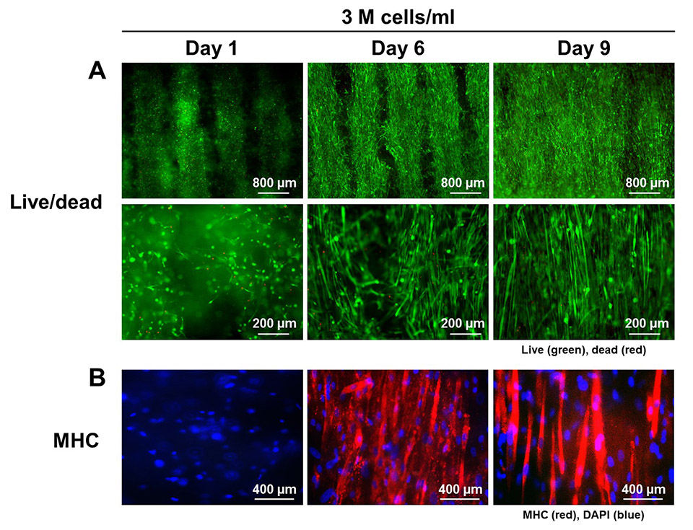

Fig. S1. Cell viability and differentiation of bioprinted muscle constructs. (A) Live/dead staining images of bioprinted muscle constructs with 3 × 10⁶ cells/ml at 1, 6, and 9 days in culture (top: low magnification, bottom: high magnification). The live/dead staining indicates high cell viability (green: live cells, red: dead cells). The hMPCs with PCL pillar showed unidirectionally organized cellular morphologies that are gradually aligned along the longitudinal axis of bioprinted construct. (B) MHC immunostaining showed the differentiation of hMPCs and their alignment in bioprinted muscle construct.

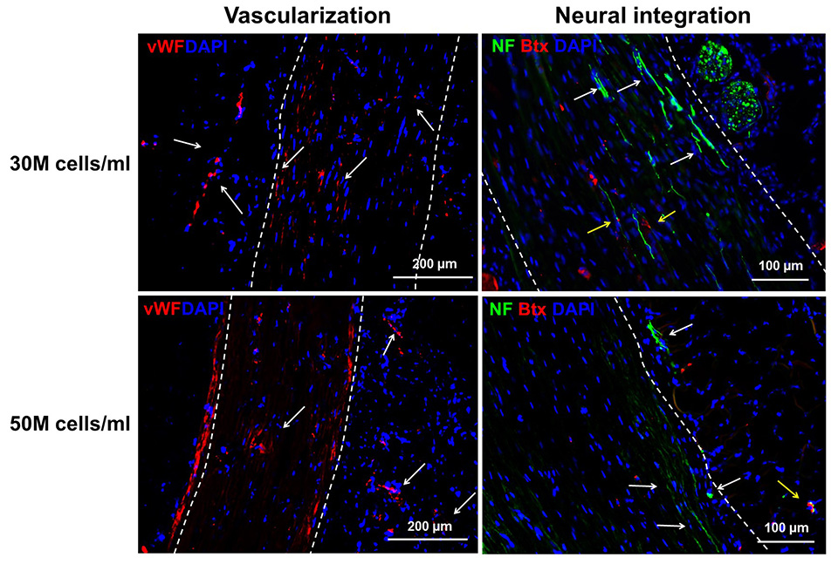

Fig. S2. Vascularization and neural integration of the ectopically implanted bioprinted muscle construct. Immunofluorescence of vWF (red) and NF (green)/α-Btx (Red) indicate vascular (white arrow, vWF+) and neural integration (white arrow, NF+ nerve; yellow arrow, NF+/α-Btx+ neuromuscular junction) in bioprinted muscle construct with cell densities of 30 × 10⁶ cells/ml and 50 × 10⁶ cells/ml after 2 weeks of implantation.

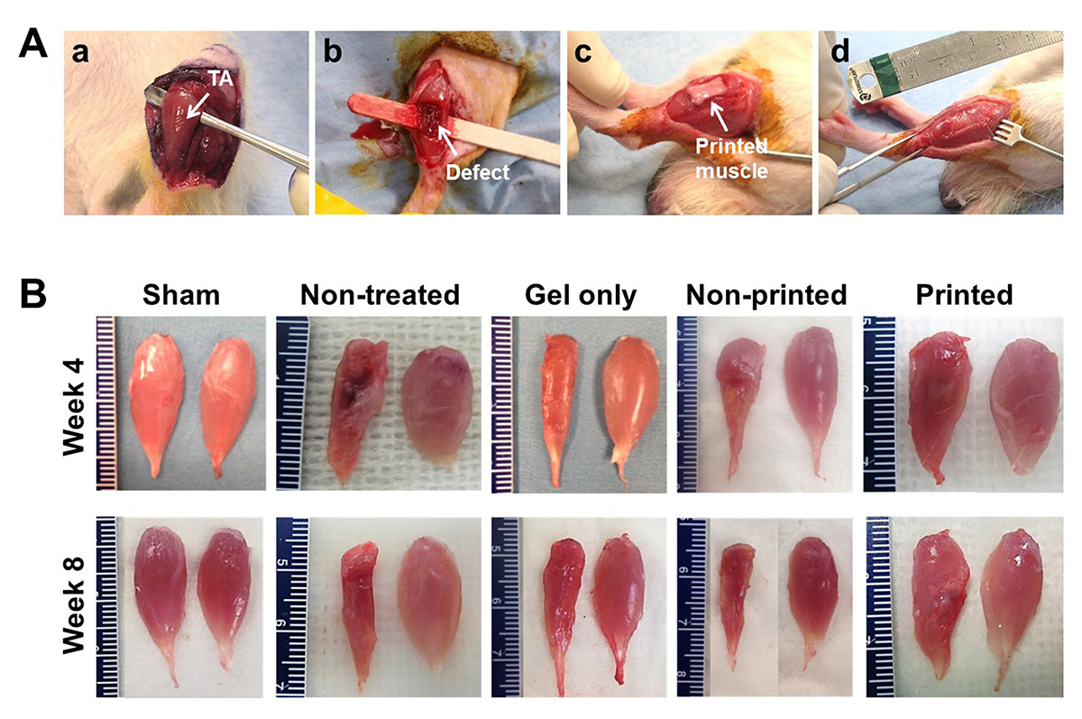

Fig. S3. Rat VML injured model. (A) Surgical procedure of volumetric TA muscle defect and implantation of bioprinted muscle construct; (a) exposure of TA muscle, (b) creation of the VML injury by removing 30 – 40% of TA muscle after ablation of EDL and EHL muscles, (c) implantation of bioprinted construct, and (d) closure using fascia. (B) Gross appearance of TA muscles of left legs (left, defected TA) and right legs (right, contralateral normal TA) at 4 and 8 weeks after implantation.

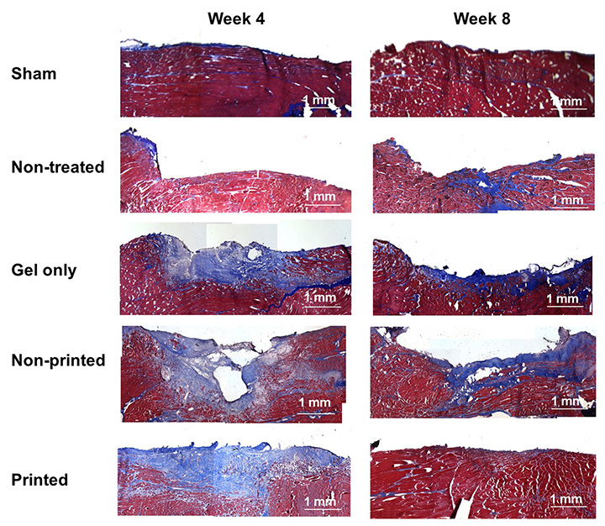

Fig. S4. Masson’s trichrome staining images at 4 and 8 weeks of implantation.

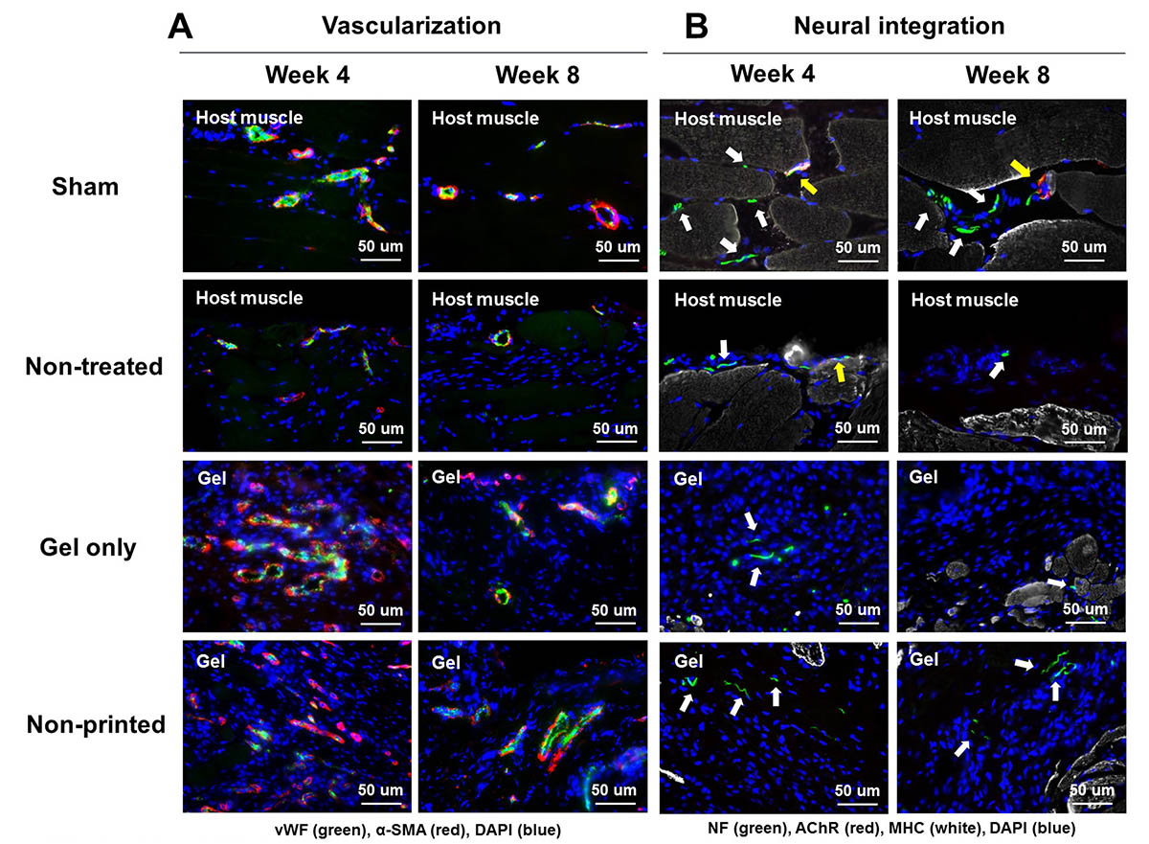

Fig. S5. Immunofluorescence of vascularization and neural integration in the implanted region at 4 and 8 weeks after implantation. Immunofluorescent images of (A) vWF (green)/α-SMA (red) and (B) NF (green)/AChR (red)/MHC (white). White arrow indicates a NF+ neuron and yellow arrow indicates a NF+/AChR+/MHC+ neuromuscular junction.

