Supplementary information for
Phenotype-oriented network analysis for discovering pharmacological effects of natural compounds

Sunyong Yoo^{1,2}, Hojung Nam^{3*} and Doheon Lee^{1,2*}

¹Department of Bio and Brain Engineering, Korea Advanced Institute of Science and Technology (KAIST), Daejeon 34141, Republic of Korea
²Bio-Synergy Research Center, Daejeon 34141, Republic of Korea
³School of Electrical Engineering and Computer Science, Gwangju Institute of Science and Technology (GIST), Gwangju 61005, Republic of Korea

Inventory
Supplementary Figures
Supplementary Tables
Supplementary Figures
Supplementary Figure 1. Comparing known molecular structures and targets between drugs and natural compounds. (a) Comparison of known molecular structure information on drugs and natural compounds. While 87% of drugs (left circle graph) have molecular structure information, only 45% of natural compounds (right circle graph) have molecular structure information. (b) Comparison of known protein targets between drugs and natural compounds. While 86% of drugs (left circle graph) have protein target information, only 3% of natural compounds (right circle graph) have protein target information.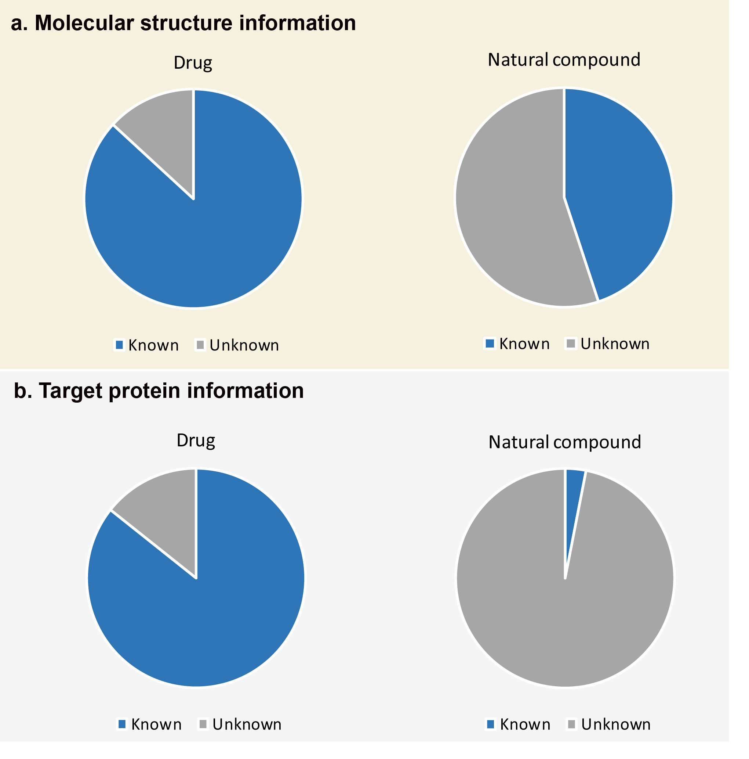

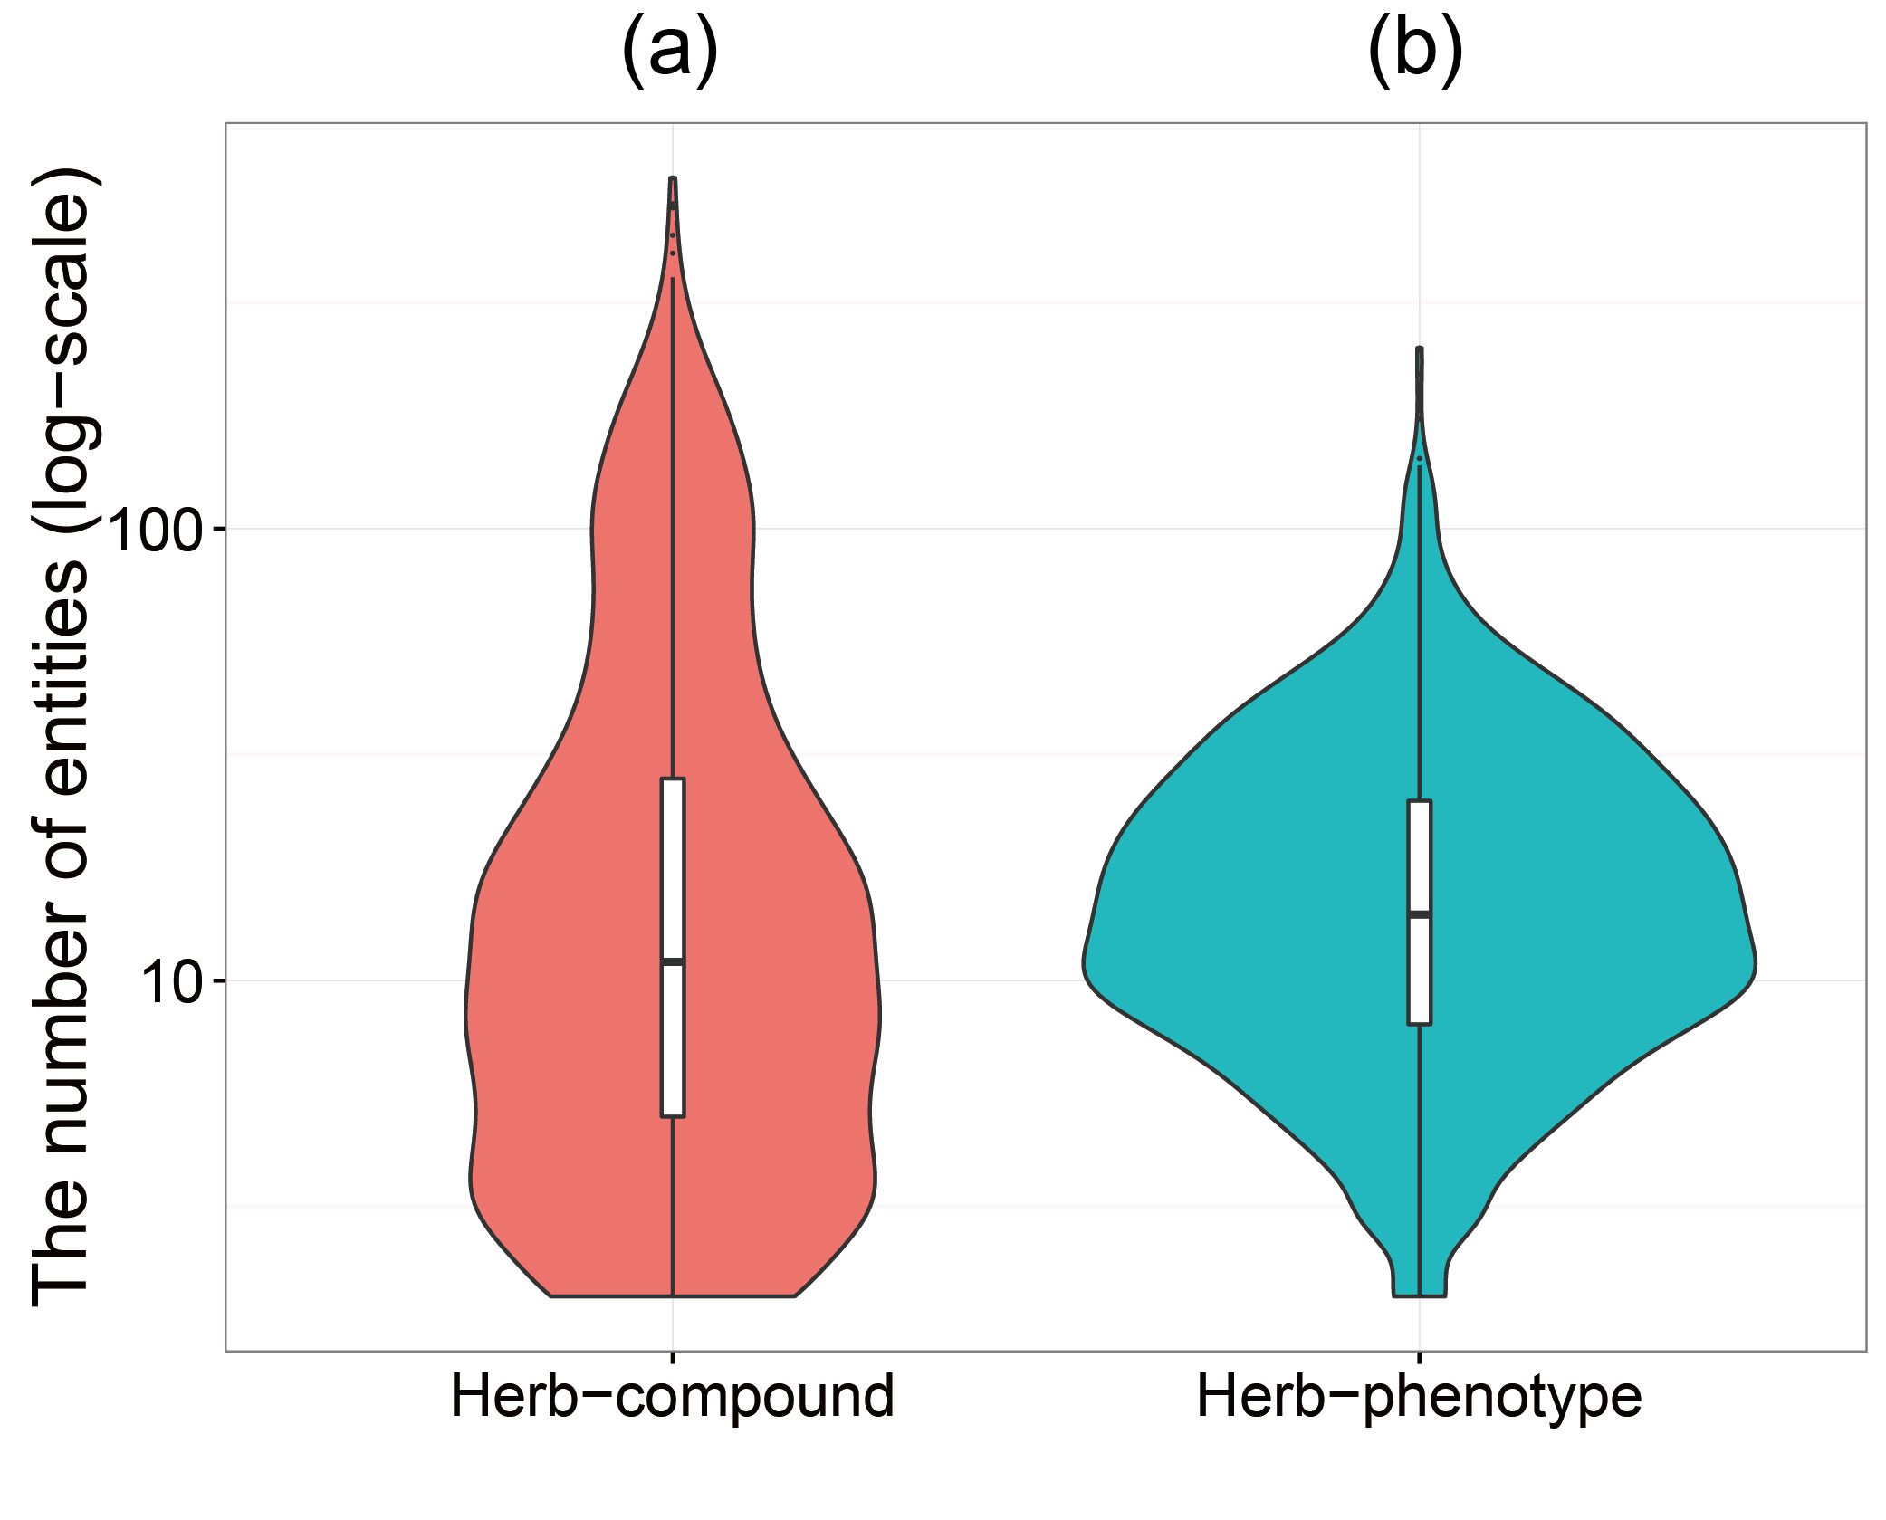
Supplementary Figure 2. Distribution of the number of compounds contained in herbs and the phenotypes associated with herbs. (a) Distribution of the number of compounds per herb. The mean number of compounds per herb is 19.9. (b) Distribution of the number of phenotypes per herb. The mean number of phenotypes per herb is 31.8.

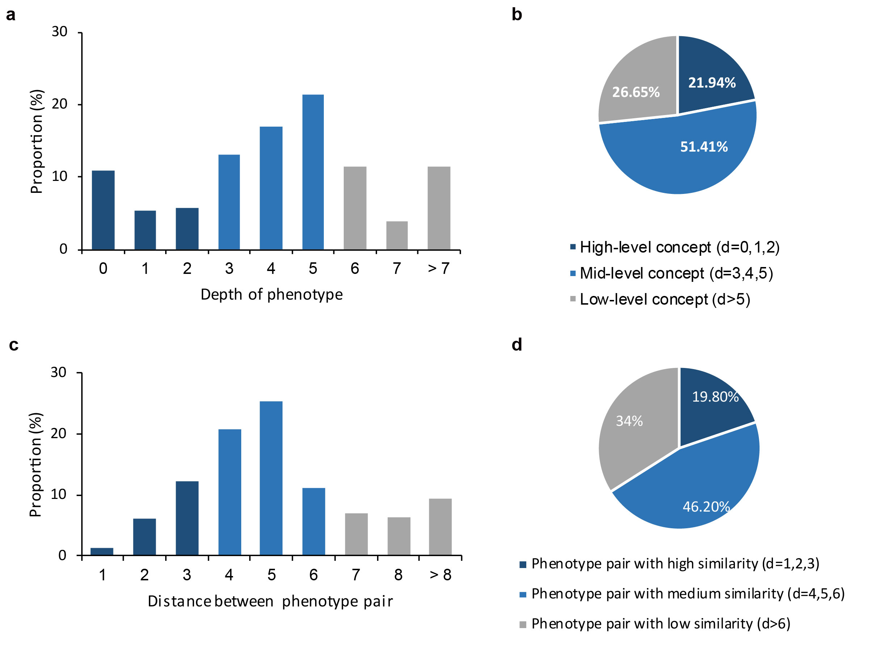
Supplementary Figure 3. Characteristics of herbal medicine. (a) Histogram of the proportion of phenotypes by depth. Known phenotypes of each herb were mapped to the phenotypic network, and the phenotype depth was found by calculating the distance from the root to the phenotype. The average proportion was calculated based on the herb. (b) The proportion of phenotypes for high-level, mid-level and low-level concepts. (c) Histogram of the proportion of the distance of a phenotype pair. (d) The proportions of phenotype pairs for high, medium and low similarity.

Supplementary Tables
Supplementary Table 1. The relationship between ROC and PR performance according to p-value threshold.
p-value | Therapeutic effects |  | Potential candidate effects
p-value | ROC | PR | ROC | PR
0.1 | 0.648±0.058 | 0.607±0.043 | 0.679±0.045 | 0.624±0.044
0.01 | 0.691±0.071 | 0.622±0.055 | 0.717±0.058 | 0.643±0.054
0.001 | 0.725±0.085 | 0.649±0.080 | 0.754±0.077 | 0.685±0.071

