Supplementary Information
A Recombinant Newcastle Disease Virus (NDV) Expressing S Protein of Infectious Bronchitis Virus (IBV) Protects Chickens against IBV and NDV.

Edris Shirvani, Anandan Paldurai, Vinoth K. Manoharan, Berin P. Varghese and Siba K. Samal

Virginia-Maryland College of Veterinary Medicine, University of Maryland, College Park, MD, USA.
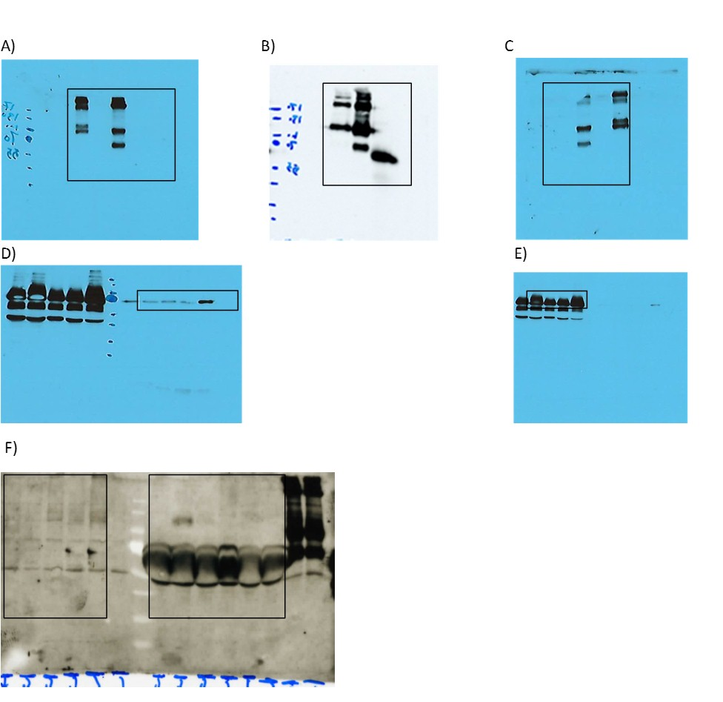
Supplementary figure S1: Full length gels of cropped versions of gels which were shown in the main text (A-F). A, B, C, D, E and F represent gels in fig. 2A- upper panel, fig. 2B, fig. 2C-upper panel, fig. 2A lower panel, fig. 2C lower panel and fig.3, respectively. The cropped bands are shown with black boxes.

