Evolutionary, structural and expression analysis of core genes involved in starch synthesis
Jianzhou Qu,^{1,2} Shutu Xu,^{1,2} Zhengquan Zhang,^{1,2} Guangzhou Chen,^{1,2} Yuyue Zhong,^{1,2} Linsan Liu,^{1,2} Renhe Zhang,^{1,2} Jiquan Xue,^{1,2,*} Dongwei Guo,^{1,2,*}
¹The key Laboratory of Biology and Genetics Improvement of Maize in Arid Area of Northwest Region, Ministry of Agriculture, College of Agronomy, Northwest A&F University, Yangling 712100, Shaanxi, China;
²Maize Engineering Technology Research Centre of Shaanxi Province, Yangling 712100, Shaanxi, China
* Corresponding author: xjq2934@163.com (J.Q.X.); gdwei1973@126.com (D.W.G)
List of Supplementary Information
Supplementary Table 1 Protein sequence information for 74 plant species.
Supplementary Table 2 Gene expression levels of core genes involved in starch synthesis.
Supplementary Fig. 1 Phylogenetic tree of AGPases.
Supplementary Fig. 2 Motif logo of AGPase subunits.
Supplementary Fig. 3 Three-dimensional modelled structures of AGPase subunits in maize.
Supplementary Fig. 4 Active sites of AGPase subunits.
Supplementary Fig. 5 Phylogenetic tree of SSs.
Supplementary Fig. 6 Cartoon representing the secondary structural organization of SS isoforms.
Supplementary Fig. 7 Motif logo of SS isoforms.
Supplementary Fig. 8 Protein sequence alignment of maize SS isoforms, barley SSI and Escherichia coli glycogen synthase.
Supplementary Fig. 9 Protein sequence alignment of maize GBSS isoforms, rice GBSSI, A. tumefaciens glycogen synthase and Escherichia coli glycogen synthase.
Supplementary Fig. 10 Phylogenetic tree of SBEs.
Supplementary Fig. 11 Three-dimensional modelled structures of SBE isoforms.
Supplementary Fig. 12 Motif logo of SBE isoforms.
Supplementary Fig. 13 Active site alignment of maize SBE isoforms, rice BEI and Escherichia coli glycogen branching enzyme.
Supplementary Fig. 14 Phylogenetic tree of DBEs.
Supplementary Fig. 15 Cartoon representing the secondary structural organizations of DBE isoforms.
Supplementary Fig. 16 Motif logo of DBE isoforms.
Supplementary Fig. 17 Active site alignment of maize DBE isoforms, Chlamydomonas ISA1, PUL of K. pneumoniae and Barley.
Supplementary Fig. 18 Expression patterns of starch synthesis-related genes in endosperm.

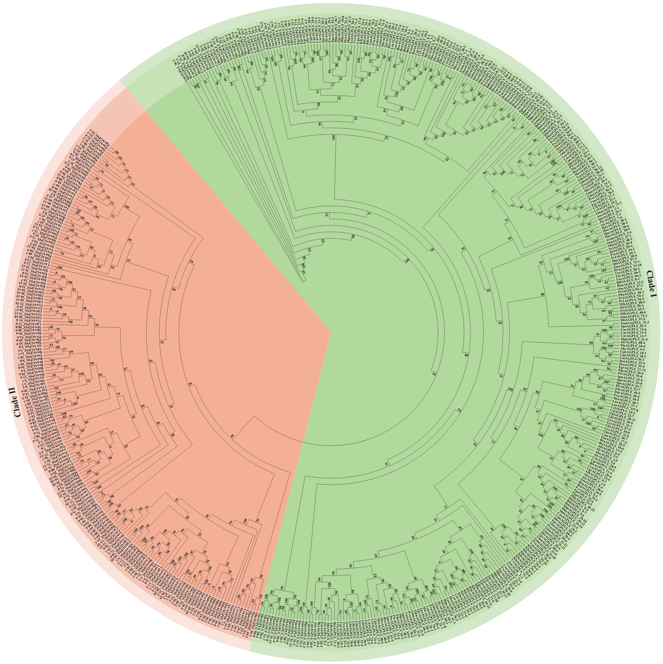Supplementary Fig. 1 Phylogenetic tree of AGPases. The protein sequences of AGPase in 73 plant species were divided into two clades, represented as AGPLS and AGPSS.

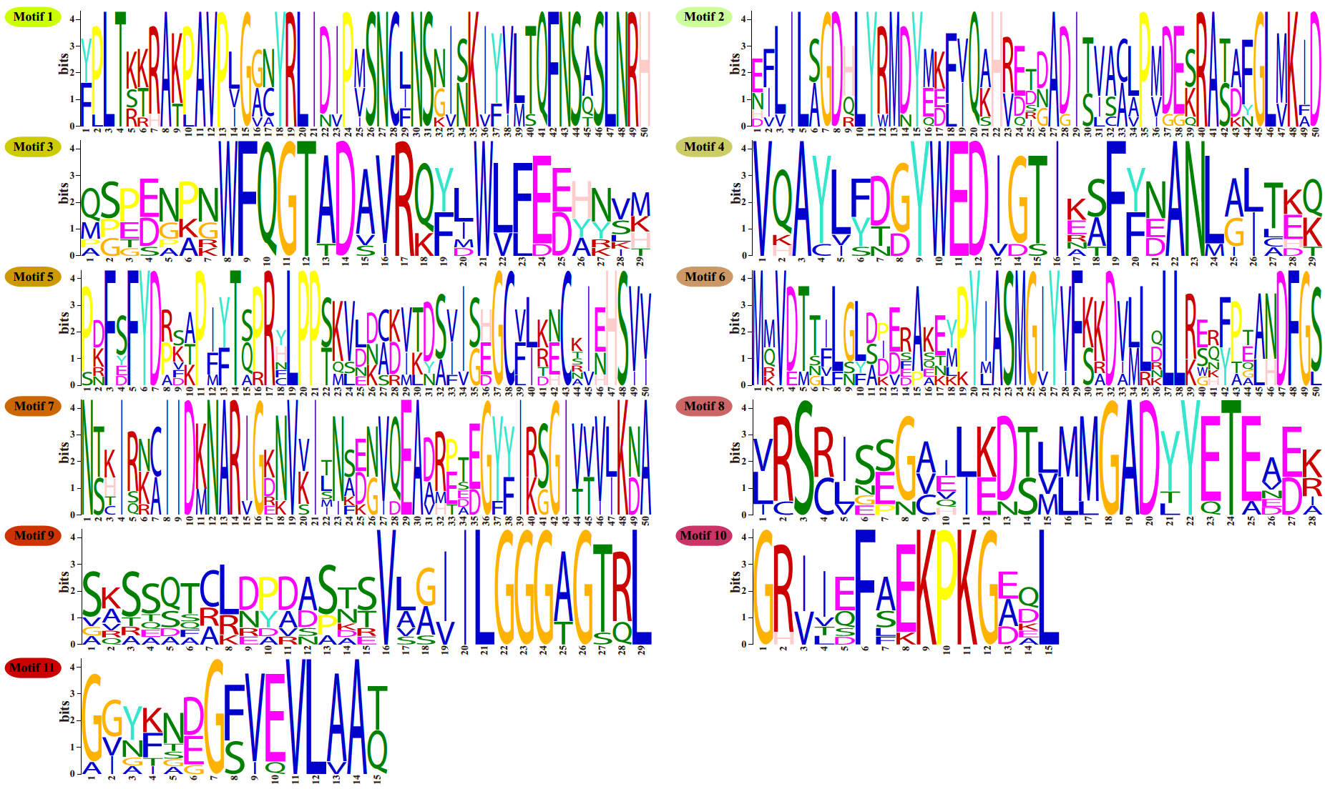Supplementary Fig. 2 Motif logo of AGPase subunits.
Supplementary Fig. 3 Three-dimensional modelled structures of AGPase subunits in maize. Α, B, C, D, E, F, G and H show the crystal structures of AGPLS1-4 and AGPSS1-4, respectively. In the cartoon structure of these AGPase subunits, an α-helix is coloured red, and a β-fold is coloured yellow.
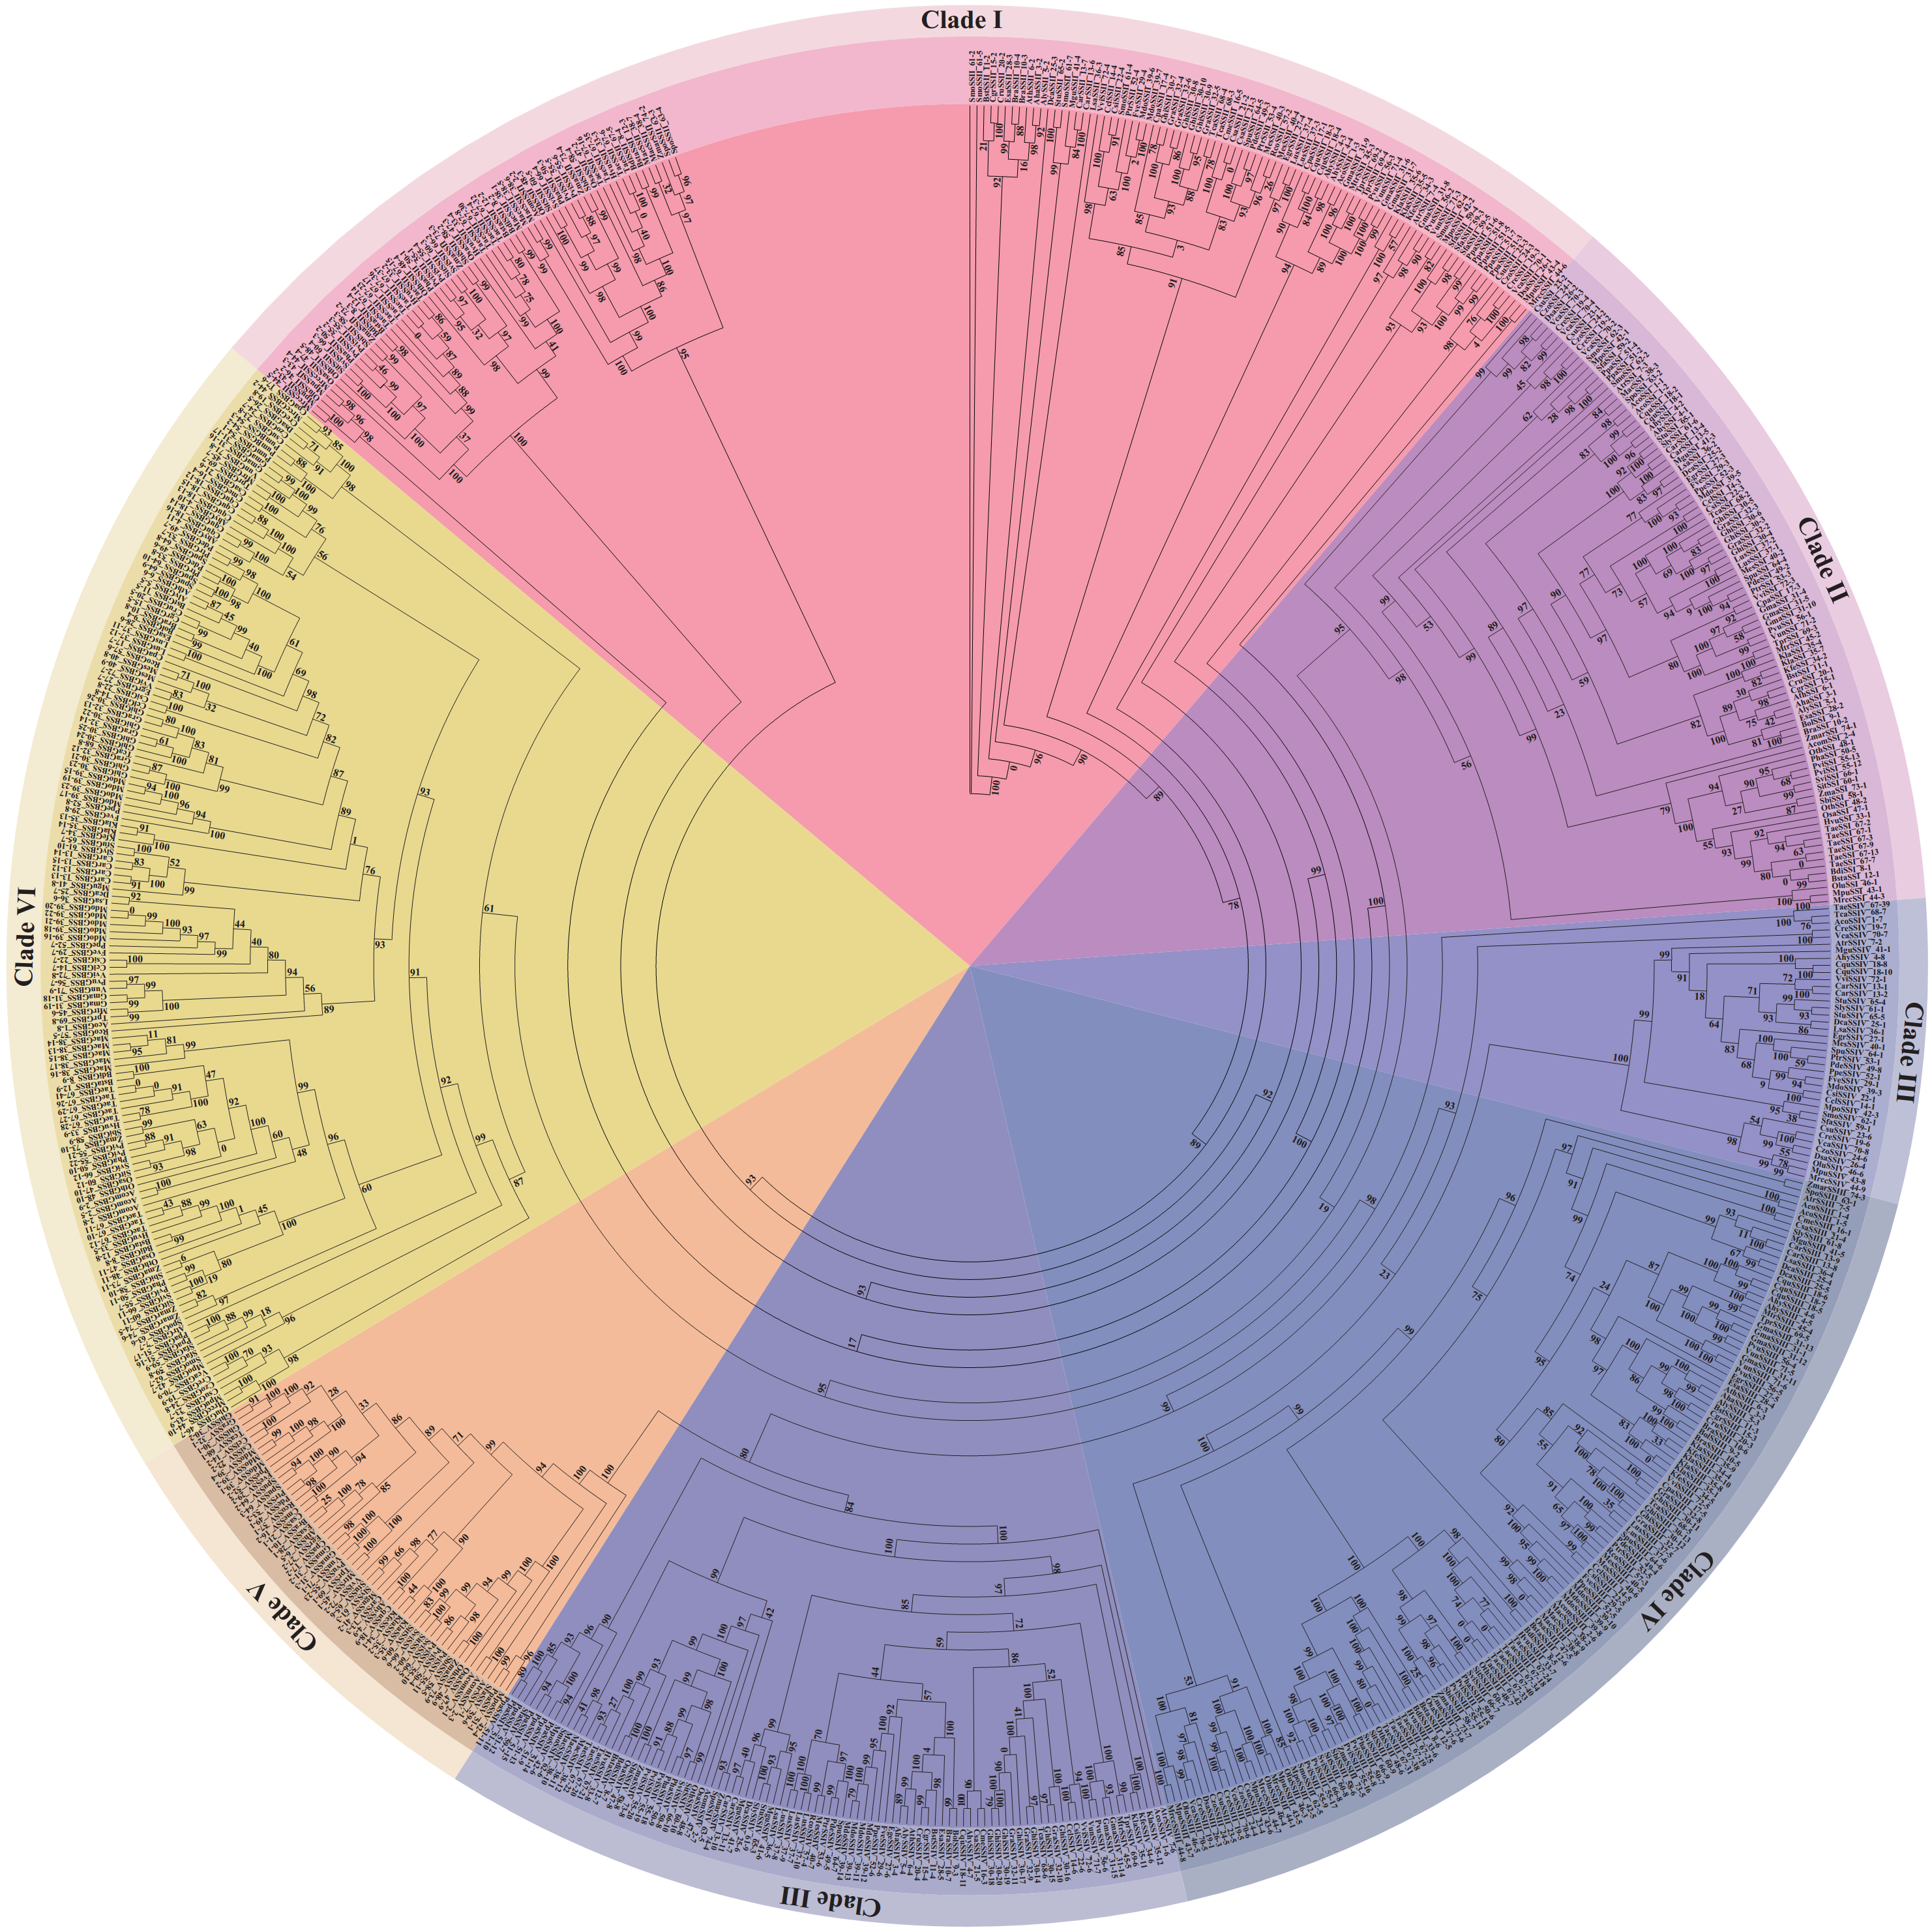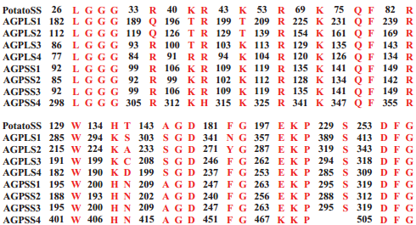Supplementary Fig. 4 Active sites of AGPase subunits. Red indicates amino acid residues that represent active sites in AGPase subunits.
Supplementary Fig. 5 Phylogenetic tree of SSs. The protein sequences of SS in 74 plant species were divided into six clades. Clade I, clade II, clade III, clade IV, clade V and clade VI represent SSII, SSI, SSIV, SSIII, SSV and GBSS, respectively.
Supplementary Fig. 6 Cartoon representing the secondary structural organization of SS isoforms. Α-K show the overall structures of SSI, SSIIa, SSIIb, SSIIc, SSIIIa, SSIIIb-a, SSIIIb-b, SSIV, SSV, GBSSI and GBSSIIa, respectively. Meanwhile, α-helixes are coloured red, and β-folds are coloured yellow.

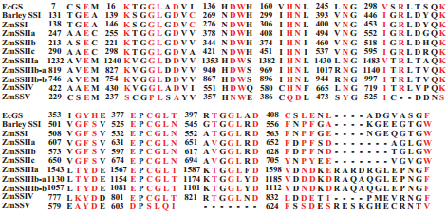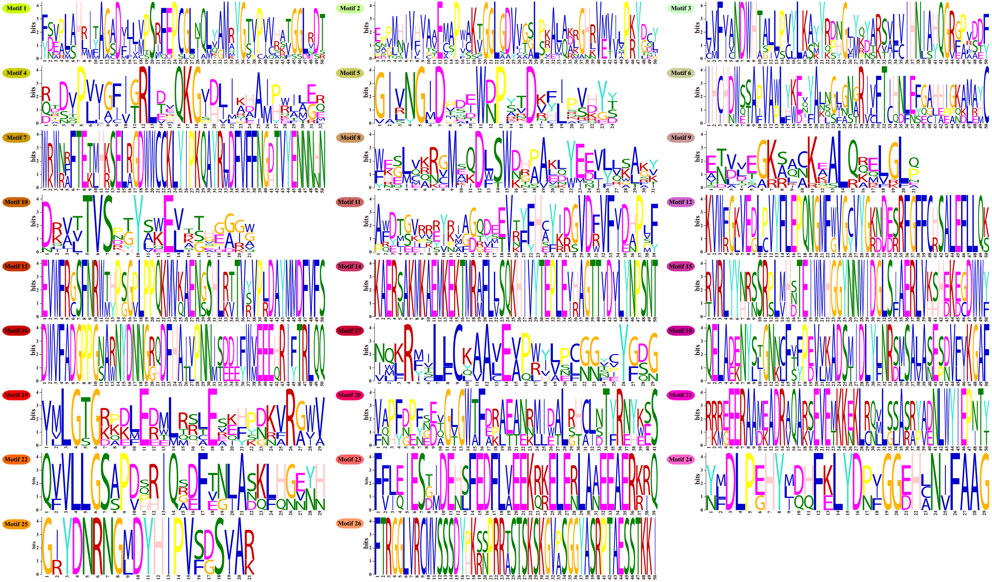Supplementary Fig. 7 Motif logo of SS isoforms.
Supplementary Fig. 8 Protein sequence alignment of maize SS isoforms, barley SSI and Escherichia coli glycogen synthase. Red indicates amino acid residues that represent active sites in maize AGPase isoforms.

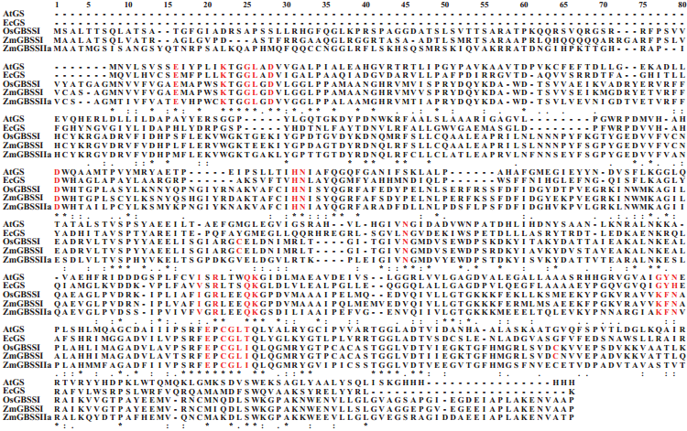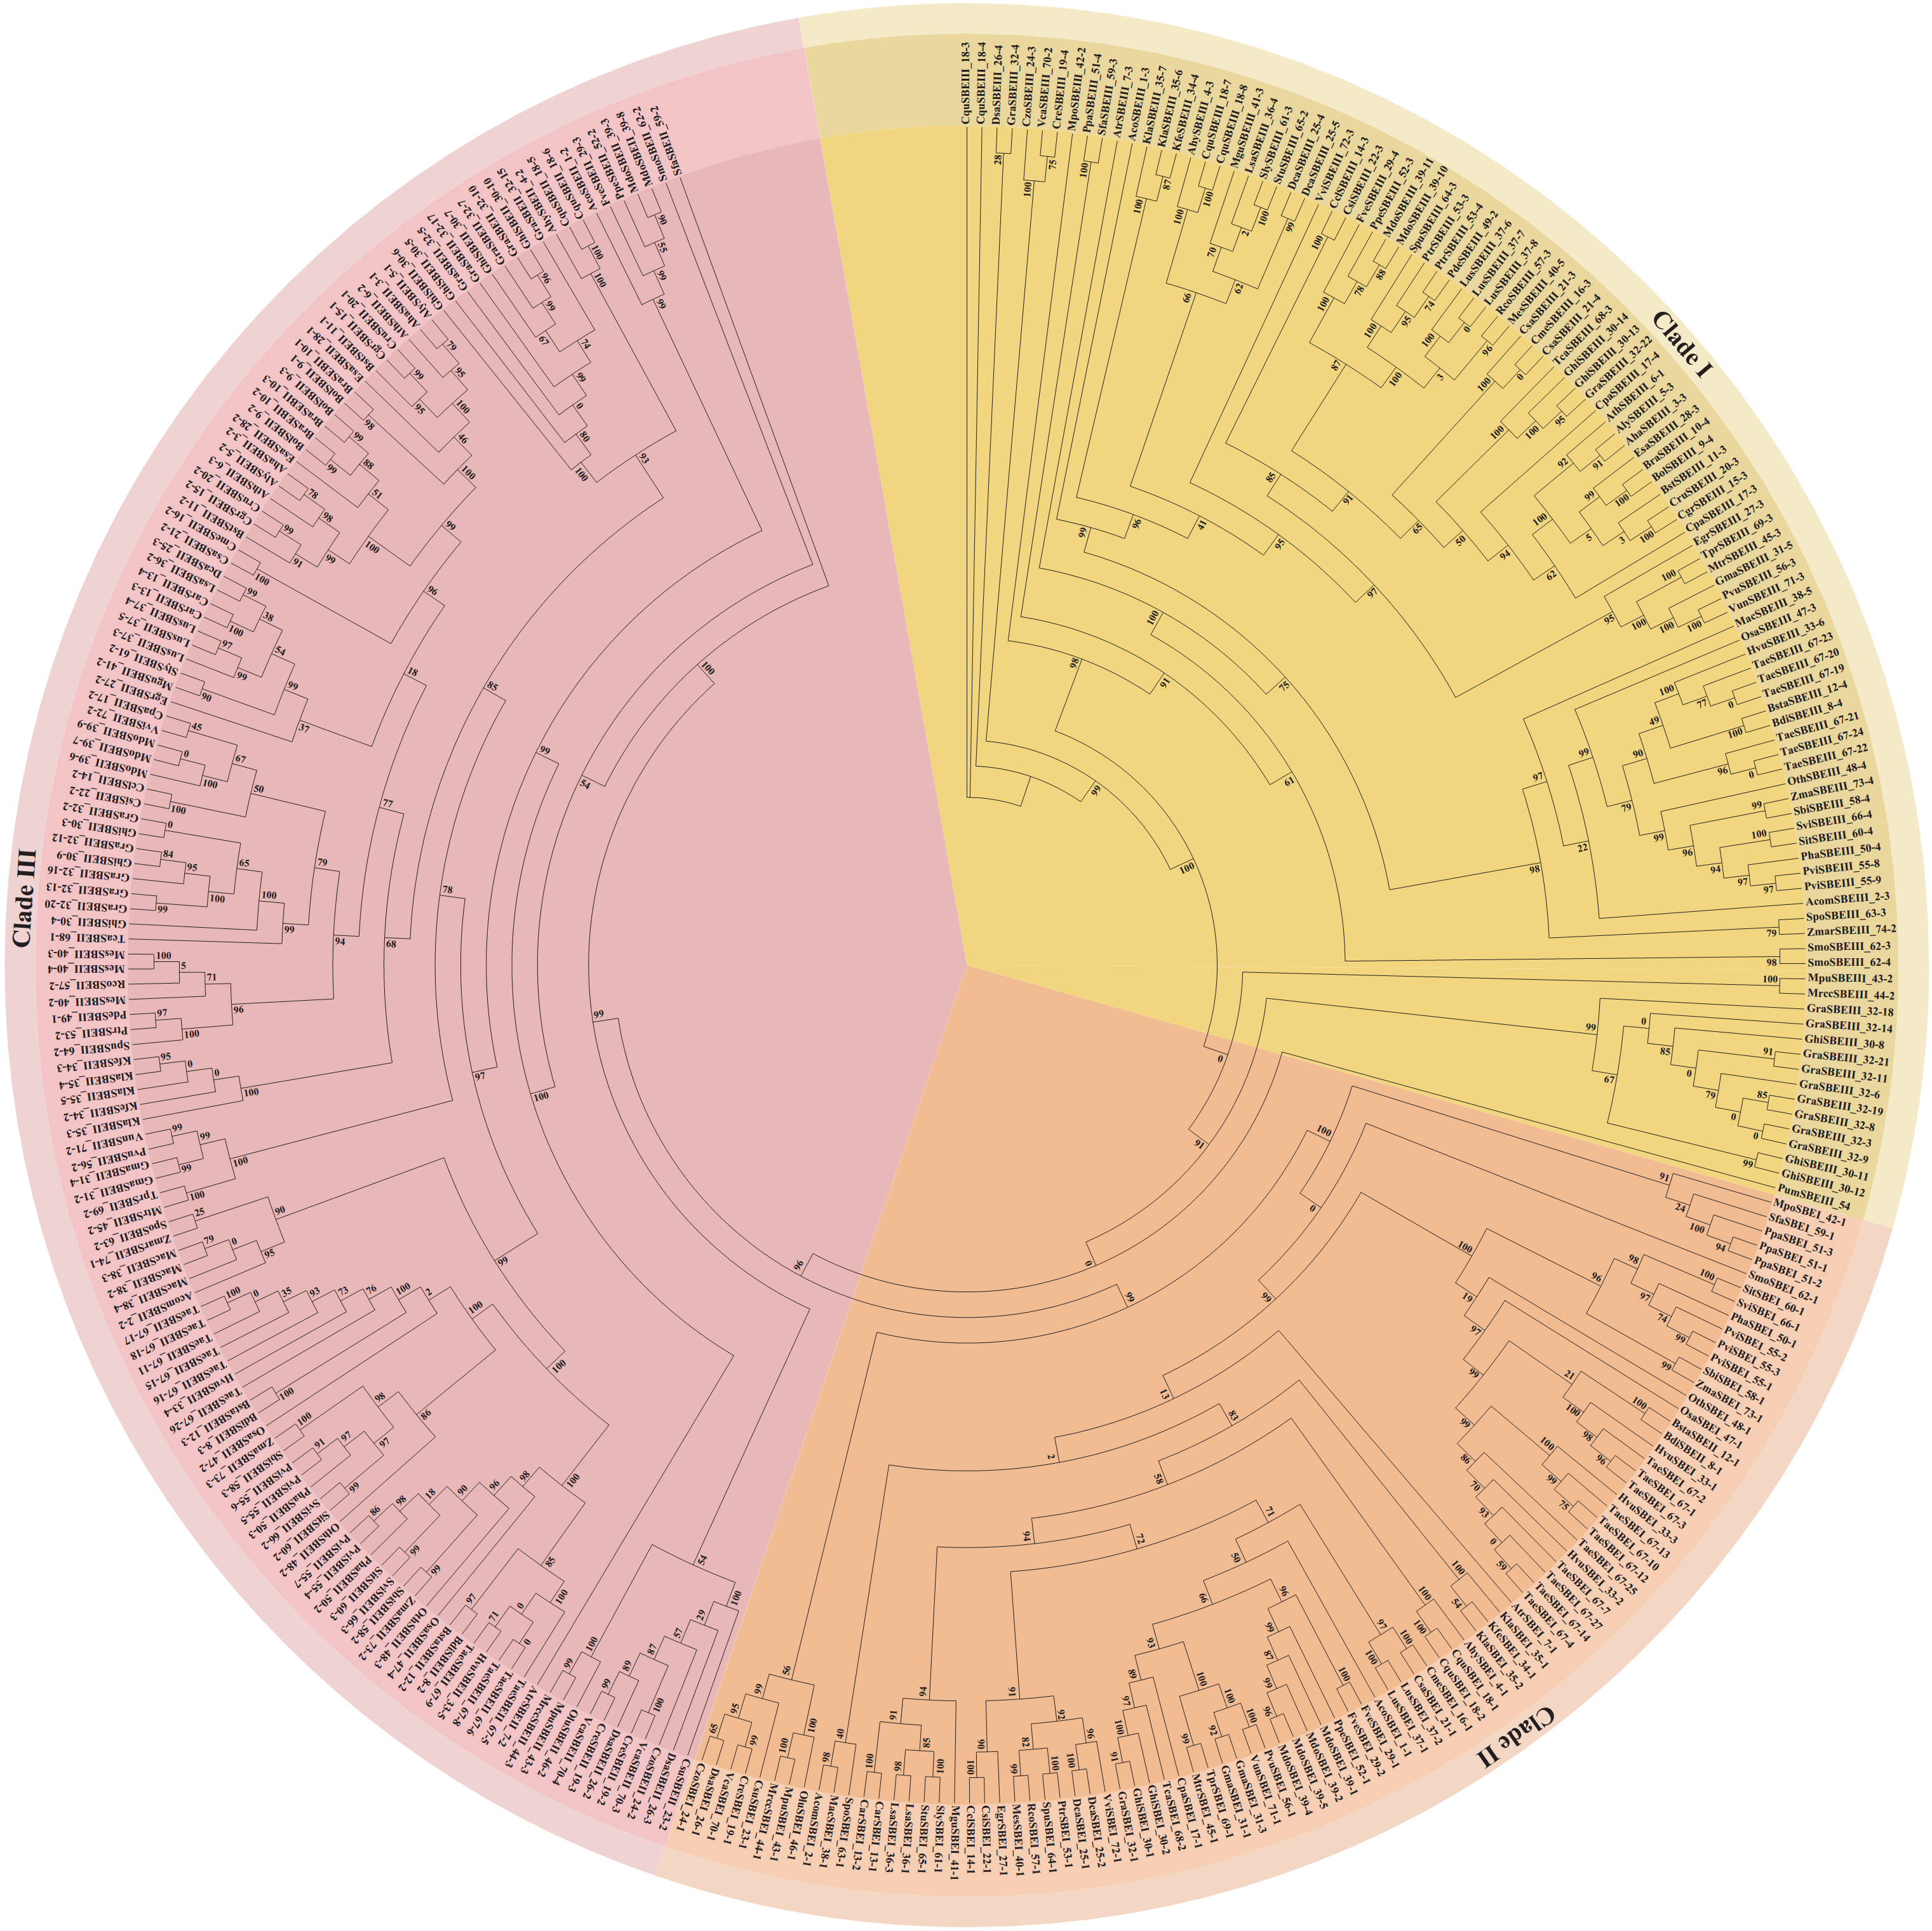Supplementary Fig. 9 Protein sequence alignment of maize GBSS isoforms, rice GBSSI, A. tumefaciens glycogen synthase and Escherichia coli glycogen synthase. Red indicates amino acid residues that represent active sites in maize GBSS isoforms.
Supplementary Fig. 10 Phylogenetic tree of SBEs. The protein sequences of SBE in 74 plant species were divided into three clades. Clade I, clade II and clade III represent SBEI, SBEII and SBEIII, respectively.
Supplementary Fig. 11 Three-dimensional modelled structures of SBE isoforms.
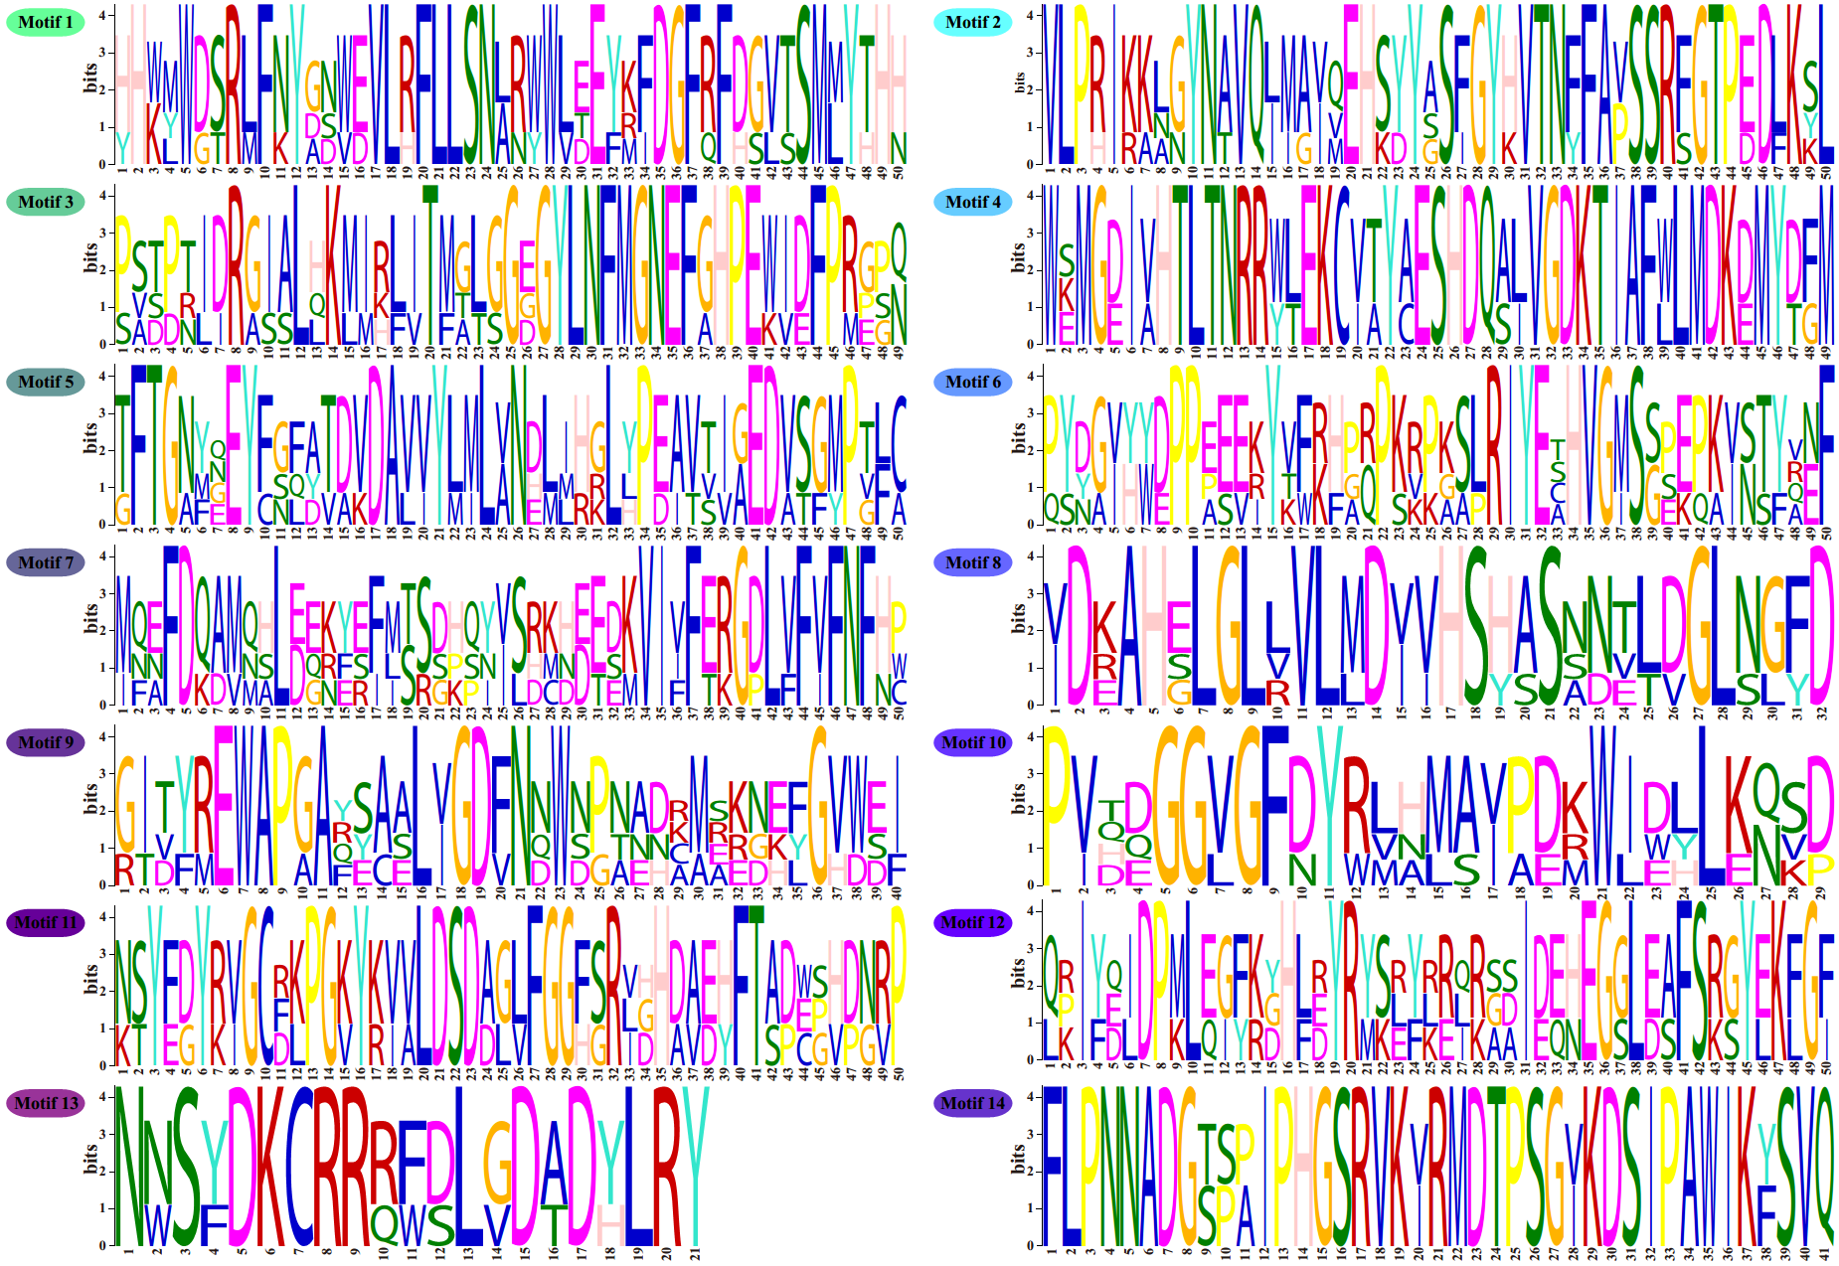A-D show the secondary structures of SBEI, SBEIIa, SBEIIb and SBEIII, respectively. Additionally, α-helixes are coloured red, and β-folds are coloured yellow.
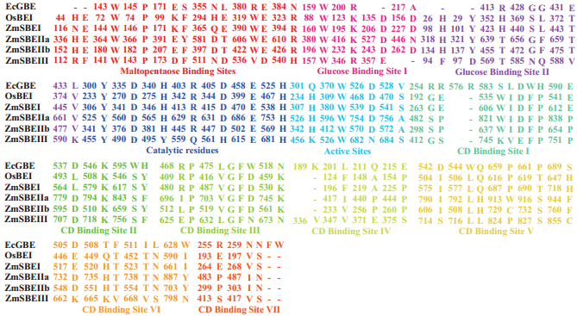Supplementary Fig. 12 Motif logo of SBE isoforms.
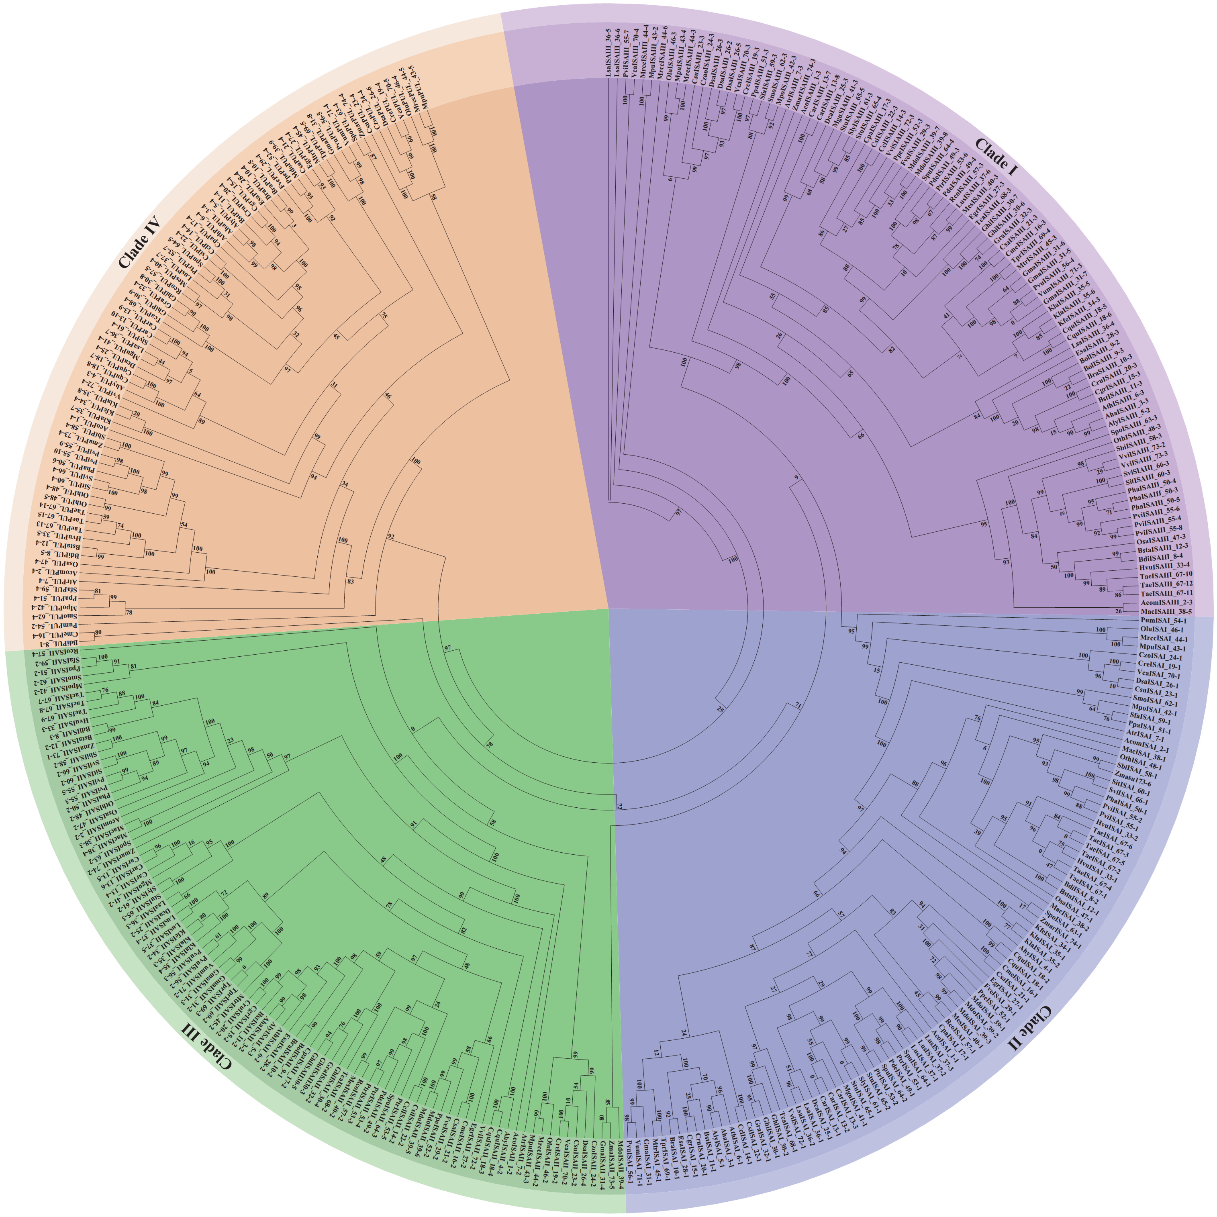Supplementary Fig. 13 Active site alignment of maize SBE isoforms, rice BEI and Escherichia coli glycogen branching enzyme. Amino acid residues shown in different colours represent different active sites.
Supplementary Fig. 14 Phylogenetic tree of DBEs. Protein sequences of DBE in 74 plant species were divided into four clades. Clade I, clade II, clade III and clade IV represent ISAIII, ISAI, ISAII and PUL, respectively.
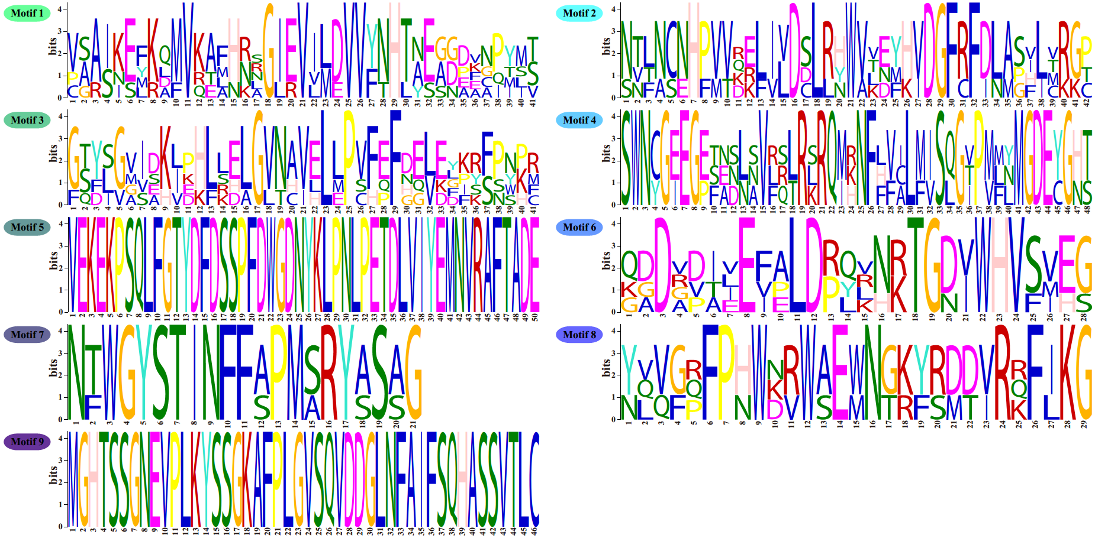Supplementary Fig. 15 Cartoon representing the secondary structural organizations of DBE isoforms. Α-E represent the overall structure of su1, ISAII, ISAIIIb, ISAIIIa and PUL, respectively. α-helixes are coloured red, and β-folds are coloured yellow.
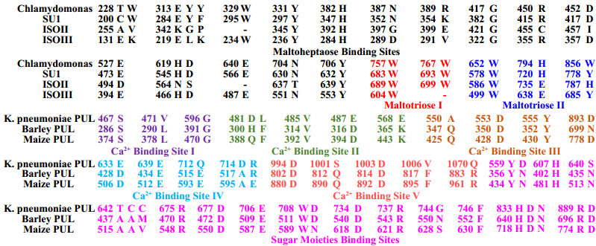Supplementary Fig. 16 Motif logo of DBE isoforms.
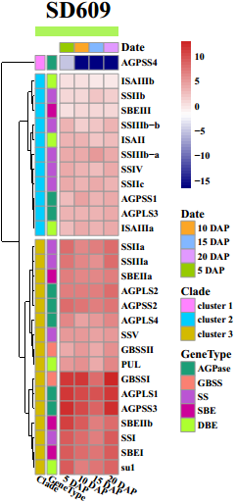Supplementary Fig. 17 Active site alignment of maize DBE isoforms, Chlamydomonas ISA1, PUL of K. pneumoniae and Barley. Amino acid residues shown as different colours represent different active sites that interact with maize DBE isoforms.
Supplementary Fig. 18 Expression patterns of starch synthesis-related genes in endosperm. Gene expression data are shown for four development stages of SD609 endosperm. The scale bar shows the normalized FPKM values.

