Computer-Guided Surface Engineering for Enzyme Improvement
Matthew Wilding, Colin Scott and Andrew C. Warden*
Supplementary Materials

PDB IDs:

5KQT (KES23360), 5KQU (N6), 5KQW (N15), 5KR3 (N16), 5KR4 (N17), 5KR5 (N43), 5KR6 (N48)

Figure S1: Alignment of the seven proteins. Master alignment attached separately in FASTA format.
Alignment performed in CLUSTAL O (v. 1.2.1).

KES23360 MTDYAKLFEQDRAHFMHPSTHAHDHASGALPGRIITGASGVRIRDHQGRELLDAFAGLYC
N6 MTDFDQLFEQDRAHFMHPSTHAHDHASGALPGRIITGASGIRIRDHEGRELIDAFAGLYC
N15 MTDLDQLFEMDRAHFMHPSTHAHDHASGALPGRIITGGKGIRIQDHEGREYIDAFAGLYC
N48 MTDTDDLLEMDRAHFFHPSTHLRDHASGELPGRIITGGKGIRIQDSEGREYIDAFAGLYC
N16 MQSLDQLFEMDRAHFMHPSTHAHDHASGALPGRIITGGKGIRIEDHEGREYIDAFAGLYC
N17 MTSLDQLFEEDRAHFMHPSTHAHDHASGALPGKIVTGGKGIRIEDHQGREYIDAFAGLYC
N43 MTSLEQLLEMDRAHFMHPSTHAYDHASGALPGRIITGGKGIRIEDHEGREYIDAFAGLYC
* . .*:* *****:***** ***** ***:*:**..*:**.* :*** :********

KES23360 VNIGYGRLEVADAIHEQAKQLAYYHTYVGHASEAIIELSARIIRDWAPAGMKKVYYGLSG
N6 VNIGYGRTEVADAIYKQAKELAYYHTYVGHSTEAIIELSSRIIRDWAPAGMKKVYYGLSG
N15 VNIGYGRTEVADAIYEQAKELAYYHTYVGHSTEAIIELSSRIIRDWAPAGMKKVYYGMSG
N48 VNVGYGRTEIADAIYEQAKELAYYHTYVGHSNEPIIELSERIIREWAPAGMSKVYYGMSG
N16 VNIGYGRTEVADAIYEQAKQLAYYHTYVGHSTDAIIELSSRIIRDWAPAGMKKVYYGMSG
N17 VNIGYGRTEVADAIYEQAKQLAYYHTYVGHSTDAIIELSSRIIRDWAPAGMKKVYYGMSG
N43 VNIGYGREEVADAIYEQAKQLAYYHTYVGHSNDPVIELSSRIIEDWAPAGMKKVFYGMSG
**:**** *:****::***:**********:.: :**** ***.:******.**:**:**

KES23360 SDANETQVKLVRYYNNVLGRPQKKKIISRQRGYHGSGIVTGSLTGLASFHQHFDLPVEGV
N6 SDANETQIKLVRYYNNVLGRPQKKKIISRQRGYHGSGIMTGSLTGLPSFHQHFDLPVEGI
N15 SDANETQIKLVWYYNNVLGRPQKKKIISRQRGYHGSGIMTGSLTGLPSFHQHFDLPIERI
N48 SDANETQIKLVWYYNNVLGRPQKKKIISRQRGYHGSGIMTGSLTGLPAFHNHFDLPLEPI
N16 SDANETQIKLVWYYNNVLGRPNKKKIISRERGYHGSGIVTGSLTGLPSFHQHFDLPIDRV
N17 SDANETQIKIVWYYNNVLGRPNKKKIISRERGYHGSGIVTGSLTGLPSFHQHFDLPIDRV
N43 SDANETQIKLVWYYNNVLGRPNKKKIIARERSYHGSGIVTGSLTGLPSFHQHFDLPIDRV
*******:*:* *********:*****:*:*.******:******* :**:*****:: :

KES23360 KHTLCPHFYKAPAGMDEAAFVRHCAQELENLILAEGPDTVAAFIGEPVMGTGGIIVPPKG
N6 KHTVCPHWYKAPAGMDEAAFVRYCADELEKLILAEGPDTVAAFIGEPVMGTGGIIVPPKG
N15 KHTVCPHWYKAPAGMSEAQFVRYCADELEKLILAEGPDTVAAFIGEPVMGTGGIIPPPQG
N48 RHTTCPHYYRAPAGMSEAEFSRHCADELEKMILAEGPDTVAAFIGEPVMGTGGIVPPPEG
N16 KHTVCPHWYRAPAGMSEAQFVAYCVEELEKLIAREGADTIAAFIAEPVMGTGGIIPPPQG
N17 KHTVCPHWYKAPAGMSEAQFVAYCVEELEKLIAREGADTIAAFIAEPVMGTGGIIAPPQG
N43 KHTVCPHWYNAPPGMSEAQFVAYCVEELEKLIAREGADTIAAFIAEPVMGTGGIVPPPQG
:** ***:*.** **.** * :*.:***::* ** **:****.*********: **:*

KES23360 YWEAIQAVLAKYDVLLIADEVVCAFGRLGDKMGSQRHAMRPDLITTAKGLTSAYAPLSAV
N6 YWEAIQAVLNKYDVLLIADEVVCAFGRLGSKMGSQRYGMRPDLITTAKGLTSAYAPLSAV
N15 YWEAIQAVLNKYDILLIADEVVCGFGRLGSKMGSQHYGMKPDLITVAKGLTSAYAPLSGV
N48 YWEAIQAVLNKYDILLIADEVVCGFGRTGSMFGSHHYGMKPDLITVAKGLTSAYAPLSGV
N16 YWEAIQAVLRKHDILLIADEVVCGFGRLGSKMGSQHYGIKPDLITVAKGLTSAYAPLSGV
N17 YWEAIQAVLRKHDILLISDEVVCGFGRLGSKMGAQHYGIKPDLITVAKGLTSAYAPLSGV
N43 YWEAIQAVLRKHDILLIADEVVCGFGRLGSKTGSEHYGIKPDLITVAKGLTSAYAPLSAV
********* *:*:***:*****.*** *. *:.::.::*****.************.*

KES23360 IVGEKVWDVIDSASTREGAMGHGWTYSGHPICAAAALANLDILERENITANAADVGGYLN
N6 IVGEKVWDVIEKASQKEGAMGHGWTYSGHPICAAAALANLDILERENLTANAADVGAYLN
N15 IVGEKVWDVIEKGSQEHGPMGHGWTYSGHPICAAAALANLDILERENLTGNAADVGAYLQ
N48 IVGEKVWKVLEQGSDQYGPIGHGWTYSGHPICAAAALANLDIIERENLTGNAADTGAYFQ
N16 IVGEKVWDVIEKGSQEHGPMGHGWTYSGHPICAAAALANLDILERENLTGNAADVGAYLQ
N17 IVGEKVWDVIEKGSQEHGPMGHGWTYSGHPICAAAALANLDILERENLTGNAADVGAYLQ
N43 IVSEKVWDVIEKGSREHGVMGHGWTYSGHPVCAAAALANLDILERENLTGNAADVGAYLQ
**.****.*::..* . * :**********:***********:****:*.****.*.*::

KES23360 QQLRQAFEGHPLVGEVRGDGMLAALEFMADREARTPFDAALKVGPKVSAACLERGMIARA
N6 QRLRETFEGHPLVGEVRGDGMLAALEFMADREARTPFDPALKVGPKVSAACLEDGMIARA
N15 QRLRETFGGHPLVGEVRGVGMLAALEFMADKDARTPFDPALKVGPKVSAACLEDGMIARA
N48 QRMRETFGDHPLVGEVRGVGLMAALEFVADKDKRTRFDPSLKVGPRVSAACLEDGMIARA
N16 QRLHEAFGAHPLVGEVRGVGMLAALEFMADKDARTPFDPALKVGPKVSAAALEDGMIARA
N17 QRLHEAFGAHPLVGEVRGVGMLAALEFMADKDARTPFDPALKVGPKVSAAALEDGVIARA
N43 QRLHEAFGAHPLVGEVRGVGMLAALEFMADKGARTPFDPALKVSQKVAAAALEDGLIVRA
*:::::* ********* *::*****:**: ** ** :***. :*:**.** *:*.**

KES23360 MPHGDILGFAPPLVLSRAEADEVVGIAKAAVDAVAAEVL
N6 MPHGDILGFAPPLVLTRAEADEIVGIAKAAVDEVAGEVL
N15 MPHGDILGFAPPLVITRAEVDEIVGIAKQAVDEVADEVL
N48 MPHGDILGFAPPLVITRAEVDEIVDIAKQAVDAVADELV
N16 MPHGDILGFAPPLVTTRAEVDEIVGIAKQAVDEVADEVL
N17 MPHGDILGFAPPLVTTRAEVDEIVGIVKQAVDEVADEVL
N43 LPHGDILGFAPPLVTTRAEVDEIVAIAKEAFDEVADAVL
:************* :***.**:* *.* *.* ** ::

Figure S2: Sequential clustering of one AHA trajectory with KES23360. This 10,000 frame trajectory with an initial total of 200,000 AHA molecules was subjected to ten sequential clustering iterations until a single centroid remained. Each output pdb contains centroids of one colour and the images are overlayed to illustrate convergence between points.

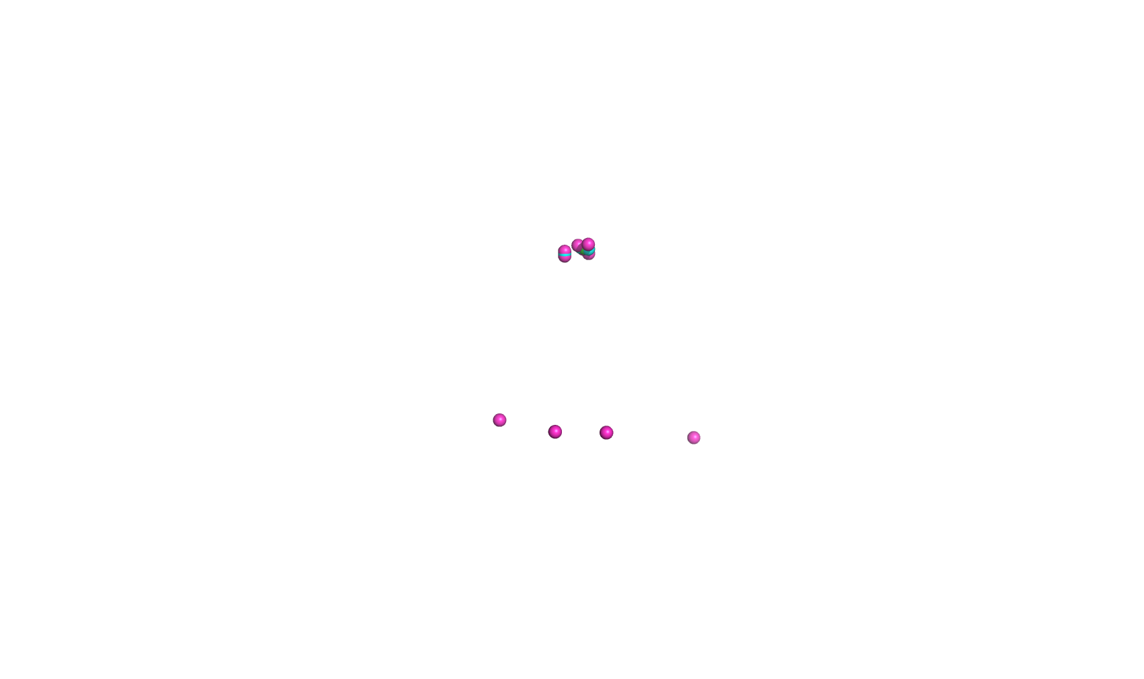
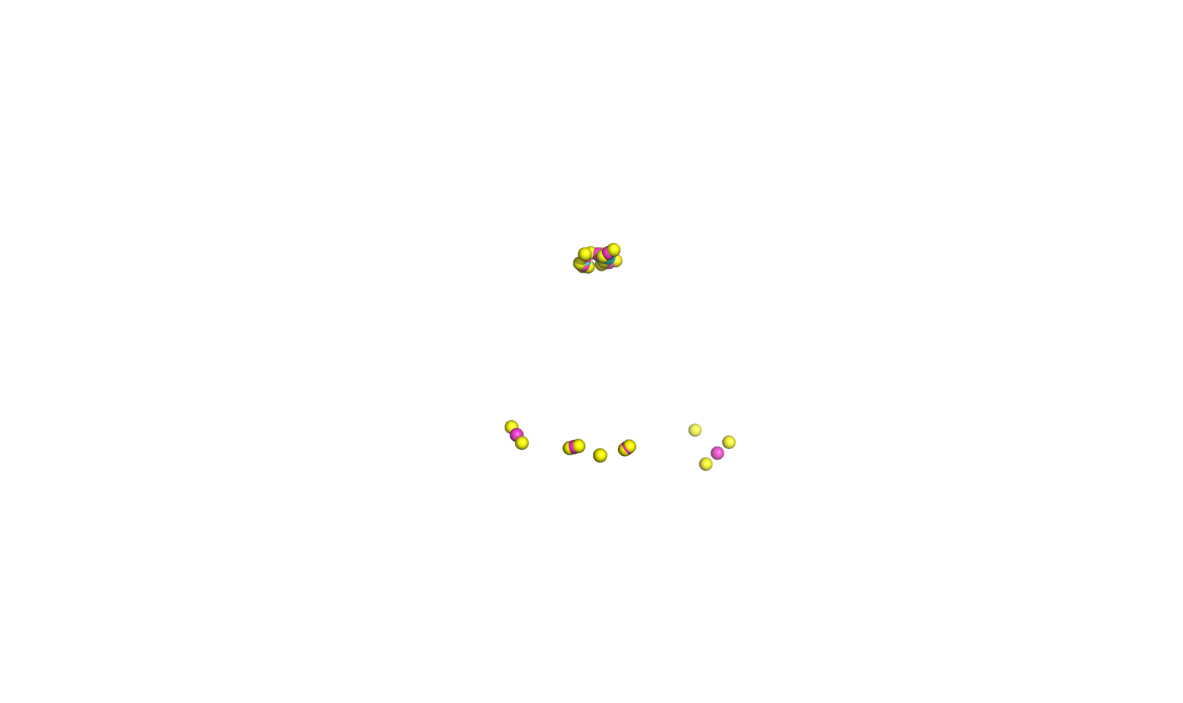
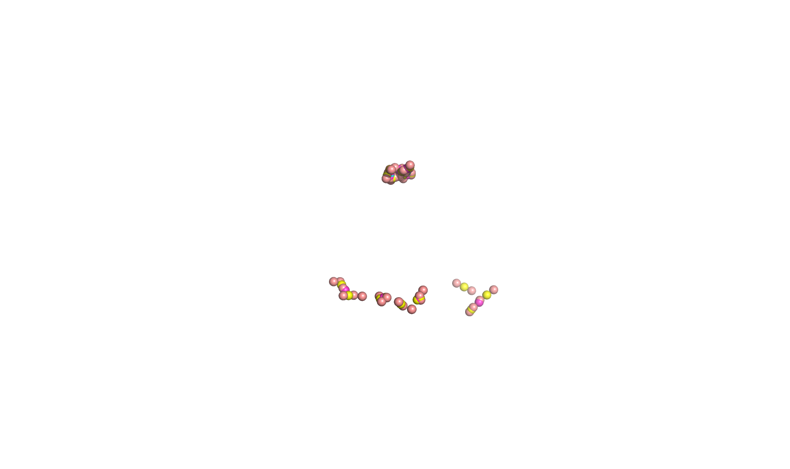
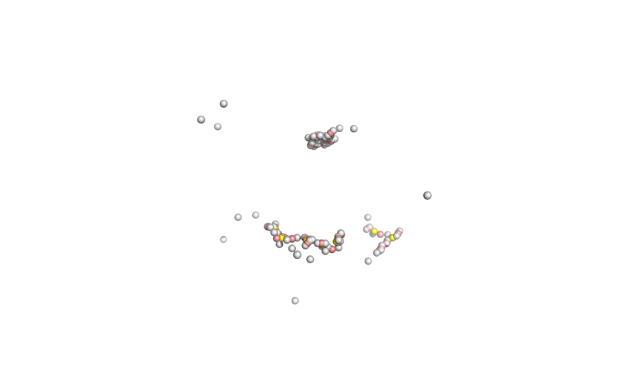
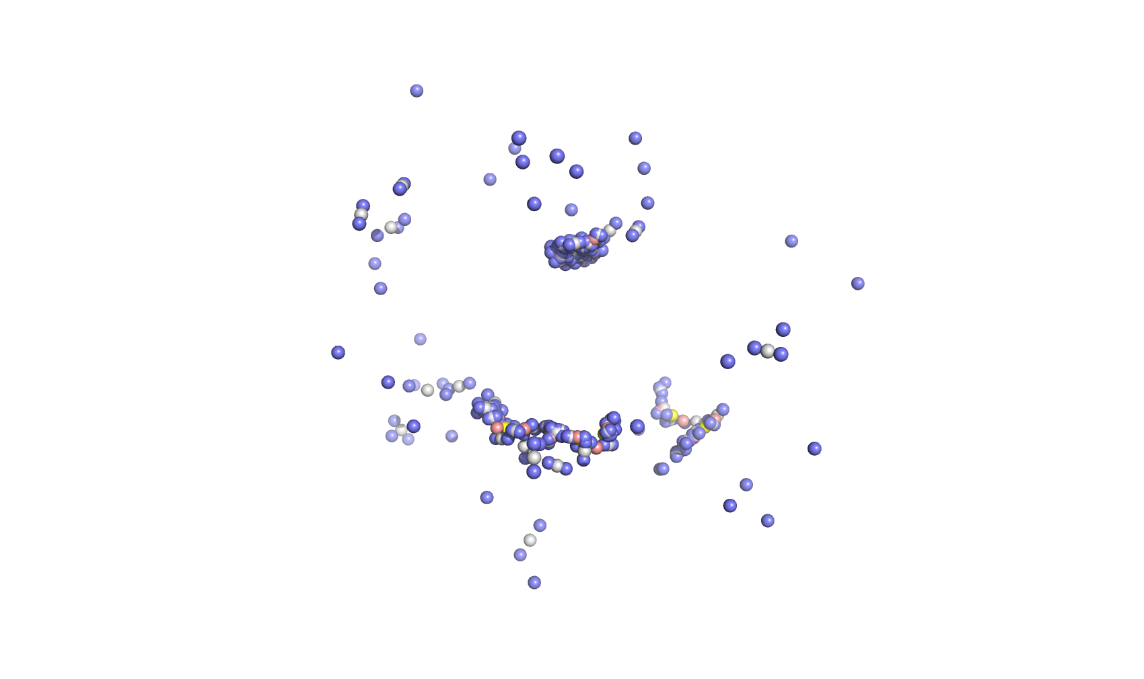
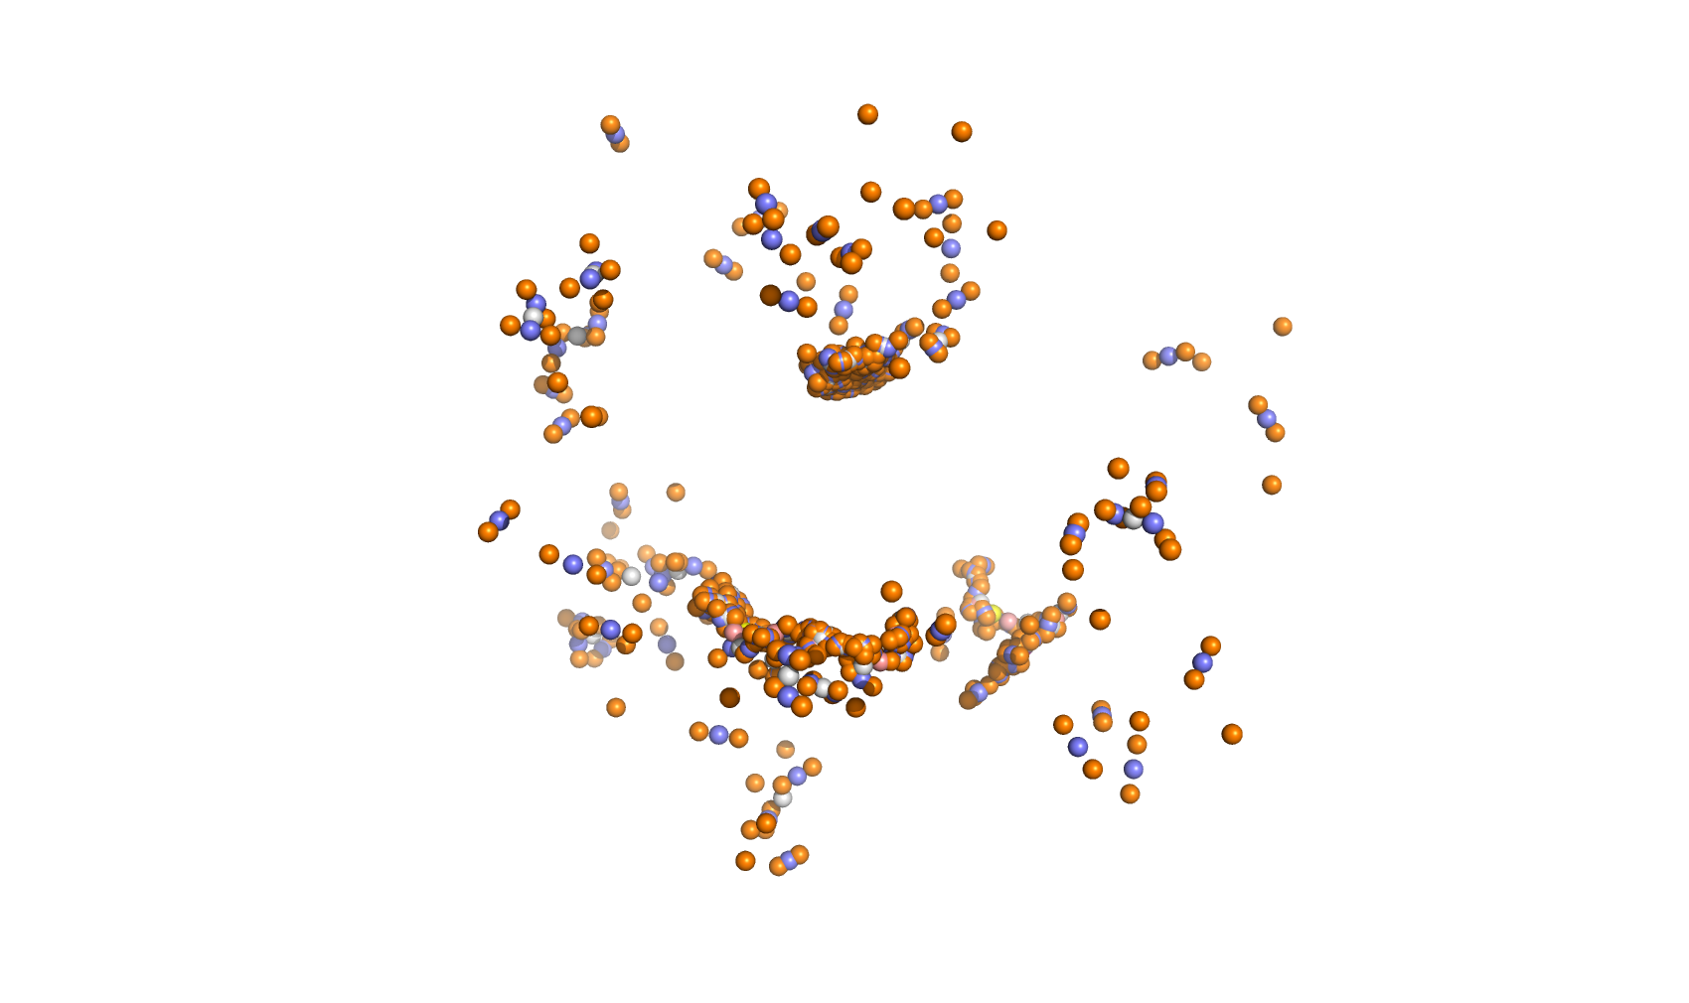
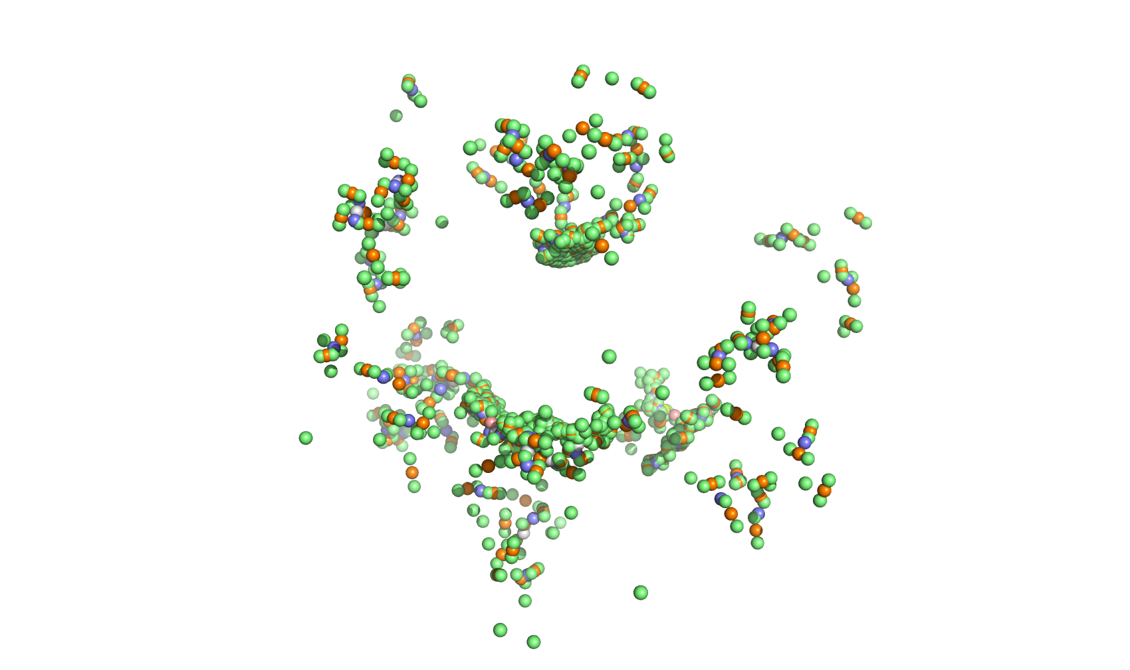
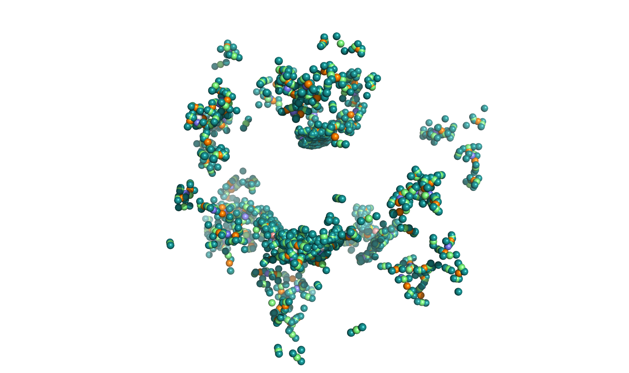
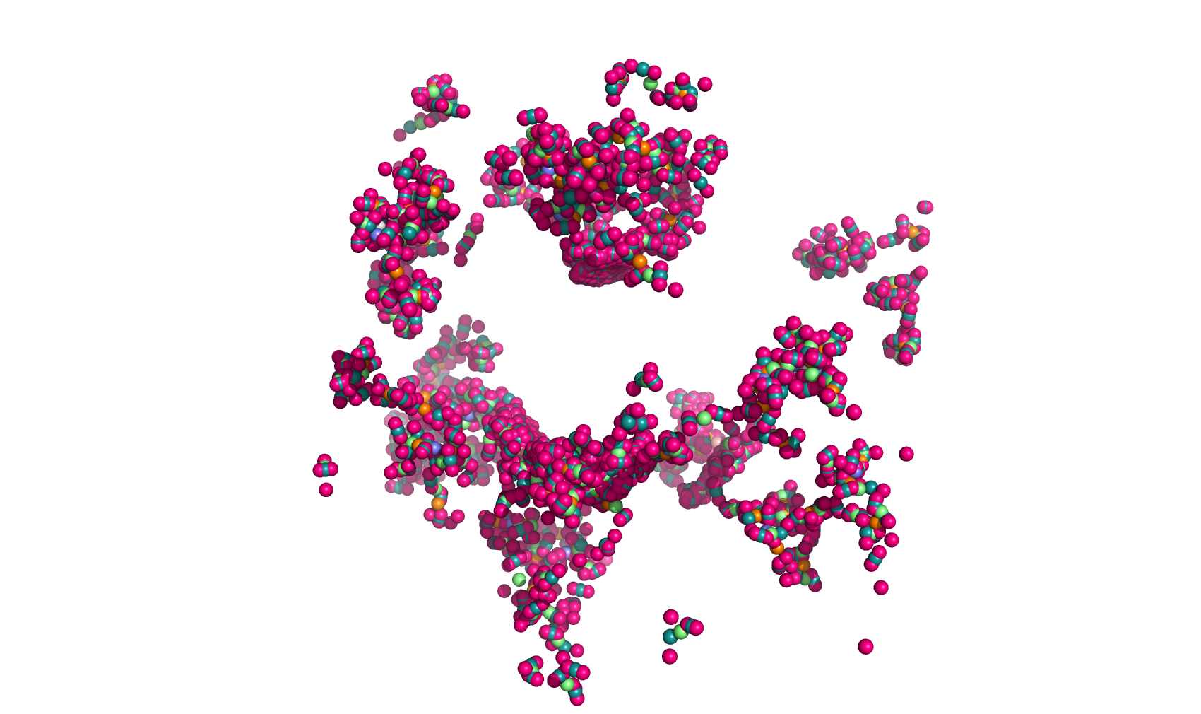


Figure S3: Superposition of the KES23360 protein against the original (10,000 centroids) and final (one centroid, green) outputs for one trajectory.

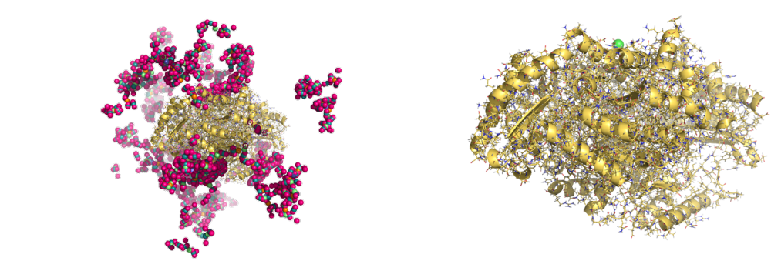

Table S1: Specific Activity and Relative Rate data for the ω-amino acids and α,ω-diamines with the tree transaminases. Specific activity data is presented in nmol/min/mg. Relative reactivity is shown in parentheses as a percentage, relative to the highest observed activity for each individual protein (treated as 100%).

Substrate | KES23360 | N16 | N43
β-Alanine | 3.2 (3) | 0.4 (7) | 1.8 (2)
4-Aminobutyrate | 48.1 (51) | 4.2 (77) | 49.7 (65)
5-Aminopentanoate | 81.4 (86) | 5.5 (100) | 76.5 (100)
6-Aminohexanoate (AHA) | 81.4 (86) | 4.5 (83) | 74.7 (98)
7-Aminoheptanoate | 78.6 (83) | 4.2 (78) | 70.6 (92)
8-Aminooctanoate | 64.9 (68) | 3.5 (64) | 61.0 (80)
12-Aminododecanoate | 8.2 (9) | 0.6 (10) | 18.7 (24)
4-NH₂-(S)-2-hydroxybutyrate | 95.1 (100) | 4.6 (84) | 50.6 (66)
2,4-(S)-Diaminobutyrate | 24.0 (25) | 1.5 (28) | 15.9 (21)
1,3-Diaminopropane | 0.7 (1) | 0.1 (3) | 1.8 (2)
Putrescine | 15.1 (16) | 2.8 (51) | 32.3 (42)
Cadaverine | 4.7 (5) | 2.6 (47) | 62.0 (81)
1,6-Hexamethylenediamine (HMD) | 5.4 (6) | 2.0 (36) | 37.8 (49)
1,7-Heptamethylenediamine | 5.7 (6) | 2.1 (38) | 48.7 (64)
1,8-Octamethylenediamine | 6.8 (7) | 1.7 (32) | 37.4 (49)
1,9-Nonamethylenediamine | 12.2 (13) | 1.7 (31) | 43.7 (57)
1,10-Decamethylenediamine | 7.2 (8) | 2.0 (36) | 38.3 (50)

