Supplementary Material

The role of Prefrontal Cortex in a Battle of the Sexes Dilemma involving a Conflict between Tribal and Romantic love
Isabel Catarina Duarte, Sónia Brito-Costa, Ricardo Cayolla, Miguel Castelo-Branco

Figures:

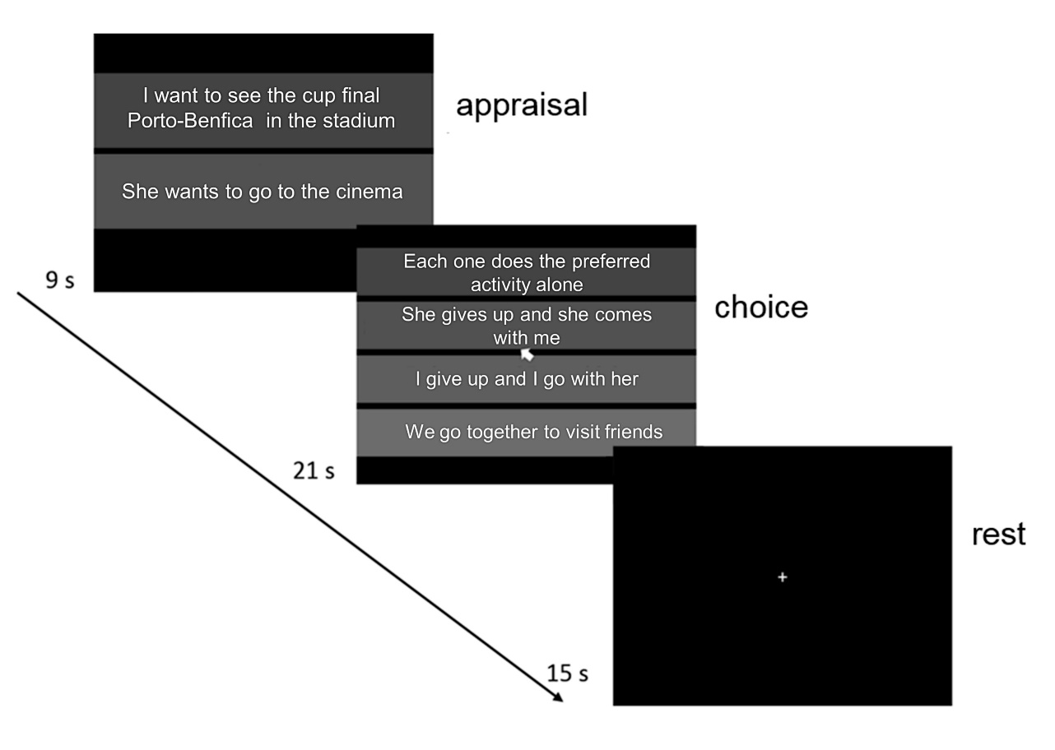
Figure S1. Experimental design. In the first block, the ‘appraisal’ condition, the participant reads the two competing components of the dilemma: 1) what he prefers to do (always involves the favorite team in a cup final match against a high rival team and it can be watched at home, in a café or in the stadium), and 2) what his partner prefers to do. In the following block, the participant has to choose the most probable scenario, according to the posed dilemma: O1) each one does the preferred activity alone, O2) she gives up her preferred activity and goes with him, O3) he gives up his preferred activity and goes with her and O4) they give up their preferred activity and do something else specified in that option. Each pair of ‘appraisal’/‘choice’ is followed by a fixation period.
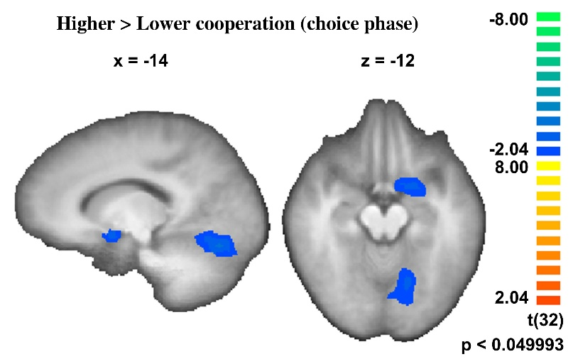
Figure S2. Contrast higher vs. lower cooperation during ‘choice’ phase. (RFX, n=33, t(32)=2.04, p<0.05, minimum cluster extent 60).

Tables:

Table S1. Regions revealed by the contrast of ‘appraisal’ vs. ‘choice’ conditions. Regions were identified from a whole-brain RFX-GLM analysis (t(43)=3.38, p<0.01 FDR corrected). The coordinates in Talairach space and the t and p values in the peak voxel describe the clusters.
 |  | Tal coordinates
 | H | x | y | z | t | p | #
anterolateral prefrontal cortex (BA 9) | R | 36 | 41 | 34 | -5,85 | 0,000001 | 8814
anterolateral prefrontal cortex (BA 9) | L | -39 | 41 | 34 | -5,76 | 0,000001 | 8802
lateral prefrontal cortex (BA 10) | R | 45 | 47 | 4 | -4,65 | 0,000031 | 714
orbitofrontal cortex (BA 11) | R | 27 | 35 | -14 | 4,59 | 0,000039 | 494
orbitofrontal cortex (BA 11) | L | -27 | 35 | -17 | 5,30 | 0,000004 | 602
operculum (BA 44) | R | 51 | 8 | 13 | -4,91 | 0,000014 | 3505
operculum (BA 44) | L | -48 | 17 | 1 | -5,32 | 0,000004 | 3191
entorhinal | R | 39 | -13 | -26 | 5,95 | <0,000001 | 7123
entorhinal | L | -36 | -7 | -23 | 5,35 | 0,000003 | 4059
putamen | L | -27 | -10 | 7 | -4,16 | 0,000149 | 494
posterior cingulate (BA 30, 23, 31) | R,L | -15 | -70 | 13 | 6,98 | <0,000001 | 42117
inferior parietal lobule | R | 57 | -37 | 31 | -7,14 | <0,000001 | 12368
motor & parietal & inferior parietal lobule | R,L | -39 | -37 | 49 | -7,70 | <0,000001 | 52920
middle temporal gyrus | L | -54 | -10 | -5 | 5,25 | 0,000005 | 854
visual cortex and MT | R,L | 3 | -79 | -11 | -7,59 | <0,000001 | 65568
MT | R | 51 | -52 | -2 | -5,86 | 0,000001 | 2902
Midline thalamus/midbrain | R,L | 0 | -19 | 1 | 6,90 | <0,000001 | 1406

Table S2. Regions revealed by the contrast higher vs lower cooperation during appraisal (contrast between ‘appraisal’ conditions where the upcoming strategy was concordant with the option for highest outcome for the couple versus the option for a lower outcome) (RFX, t(32)=2.04, p<0.05, minimum cluster extent 60). The coordinates in Talairach space and the t and p values in the peak voxel describe the clusters.
 |  | Tal coordinates
 | H | x | y | z | t | p | #
anterolateral prefrontal cortex (BA 9) | R | 33 | 23 | 31 | 3.06 | 0.004404 | 4441
anterolateral prefrontal cortex (BA 9) | L | -24 | 32 | 28 | 2.70 | 0.010239 | 1735
orbitofrontal/ventromedial prefrontal cortex (BA 11, 12) | R,L | 3 | 44 | -11 | 3.25 | 0.002718 | 4141
ventrolateral prefrontal cortex (BA 11, 10) | R | 45 | 50 | -3 | 3.19 | 0.003207 | 2522
temporal pole | R | 52 | 8 | -32 | 4.00 | 0.00035 | 13956
angular gyrus | R | 36 | -79 | 31 | -2.66 | 0.012126 | 2417
angular gyrus | L | -30 | -85 | 25 | -3.11 | 0.003932 | 3463
middle temporal/occipital | L | -66 | -47 | 10 | -3.74 | 0.000726 | 2525

Table S3 Regions revealed by the contrast higher cooperation vs lower cooperation (contrast between ‘choice’ conditions where the strategy was concordant with the option for highest outcome for the couple versus the option for a lower outcome) (RFX, t(32)=2.04, p<0.05, minimum cluster extent 60). The coordinates in Talairach space and the t and p values in the peak voxel describe the clusters.
 |  | Tal coordinates
 | H | x | y | z | t | p | #
posterior orbitofrontal cortex (BA 25, 34) | L | -21 | 5 | -11 | -3.40 | 0.001814 | 1907
temporal pole | R | 30 | 11 | -20 | -3.64 | 0.000962 | 1645
inferior parietal lobule/occipital gyrus | L | -49 | -79 | 19 | -3.70 | 0.000804 | 8092
lingual gyrus | L | -15 | -70 | -17 | -3.69 | 0.000838 | 8671
precuneus | R,L | 0 | -67 | 59 | -3.23 | 0.002839 | 2260
precentral gyrus | R | 12 | -25 | 67 | 2.67 | 0.011705 | 1846

