SUPPLEMENTARY INFORMATION

Astrocyte-specific overexpression of Nrf2 protects against optic tract damage and behavioural alterations in a mouse model of cerebral hypoperfusion

Authors:
Emma Sigfridsson¹, Martina Marangoni^{1,2}, Jeffrey A. Johnson^{3,4,5,6}, Giles E. Hardingham^{1,7,8}, Jill H. Fowler¹*, Karen Horsburgh¹*

Author Affiliations:
¹Centre for Discovery Brain Sciences, University of Edinburgh, Edinburgh, UK
²Current address: Department of Health Sciences, University of Florence, Florence, Italy.
³Division of Pharmaceutical Sciences, ⁴Molecular and Environmental Toxicology Center, ⁵Center for Neuroscience and ⁶Waisman Center, University of Wisconsin. Madison, US.
⁷Edinburgh Medical School, University of Edinburgh, Edinburgh, UK.
⁸The UK Dementia Research Institute, University of Edinburgh, Edinburgh, UK.
*Joint senior authors
Correspondence and request for materials should be addressed to J.H.F (Chancellor's Building, 49 Little France Crescent, Edinburgh, EH16 4SB, UK. Email: jill.fowler@ed.ac.uk) or K.H. (Chancellor's Building, 49 Little France Crescent, Edinburgh, EH16 4SB, UK. Email: karen.horsburgh@ed.ac.uk)

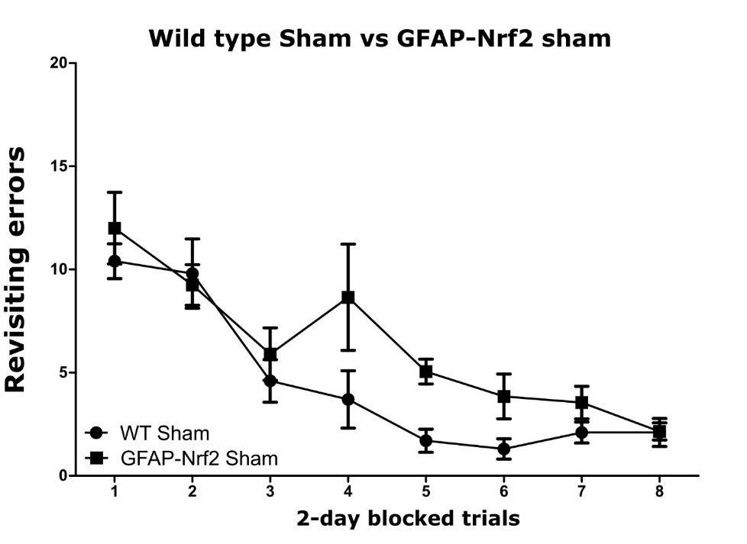
Supplementary Figure 1. Sham wild type and GFAP-Nrf2 transgenics had different learning pattern. The learning curve for WT sham and GFAP-Nrf2 sham animals followed different patterns, however there was no statistical significance between the groups (F_{1,13)}=2.73, p=0.12). Mean ± SEM. WT sham n=5, GFAP-Nrf2 sham n=10.

