Supplementary Material

Predictors of mosaic chromosome Y loss and associations with mortality in the UK Biobank

Erikka Loftfield, Weiyin Zhou, Barry I. Graubard, Meredith Yeager, Stephen J. Chanock, Neal D. Freedman and Mitchell J. Machiela

Supplementary Table 1. Allele frequencies in the 1000 Genomes European and African populations of germline genetic variants associated with mosaic loss of the Y chromosome.
Variant | Coordinates (GRCh37) | Location | Nearby Gene | Alleles |  | LRR Lowering Allele Frequency
 |  |  |  | LRR Lowering | LRR Increasing | 1000G Europeans | 1000G Africans
rs2736609 | chr1:156202640 | 1q22 | PMF1 | T | C | 0·351 | 0·281
rs115854006 | chr3:48388170 | 3p21·31 | TREX1 | C | T | 0·964 | 0·999
rs13088318 | chr3:101242751 | 3q12.3 | SENP7 | G | A | 0·348 | 0·011
rs59633341 | chr3:150018880 | 3q25.1 | TSC22D2 | A | AT | 0·150 | 0·012
rs56084922 | chr5:111061883 | 5q22.1 | NREP | G | A | 0·070 | 0·216
rs13191948 | chr6:109634599 | 6q21 | SMPD2 | C | T | 0·571 | 0·650
rs381500 | chr6:164478388 | 6q26 | QKI | C | A | 0·514 | 0·538
rs4721217 | chr7:1973579 | 7p22.3 | MAD1L1 | T | C | 0·391 | 0·029
rs35091702 | chr8:30279470 | 8p12 | RBPMS | C | CAAAAAAG | 0·775 | 0·886
rs4754301 | chr11:108048541 | 11q22.3 | NPAT | A | G | 0·621 | 0·334
rs10687116 | chr13:41678081 | 13q14.11 | WBP4 | AGATG | A | 0·843 | 0·899
rs1122138 | chr14:96180242 | 14q32.13 | TCL1A | C | A | 0·827 | 0·626
rs137952017 | chr14:101176090 | 14q32.2 | DLK1 | C | CT | 0·831 | 0·826
rs12448368 | chr16:81044947 | 16q23.2 | CENPN | C | T | 0·125 | 0·062
rs78378222 | chr17:7571752 | 17p13.1 | TP53 | G | T | 0·013 | 0·000
rs77522818 | chr17:47817373 | 17q21·33 | FAM117A | A | T | 0·939 | 0·928
rs11082396 | chr18:42080720 | 18q12.3 | SETBP1 | C | T | 0·146 | 0·078
rs17758695 | chr18:60920854 | 18q21·33 | BCL2 | C | T | 0·970 | 0·999
rs60084722 | chr20:30355738 | 20q11·21 | TPX2 | CT | C | 0·781 | 0·626

Abbreviations: GRCh37, Genome Reference Consortium Human Build 37; LRR, log₂ intensity ratio of the Y chromosome; 1000G, 1000 Genomes

Supplementary Table 2. Association of mosaic loss of the Y chromosome with all-cause mortality excluding key population subgroups
 | mLOY (mLRR < -0·15) |  |  |  | mLOY (mLRR < -0·40) |  |  |  | mLRR ^{d}
 | HR ª | 95% CI | P-value |  | HR ª | 95% CI | P-value |  | HR ª | 95% CI | P-value
Excluding mLRR > +0·15 ^{b} | 1·11 | (1·00-1·24) | 0·06 |  | 1·40 | (1·11-1·76) | 0·004 |  | 1·02 | (1·00-1·04) | 0·01
Excluding prevalent chronic disease ^{c} | 1·06 | (0·91-1·22) | 0·47 |  | 1·49 | (1·11-2.00) | 0·008 |  | 1·03 | (1·01-1·05) | 0·008
ª Multivariable model is adjusted for age (as the underlying time metric), detailed smoking history (25-level variable incorporating current smoking status, smoking intensity (current and former smokers); time since quitting (former smokers), and cigar and pipe use (current and former smokers)); time to first cigarette among current smokers (<5 minutes, 5 to 15 minutes, 30 minutes to 1 hour, or >1 hour)); race/ethnicity (white, black, Asian, mixed, or other race); alcohol drinking (never drinker, former drinker, infrequent drinker (<1 drink/week), occasional drinker (>1 drink/week but <1 drink/day), moderate daily drinker (1 to 3 drinks/day), or heavy daily drinker (>3 drinks/day); general health status (excellent, good, fair, or poor); education level (college or university degree, A levels/AS levels or equivalent, O levels/GCSEs or equivalent, CSEs or equivalent, NVQ or HND or HNC equivalent, or other professional qualifications); body mass index (<18·5, 18·5 to <25, 25 to <30, 30 to <35, or ≥35 kg/m²); and physical activity (>10 minutes of moderate of vigorous activity 0, 1-2, 3-4, or ≥5 days/week)
^{b} Excluding individuals with a Y chromosome gain event (mLRR > +0·15, n=205)
^{c} Excluding individuals with a self-reported diagnosis of diabetes, cancer (other than non-melanoma skin cancer), heart attack or stroke or missing data on self-reported history (n=36,382)
^{d} Scaled by the - (standard deviation) of mLRR such that the HR corresponds to a one standard deviation decrease in mLRR
Abbreviations: CI, confidence interval; HR, hazard ratio; mLOY, mosaic loss of the Y chromosome; mLRR, median log₂ intensity ratio of the Y chromosome

Supplementary Table 3. Lag analysis of the association of mosaic loss of the Y chromosome with all-cause mortality for more than 5 years of follow-up
 | mLOY (mLRR < -0·15) |  |  |  | mLOY (mLRR < -0·40) |  |  |  | mLRR ^{b}
Years of follow-up | HR ª | 95% CI | P-value |  | HR ª | 95% CI | P-value |  | HR ª | 95% CI | P-value
0 to 5 years (n=223,338) | 1·00 | (0·86-1·16) | 0·98 |  | 1·37 | (1·03-1·83) | 0·03 |  | 1·01 | (0·99-1·03) | 0·36
>5 to 10 years (n=218,238) | 1·26 | (1·06-1·49) | 0·008 |  | 1·35 | (0·92-1·97) | 0·12 |  | 1·03 | (1·00-1·06) | 0·03
ª Multivariable model is adjusted for age (as the underlying time metric), detailed smoking history (25-level variable incorporating current smoking status, smoking intensity (current and former smokers); time since quitting (former smokers), and cigar and pipe use (current and former smokers)); time to first cigarette among current smokers (<5 minutes, 5 to 15 minutes, 30 minutes to 1 hour, or >1 hour)); race/ethnicity (white, black, Asian, mixed, or other race); alcohol drinking (never drinker, former drinker, infrequent drinker (<1 drink/week), occasional drinker (>1 drink/week but <1 drink/day), moderate daily drinker (1 to 3 drinks/day), or heavy daily drinker (>3 drinks/day); general health status (excellent, good, fair, or poor); education level (college or university degree, A levels/AS levels or equivalent, O levels/GCSEs or equivalent, CSEs or equivalent, NVQ or HND or HNC equivalent, or other professional qualifications); body mass index (<18·5, 18·5 to <25, 25 to <30, 30 to <35, or ≥35 kg/m²); and physical activity (>10 minutes of moderate of vigorous activity 0, 1-2, 3-4, or ≥5 days/week)
^{b} Scaled by the - (standard deviation) of mLRR such that the HR corresponds to a one standard deviation decrease in mLRR
Abbreviations: CI, confidence interval; HR, hazard ratio; mLOY, mosaic loss of the Y chromosome; mLRR, median log₂ intensity ratio of the Y chromosome

Supplementary Figure 1. Plot of median log₂ intensity ratio of the Y chromosome (mLRR) values for all UK Biobank men in our analytical set by age of blood draw. Solid line represents expected baseline mLRR of 0 and dashed lines represent mLRR cutoff values of +0·15, -0·15 and -0·40, respectively.
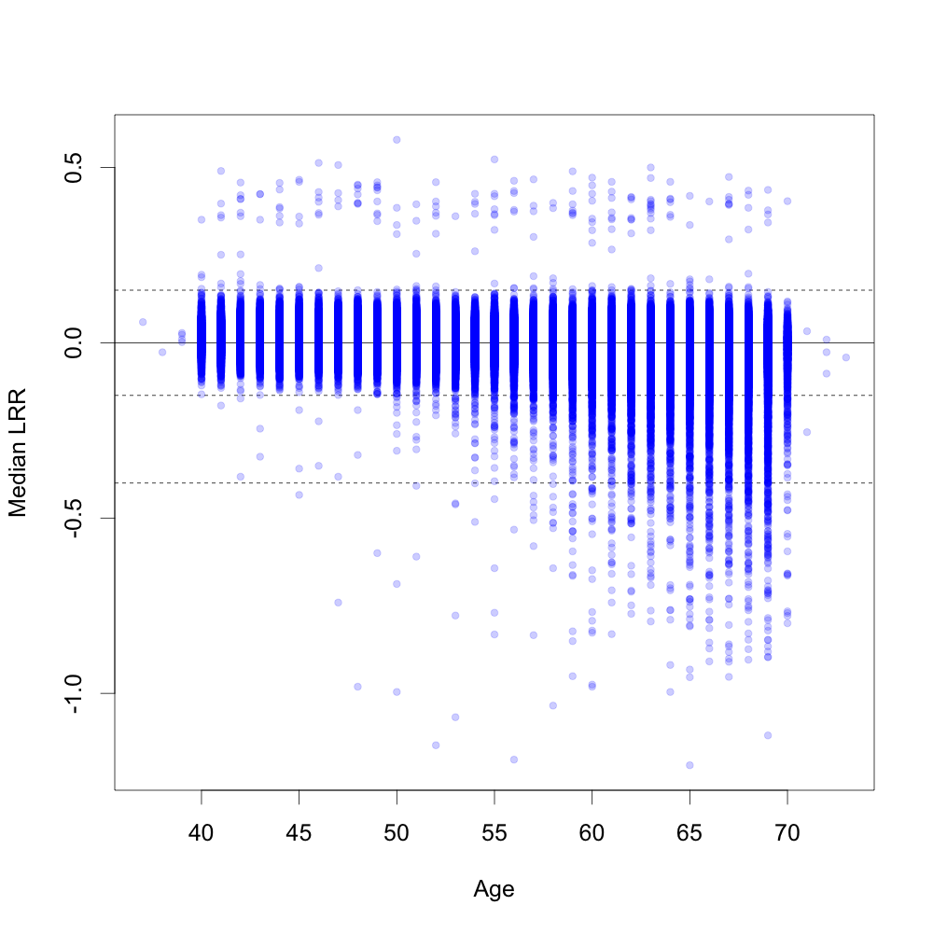

Supplementary Figure 2. Comparison of the frequency of mLOY in the UK Biobank to a previous study by Zhou et al¹⁵ by 5-year age group and smoking status. Bar height represents mLOY frequency estimates and plotted whiskers represent 95% confidence intervals.

