Cytochrome C oxidase Inhibition and Cold Plasma-derived Oxidants Synergize in Melanoma Cell Death Induction

Rajesh Kumar Gandhirajan¹, Katrin Rödder¹, Yana Bodnar¹, Gabriella Pasqual-Melo¹, Steffen Emmert², Corinne E. Griguer³, Klaus-Dieter Weltmann¹, Sander Bekeschus¹

¹ Leibniz-Institute for Plasma Science and Technology (INP Greifswald), ZIK plasmatis, Felix-Hausdorff-Str. 2, 17489 Greifswald, Germany

² University Medical Center Rostock, Clinic for Dermatology and Venerology, Strempelstr. 13, 18057 Rostock, Germany

³ University of Birmingham, Department of Neurosurgery, 1670 University Boulevard Birmingham, Alabama 35233, USA

Figure S1. Mitochondrial CcO inhibitor sodium azide (NaN₃) selectively decreases H2O2 mediated metabolic activity in SK-MEL-28 cells but not normal HaCaT cells. Comparison of metabolic activity of human melanoma cells and normal human keratinocytes following treatment with 50 µM H₂O₂ and 500 µM NaN₃ for 6 h. Data are mean +SEM from three independent experiments.

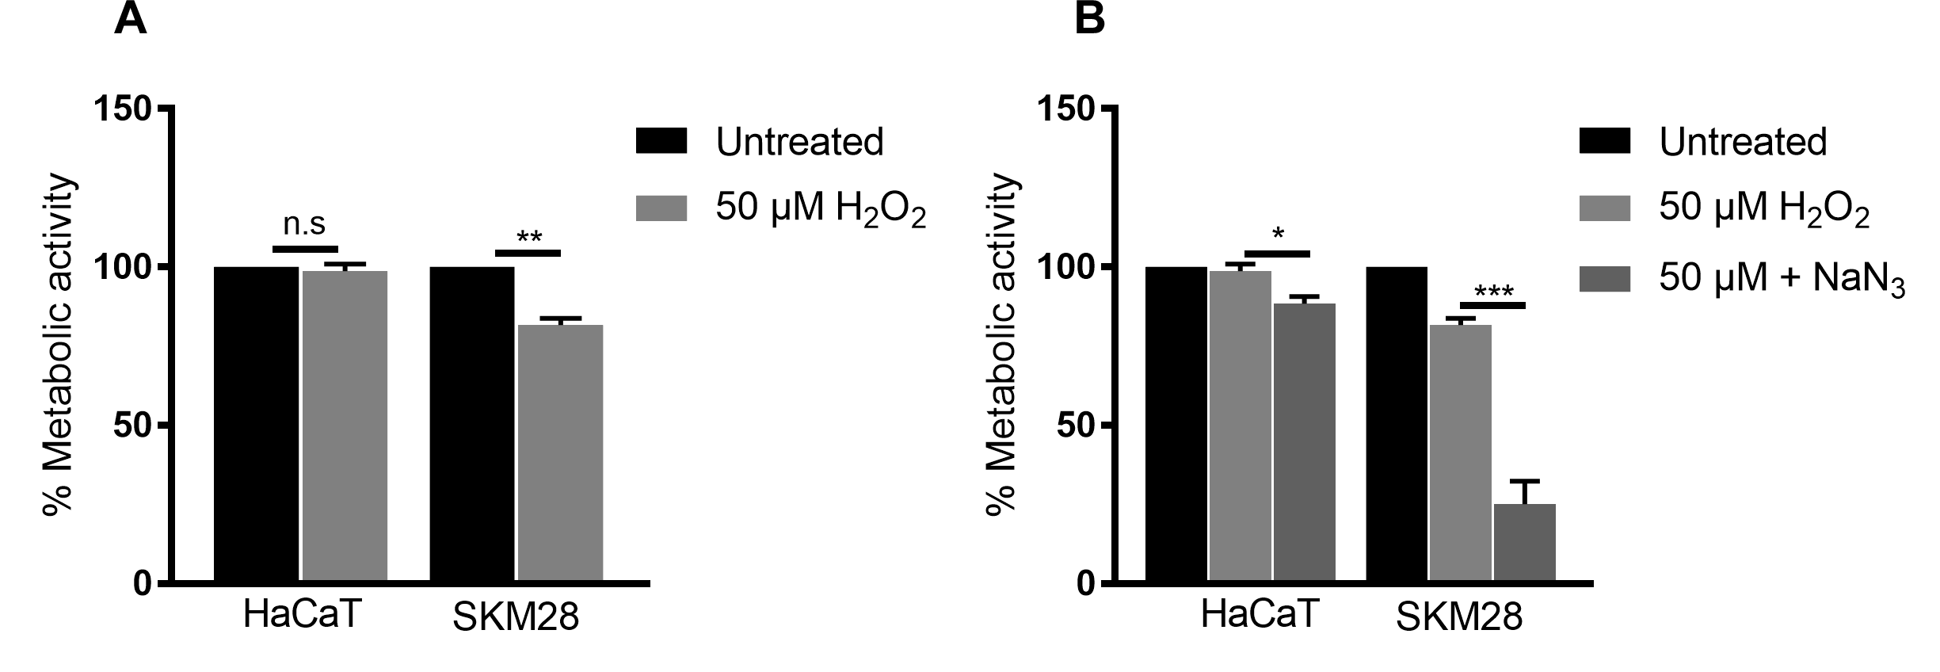

Figure S2. H₂O₂ decreases the metabolic activity of melanoma following treatment with KCN or NaN₃ (A) Metabolic activity of melanoma cells incubated with indicated concentrations of KCN in the presence 50 µM H₂O₂ for 6 h. (B) Metabolic activity of melanoma cells incubated with indicated concentrations of KCN in the presence 50 µM H₂O₂ for 6 h. Catalase (1000 IU/ml) served as quencher. Data are mean +SEM from three independent experiments.

