Title: Expression of key genes affecting artemisinin content in five Artemisia species

Authors: Maryam Salehi, Ghasem Karimzadeh, Mohammad Reza Naghavi, Hassanali Naghdi Badi and Sajad Rashidi Monfared

Supplementary Information 1

Fig. S1. Scanning electron micrographs of leaves of five Artemisia species including A. annua found in Iran (S1, Area = 1050 μm² ± 132.3), A. persica (S3, Area = 297 μm² ± 25.2), A. deserti (S4, Area = 3630 μm² ± 206.6), and A. marschalliana (S5, Area = 320 μm² ± 26.8). S1, S4, S5 (× 500, Scale bar 100 μm), S3 (× 2000, Scale bar 10 μm, Salehi et al. 2018).

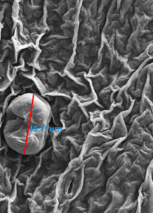
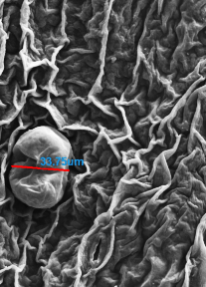
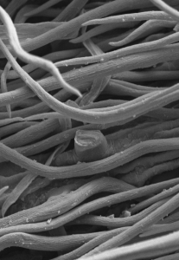
S1
S3
S4
S5

Supplementary Information 2
Fig. S2. Scanning electron micrographs of leaves of A. annua found in Iran (J, K, L) and A. khorassanica. (S, T, U); J, S (× 75, Scale bar 100 μm); K, T (× 250, Scale bar 100 μm); L, U (× 500, Scale bar 100 μm, Salehi et al. 2018).

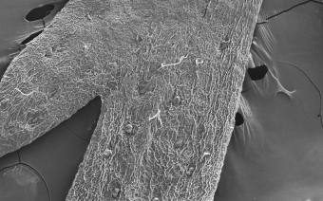
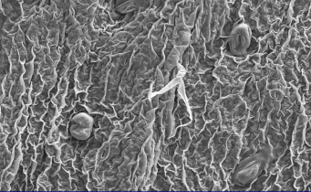
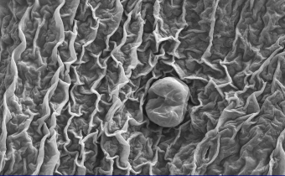
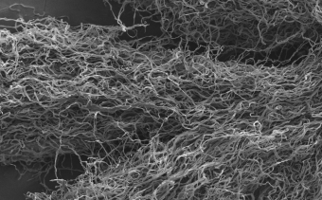
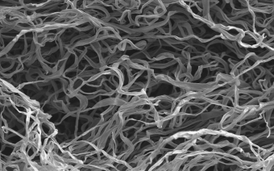
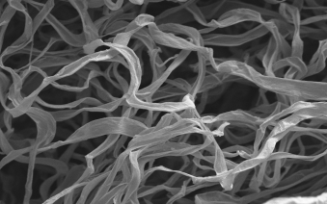
J
K
L
S
T
U

Supplementary Information 3
Fig. S3. Agarose gel electrophoresis of RNA extracted from five studied Artemisia species.
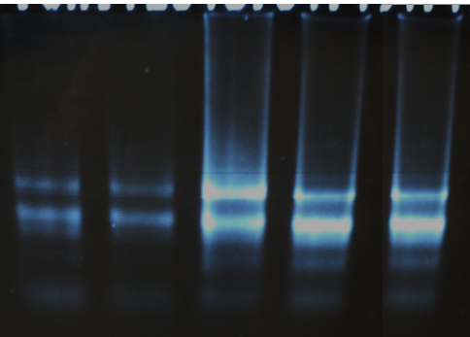
28S rRNA
18S rRNA
5S rRNA

Supplementary Information 4
Fig. S4. Alignments of the mRNA sequences of artemisinin biosynthesis genes (a, ADS; b, DBR2; c, ALDH1; d, CYP and e, RED1) from A. deserti with A. annua.
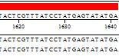

Fig. S4-a.

Fig. S4-b.

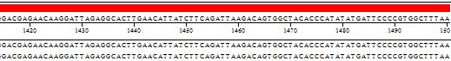

Fig. S4-c.

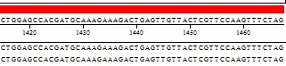

Fig. S4-d.

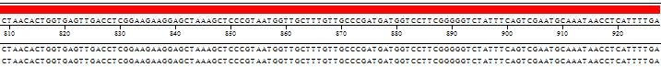

Fig. S4-e.

Supplementary Information 5
Fig. S5. Alignments of the partial mRNA sequences of Actin (a) and PCR products of CPR (b), CPS (c), GAS (d), BFS (e), ORA (f), ABCG6 (g) and ABCG7 (g) primers pairs of five studied Artemisia species.
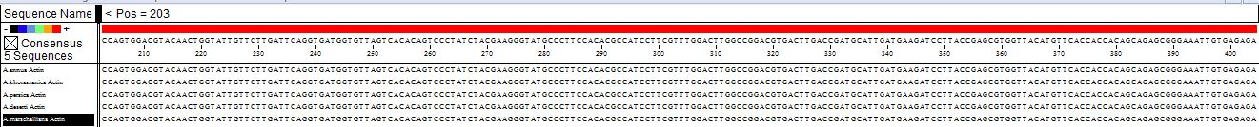
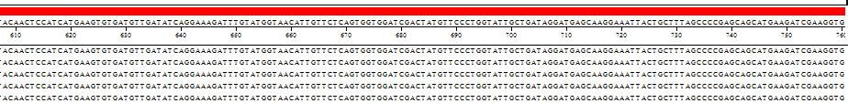

Fig. S5-a.

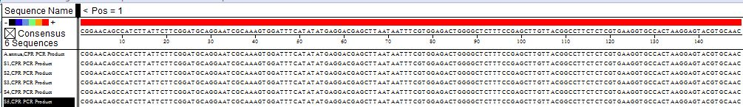

Fig. S5-b.

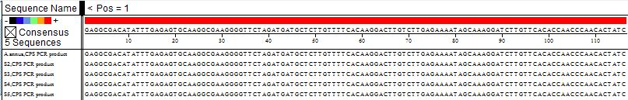

Fig. S5-c.

Fig. S5-d.

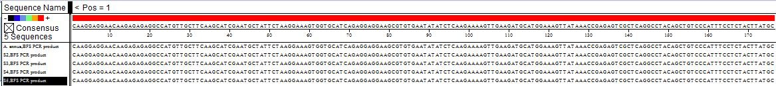

Fig. S5-e.

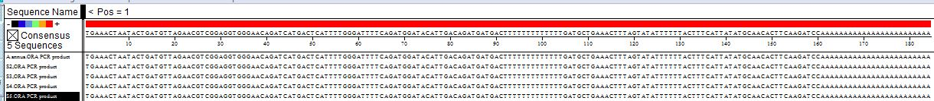

Fig. S5-f.

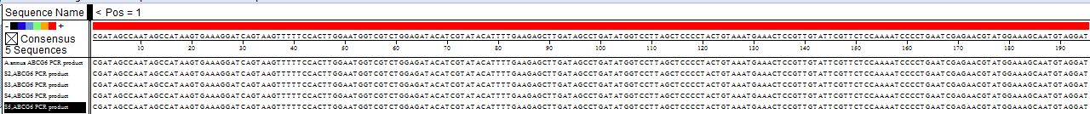

Fig. S5-g.

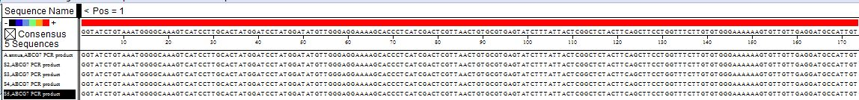

Fig. S5-h.

Supplementary Information 6
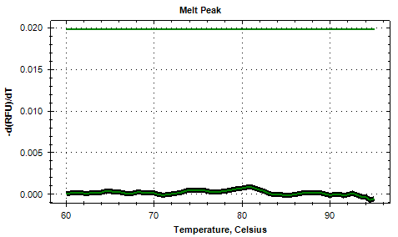
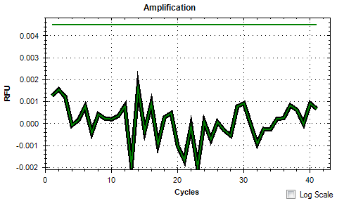
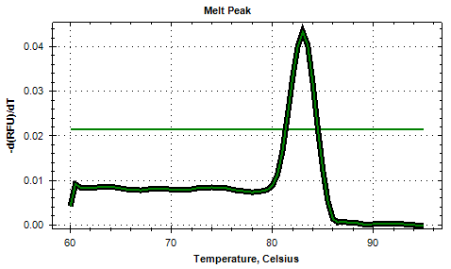
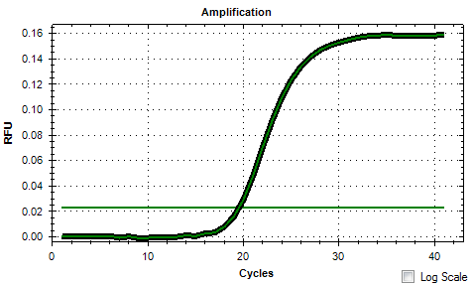
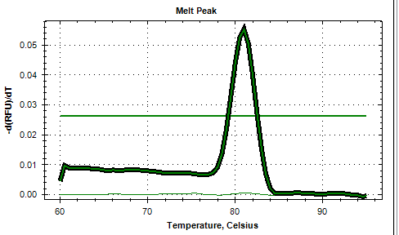
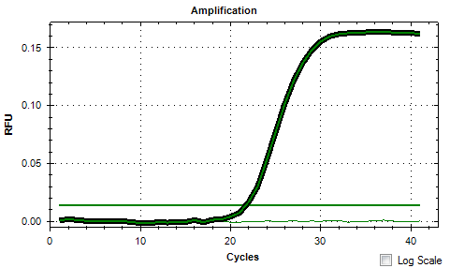
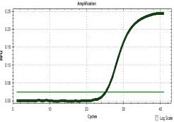
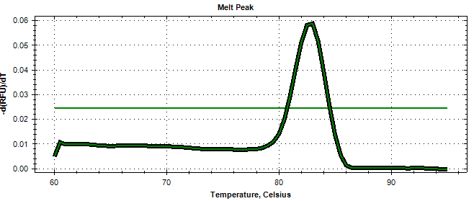
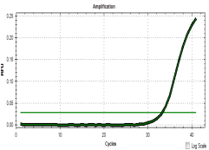
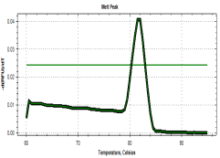
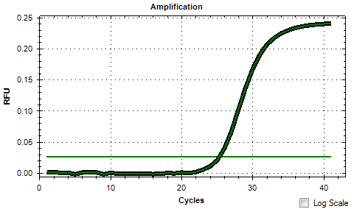
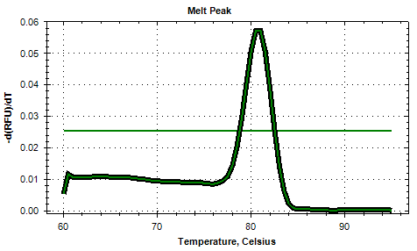
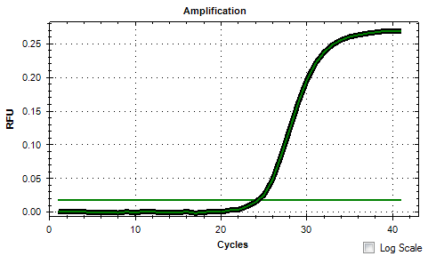
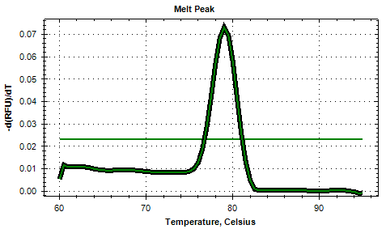
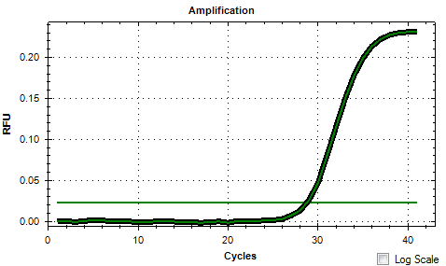
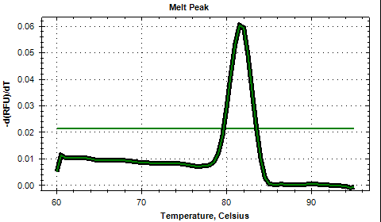
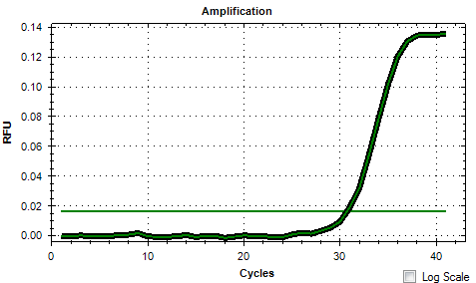
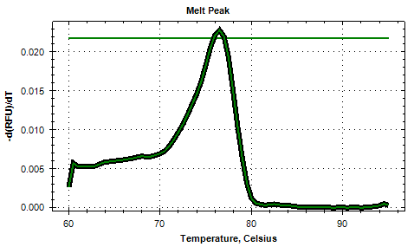
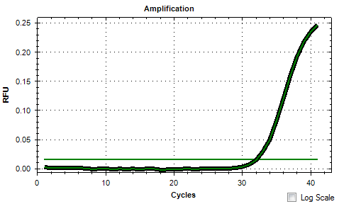
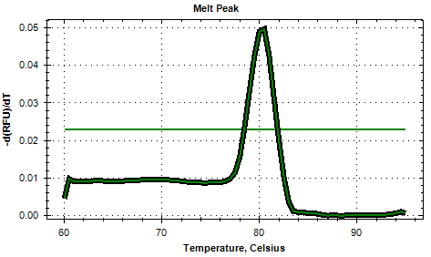
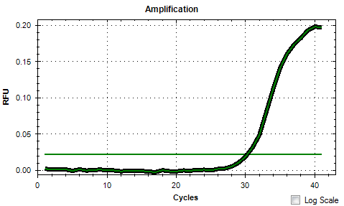
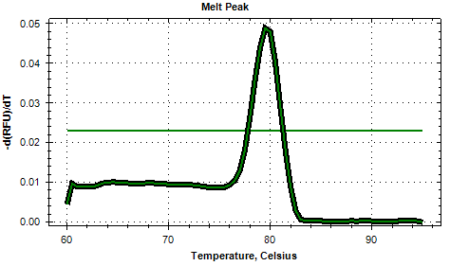
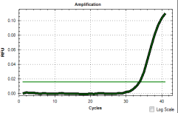
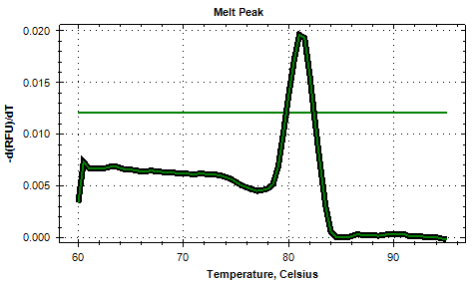
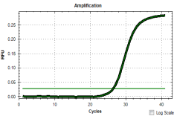
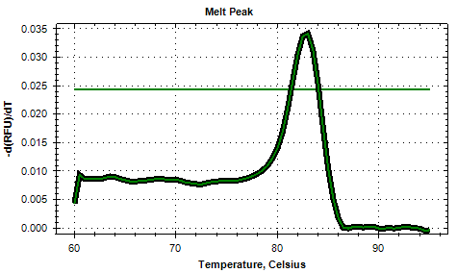
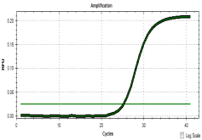
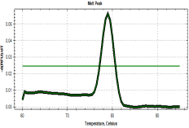
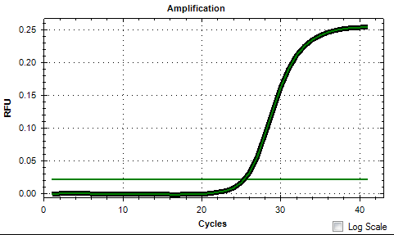
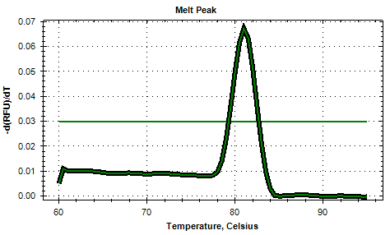
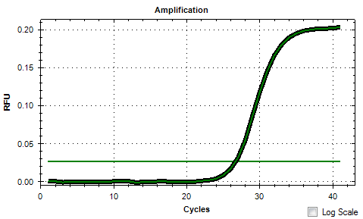
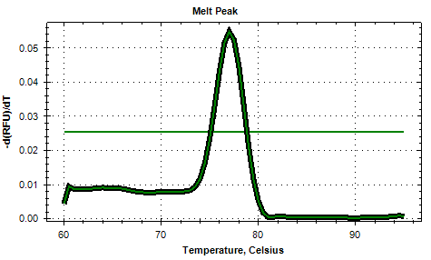
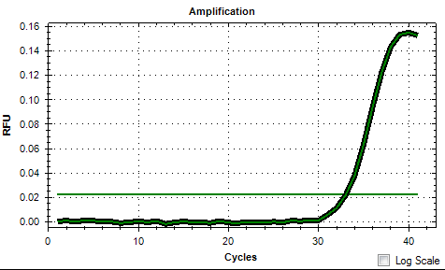
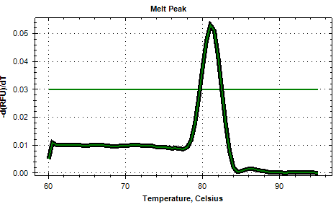
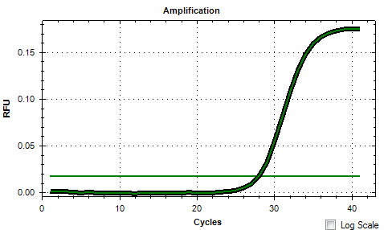
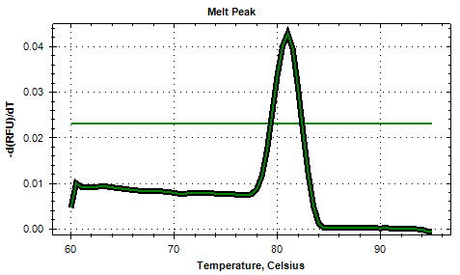
Fig. S6. The amplification (a1, b1, c1, d1, e1, f1, g1, h1, i1, j1, k1, l1, m1, n1, o1, p1, q1, r1) and melting curves (a2, b2, c2, d2, e2, f2, g2, h2, i2, j2, k2, l2, m2, n2, o2, p2, q2, r2) of amplicons of negative control (a) and of studied primers pairs including β-Actin (b), CPR (c), ADS (d), CYP (e), ALDH1 (f), DBP2 (g), RED1 (h), ORA (i), ERF1 (j), WIRKY1 (k), ABCG6 (l), ABCG7 (m), BFS (n), GAS (o), CPS (p), ECS (q), SQS (r).
c1
c2
d1
d2
e2
f1
f2
g1
g2
h1
h2
i2
j1
j2
k1
k2
l1
l1
l2
m1
m2
n1
o1
o2
p1
p2
q1
q2
i1
r2
a1
a2
b1
b2
e1
n2
r1

i1

Supplementary Information 7
Fig. S7. The melting curves of amplicons of Actin (a-e) and CPR (f-j) primers pairs in five Artemisia species including A. annua found in Iran (a, f), A. khorassanica (b, g), A. persica (c, h), A. deserti (d, i) and A. marschalliana (e, j).
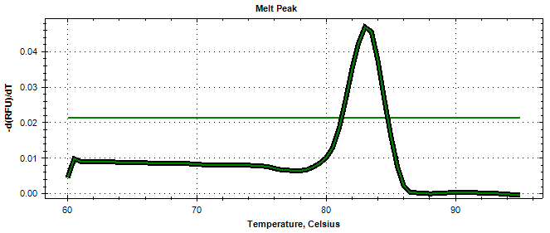
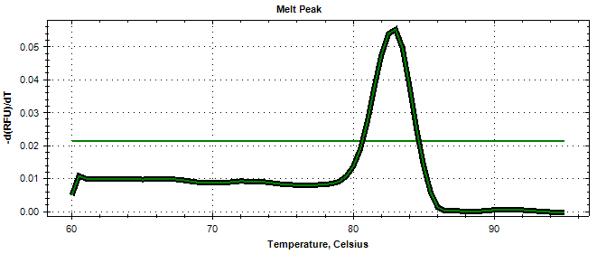
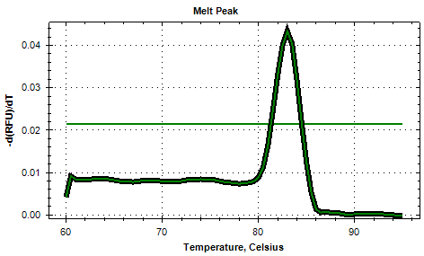
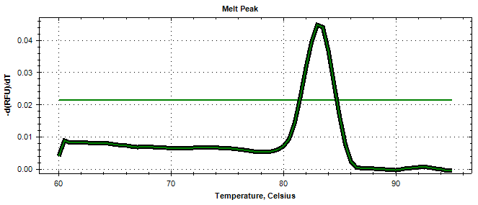
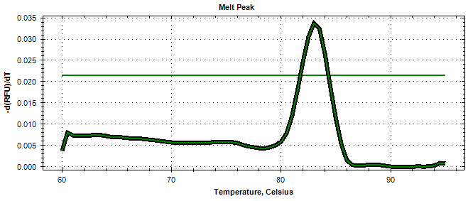
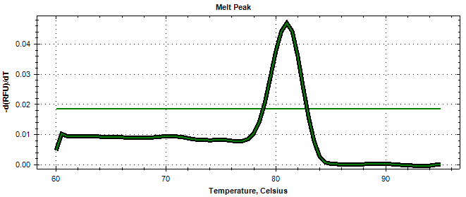
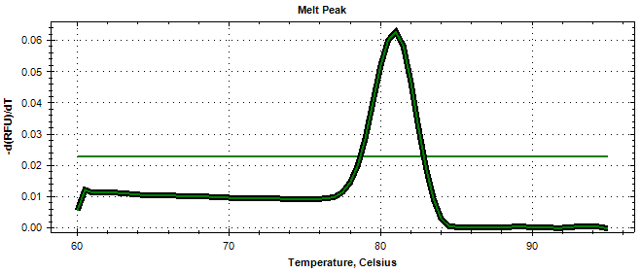
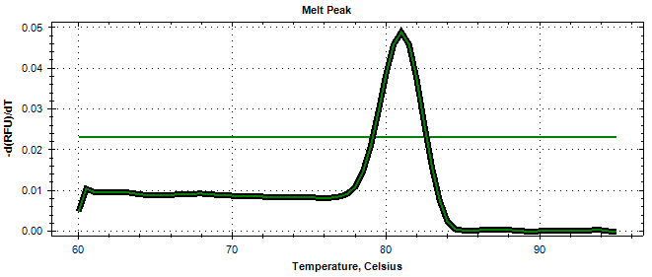
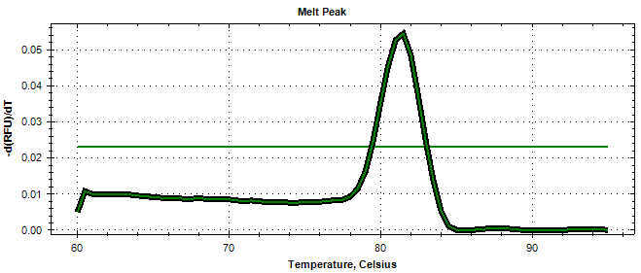
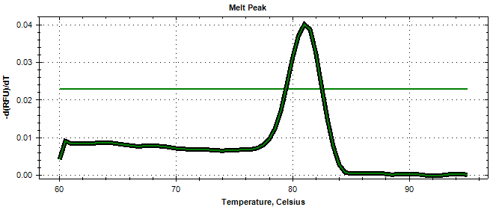
a
b
c
d
e
f
g
h
i
j

Supplementary Information 8
Fig. S8. Agarose gel electrophoresis of PCR products of Actin (a) and CPR (b) primers pairs from five studied Artemisia species including A. annua (1), A. khorassanica (2), A. persica (3), A. deserti (4), A. marschalliana (5), negative control 6). Ma, 100 bp DNA ladder; Mb, 1 KB Plus ladder.

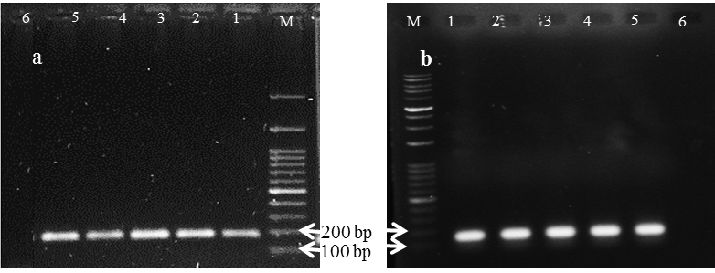

Supplementary Information 9
Table S1. Chromosomal parameters and some karyotypic symmetry formula of five Artemisia species including S1 (A. annua found in Iran), S2 (A. khorassanica), S3 (A. persica), S4 (A. deserti), and S5 (A. marschalliana)
Karyotype formula² | Stebbins’ type¹ | CI | TCV | AR | CL | L | S | Species codes
18m | 1A | 0.42^{b} ± 0.005 | 4.60^{d} ± 0.10 | 1.39ª ± 0.03 | 3.37^{d} ± 0.06 | 1.95^{d} ± 0.04 | 1.42^{d} ± 0.03 | S1
18m | 1A | 0.44ª ± 0.010 | 5.38^{c} ± 0.12 | 1.31^{ab} ± 0.03 | 3.93^{c} ± 0.06 | 2.22^{c} ± 0.04 | 1.72^{c} ± 0.04 | S2
18m | 1A | 0.42^{b} ± 0.006 | 6.40^{b} ± 0.15 | 1.39ª ± 0.04 | 4.67^{b} ± 0.07 | 2.70^{b} ± 0.05 | 1.97^{b} ± 0.04 | S3
18m | 1A | 0.44ª ± 0.004 | 11.76ª ± 0.25 | 1.28^{b} ± 0.02 | 6.11ª ± 0.12 | 3.41ª ± 0.07 | 2.70ª ± 0.07 | S4
 |  | 0.531 | 0.299 | 0.531 | 0.315 | 0.184 | 0.176 | LSD_{1%}
36m | 1A | 0.43 ± 0.004 | 5.92 ± 0.08 | 1.34 ± 0.02 | 4.35 ± 0.04 | 2.48 ± 0.03 | 1.88 ± 0.02 | S5
Means within a column followed by the same letter are not significantly different according to the LSD at the 0.01 probability level
¹ST: Stebbins classification (1971), ²KF: Karyotype formula

