In Vitro Modulation of Redox and Metabolism Interplay at the Brain Vascular Endothelium: Genomic and Proteomic Profile of Sulforaphane Activity
Ravi K. Sajja1, Mohammad A. Kaisar1, Vikrant Vijay3, Varsha G. Desai3, Shikha Prasad2 , Luca Cucullo1,4*

Supplementary Material

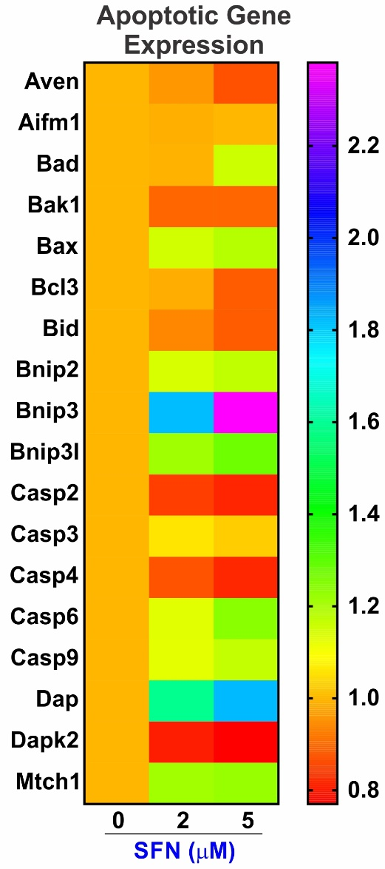
Supplementary Figure 6: SFN regulation of apoptotic genes (B).

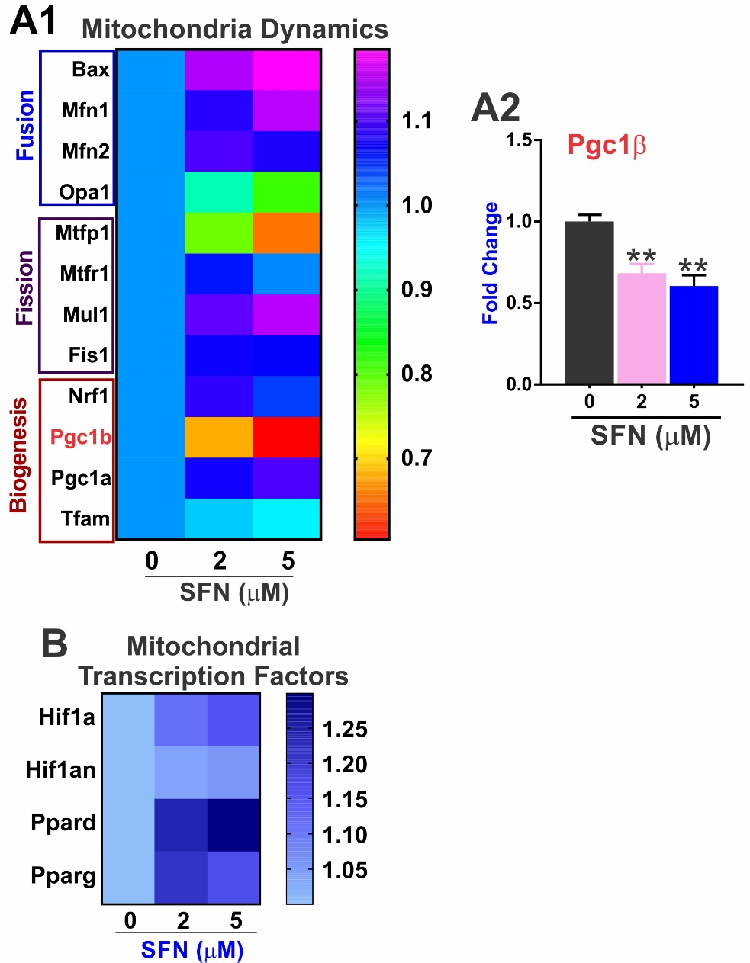
Supplementary Figure 7: SFN impacts mitochondrial dynamics. A1) Analysis of the heatmap shows how SFN differentially impact the expression levels of genes involved in mitochondrial fission, fusion and biogenesis. A2) Representative RT-PCR bar graph showing then effect of SFN treatment on Pgc1β expression. B) Heatmap of SFN regulation of mitochondrial transcriptional factors. Data were obtained from two independent experiments (n= 4 biological replicates/each). “**” p<0.01 vs. control.

Supplementary-Table 2: Excel List of all the 1026 genes included on MitoChips. The attached excel spreadsheet contains to separate sheets: The first one “LS Means per gene per group” contains the “mean” gene expression data for each experimental group including gene name, gene description and whether is encoded in the nucleus or the mitochondria. The second one “MitoChip data comparison” contains the data relative to the experimental comparisons shown in the volcano plots. The following is the column legend for the above mention excel file.
GENEBANKACC | Contains Genbank Accession or Refseq Gene IDs
GENENAME | Contains Entrez Gene Symbols
GEN_DESCR_MFR | Contains expanded Gene Name
MitoEncoded | "1" represents that the gene is encoded by mitochondria and "0" represents nuclear-encoded genes
LOCUSID | Nuclear-encoded genes
fold_ratio_linear | Contains Entrez Gene IDs
raw_p | Fold change

Supplementary-Table 3: Effects of SFN on gene expression of mitochondrial transporter/carrier systems
Gene Bank Acc | Gene | SFN2/ctrl |  | SFN5/ctrl
Gene Bank Acc | Gene | Abs FC | Fdr_P | Abs FC | Fdr_P
NM_053196 | Sideroflexin 2 (sfxn2) | -1.61 | <0.001 | -2.08 | <0.0001
NM_007472 | Aquaporin 1 (Aqp1) | 1.56 | 0.002 | 1.63 | <0.0001
NM_019687 | Solute carrier family 22 (organic cation transporter), member 4 (Slc22a4) | -1.43 | 0.009 | -1.39 | 0.007
NM_153150 | Solute carrier family 25, member 1 (Slc25a1) | 1.19 | 0.07 | 1.24 | 0.015
NM_013770 | Solute carrier family 25 (mitochondrial carrier; dicarboxylate transporter), member 10 (Slc25a10) | -1.1 | 0.08 | -1.26 | 0.048
NM_175194 | Solute carrier family 25 (mitochondrial carrier; Graves’ disease autoantigen), member 16 (Slc25a16) | -1.16 | 0.06 | -1.25 | 0.005
NM_030054 | Solute carrier family 25, member 37 (Slc25a37) | 1.21 | 0.03 | 1.43 | <0.001
NM_144793 | Solute carrier family 25, member 37 (Slc25a38) | -1.15 | 0.02 | -1.2 | 0.004

Gene Bank Acc | Gene | SFN2/ctrl |  | SFN5/ctrl
Gene Bank Acc | Gene | Abs FC | Fdr_P | Abs FC | Fdr_P
NM_133670 | Sulfotransferase family 1a, phenol-preferring, member 1 (Sult1a1) | -1.005 | 0.97 | -1.326 | 0.029
NM_016771 | Sulfotransferase family 1d, member 1 (Sult1d1) | 1.24 | 0.0357 | 1.49 | 0.046
NM_139297 | UDP-glucose pyrophosphorylase 2 (Ugp2) | 1.19 | 0.001 | 1.2 | 0.0006
NM_201641 | UDP glycosyltransferase 1 family, polypeptide a10 (Ugt1a10) | 1.13 | 0.073 | 1.73 | 0.028
NM_201643 | UDP glucuronosyltransferase 1 family, polypeptide a5 (Ugt1a5) | 1.29 | 0.0163 | 1.545 | 0.012
NM_201410 | UDP glucuronosyltransferase 1 family, polypeptide a6b (Ugt1a6b) | 1.81 | <0.0001 | 2.26 | <0.0001
NM_201642 | UDP glucuronosyltransferase 1 family, polypeptide a7c (Ugt1a7c) | 1.51 | 0.096 | 1.66 | 0.026
NM_201644 | UDP glucuronosyltransferase 1 family, polypeptide a9 | 1.31 | 0.0366 | 1.82 | 0.023
Supplementary-Table 4: Other SFN-modulated phase 2 enzymes

