Targeted enrichment outperforms other enrichment techniques and enables more multi-species RNA-Seq analyses
Matthew Chung^{1,2}, Laura Teigen³, Hong Liu⁴, Silvia Libro⁵, Amol Shetty¹, Nikhil Kumar¹, Xuechu Zhao¹, Robin E. Bromley¹, Luke J. Tallon¹, Lisa Sadzewicz¹, Claire M. Fraser^{1,6}, David A. Rasko^{1, 2}, Scott G. Filler^{4,7}, Jeremy M. Foster⁵, Michelle L. Michalski³, Vincent M. Bruno ^{1, 2}, Julie C. Dunning Hotopp^{1,2,8}

Supplementary Files
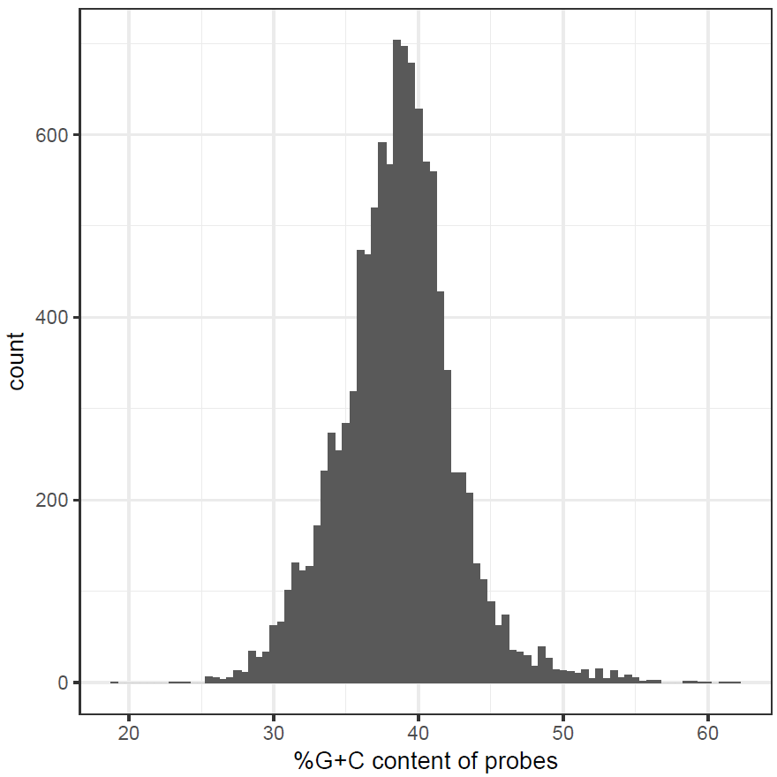

Supplementary Figure 1. G+C content of Brugia malayi AgSS probes
For each gene in the B. malayi genome, the average G+C content for its set of probes was determined and plotted on a histogram. The average G+C content of the B. malayi probe sets is 38.6%, with a range of 19.2-66.2%.
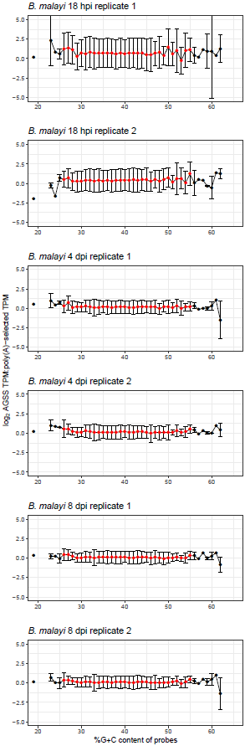

Supplementary Figure 2. The impact of G+C content on capturing Brugia malayi genes
At increments of 1% G+C, probe sets for each gene were binned to a specific G+C content. Points colored in red, between 26-55% G+C content, indicate ≥10 genes have probe sets at that specific G+C content. Error bars indicate standard error of the mean for each G+C content. For any G+C content, the average ratio of the log₂ AgSS TPM to the poly(A)-selected TPM for each protein-coding is calculated. Because 26-55% G+C content, the capture ability of a probe set is independent of its G+C content, as seen by the linear relationship between these points.
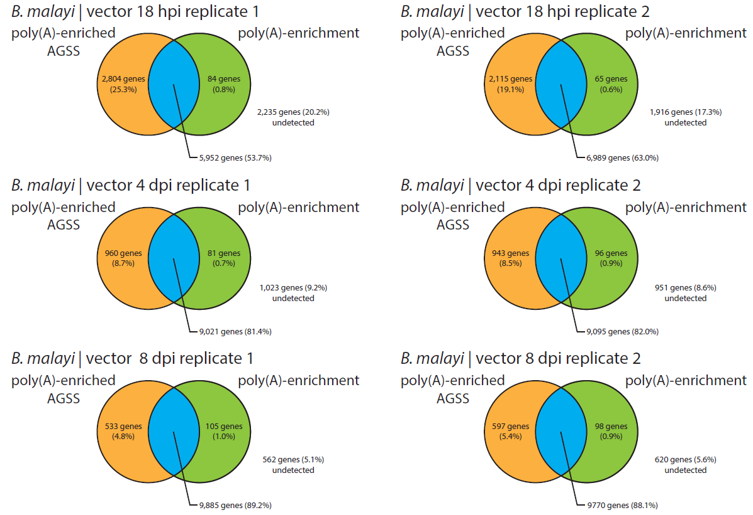

Supplementary Figure 3. Genes identified only in either the poly(A)-enriched AgSS or poly(A)-enrichment libraries from B. malayi samples
For six B. malayi transcriptome comparisons, Venn diagrams were generated to display the number of genes able to be extracted using the poly(A)-enriched AgSS (orange), the poly(A)-enrichment (green), or both (blue). The numbers in parentheses indicate the proportion of total protein-coding genes identified in each gene subset.
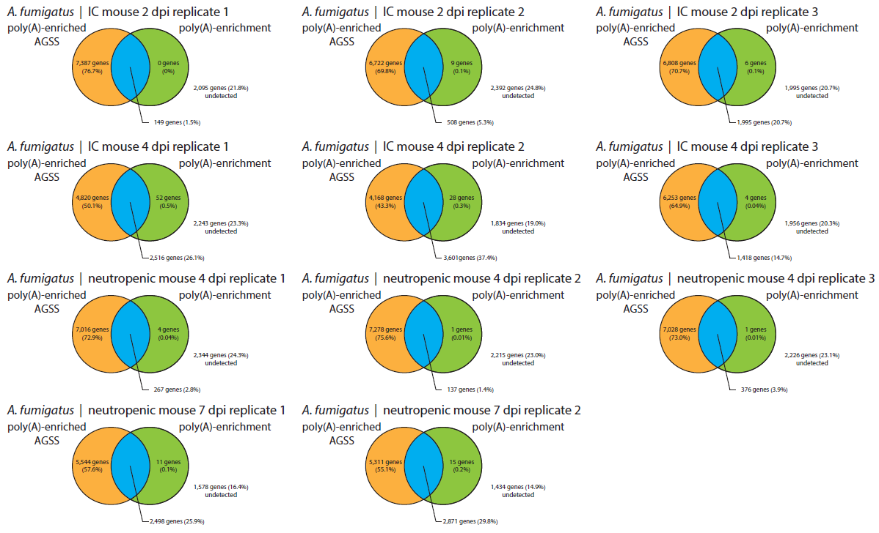

Supplementary Figure 4. Genes identified only in either the poly(A)-enriched AgSS or poly(A)-enrichment libraries from A. fumigatus samples
For 11 A. fumigatus transcriptome comparisons, Venn diagrams were generated to display the number of genes able to be extracted using the poly(A)-enriched AgSS (orange), the poly(A)-enrichment (green), or both (blue). The numbers in parentheses indicate the proportion of total protein-coding genes identified in each gene subset.
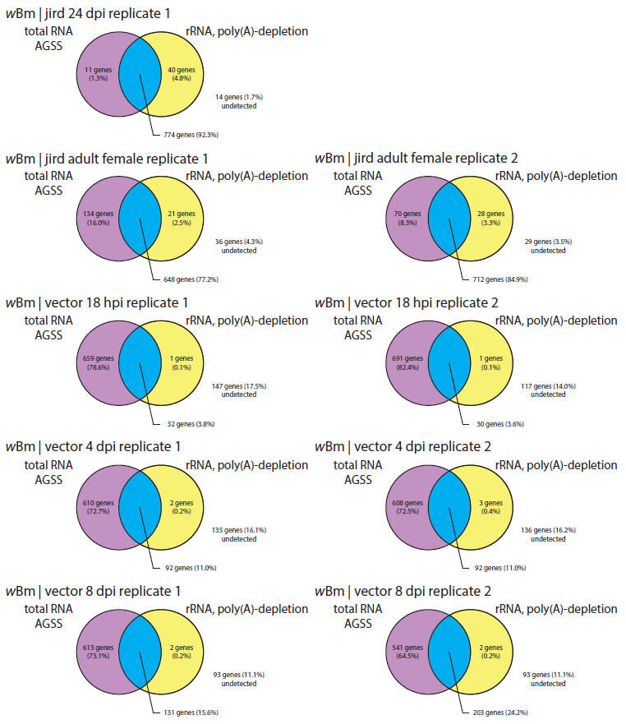

Supplementary Figure 5. Genes identified only in either the total RNA AgSS or rRNA-, poly(A)-depletion libraries from wBm samples
For nine wBm transcriptome comparisons, Venn diagrams were generated to display the number of genes able to be extracted using the total RNA, AgSS (purple), the rRNA, poly(A)-depletion (yellow), or both (blue). The numbers in parentheses indicate the proportion of total protein-coding genes identified in each gene subset.
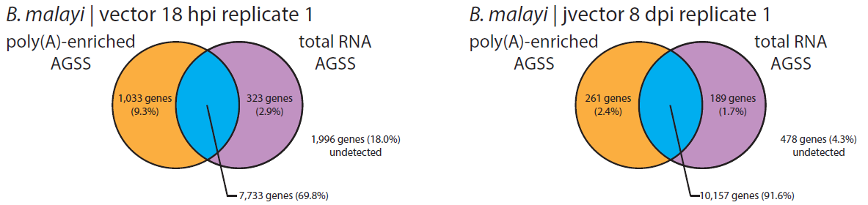

Supplementary Figure 6. Genes identified only in either the total RNA AgSS or poly(A)-enriched AgSS libraries from B. malayi samples
For two B. malayi transcriptome comparisons, Venn diagrams were generated to display the number of genes able to be extracted using the poly(A)-enriched, AgSS (orange), the total RNA AgSS (yellow), or both (blue). The numbers in parentheses indicate the proportion of total protein-coding genes identified in each gene subset.
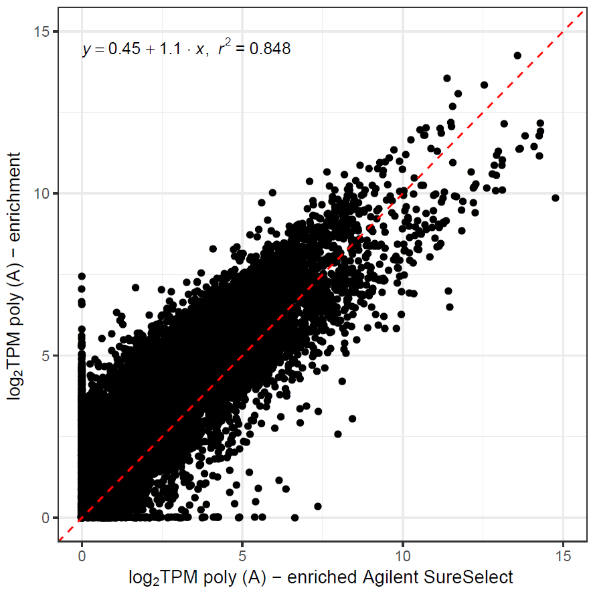

Supplementary Figure 7. Comparison of the poly(A)-enrichment to the total RNA A. fumigatus AgSS library preparations of the transcriptomes of 2 dpi immunocompromised mouse
Using the sample taken at 2 dpi of an immunocompromised mouse, the log₂ TPM values for mouse protein-coding genes in the poly(A)-enriched, A. fumigatus AgSS were plotted against the log₂ TPM values for mouse protein-coding genes in the poly(A)-enrichment only. Genes with similar expression in both enrichments lie close to the identity line (x=y; red). Mouse genes whose expression values are more elevated in the poly(A)-enriched A. fumigatus AgSS sample compared to the poly(A)-enrichment sample lie below the identity line while genes more elevated in the poly(A)-enrichment compared to the poly(A)-enriched A. fumigatus AgSS lie above the identity line.

Supplementary Dataset 1: RNA-Seq statistics for poly(A)-enriched AgSS and poly(A)-enrichment libraries from B. malayi samples collected following infection of the mosquito vector

Supplementary Dataset 2: RNA-Seq statistics for AgSS and poly(A)-enrichment libraries from A. fumigatus

Supplementary Dataset 3: RNA-Seq statistics for AgSS and rRNA-, poly(A)-depletion libraries from wBm

Supplementary Dataset 4: RNA-Seq statistics for B. malayi transcriptome data using AgSS with total RNA or poly(A)-enriched RNA

