Supplementary Material for

Comparison of initial oral microbiomes of young adults with and without cavitated dentin caries lesions using an in situ biofilm model

Stefan Rupf^{1*}, Cedric C. Laczny², Valentina Galata², Christina Backes², Andreas Keller², Natalia Umanskaya¹, Arzu Erol¹, Sascha Tierling³, Christina Lo Porto³, Jörn Walter³, Jasmin Kirsch⁴, Matthias Hannig¹, Christian Hannig⁴

¹ Clinic of Operative Dentistry, Periodontology and Preventive Dentistry, Saarland University Medical Center, Homburg, Germany,
² Chair for Clinical Bioinformatics, Saarland University, Germany,
³ Faculty of Natural Sciences and Technology, Department of Genetics/Epigenetics, University of Saarland, Germany,
⁴ Policlinic of Operative and Pediatric Dentistry, Medical Faculty Carl Gustav Carus, TU Dresden, Germany

stefan.rupf@uks.eu, *corresponding author

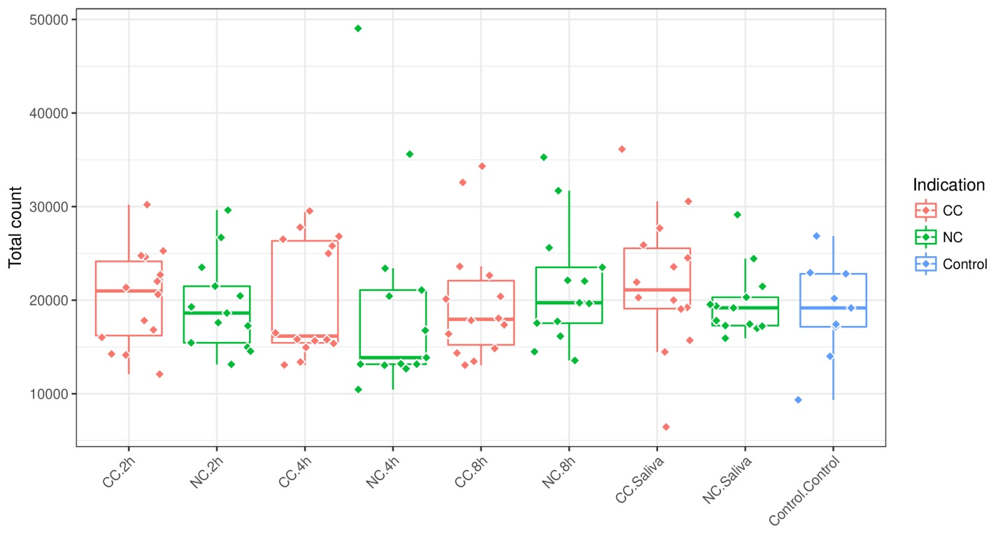

Figure S1: Total OTU count per sample and sample groups. The samples were grouped by type (2 h, 4 h and 8 h biofilm samples, and saliva samples) and indication (CC, NC, and control). The boxplots show the distribution of total OTU counts per sample within the respective groups. The dots demonstrate the total OTU counts per sample. The colors highlight the sample indication as CC, NC, or control.

Figure S2 (please open according HTML-files): Krona plots showing the taxonomic composition of sets of OTUs w.r.t. taxonomic lineages assigned by LotuS. The depicted OTU sets comprise all OTUs without OTUs present in at least one control probe (a) and OTU present in at least one control probe (b).

Supplementary_Figures 2_3.zip

Figure S3 (please open according HTML-files): Krona plots showing the taxonomic composition of sets of OTUs w.r.t. taxonomic lineages assigned by LotuS. The depicted OTU sets comprise all OTUs present in 2h- (a), 4h- (b), 8h-bioflim samples (c), and in saliva (d), respectively. OTUs present in any control probe were removed.

Supplementary_Figures 2_3.zip

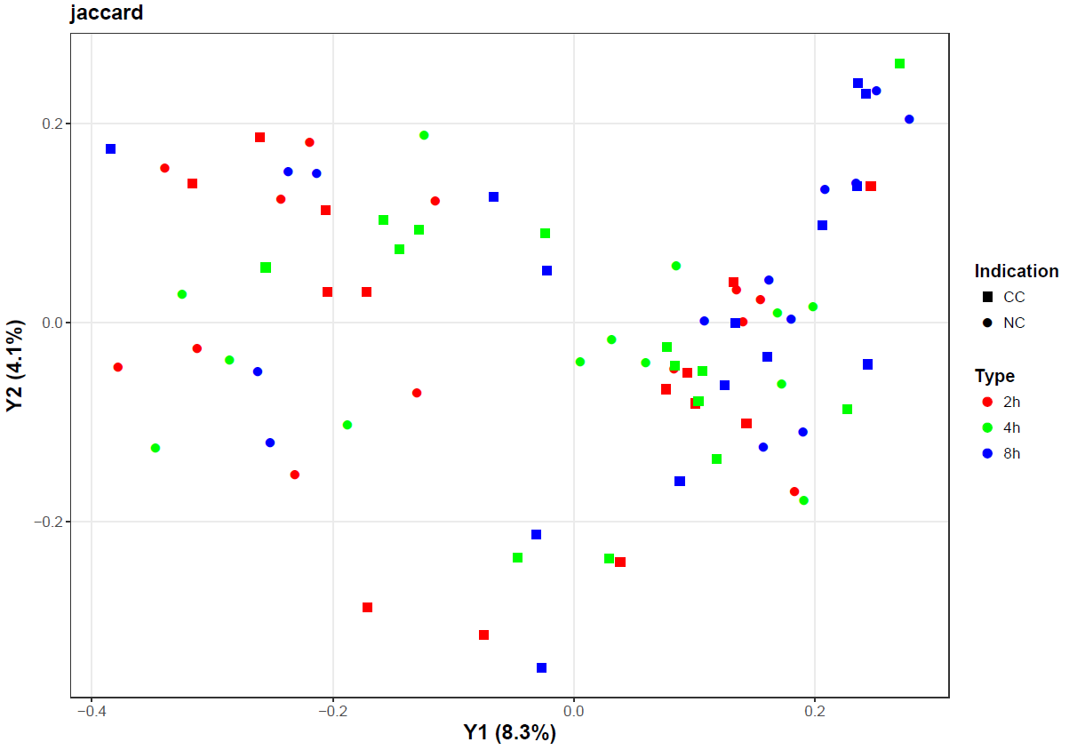

Figure S4: PCoA-based ordination of the Jaccard distance matrix. Colors reflect the sample type (2 h, 4 h, and 8 h) and shapes reflect the CC and NC groups. The percentage of variation explained is included in the axis labels.

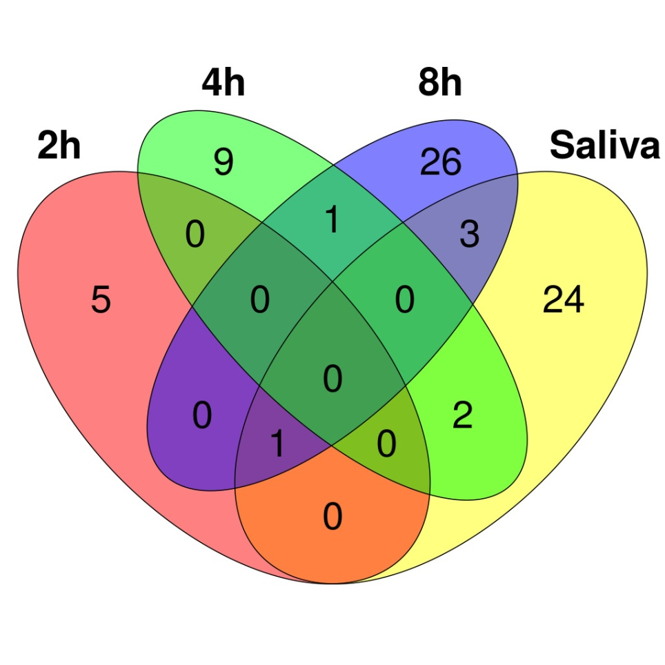

Figure S5: Number of and overlaps between statistically significantly differentially abundant OTUs per time point for the comparison of samples in CC and NC groups.

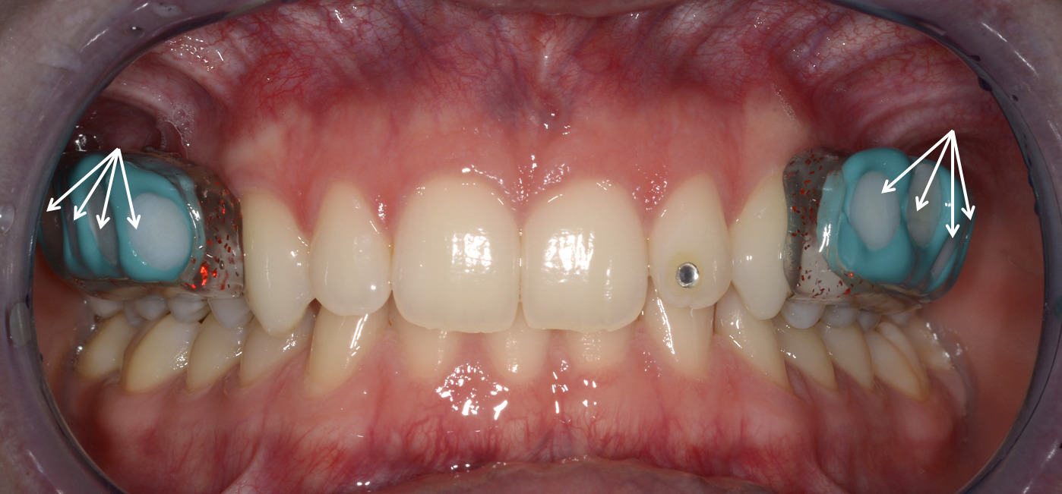

Figure S6: Individually removable acrylic splints, placed in the upper jaw. The specimens (arrows) are fixed with silicone in the left and right buccal regions of the upper premolars to the first molar.

Supplementary Tables
Supplementary Tables 1: Supplemental table 1: (a) Clinical data overview of study participants with cavitated dentin caries (CC) and without cavitated caries (NC). Mean and standard deviation are given. DMFS: decayed, missing, filled surfaces, DS: decayed surfaces, ICDAS: International Caries Detection and Assessment System; mean number of surfaces for cavitated caries/subject: 132.8 (occlusal (occ): 17, oral/vestibular (o/v): 58, mesial/distal (m/d): 58), for no cavitated caries/subject: 132.4 (occlusal: 16.9, oral/vestibular: 57.8, mesial/distal: 57.8). Percentages are given for scores 0, scores 1/2: first or distinct visual changes in enamel, scores 3/4: localized enamel breakdown or underlaying dark shadow from dentin, scores 5/6: distinct or extensive distinct cavity in dentin, age, gender, mSBI: modified sulcus bleeding index, API: approximal plaque index.

 | Cavitated caries |  |  | No cavitated caries
DMFS | 22.7 ± 12.1 |  |  | 1.5 ± 1.8
DS | 4.4 ± 1.8 |  |  | 0
ICDAS % surfaces | occ | o/v | m/d | occ | o/v | m/d
ICDAS score 0 | 39,30% | 79,60% | 76,70% | 31,80% | 92,30% | 93,60%
ICDAS scores1/2 | 24.4 ± 9.2% | 8.8 ± 2.2% | 7.6 ± 1.3% | 34.1 ± 1.3% | 3.9 ± 3.1% | 3.2 ± 2.4%
ICDAS scores ¾ | 5.05 ± 1.2% | 1.2 ± 1.5% | 3.1 ± 0.1% | 0,00% | 0,00% | 0,00%
ICDAS scores 5/6 | 0.9 ± 0.4% | 0.1 ± 0.1% | 0.9 ± 1.3% | 0,00% | 0,00% | 0,00%
Age (mean, years) | 24,6 |  |  | 25,2
Age (range, years) | 20 – 30 |  |  | 19 – 33
Ratio female : male | 43 % : 57 % |  |  | 69 % : 31 %
mSBI | 44.6 ± 23.8 % |  |  | 35.2 ± 24.2 %
API | 70.8 ± 27.7 % |  |  | 61.6 ± 29.4 %
Salivary flow rate | > 0.25 ml/min, < 1.0 ml / min

(b) Clinical data listed per subject including DMFS, DS, gender, age, mSBI, API. Note: Subjects with active enamel caries lesions (white spots) were excluded from group “no cavitated caries”. The visible changes in the enamel were brown discolorations, the surrounding enamel appeared glossy.

CC | DMFS | DS | Gender | Age | mSBI | API
1 | 24 | 3 | M | 28 | 78 | 100
2 | 20 | 3 | F | 25 | 67 | 96
3 | 14 | 8 | M | 25 | 33 | 80
4 | 18 | 4 | M | 23 | 36 | 96
5 | 54 | 5 | F | 30 | 86 | 100
6 | 26 | 3 | M | 24 | 50 | 65
7 | 19 | 4 | F | 23 | 39 | 93
8 | 11 | 4 | F | 23 | 43 | 79
9 | 26 | 7 | M | 22 | 75 | 75
10 | 15 | 3 | F | 21 | 27 | 77
11 | 22 | 8 | M | 20 | 43 | 47
12 | 29 | 4 | M | 25 | 22 | 23
13 | 24 | 3 | M | 30 | 12 | 25
14 | 16 | 3 | F | 20 | 14 | 35
NC | DMFS | DS | Gender | age | mSBI | API
1 | 2 | 0 | F | 33 | 46 | 75
2 | 0 | 0 | F | 25 | 17 | 71
3 | 0 | 0 | F | 22 | 42 | 83
4 | 0 | 0 | F | 22 | 39 | 64
5 | 5 | 0 | M | 23 | 58 | 71
6 | 3 | 0 | F | 27 | 71 | 96
7 | 1 | 0 | F | 30 | 42 | 75
8 | 0 | 0 | F | 27 | 73 | 82
9 | 3 | 0 | M | 26 | 25 | 86
10 | 0 | 0 | M | 29 | 0 | 11
11 | 0 | 0 | M | 19 | 0 | 8
12 | 4 | 0 | F | 24 | 36 | 59
13 | 2 | 0 | F | 20 | 9 | 20

(c) Sample information table including sample ID (column “UniqueSeqID”), grouping into CC/NC/controls (column “Indication”, “1” = CC, “2” = NC, “Kontrolle Schmelz” = enamel control, “Kontrolle-PCR” = PCR control, “Kontrolle-NTC” = NTC control), grouping into 2/4/8 h biosamples, saliva and controls (column “Type”), and subject ID (column “Individual”).
UniqueSeqID | Indication | Type | Subject ID
140929-ad1_001 | 1 | 2h | 1
140929-ad1_003 | 1 | 2h | 2
140929-ad1_008 | 2 | 2h | 1
140929-ad1_009 | 2 | 2h | 2
140929-ad1_010 | 2 | 2h | 3
140929-ad1_011 | 2 | 2h | 4
140929-ad1_013 | 1 | 2h | 4
140929-ad1_014 | 2 | 2h | 5
140929-ad1_015 | 2 | 2h | 6
140929-ad1_016 | 2 | 2h | 7
140929-ad1_018 | 1 | 2h | 5
140929-ad1_019 | 1 | 2h | 6
140929-ad1_020 | 2 | 2h | 8
140929-ad1_021 | 1 | 2h | 7
140929-ad1_022 | 1 | 2h | 8
140929-ad1_023 | 2 | 2h | 9
140929-ad1_025 | 2 | 2h | 10
140929-ad1_027 | 1 | 2h | 11
140929-ad1_028 | 2 | 2h | 11
140929-ad1_034 | 2 | 2h | 12
140929-ad1_035 | 1 | 2h | 12
140929-ad1_036 | 2 | 2h | 13
140929-ad1_037 | 1 | 2h | 13
140929-ad1_038 | 1 | 2h | 14
140929-ad1_039 | 1 | 4h | 1
140929-ad1_040 | 1 | 4h | 2
140929-ad1_041 | 1 | 4h | 3
140929-ad1_042 | 2 | 4h | 1
140929-ad1_043 | 2 | 4h | 2
140929-ad1_044 | 2 | 4h | 3
140929-ad1_045 | 2 | 4h | 4
140929-ad1_046 | 1 | 4h | 4
140929-ad1_047 | 2 | 4h | 5
140929-ad1_048 | 2 | 4h | 6
140929-ad2_001 | 2 | 4h | 7
140929-ad2_003 | 1 | 4h | 5
140929-ad2_008 | 2 | 4h | 8
140929-ad2_009 | 1 | 4h | 6
140929-ad2_010 | 1 | 4h | 7
140929-ad2_011 | 2 | 4h | 9
140929-ad2_013 | 2 | 4h | 10
140929-ad2_014 | 1 | 4h | 11
140929-ad2_015 | 2 | 4h | 11
140929-ad2_022 | 2 | 4h | 12
140929-ad2_023 | 1 | 4h | 12
140929-ad2_025 | 2 | 4h | 13
140929-ad2_027 | 1 | 4h | 13
140929-ad2_028 | 1 | 4h | 14
140929-ad2_044 | 2 | 8h | 10
140929-ad2_045 | 1 | 8h | 11
140929-ad2_046 | 2 | 8h | 11
140929-ad3_018 | 2 | 8h | 12
140929-ad3_019 | 1 | 8h | 12
140929-ad3_020 | 2 | 8h | 13
140929-ad3_021 | 1 | 8h | 13
140929-ad3_022 | 1 | 8h | 14
140929-ad3_023 | Kontrolle-Schmelz | Kontrolle-Schmelz
140929-ad3_025 | Kontrolle-Schmelz | Kontrolle-Schmelz
140929-ad3_027 | Kontrolle-Schmelz | Kontrolle-Schmelz
140929-ad3_028 | Kontrolle-Schmelz | Kontrolle-Schmelz
140929-ad3_029 | 1 | 2h | 3
140929-ad3_030 | 1 | 4h | 6
141128-ad1_038 | 1 | 2h | 9
141128-ad1_039 | 1 | 4h | 9
141128-ad1_040 | 1 | 2h | 10
141128-ad1_041 | 1 | 4h | 10
141128-ad1_042 | 1 | 8h | 10
141128-ad2_001 | 1 | 8h | 1
141128-ad2_003 | 1 | 8h | 2
141128-ad2_008 | 1 | 8h | 3
141128-ad2_009 | 2 | 8h | 1
141128-ad2_010 | 2 | 8h | 2
141128-ad2_011 | 2 | 8h | 3
141128-ad2_013 | 2 | 8h | 4
141128-ad2_014 | 1 | 8h | 4
141128-ad2_015 | 2 | 8h | 5
141128-ad2_016 | 2 | 8h | 6
141128-ad2_018 | 2 | 8h | 7
141128-ad2_019 | 1 | 8h | 5
141128-ad2_020 | 1 | 8h | 6
141128-ad2_021 | 2 | 8h | 8
141128-ad2_022 | 1 | 8h | 7
141128-ad2_023 | 1 | 8h | 8
141128-ad2_025 | 2 | 8h | 9
141128-ad2_027 | 1 | 8h | 9
141128-ad2_042 | 2 | Saliva | 10
141128-ad2_043 | 1 | Saliva | 11
141128-ad2_044 | 2 | Saliva | 11
141128-ad3_003 | 2 | Saliva | 12
141128-ad3_008 | 1 | Saliva | 12
141128-ad3_009 | 2 | Saliva | 13
141128-ad3_010 | 1 | Saliva | 14
141128-ad3_011 | 1 | Saliva | 13
141128-ad3_013 | 1 | Saliva | 1
141128-ad3_014 | 1 | Saliva | 2
141128-ad3_015 | 1 | Saliva | 3
141128-ad3_016 | 2 | Saliva | 1
141128-ad3_018 | 2 | Saliva | 2
141128-ad3_019 | 2 | Saliva | 3
141128-ad3_020 | 2 | Saliva | 4
141128-ad3_021 | 1 | Saliva | 4
141128-ad3_022 | 2 | Saliva | 5
141128-ad3_023 | 2 | Saliva | 6
141128-ad3_025 | 2 | Saliva | 7
141128-ad3_027 | 1 | Saliva | 6
141128-ad3_028 | 1 | Saliva | 5
141128-ad3_029 | 2 | Saliva | 8
141128-ad3_030 | 1 | Saliva | 7
141128-ad3_031 | 1 | Saliva | 8
141128-ad3_032 | 2 | Saliva | 9
141128-ad3_033 | 1 | Saliva | 9
141128-ad3_034 | 1 | Saliva | 10
150402-ad044_S42 | Kontrolle-Schmelz | Kontrolle-Schmelz
150402-ad045_S43 | Kontrolle-Schmelz | Kontrolle-Schmelz
150402-ad046_S44 | Kontrolle-Schmelz | Kontrolle-Schmelz
150402-ad047_S45 | Kontrolle-PCR | Kontrolle-PCR
150402-ad048_S46 | Kontrolle-NTC | Kontrolle-NTC

Supplementary Table 2 (please open supplementary dataset): Table with all OTUs present in samples and controls. The table contains the following information: OTU ID (column “OTU”); taxonomic lineage assigned by LotuS (columns “Kingdom” to “Species”); top hit of the BLAST search in eHOMD with the corresponding taxon (column “eHOMD”), match identity (column “eHOMDindent”) and mismatches (column “eHOMDmismatch”); a column containing a flag showing whether the OTU is contain in any control sample (column “inControls”, the value is “Yes” if present in any control); OTU counts per sample (all remaining columns).

Supplementary Tables 3: Overview of the OTUs with significant differences in their abundance in CC and NC sample groups considering 2 h (a), 4 h (b), 8 h (c), and saliva (d) group separately. The table contains the OTU ID (column “otu”), WMW test statistic (column “wmw_statistic”), log fold-change (bases 2, column “log2_fc”), the raw and adjusted p-values (columns “p” and “adj_p”), and the AUC (column “auc”). A positive log fold-change indicates higher presence in CC samples.

log2_fc: (-) signifikant for no cavitated caries
log2_fc: ( ) signifikant for cavitated caries

(a)
otu | wmw_statistic | log2_fc | P | auc | adj_p
OTU_624 | 65 | Inf | 0.045323 | 0.642857 | 0.495585
OTU_494 | 52 | 3.47231341753159 | 0.020683 | 0.785714 | 0.495585
OTU_243 | 126 | -Inf | 0.013510 | 0.307692 | 0.495585
OTU_77 | 52 | Inf | 0.010274 | 0.714285 | 0.495585
OTU_363 | 127.5 | -3.45589516760706 | 0.023413 | 0.299450 | 0.495585
OTU_97 | 59 | 3.63331303333882 | 0.047334 | 0.675824 | 0.495585

(b)
otu | wmw_statistic | log2_fc | P | Auc | adj_p
OTU_71 | 143 | -1.04931058037706 | 0.003927 | 0.214285 | 0.484845
OTU_134 | 65 | Inf | 0.045323 | 0.642857 | 0.484845
OTU_290 | 65 | Inf | 0.045323 | 0.642857 | 0.484845
OTU_253 | 119 | -Inf | 0.030878 | 0.346153 | 0.484845
OTU_1022 | 119 | -Inf | 0.030878 | 0.346153 | 0.484845
OTU_633 | 65 | Inf | 0.045323 | 0.642857 | 0.484845
OTU_39 | 36 | 6.28660436202286 | 0.002273 | 0.802197 | 0.484845
OTU_1496 | 119 | -Inf | 0.030878 | 0.346153 | 0.484845
OTU_826 | 65 | Inf | 0.045323 | 0.642857 | 0.484845
OTU_144 | 53 | 2.4333376249777 | 0.045657 | 0.708791 | 0.484845
OTU_198 | 130 | -3.8856263837612 | 0.040185 | 0.285714 | 0.484845
OTU_174 | 128 | -3.35466253040414 | 0.034802 | 0.296703 | 0.484845

(c)

otu | wmw_statistic | log2_fc | P | Auc | adj_p
OTU_201 | 53.5 | 4.8592818349925 | 0.0323898 | 0.706043 | 0.531993
OTU_447 | 58.5 | Inf | 0.0219620 | 0.678571 | 0.531993
OTU_94 | 51 | 4.36403671725705 | 0.0312997 | 0.719780 | 0.531993
OTU_103 | 134 | -4.2277062879714 | 0.0235114 | 0.263736 | 0.531993
OTU_295 | 58.5 | Inf | 0.0219620 | 0.678571 | 0.531993
OTU_640 | 58.5 | Inf | 0.0219620 | 0.678571 | 0.531993
OTU_137 | 53 | 3.44238199512696 | 0.0409322 | 0.708791 | 0.531993
OTU_314 | 45.5 | Inf | 0.0046073 | 0.75 | 0.531993
OTU_472 | 45.5 | Inf | 0.0046073 | 0.75 | 0.531993
OTU_837 | 65 | Inf | 0.0453235 | 0.642857 | 0.531993
OTU_832 | 65 | Inf | 0.0453235 | 0.642857 | 0.531993
OTU_1007 | 58 | 4.19137584672285 | 0.0407312 | 0.681318 | 0.531993
OTU_474 | 65 | Inf | 0.0453235 | 0.642857 | 0.531993
OTU_83 | 42 | 5.74410153008783 | 0.0097439 | 0.769230 | 0.531993
OTU_166 | 52 | 3.65084509352905 | 0.0358408 | 0.714285 | 0.531993
OTU_915 | 65 | Inf | 0.0453235 | 0.642857 | 0.531993
OTU_77 | 43.5 | 4.94997716657573 | 0.0139796 | 0.760989 | 0.531993
OTU_932 | 58.5 | Inf | 0.0219620 | 0.678571 | 0.531993
OTU_112 | 46 | 2.63824104797893 | 0.0286956 | 0.747252 | 0.531993
OTU_39 | 48 | 1.97071223369252 | 0.0385755 | 0.736263 | 0.531993
OTU_585 | 59 | 5.36992760154414 | 0.0473346 | 0.675824 | 0.531993
OTU_308 | 50 | 5.26396795095666 | 0.0149372 | 0.725274 | 0.531993
OTU_42 | 40 | 3.71397469521787 | 0.0093435 | 0.780219 | 0.531993
OTU_145 | 133 | -5.37083918938089 | 0.0164047 | 0.269230 | 0.531993
OTU_68 | 34 | 2.33346410709322 | 0.0056841 | 0.813186 | 0.531993
OTU_436 | 58.5 | Inf | 0.0219620 | 0.678571 | 0.531993
OTU_755 | 58.5 | Inf | 0.0219620 | 0.678571 | 0.531993
OTU_246 | 58.5 | Inf | 0.0219620 | 0.678571 | 0.531993
OTU_58 | 42.5 | 1.40723320874904 | 0.0182894 | 0.766483 | 0.531993
OTU_157 | 149 | -3.64109041226492 | 0.0030812 | 0.181318 | 0.531993
OTU_254 | 57 | 5.32989233100857 | 0.0349258 | 0.686813 | 0.531993

(d)

otu | wmw_statistic | log2_fc | P | Auc | adj_p
OTU_134 | 142 | -1.54237038573542 | 0.012467 | 0.219780 | 0.678748
OTU_290 | 26 | Inf | 0.000303 | 0.857142 | 0.151655
OTU_250 | 48 | 1.56746775024577 | 0.036678 | 0.736263 | 0.678748
OTU_935 | 125.5 | -2.48961140167095 | 0.032298 | 0.310439 | 0.678748
OTU_1092 | 122 | -4.68787457550199 | 0.042035 | 0.329670 | 0.678748
OTU_1039 | 119 | -Inf | 0.030878 | 0.346153 | 0.678748
OTU_1648 | 122 | -2.74273050270994 | 0.042035 | 0.329670 | 0.678748
OTU_239 | 126 | -7.29461672628794 | 0.038142 | 0.307692 | 0.678748
OTU_380 | 143 | -1.31411621143186 | 0.011986 | 0.214285 | 0.678748
OTU_1776 | 58.5 | Inf | 0.021962 | 0.678571 | 0.678748
OTU_278 | 44.5 | 0.905332582560492 | 0.023735 | 0.755494 | 0.678748
OTU_625 | 128 | -2.97695007662644 | 0.040957 | 0.296703 | 0.678748
OTU_291 | 135 | -1.38985478365878 | 0.034229 | 0.258241 | 0.678748
OTU_1575 | 126 | -2.29877201861128 | 0.038142 | 0.307692 | 0.678748
OTU_270 | 138.5 | -1.55683092646009 | 0.022358 | 0.239010 | 0.678748
OTU_256 | 142 | -0.584552078464772 | 0.014248 | 0.219780 | 0.678748
OTU_1276 | 146 | -1.51735178459151 | 0.005635 | 0.197802 | 0.678748
OTU_77 | 49 | 3.55770499158559 | 0.043704 | 0.730769 | 0.678748
OTU_1062 | 133.5 | -2.24288482516384 | 0.022049 | 0.266483 | 0.678748
OTU_1118 | 39 | Inf | 0.001968 | 0.785714 | 0.491121
OTU_632 | 50.5 | 2.94373088620411 | 0.036462 | 0.722527 | 0.678748
OTU_1569 | 127.5 | -2.83670987726995 | 0.023413 | 0.299450 | 0.678748
OTU_1531 | 124.5 | -2.1633890267602 | 0.037733 | 0.315934 | 0.678748
OTU_216 | 133 | -2.82787248405425 | 0.012631 | 0.269230 | 0.678748
OTU_719 | 128.5 | -2.91807319219105 | 0.019828 | 0.293956 | 0.678748
OTU_755 | 49 | 1.36720991931822 | 0.037063 | 0.730769 | 0.678748
OTU_244 | 46 | 2.20717326135212 | 0.029397 | 0.747252 | 0.678748
OTU_568 | 58.5 | Inf | 0.021962 | 0.678571 | 0.678748
OTU_157 | 132 | -0.685348825674922 | 0.034185 | 0.274725 | 0.678748
OTU_254 | 43 | 1.18531219647737 | 0.020074 | 0.763736 | 0.678748

Supplementary Table 4 (please open supplementary dataset): Absolute differences in correlation values of mean OTU abundances against time points between individuals with and without cavitated caries. The absolute difference in the correlation values for the groups (CC vs. NC) was computed, possibly reaching a maximal value of 2.

