Experimental Observation of the High Pressure Induced Substitutional Solid Solution and Phase Transformation in Sb₂S₃

Yingying Wang¹, Yanmei Ma^{1＊}, Guangtao Liu², Jianyun Wang¹, Yue Li¹, Quan Li¹, Jian Zhang^{1＊}, YanmingMa¹, Guangtian Zou¹

¹College of Physics, State Key Laboratory of Superhard Materials, Jilin University, Changchun 130012, China
²National Key Laboratory of Shock Wave and Detonation Physics, Institute of Fluid Physics, Chinese Academy of Engineering Physics, Mianyang 621900, China

Supplementary Materials

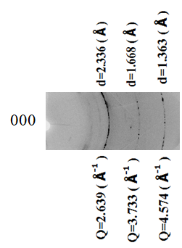

Supplementary Fig.1. two-dimensional X-ray diffraction images of Sb₂S₃ at pressure of 42.5 GPa and ambient temperatures obtained in an angle-dispersive mode. Each Q(d) value corresponds to a diffraction ring. The scale for Q and d-spacing are given, and they correspond to each other.

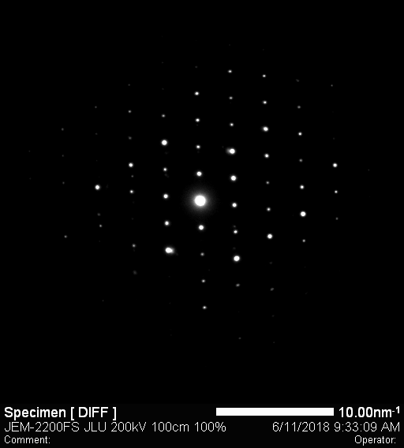
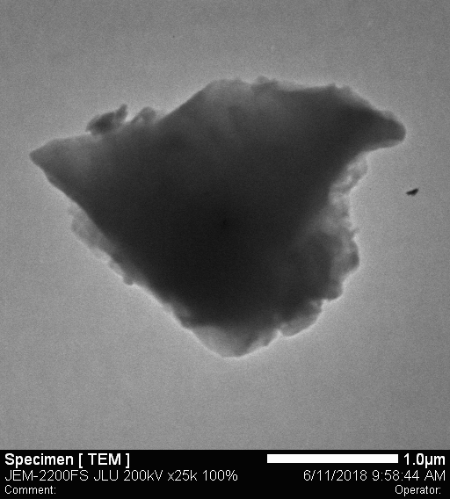

(a) (b) (c)

Supplementary Fig.2. The morphological studies of the sample powders via SEM (a) and TEM (b,c) techniques. The select area electron beam diffractions (SAED) indicate each particle is a single crystalline grain. The particle size of the sample is about 2-3 μm in diameter.

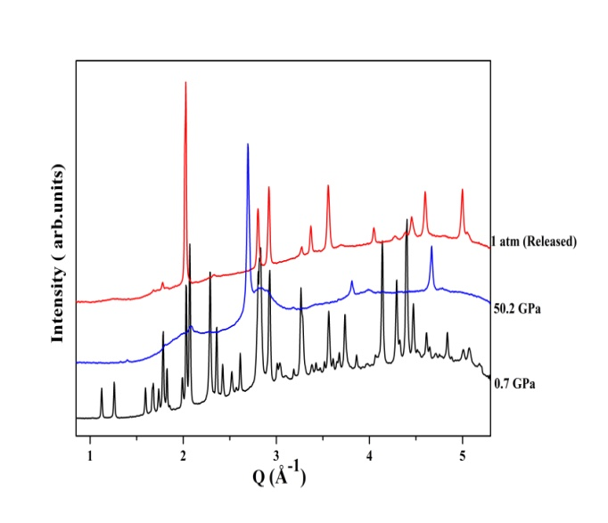
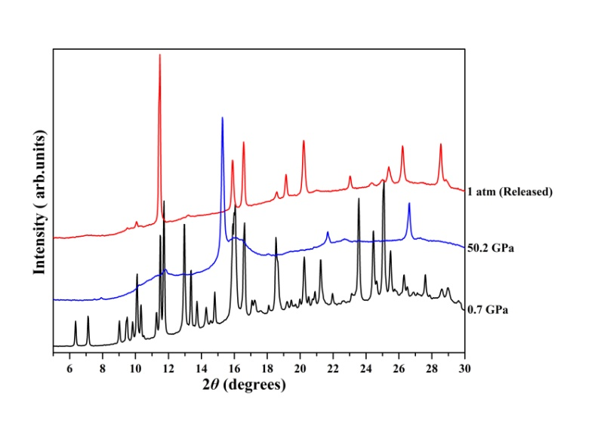

Supplementary Fig.3. XRD patterns collected at 0.7GPa, 50.2 GPa and after pressure release for Sb₂S₃ with an incident wavelength λ = 0.6199 Å. The existing peaks in the released pattern match those in the starting pattern very well. Apparently, there is not bcc phase quenched

