Afar triple junction triggered by plume-assisted bi-directional continental break-up
Alexander Koptev^{1,2}, Taras Gerya³, Eric Calais⁴, Sylvie Leroy¹, and Evgueni Burov^{1Ϯ}

¹Sorbonne Université, CNRS, Institut des Sciences de la Terre de Paris (ISTeP), Paris, France ²Department of Geosciences, University of Tübingen, Tübingen, Germany
³ETH-Zurich, Institute of Geophysics, Sonnegstrasse 5, 8092 Zurich, Switzerland
⁴Ecole Normale Supérieure, Dept. of Geosciences, PSL Research University, CNRS UMR 8538, Paris, France

^{Ϯ} Deceased 9 October 2015

SUPPLEMENTARY TABLES

Supplementary Table 1. Controlling parameters and resulting deformation style of 3D experiments.
Experiment title | Controlling parameters |  | Deformation mode | Supplementary Figure
Experiment title | EW extension, V_{ext} (mm/yr) | Northward pull,  V_{pull} (mm/yr) | Deformation mode | Supplementary Figure
Model 1 | 0 | 0 | axisymmetric deformation | Suppl. Fig. 2m
Model 2 | 0 | 4 | EW linear rift | Suppl. Fig. 2n
Model 3 | 0 | 0-6 | WNW-ESE linear rift | Suppl. Fig. 2o
Model 4 | 0 | 3-6 | WNW-ESE linear rift | Suppl. Fig. 2p
Model 5 | 0 | 6-12 | EW linear rift | Suppl. Fig. 2q
Model 6 | 0 | 6-18 | EW linear rift | Suppl. Fig. 2r
Model 7 | 3 | 0 | NS linear rift | Suppl. Fig. 2g
Model 8 | 3 | 4 | NS linear rift | Suppl. Fig. 2h
Model 9 | 3 | 0-6 | NS and NW-SE linear rifts | Suppl. Fig. 2i
Model 10 | 3 | 3-6 | triple junction | Suppl. Fig. 2j
Model 11 | 3 | 6-12 | WNW-ESE linear rift | Suppl. Fig. 2k
Model 12 | 3 | 6-18 | EW linear rift | Suppl. Fig. 2l
Model 13 | 6 | 0 | ridge-transform pattern | Suppl. Fig. 2a
Model 14 | 6 | 4 | NS linear rift | Suppl. Fig. 2b
Model 15 | 6 | 0-6 | NS linear rift | Suppl. Fig. 2c
Model 16 | 6 | 3-6 | ridge-transform pattern | Suppl. Fig. 2d
Model 17 | 6 | 6-12 | triple junction | Suppl. Fig. 2e
Model 18 | 6 | 6-18 | four interconnected triple junctions | Suppl. Fig. 2f

SUPPLEMENTARY FIGURES
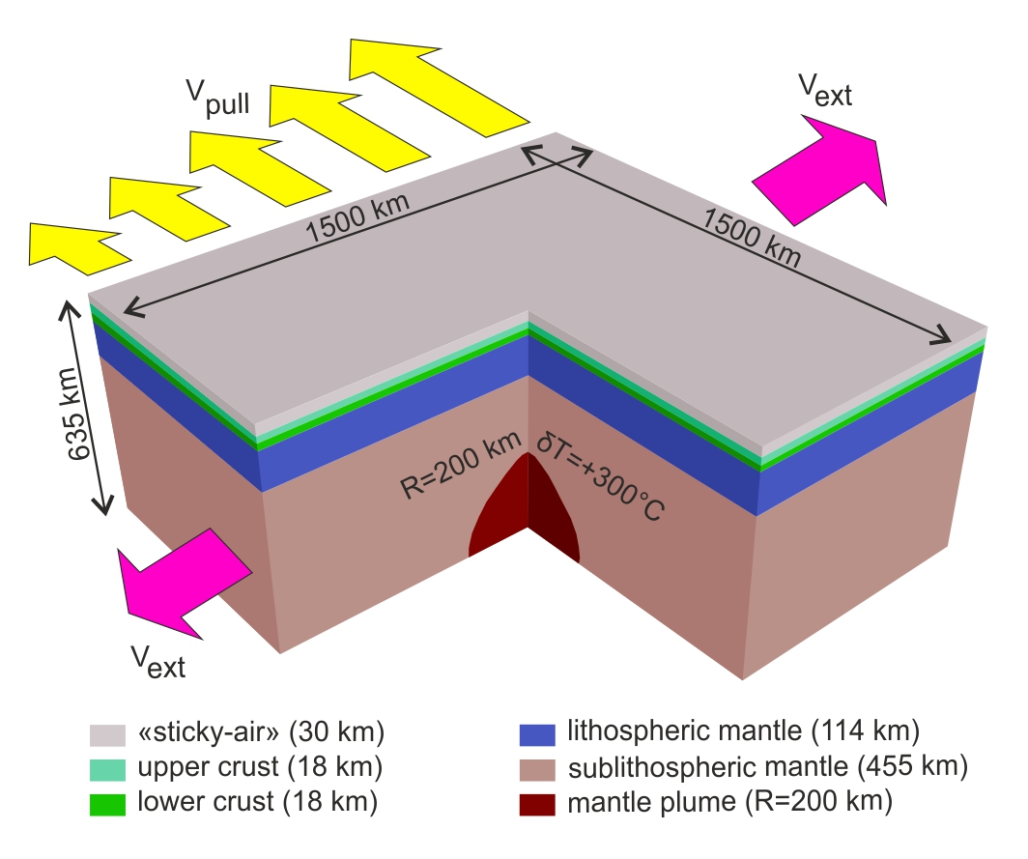
Supplementary Figure 1. Model setup. Symmetrical EW extension (V_{ext}) and laterally varying northward pull (V_{pull}) are shown by green and blue arrows, respectively.

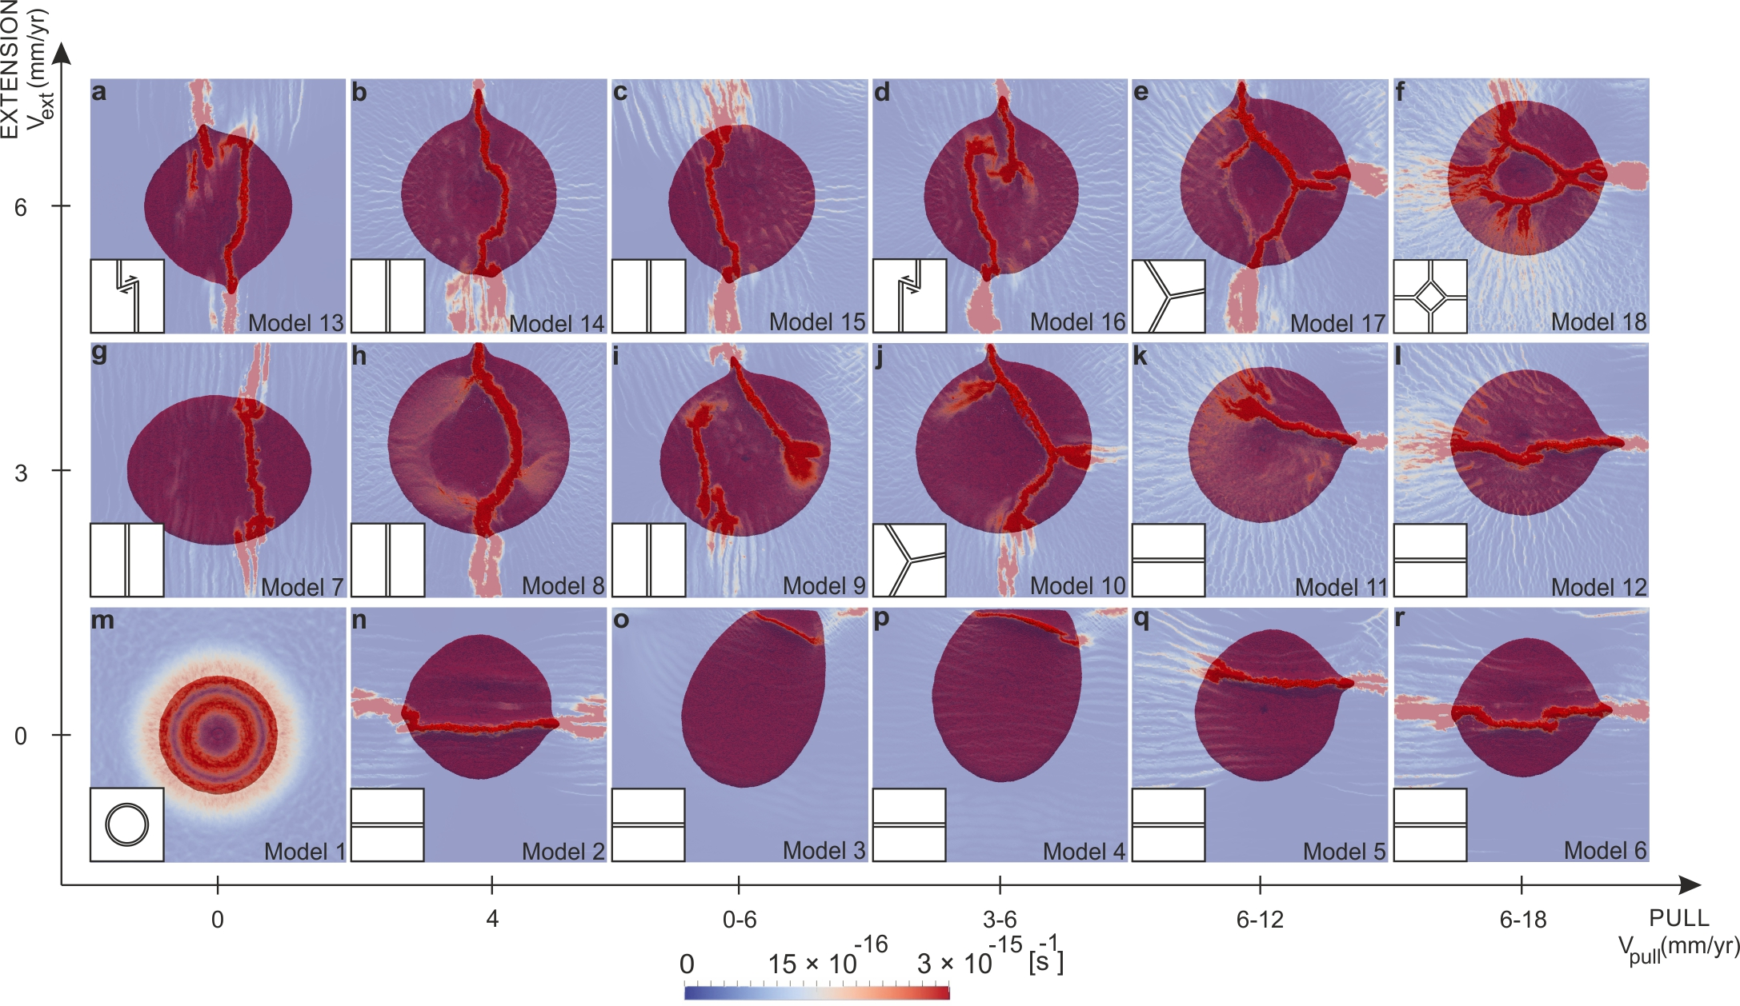
Supplementary Figure 2. Top view of all performed 3D experiments (see Supplementary Table 1). Blue to red colors indicate crustal strain rate at the level of 10 km (i.e. in the upper crust). The plume material is shown in dark red.
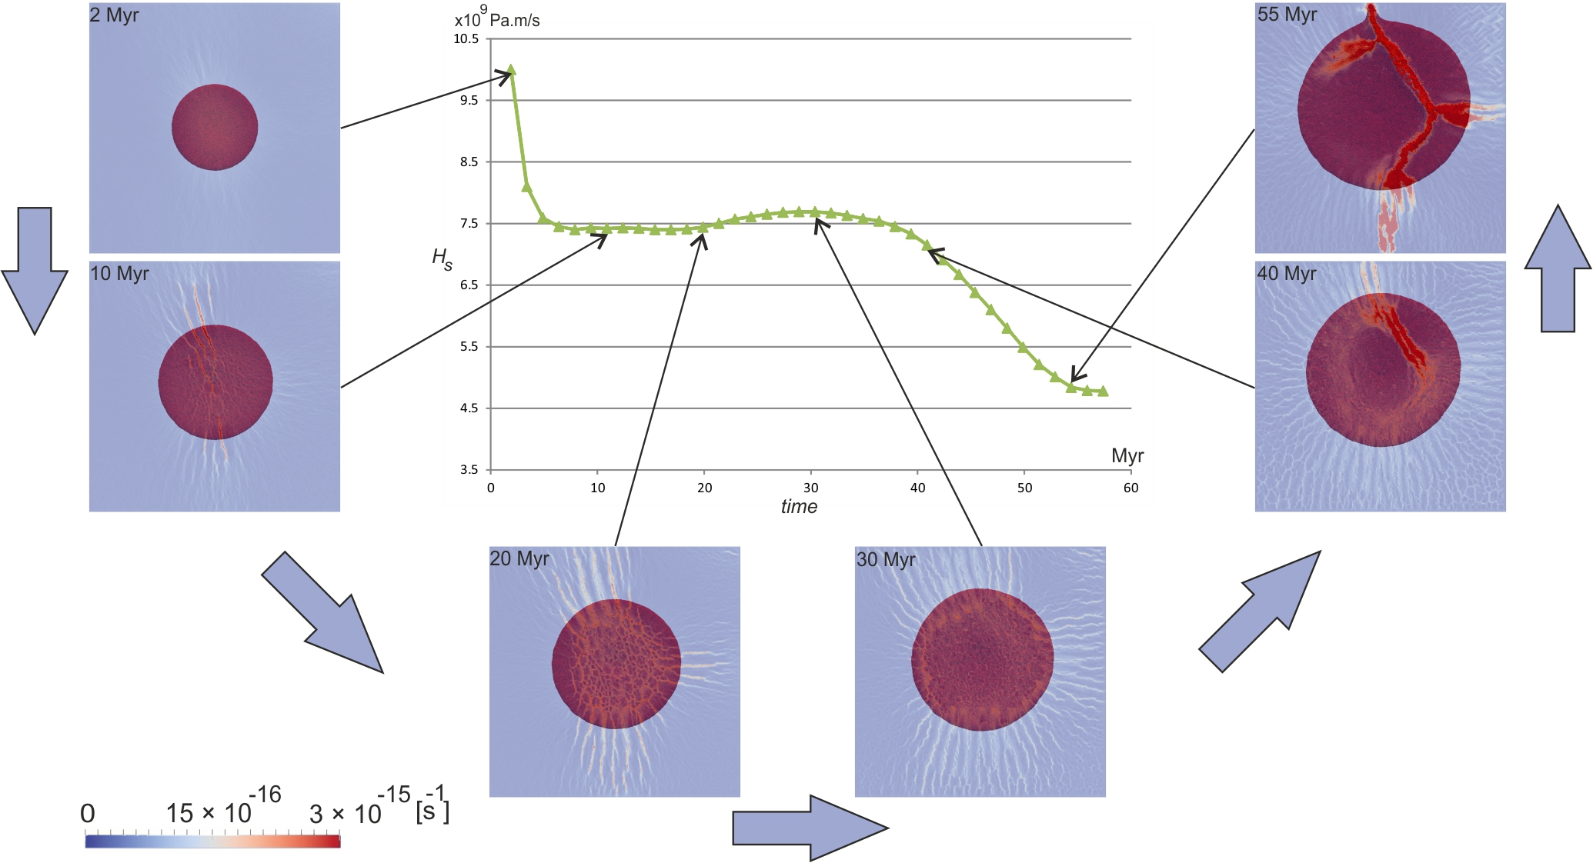
Supplementary Figure 3. Temporal evolution of triple junction model (see Fig. 2f; Fig. 3). The graph in center shows the shear heat production (H_{s}) that is related to dissipation of the mechanical energy during irreversible non-elastic (e.g., viscous) deformation. Note that self-organized break-up geometry presumably maximizes the rate of decrease in the mechanical work needed for deformation. Total strain, localized on rift basins over the last 10-15 Myr of the model evolution, amounts to 40 km of total extension, in approximate accord with geological estimates from the Main Ethiopian rift (Corti, 2009) to Turkana (Hendrie et al., 1994). However, this agreement is not an accurate model validation given that the model parameters were not specifically tuned to match the details of tectonics observed in the studied area.

References
Corti, G. Continental rift evolution: from rift initiation to incipient break-up in the Main Ethiopian Rift, East Africa. Earth-Science Reviews 96, 1–53 (2009).
Hendrie, D. B., Kusznir, N. J., Morley, C. K. & Ebinger, C. J. Cenozoic extension in northern Kenya: a quantitative model of rift basin development in the Turkana region. Tectonophysics 236, 409-438 (1994).

