Supplementary Information

Photosystem-II D1 protein mutants of Chlamydomonas reinhardtii in relation to metabolic rewiring and remodelling of H-bond network at QB site

Amina Antonacci¹, Maya D. Lambreva¹, Andrea Margonelli¹, Anatoly Sobolev², Sandro Pastorelli¹, Ivo Bertalan³, Udo Johanningmeier³, Vladimir Sobolev⁴, Ilan Samish^{4,5}, Marvin Edelman⁴, Vesa Havurinne⁷, Esa Tyystjärvi⁷, Maria T. Giardi¹, Autar K. Mattoo^{6*}, and Giuseppina Rea^{1*}

¹Institute of Crystallography, National Research Council of Italy, Via Salaria Km 29,3 00015 Monterotondo Stazione, Rome, Italy
²Institute of Chemical Methodologies, National Research Council of Italy, Via Salaria km 29,3 00015 Monterotondo Stazione, Rome, Italy
³Current address: Neotron S.p.a., Santa Maria di Mugnano, Modena, Italy

⁴Martin-Luther-University, Plant Physiology Institute, Weinbergweg 10 D-06120 Halle (Saale), Germany
⁵Department of Plant and Environmental Sciences, Weizmann Institute of Science, Rehovot, Israel
⁶Current address: Amai Proteins Ltd., 2 Bergman St. Rehovot, Israel
⁷Department of Biochemistry/Molecular Plant Biology, FI-20014, University of Turku, Turku, Finland
⁸The Henry A Wallace Beltsville Agricultural Research Centre, United States Department of Agriculture, Sustainable Agricultural Systems Laboratory, Beltsville, Maryland 20705, USA

*To whom correspondence should be addressed:
giuseppina.rea@ic.cnr.it; telephone: +390690672631 fax: +390690672630
Autar.Mattoo@ars.usda.gov; telephone: +1 3015046622; fax +1 301 5046492

Figures and Tables are organized as they appear in the running text.
Short Legend
Figure S1. The growth rate of different C. reinhardtii IL, A250R and S264K strains.
Figure S2. Accumulation levels of carotenoids in C. reinhardtii IL, A250R and S264K strains under physiological conditions.
Figure S3. An expanded PCA scores plot region where A250R and S264K sample scores are located.
Figure S4. Correlation plots for b-carotene/a-carotene (A) and chlorophylls a and b (B).
Figure S5. Chla content per cell in the C. reinhardtii strains.
Figure S6. Schematic representation of the C. reinhardtii strains response to HL/HT.
Table S1. Photosynthetic parameters of IL parent strain and D1 site-directed mutants of C. reinhardtii.
Table S2. NMR signal assignment and quantification of metabolite levels.
Table S3. PCA analysis reporting ratios (A250R/S264K) of mean values of pigments.
Table S4. Primer pairs used in the two-step PCR for the site-directed mutagenesis.
Table S5. Sequences of primers used in the qRT-PCR experiments.

Figure S1. The time courses of cell culture growth A) and chlorophylls accumulation B) of C. reinhardtii D1 strains during a period of 168 h. The difference between the mutants and the parent strain gradually increased with time. At least three separate repetitions were done per each strain. Each point represents the average of three experiments ± SD. P≤0.05 (Mann-Whitney U Test).
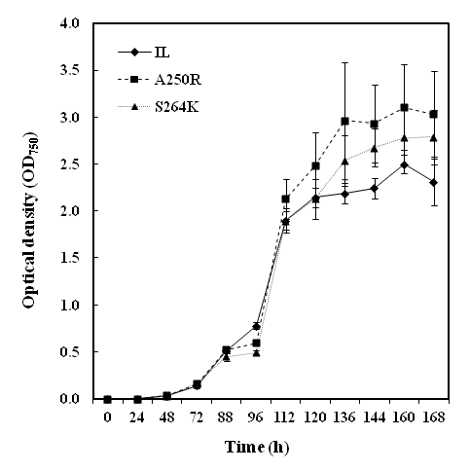
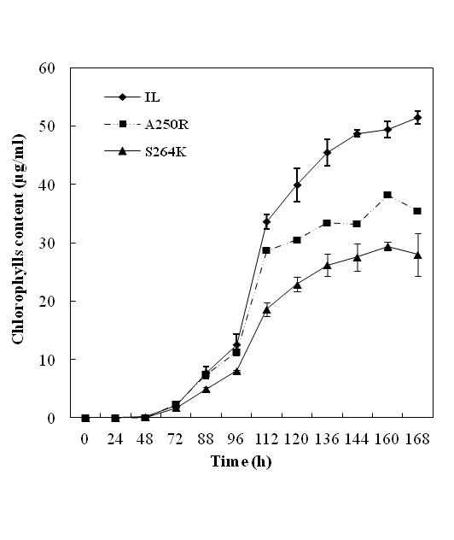
A
B

Table S1. Photosynthetic parameters of IL parent strain and D1 site-directed mutants of C. reinhardtii. All parameters were determined in cell cultures in early-exponential growth phase, corresponding to OD₇₅₀=0.35±0.05. The maximum quantum yield of PSII photochemical reaction (F_{v}/F_{m}=(F_{m}-F₀)/F_{m}) and the PSII electron transport efficiency (1-V_{J}=(1-(F_{J}-F₀)/(F_{m}-F₀)) were calculated from the OJIP fluorescence transients according to¹. Photosynthetic capacity, photosynthetic efficiency, light compensation point and dark respiration were calculated from the light dependency curves of oxygen evolution according to².
Parameters | Strains
 | IL | A250R | S264K
pg Chla⁴ cell⁻¹ | 0.0086±0.0019 | 0.005±0.0010 | 0.0035±0.0004
pg Chlb⁴ cell⁻¹ | 0.0035±0.0008 | 0.0021±0.0004 | 0.0013±0.0002
pg Chl(a+b)⁴ cell⁻¹ | 0.0103 ± 0.0011 | 0.0063 ± 0.0006 | 0.0043 ± 0.0003
Chla/b | 2.49±0.04 | 2.54±0.07 | 2.50±0.03
Fv/Fm | 0.792 ± 0.005 | 0.753 ± 0.006 | 0.706 ± 0.006
1-V_{J} | 0.56 ± 0.03 | 0.41 ± 0.02 | 0.23 ± 0.01
Photosynthetic capacity  (µmol O₂ mg Chl⁻¹ h⁻¹) | 79 ± 2 | 55 ± 6 | 34 ± 2
Photosynthetic efficiency  (µmol O₂ mg Chl⁻¹ h⁻¹)/ (µmol photon m⁻² s⁻¹) | 0.5 ± 0.1 | 0.4 ± 0.0 | 0.3 ± 0.0
Light compensation point  (µmol photon m⁻² s⁻¹) | 48 ± 5 | 59 ± 3 | 76 ± 4
Dark respiration  (µmol O₂ mg Chl⁻¹ h⁻¹) | 21 ± 1 | 20 ± 1 | 27 ± 2

¹Strasser, R.J., Srivastava, A. & Tsimilli-Michael, M. The fluorescence transient as a tool to
characterize and screen photosynthetic samples. In Probing Photosynthesis: Mechanism,
Regulation and Adaptation (eds. Yunus, M., Pathre, U., Mohanty, P.) 443-480 (Taylor and
Francis, London, 2000).
²Walker, D. The use of the oxygen electrode and fluorescence probes in simple
measurements of photosynthesis,
http://citeseerx.ist.psu.edu/viewdoc/download?doi=10.1.1.129.2517&rep=rep1&type=pdf (1990).
³Lichtenthaler, H.K. Chlorophylls and carotenoids: pigments of photosynthetic biomembranes.
Methods Enzymol. 148, 350-382 (1987).

Figure S2. Carotenoid pigments accumulation in C. reinhardtii IL, A250R and S264K strains under physiological conditions. The content of zeaxanthin, anteraxanthin and violaxanthin (A), lutein (B) and β-carotene (C) per cell are presented. At least three separate runs in HPLC system were done per each strain. The values represent the average ± SD, n=9. P≤0.05 (Mann-Whitney U Test).

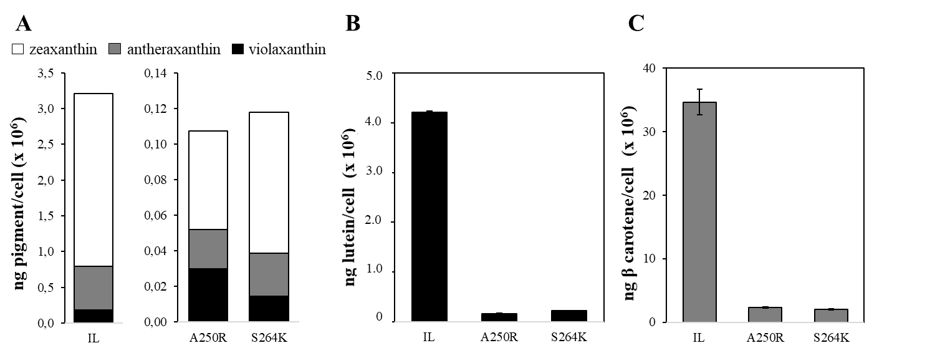

Table S2. NMR signal assignment and quantification of metabolite levels.
Num | Ppm | Assignment | Mean IL | SD_IL | Mean A250R | SD_A | Mean S264K | SD_S
1 | 9.365 | NAD | 1.97 | 0.33 | 1.12 | 0.45 | 0.80 | 0.23
7 | 8.605 | AMP | 2.41 | 0.85 | 2.24 | 0.46 | 3.05 | 0.14
10 | 8.488 | Formic A | 28.60 | 10.37 | 28.86 | 7.61 | 38.95 | 5.45
31 | 7.574 | Uracil | 0.40 | 0.14 | 0.45 | 0.17 | 0.29 | 0.16
33 | 7.454 | Phe | 0.36 | 0.26 | 0.60 | 0.10 | 0.69 | 0.19
37 | 6.93 | Tyr | 0.32 | 0.19 | 0.65 | 0.21 | 0.69 | 0.14
38 | 6.536 | Fumaric A | 0.62 | 0.14 | 0.71 | 0.44 | 1.13 | 0.34
49 | 5.46 | Maltodextr | 2.85 | 1.25 | 1.26 | 0.26 | 3.20 | 1.00
88 | 3.037 | Lys | 1.56 | 0.96 | 1.94 | 0.48 | 2.45 | 0.76
102 | 2.708 | DHU | 0.50 | 0.23 | 0.50 | 0.18 | 1.02 | 0.56
104 | 2.687 | Malic A | 0.46 | 0.08 | 1.03 | 0.51 | 1.13 | 0.27
109 | 2.422 | Succinic A | 24.14 | 5.88 | 28.27 | 9.10 | 36.35 | 3.40
110 | 2.378 | Glu | 15.09 | 6.44 | 15.14 | 6.34 | 14.95 | 8.38
117 | 1.95 | Acetic A | 49.71 | 42.09 | 143.01 | 137.59 | 71.97 | 43.95
118 | 1.829 | Putrescine | 19.86 | 7.93 | 30.86 | 14.96 | 29.24 | 2.93
121 | 1.51 | Ala | 28.32 | 2.37 | 36.13 | 3.32 | 39.99 | 0.74
132 | 1.064 | Val | 3.65 | 0.40 | 3.46 | 0.10 | 3.24 | 0.24
133 | 1.029 | Ile | 0.57 | 0.08 | 0.61 | 0.17 | 0.61 | 0.05
134 | 0.984 | Leu | 5.26 | 1.24 | 4.87 | 0.51 | 5.49 | 0.62
 | 1.35 | Thr | 3.89 | 0.74 | 2.68 | 0.89 | 2.29 | 0.25
 | 1.34 | Lactic A | 35.45 | 16.93 | 43.39 | 16.25 | 25.84 | 10.10
28 | 7.80 |  | 0.18 | 0.06 | 0.41 | 0.13 | 0.24 | 0.10
29 | 7.78 |  | 0.35 | 0.05 | 1.04 | 0.43 | 0.66 | 0.19
30 | 7.73 |  | 0.47 | 0.21 | 1.97 | 1.70 | 1.11 | 0.40
41 | 6.10 |  | 0.57 | 0.21 | 0.21 | 0.06 | 0.22 | 0.07
52 | 4.62 |  | 7.41 | 2.38 | 3.60 | 0.61 | 5.77 | 2.84
63 | 3.78 |  | 94.67 | 7.21 | 85.12 | 18.53 | 81.61 | 5.20
91 | 3.00 |  | 0.39 | 0.06 | 0.67 | 0.12 | 0.60 | 0.25
94 | 2.96 |  | 0.53 | 0.03 | 0.87 | 0.07 | 0.65 | 0.07
99 | 2.82 |  | 2.13 | 0.17 | 0.78 | 0.87 | 0.66 | 0.19
112 | 2.19 |  | 16.19 | 1.66 | 12.05 | 1.33 | 11.48 | 1.15
125 | 1.25 |  | 0.71 | 0.26 | 1.19 | 0.11 | 0.83 | 0.18
126 | 1.23 |  | 1.00 | 0.27 | 1.63 | 0.36 | 1.12 | 0.02
127 | 1.21 |  | 0.30 | 0.08 | 0.59 | 0.12 | 0.62 | 0.27

Figure S3. An expanded PCA scores plot region where A250R and S264K sample scores are located.

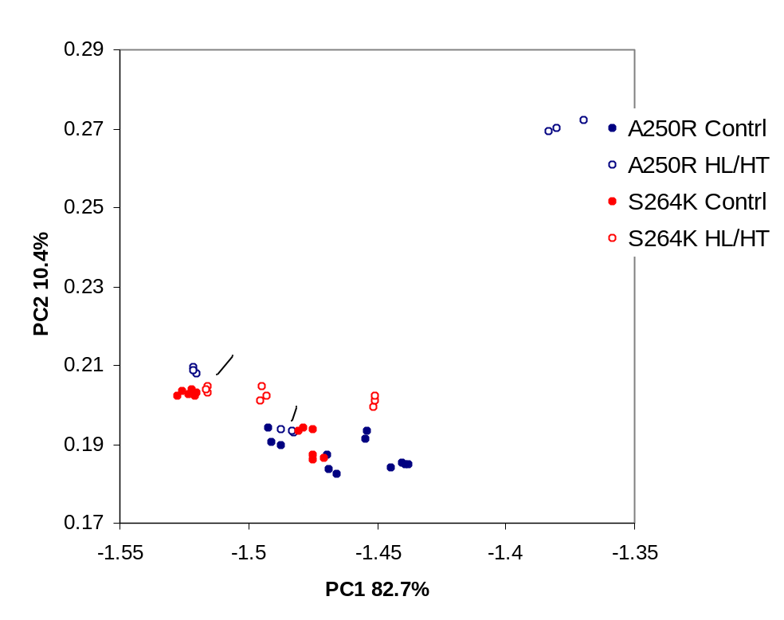

Figure S4. Correlation plots for β-carotene/α-carotene (A) and chlorophylls a and b (B).

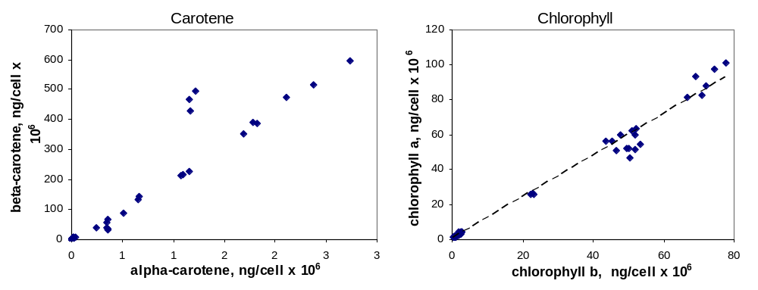

Table S3. Ratios (A250R/S264K) of mean values of pigments. The values are reported only for statistically significant (p<0.05) differences. When the level of a specific pigment is higher in S264K than in A250R, the corresponding value is highlighted by gray background color.

Type | Time | VIO | ANTER | CHL b | LUTEIN | ZEA | CHL a | α-CAR | β-CAR
 | T0 | 0.70 |  | 0.79 | 0.74 | 2.05 | 0.75 |  | 1.12
Control | T15 | 3.42 |  | 2.54 | 2.63 | 7.82 | 2.11 | 2.98 | 1.94
Control | T30 | 1.75 | 2.67 | 1.75 | 6.29 | 7.51 | 1.59 | 3.87 | 4.68
Control | T90 | 1.61 | 1.40 | 1.41 | 1.56 | 1.53 | 1.37 | 1.57 | 1.84
HL/HT | T15 |  | 1.24 | 2.14 | 1.55 |  | 1.91 |  | 1.30
HL/HT | T30 | 0.34 | 1.85 | 0.20 | 0.71 |  | 0.45 | 3.60 | 2.29
HL/HT | T90 | 1.42 | 5.50 | 0.74 | 1.86 | 4.48 | 1.17 | 4.30 | 2.12

Table S4. Sequences of primers used in the two-step PCR for the site-directed mutagenesis. The modified nucleotides in the mutagenic primers (e.g. corresponding to Ala→Arg amino acid substitution in position 250 in D1 protein) are pointed out.

1st PCR |  | 2nd PCR
Primers | Sequence (5’ → 3’) | Primers | Sequence (5’ → 3’)
outer for | GGTGCTGTAATCCCAACTTCT
outer rev | CTAGAGTTAGTTGAAGCTAAGTCTAGAGGGA
A250 rev | TACAATGTTGTAAGTTTCTTCTTC | A250R mut-rev | CGACCAAAGTAACCATGAGCACGTACAATGTTGTAAG
A250 for | GCTCATGGTTACTTTGGTC | A250R mut-for | CAACATTGTACGTGCTCATGGTTACTTTGGTCGTC
S264 rev | AGCGTATTGGAAGATTAG | S264K mut-rev | GAACGAGAGTTGTTGAATTTAGCGTATTGGTTC
S264 for | TTCAACAACTCTCGTTC | S264K mut-for | CGTCTAATCTTCCAATACGCTAAATTCAACAACTC

Table S5. Specific primers used for qRT-PCR analysis and amplified fragments size

Gene | Primer sequence (5'→3') | Amplified fragment size (cDNA bp) | C. reinhardtii  loci
psy | TGGATGAGCTGGACAAGT  GTCCGTGAAGTATTGCCG | 140 | AY604702
pds | ACCATGACTGAGCTGGAG CTTGTACTTGCGGATCTTGG | 78 | XM_001690807
lyc-β | TGACGCTGTTCTGGAAGA CTCCTTGAGCGACATTGT | 140 | AY860818
lyc-ε | CAAGTTCCTGCGCTATGA GCCTGAAATCCATGAAGGTC | 128 | XM_001696477
chy-β | CAACCTGCCGTACATGAA CCCAGAAACATGCCGAA | 90 | XM_001698646
zep | AGGACAGCCGCATTTTG TCAACCCACTTGCTCCA | 112 | XM_001701649
vdr1 | CCTTCTACTTGTCGGTATTGG TTCTCATCGCAGTCCACA | 73 | XM_001694990
mpbq-mt | CACCCCTACTTCATCTCCAT GTGTTCTTGTTCCAGTCCTC | 95 | XM_001692671
hst1 | ACCAGCCTCTACACCTTT TGTACACGCCGAAGTTGA | 136 | XM_001695289
rack1 | TGCAAGTACACCATTGGC CCAGACCTTGACCATCTTGT | 123 | XM_001698013

Figure S5. A. Diameter of IL, A250R and S264K cells (µm) with relative standard deviations, and the Feret diameters, defined as the longest distance between two points along the perimeter of a particle. B. Chla content per cell in C. reinhardtii strains. The average values of three independent experiments are shown. The ratio Chla/cell was calculated, using the average value for the chlorophyll content and the cell number in each independent experiment. For each independent experiment three internal repetitions were done. The values represent the average ± SD, n=9. P≤0.05 (Mann-Whitney U Test).

