FUNCTIONAL ANALYSIS OF HUMAN PATHOLOGICAL SEMEN SAMPLES IN AN OOCYTE CYTOPLASMIC EX VIVO SYSTEM

Farners Amargant^{1,2}, Désirée García³, Montserrat Barragán², Rita Vassena^{2*}, Isabelle Vernos.^{1,4,5*}

Affiliations:
¹ Cell and Developmental Biology Programme, Centre for Genomic Regulation (CRG), Barcelona Institute of Science and Technology, Doctor Aiguader 88, 08003 Barcelona, Spain.
² Clínica EUGIN, Travessera de les Corts 322, Barcelona, 08029, Spain.
³ Fundació EUGIN, Travessera de les Corts 314, Barcelona, 08029, Spain.
⁴ Institució Catalana de Recerca I Estudis Avançats (ICREA), Passeig de Lluis Companys 23, 08010 Barcelona, Spain
⁵ Universitat Pompeu Fabra (UPF), Barcelona, Spain

*To whom correspondence should be addressed:
rvassena@eugin.es, isabelle.vernos@crg.es

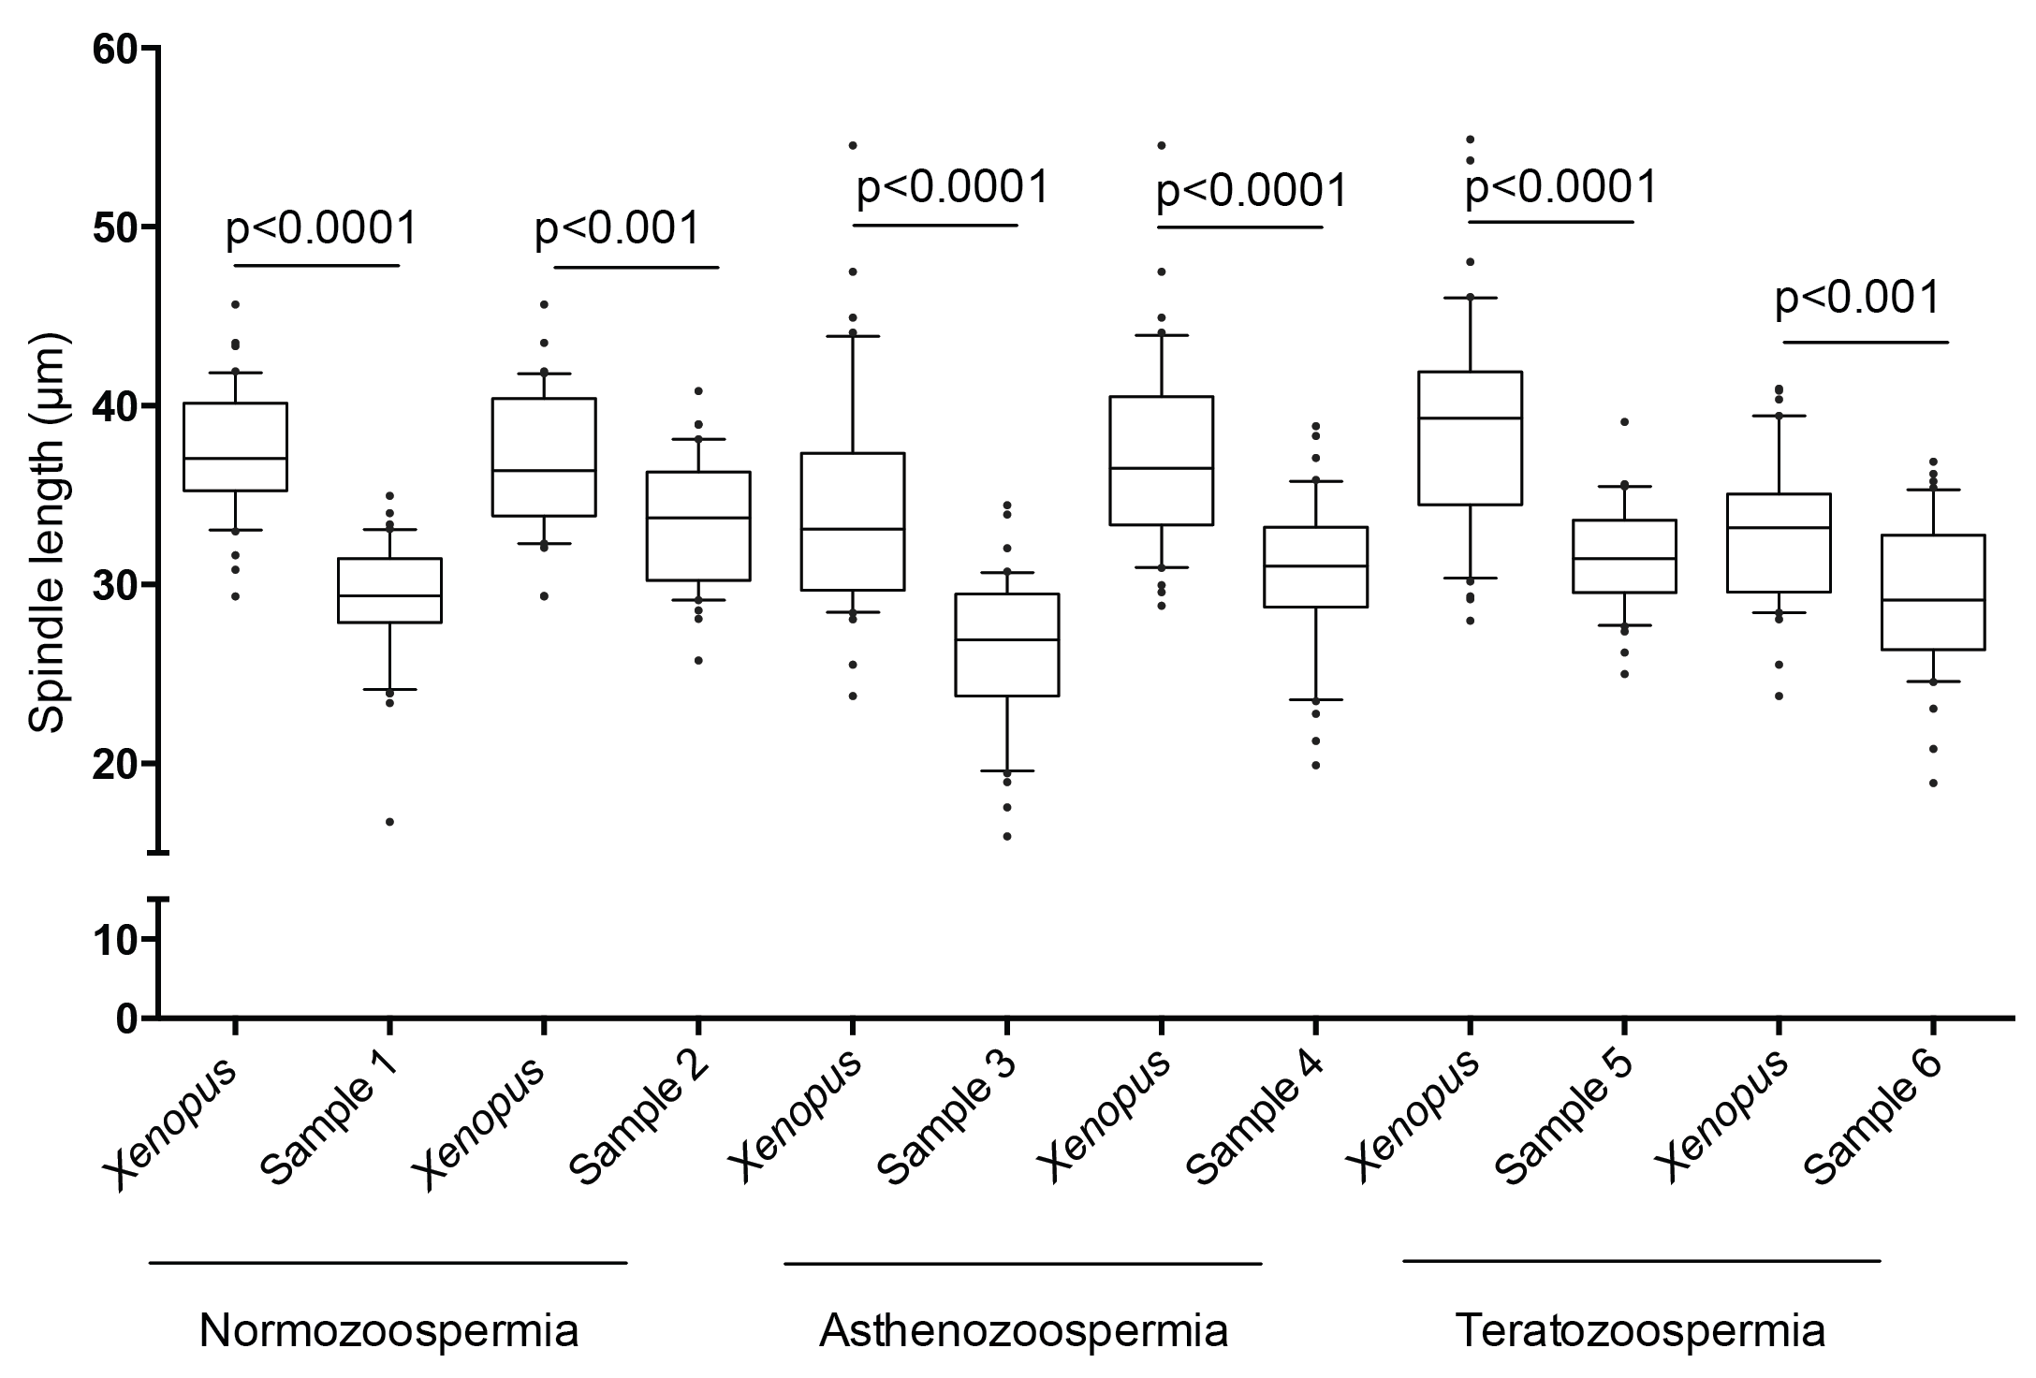

Supplementary Figure 1
Bipolar spindles assembled around human sperm are smaller than those assembled around Xenopus sperm. The graph shows the length of bipolar spindles assembled by Xenopus sperm and normozoospermic, asthenozoospermic and teratozoospermic human samples.

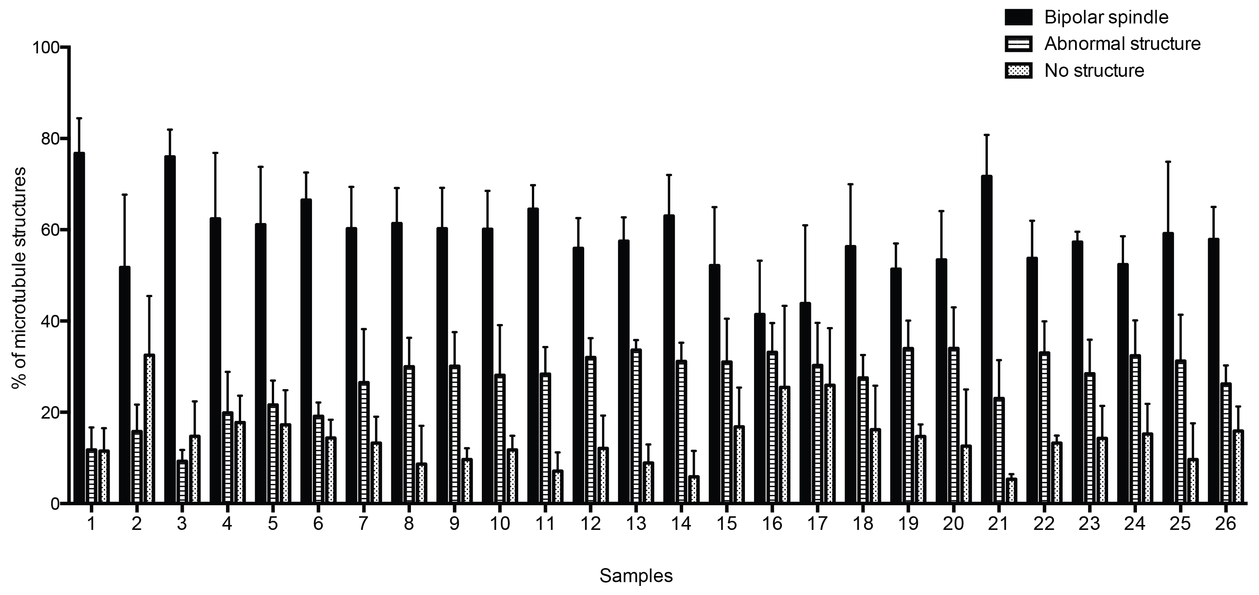

Supplementary Figure 2
Microtubule structures formed upon incubation of individual human semen samples with different diagnosis in XEE. The graph shows the percentage of bipolar spindles, abnormal structures and no structures per semen sample.

Supplementary Table 1
Conditions tested to optimise the human sperm membrane destabilization
CONDITION | BIPOLAR SPINDLES (%) | ABNORMAL STRUCTURES (%) | NO STRUCTURES (%)
Xenopus | 60.8 | 24.2 | 15.0
Human not treated | 2.3 | 0.9 | 96.8
Lysolecithin 1.5% | 9.0 | 2.2 | 88.8
Lysolecithin 1.5% + 1mM DTT | 57.3 | 22.0 | 20.7
Triton 0.05% | 13.3 | 1.6 | 85.1
Triton 0.25% | 2.2 | 5.0 | 92.7
Triton 0.25% + 1mM DTT | 65.3 | 20.7 | 14.0
NP40 0.05% | 5.4 | 3.6 | 91.0
NP40 0.25% | 12.4 | 3.7 | 83.9
NP40 0.25% + 1mM DTT | 65.7 | 18.7 | 15.7
1mM DTT | 50.7 | 20.0 | 29.3

