Direct observation of symmetrization of hydrogen bond in δ-AlOOH under mantle conditions using neutron diffraction

Supplementary information

Asami Sano-Furukawa^{1*}, Takanori Hattori¹, Kazuki Komatsu², Hiroyuki Kagi², Takaya Nagai³, Jamie J. Molaison⁴, António M. dos Santos⁴ and Christopher A. Tulk⁴

¹ J-PARC Center, Japan Atomic Energy Agency, Tokai-mura, Ibaraki 319-1195, Japan.
² Geochemical Research Center, Graduate School of Science, The University of Tokyo, Tokyo 113-0033, Japan.
³ Department of Natural History of Sciences, Faculty of Science, Hokkaido University, Sapporo 060-0810, Japan.
⁴ Neutron Scattering Division, Oak Ridge National Laboratory, Oak Ridge, Tennessee 37831, U.S.A.

* Correspondence to sanoasa@post.j-parc.jp

Supplementary Figure S1
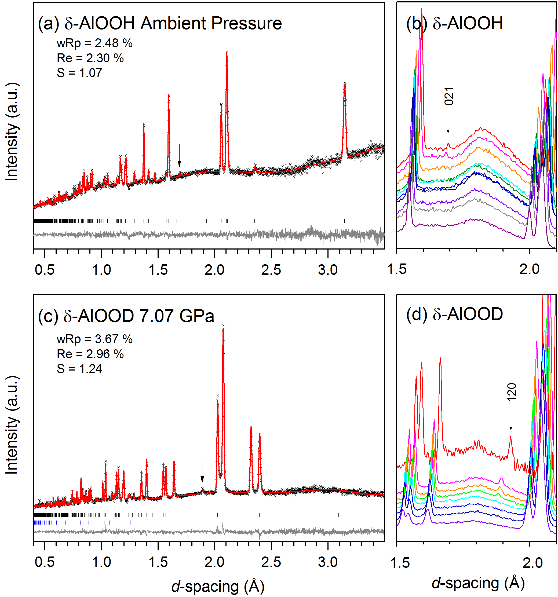
Supplementary Figure S1: Rietveld fits of profiles of (a) δ-AlOOH and (c) δ-AlOOD with P2₁nm model and (b, d) enlarged raw profile around d-spacing of 2 Å. The allows in (a) and (c) indicate the reflections of 021 and 120, respectively. The measurement conditions were ambient pressure, 2.37, 6.37, 8.40, 9.50, 10.2, 10.9, 13.6, 15.1 and 19.1 GPa for (b) and ambient pressure, 7.07, 8.73, 10.2, 12.0, 13.5, 15.1 and 17.4 GPa for (d) from top to bottom, respectively. The binning of data of (b, d) was Δt = 40 μs to get a good statistics.
Supplementary Figure S2
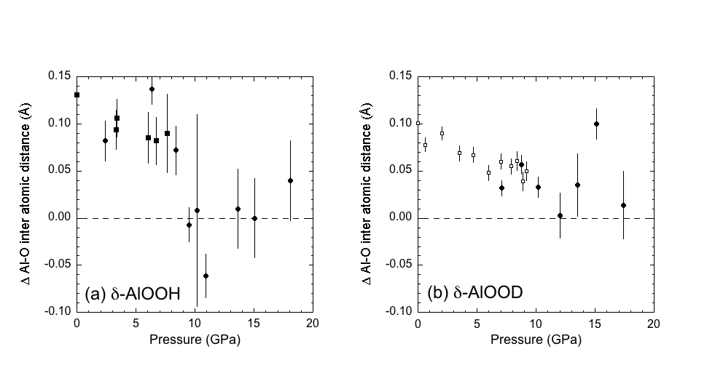
Supplementary Figure S2: Difference of interatomic distances between Al-O2 and Al-O1 at equatorial plane of AlO₆ octahedron. All the data was refined with P2₁nm model. The open symbols in (b) represent the results of the previous study¹. The filled symbols are the results of the present study indicating the individual experimental runs with different symbols.

Supplementary Figure S3

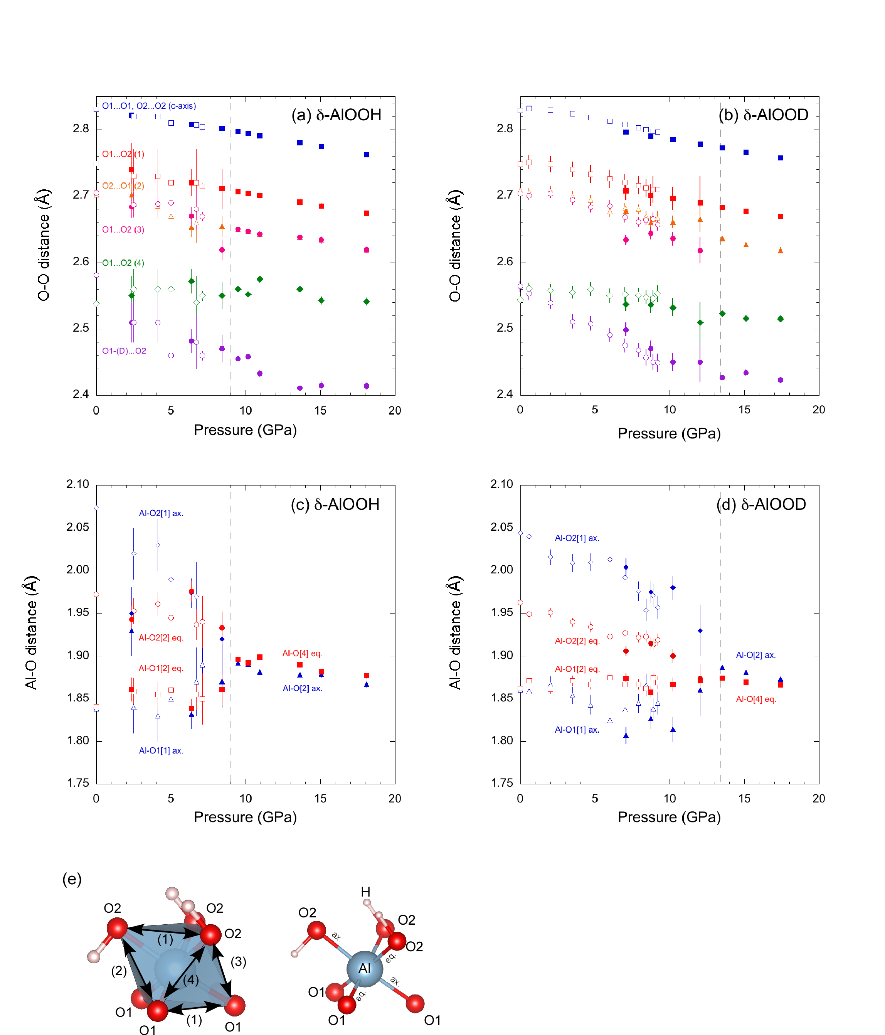

Supplementary Figure S3: (a, b) Variations of O-O distances, and (c, d) axial and equatorial Al-O bond lengths of AlO₆ octahedron in δ-AlOOH and δ-AlOOD. The numbers in the parentheses in the captions of (a) and (b) corresponding to these variations are indicated by the octahedral edge in (e). The numbers in the parentheses in the captions of (c) and (d) indicate the numbers of identical bonds in the octahedra. The open symbols in (b) and (d) represent the results of a previous study¹, and the other symbols are those used in the present study. Results of Rietveld fitting with space group of P2₁nm and Pnnm at below and above the transition pressure are shown. The gray dotted line indicates the transition pressure from P2₁nm to Pnnm.
Supplementary Figure S4

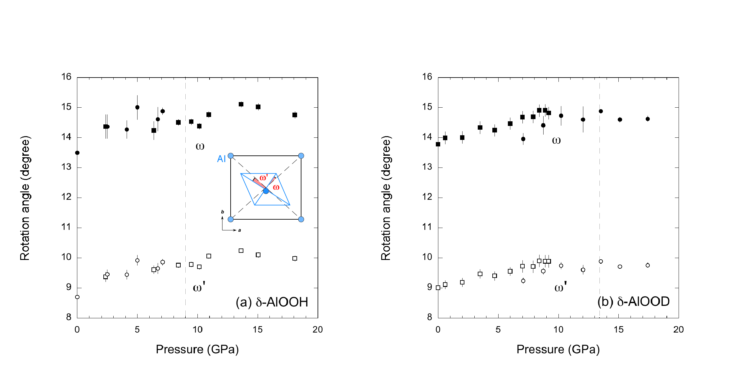

Supplementary Figure S4: Variations of rotation angles ω and ω’ of AlO₆ octahedra in (a) δ-AlOOH and (b) δ-AlOOD. The gray dotted line indicates the transition pressure from P2₁nm to Pnnm.

Supplementary Figure S5

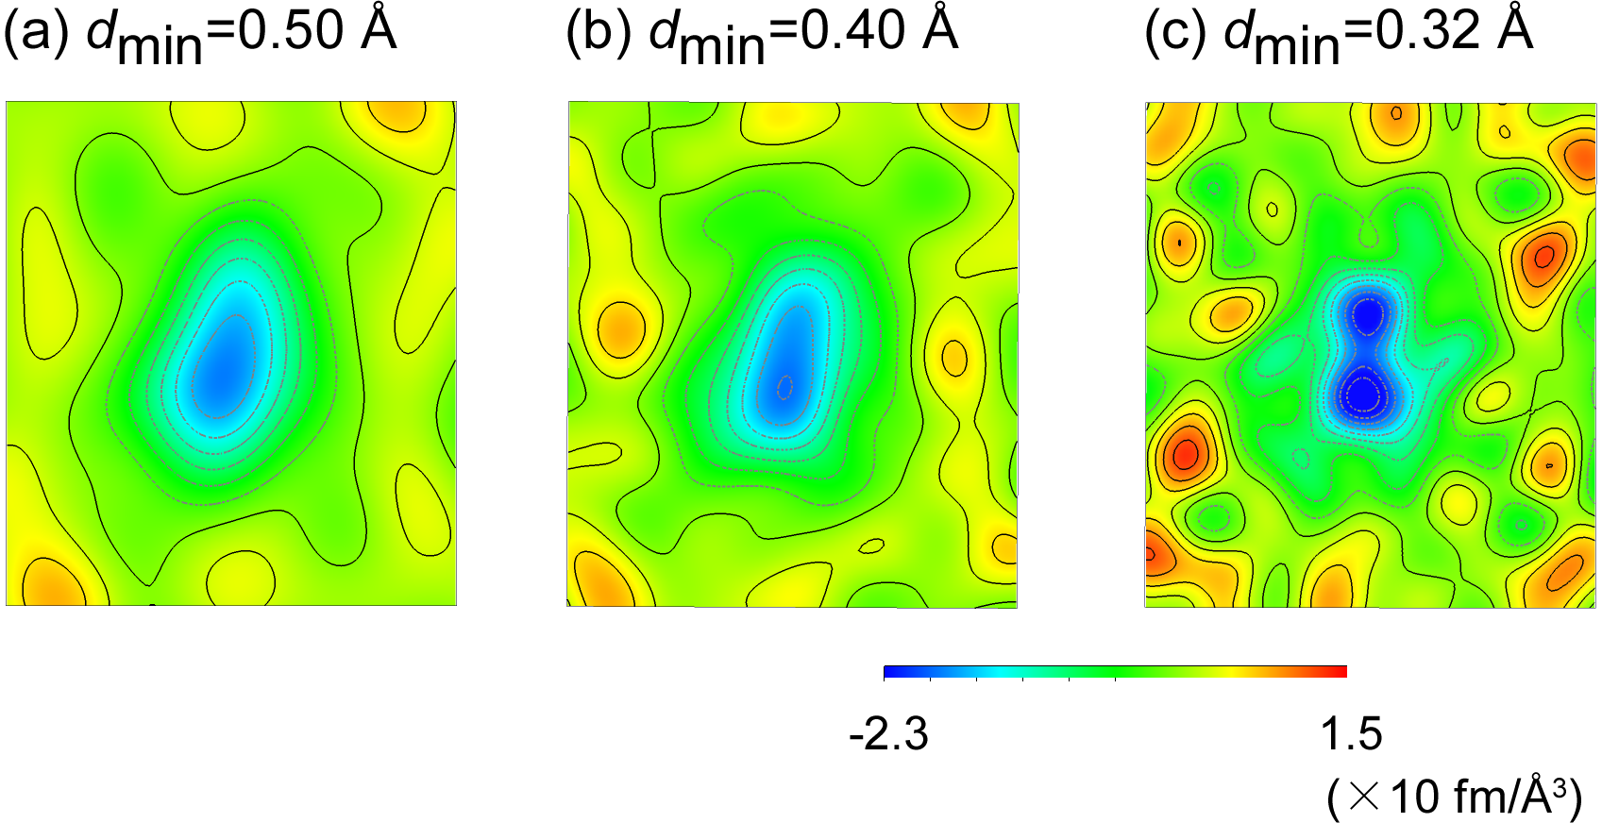

Supplementary Figure S5: Difference Fourier maps of δ-AlOOH in section containing H-bond at ambient pressure using different d-spacing range. The resolution of the Fourier map is determined by the Q_{max}, which was used to synthesize. The maps become blurred when the Q_{max} become small, which corresponds to the larger d-spacing (a, b). In the present study, the d-spacing ranges to 0.32 Å (c) was used in the discussion.

Supplementary Table S1: Details of structure refinements at selected pressures.
Sample | δ-AlOOH |  |  | δ-AlOO(D_{0.744}H_{0.256})
Pressure (GPa) | 6.37 | 9.50 | 18.1 | 10.2 | 17.4
Space group | P2₁nm | Pnnm | Pnnm | P2₁nm | Pnnm
a (Å) | 4.6888(2) | 4.6326(2) | 4.5774(3) | 4.6148(2) | 4.5700(4)
b (Å) | 4.1964(2) | 4.1303(2) | 4.0829(4) | 4.1222(2) | 4.0763(6)
c (Å) | 2.8215(2) | 2.7973(2) | 2.7625(3) | 2.78487(8) | 2.7579(2)
V (Å³) | 54.338(3) | 56.524(3) | 51.628(5) | 52.977(2) | 51.377(6)
Refinement
R_{p} | 2.67 | 2.56 | 3.31 | 3.37 | 4.92
R_{wp} | 2.99 | 2.87 | 3.59 | 3.46 | 5.38
R_{e} | 2.17 | 2.53 | 3.30 | 3.14 | 4.08
S | 1.12 | 1.14 | 1.09 | 1.21 | 1.12
Data points | 3193 | 3193 | 3193 | 3194 | 3194
Parameters | 31 | 27 | 25 | 29 | 23

Notes: R_{WP} = Σ_{i}|y_{i}-f_{i}(x)|/ Σ_{i}y_{i}, R_{P} = [Σ_{i}w_{i}{y_{i}-f_{i}(x)}²/ Σ_{i}w_{i}y_{i}²]^{1/2}, R_{e} = [N-P/ Σ_{i}w_{i}y_{i}²]^{1/2}, S = R_{WP}/R_{e} , where y_{i}, observed intensities; f_{i}(x), calculated intensities; w_{i}, statistical weight; N, Number of data points; P, Number of parameters.

Supplementary Table S2 Atomic positions, isotropic displacement parameters, and H-bond geometry at selected pressures.

 | δ-AlOOH |  |  | δ-AlOO(D_{0.744}H_{0.256})
Pressure (GPa) | 6.37 | 9.50 | 18.1 | 10.2 | 17.4
Spacegroup | P2₁nm | Pnnm | Pnnm | P2₁nm | Pnnm
Al
x | 0 | 0 | 0 | 0 | 0
y | 0.280(3) | 0 | 0 | 0.267(2) | 0
z | 0 | 0 | 0 | 0 | 0
U_{iso}×100 (Å²) | 0.54(16) | 1.22(14) | 0.88(17) | 0.66(7) | 0.46(9)
O1
x | 0.344(3) | 0.3465(5) | 0.3464(6) | 0.338(3) | 0.3478(5)
y | 0.495(2) | 0.2423(8) | 0.2402(10) | 0.492(1) | 0.2429(7)
z | 0 | 0 | 0 | 0 | 0
U_{iso}×100 (Å²) | 0.41(4) | 0.42(3) | 0.59(5) | 0.33(2) | 0.44(4)
O2
x | 0.652(4) |  |  | 0.641(3)
y | 0.008(2) |  |  | 0.0040(12)
z | 0 |  |  | 0
U_{iso}×100 (Å²) | 0.41(4) |  |  | 0.33(2)
H/D
g | 1 | 0.5 | 1 | 1 | 0.5
x | 0.523(5) | 0.479(4) | 1/2 | 0.508(3) | 0.493(7)
y | 0.225(4) | 0.013(5) | 0 | 0.217(2) | 0.012(8)
z | 0 | 0 | 0 | 0 | 0
U_{iso}×100 (Å²) | 2.2(2) | 1.29(19) | 1.8(2) | 1.44(11) | 2.1(2)

Notes: The isotropic atomic displacement parameters in the P2₁nm model of oxygen were constrained to be U_{iso}(O1) = U_{iso}(O2).

Reference
- Sano-Furukawa, A., Komatsu, K., Vanpeteghem, C. B. & Ohtani, E. Neutron diffraction study of δ-AlOOD at high pressure and its implication for symmetrization of the hydrogen bond. Am. Mineral. 93, 1558-1567 (2008).

