Supplementary Material

Weaning Stress Perturbs Gut Microbiome and

Its Metabolic Profile in Piglets
Yuan Li¹, Xuemei Jiang¹, Xin Ma¹, Saisai Cheng¹, Shijie Geng¹, Xinyan Han*¹

*Corresponding author
Xinyan Han
College of Animal Science, Zhejiang University，866 Yuhangtang Road, Hangzhou 310058, China
Tel: +86-0571-88982446
Fax: +86-0571-88982650
E-mail: xyhan@zju.edu.cn

Table S1 The sequences of each sample in colonic contents of nursing and weaned piglets (n=6)
Sample | Clean Readsª | Bases(bp)^{b} | Q20(%)^{c} | Q30(%)^{d} | GC(%)^{e} | Average length(bp)^{f}
Weaned6 | 34729 | 14228621 | 95.68% | 92.62% | 53.21% | 409
Weaned5 | 35573 | 14858091 | 94.71% | 91.23% | 50.99% | 417
Weaned4 | 35260 | 14489685 | 95.63% | 92.52% | 53.07% | 410
Weaned3 | 34666 | 14243111 | 95.58% | 92.47% | 53.37% | 410
Weaned2 | 35138 | 14731095 | 94.92% | 91.62% | 50.36% | 419
Weaned1 | 38994 | 16156088 | 95.25% | 92.04% | 52.08% | 414
Nursing5 | 33749 | 14066316 | 94.70% | 91.15% | 53.73% | 416
Nursing4 | 33994 | 14171670 | 95.09% | 91.74% | 53.73% | 416
Nursing6 | 33401 | 13951973 | 94.69% | 91.17% | 52.99% | 417
Nursing1 | 36594 | 15217278 | 95.04% | 91.68% | 53.74% | 415
Nursing3 | 36178 | 15131736 | 94.98% | 91.59% | 52.32% | 418
Nursing2 | 38865 | 16198744 | 94.99% | 91.64% | 53.76% | 416
Mean reads | 35595
ª Clean Reads： the number of valid sequences
^{b} Bases (bp) ：the total number of bases
^{c} Q20 (%)：the percentage of Q20 bases that make up the total number of bases
^{d} Q30 (%)：the percentage of Q30 bases that make up the total number of bases
^{e} GC (%)：the GC content of the sample
^{f} Average length (bp) the average length of the sample
Table S2 The OTU numbers of each sample in colonic contents of nursing and weaned piglets (n=6)
sample_name | clean reads | mapped reads | mapped ratio(%) | OTUs
Weaned1 | 38994 | 33771 | 86.60563164 | 265
Weaned2 | 35138 | 31111 | 88.53947294 | 104
Weaned3 | 34666 | 29659 | 85.55645301 | 174
Weaned4 | 35260 | 32747 | 92.87294385 | 181
Weaned5 | 35573 | 30875 | 86.79335451 | 264
Weaned6 | 34729 | 29536 | 85.04707881 | 169
Nursing1 | 36594 | 32563 | 88.98453298 | 266
Total OTUs |  |  |  | 1157
Nursing2 | 38865 | 32741 | 84.24289206 | 272
Nursing3 | 36178 | 32127 | 88.80258721 | 220
Nursing4 | 33994 | 28834 | 84.82085074 | 255
Nursing5 | 33749 | 28813 | 85.37438146 | 296
Nursing6 | 33401 | 29428 | 88.10514655 | 275
Total OTUs |  |  |  | 1584
The OTUs were identified based on 97% sequence similarity.
Table S3 The phyla composition of colonic microbiome in nursing and weaned piglets (n=6)
tax_name | Weaned(n=6) | Nursing(n=6) | p
Bacteroidetes | 34.92±24.72% | 55.85±1.83% | 0.07
Firmicutes | 50.82±34.46% | 35.42±8.48% | 0.31
Proteobacteria | 9.27±10.26% | 3.27±1.03% | 0.20
Fusobacteria | 4.38±6.79% | 4.39±7.02% | 0.99
Spirochaetes | 0.06±0.09% | 0.79±0.50% | 0.01
Actinobacteria | 0.52±0.50% | 0.07±0.05% | 0.05
Euryarchaeota | 0.01±0.01% | 0.17±0.15% | 0.03
Synergistetes | 0.01±0.01% | 0.04±0.05% | 0.11
Candidatus Saccharibacteria | 0.00±0.00% | 0.01±0.01% | 0.21
Planctomycetes | 0.00±0.00% | 0.01±0.01% | 0.34
Deferribacteres | 0.01±0.01% | 0.00±0.00% | 0.08
Verrucomicrobia | 0.01±0.01% | 0.00±0.00% | 0.34
Lentisphaerae | 0.01±0.01% | 0.00±0.00% | 0.34
Other | - | - | -
The relative abundance of phyla higher than 0.05% in two groups was shown. The predominant phyla (the average abundance of all samples higher than 1%) including Bacteroidetes, Firmicutes, Proteobacteria, Fusobacteria showed no significant differences between two groups. The proportion of Spirochaetes and Euryarchaeota in colon samples was significantly decreased in the weaned group (P < 0.05).
Table S4 The family composition of colonic microbiome in nursing and weaned piglets (n=6)
tax_name | Weaned(n=6) | Nursing(n=6) | p
Prevotellaceae | 20.44±13.83% | 37.12±4.68% | 0.02
Ruminococcaceae | 19.48±16.81% | 19.98±9.44% | 0.95
Lachnospiraceae | 20.28±13.30% | 7.43±2.33% | 0.04
Porphyromonadaceae | 4.21±2.97% | 17.78±6.41% | 0
Bacteroidaceae | 10.31±11.67% | 4.06±4.90% | 0.25
Lactobacillaceae | 4.21±3.05% | 5.81±1.56% | 0.28
Fusobacteriaceae | 4.40±6.81% | 4.63±7.35% | 0.96
Campylobacteraceae | 6.7±10.23% | 0.32±0.32% | 0.14
Veillonellaceae | 5.63±2.29% | 0.32±0.29% | 0
Acidaminococcaceae | 0.94±0.58% | 0.73±0.25% | 0.44
Desulfovibrionaceae | 0.29±0.28% | 1.06±0.48% | 0.01
Pasteurellaceae | 0.10±0.12% | 1.15±1.47% | 0.11
Spirochaetaceae | 0.06±0.09% | 0.92±0.59% | 0.01
Sutterellaceae | 0.76±1.12% | 0.04±0.06% | 0.15
Rikenellaceae | 0.03±0.04% | 0.77±0.53% | 0.01
Succinivibrionaceae | 0.58±0.78% | 0.00±0.00% | 0.1
Coriobacteriaceae | 0.53±0.51% | 0.05±0.04% | 0.05
Enterobacteriaceae | 0.29±0.37% | 0.25±0.24% | 0.86
Methanobacteriaceae | 0.01±0.01% | 0.19±0.18% | 0.03
Streptococcaceae | 0.06±0.03% | 0.12±0.06% | 0.06
Other | 0.31±0.36% | 0.29±0.12% | 0.89
The relative abundance of families higher than 0.05% in groups was shown. The most predominant families (the average abundance of all samples higher than 10%) were Prevotellaceae and Ruminococcaceae. Followed dominant families were Lachnospiraceae, Porphyromonadaceae, and Bacteroidaceae. Ruminococcaceae showed no significant differences between two groups (P >0.05). The proportion of Prevotellaceae and Porphyromonadaceae was significantly decreased in weaned group. And the relative abundance of Lachnospiraceae was significantly higher than that in nursing group (P < 0.05).

Table S5 The genus composition of colonic microbiome in nursing and weaned piglets (n=6)
tax_name | Weaned(n=6) | Nursing(n=6) | p
Prevotella | 19.18±15.01% | 33.07±4.53% | 0.06
Bacteroides | 11.53±12.53% | 5.22±4.53% | 0.28
Lactobacillus | 5.76±4.37% | 8.86±3.31% | 0.2
Alloprevotella | 1.81±2.23% | 12.81±4.99% | 0
Fusobacterium | 4.72±7.25% | 5.43±8.41% | 0.88
Campylobacter | 8.94±12.59% | 0.46±0.49% | 0.14
Faecalibacterium | 9.02±9.06% | 0.05±0.04% | 0.04
Barnesiella | 1.53±2.89% | 9.21±9.20% | 0.08
Roseburia | 5.28±3.41% | 1.77±1.30% | 0.04
Oscillibacter | 0.69±0.56% | 5.52±6.19% | 0.09
Clostridium XlVb | 2.42±3.26% | 1.92±0.26% | 0.72
Megasphaera | 3.86±4.45% | 0.08±0.11% | 0.06
Blautia | 3.29±3.45% | 0.08±0.06% | 0.05
Clostridium XlVa | 2.42±3.26% | 1.92±0.26% | 0.72
Flavonifractor | 2.78±4.27% | 0.00±0.01% | 0.14
Gemmiger | 2.10±2.56 | 0.61±0.64% | 0.2
Butyricicoccus | 2.46±2.89% | 0.08±0.06% | 0.07
Parabacteroides | 0.33±0.48% | 2.66±3.00% | 0.09
Phascolarctobacterium | 1.24±0.77% | 1.12±0.54% | 0.28
Anaerovibrio | 1.65±0.71% | 0.00±0.00% | 0
Other | 9.47±2.68% | 10.15±2.73% | 0.67
The relative abundance of genera higher than 0.05% in two groups was shown. The most predominant genera (the average abundance of all samples higher than 10%) were Prevotella and Bacteroides, which showed no significant differences between two groups (P>0.05). Followed dominant genera were Lactobacillus and Alloprevotella. The relative abundance of Alloprevotella in Weaned group was significantly lower than that in the Nursing group in colonic microbiota (P < 0.05).
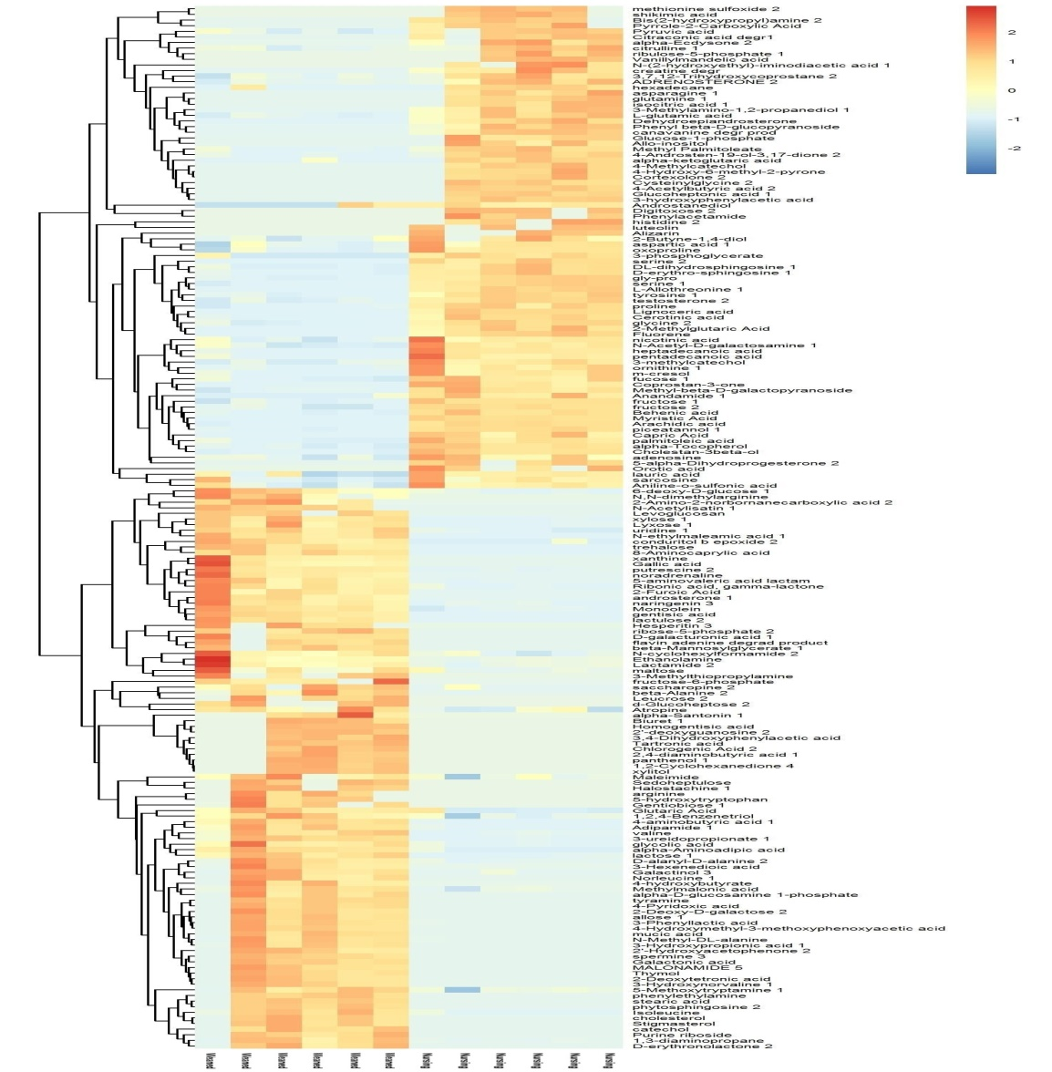
Fig S1 Heatmap of hierarchical clustering analysis for Weaned and Nursing group. The abscissa represents weaned and nursing groups, and the ordinate represents the differential metabolites between two groups. Color patches represent the relative expression of metabolites at the corresponding groups.

