Supplementary Information
Title: GCSH antisense regulation determines breast cancer cells’ viability.
Anna Adamus^{1,2}, Petra Müller², Bente Nissen², Annika Kasten³, Stefan Timm⁴, Hermann Bauwe⁴, Guido Seitz¹, Nadja Engel^{1,2}*
¹ Department of Pediatric Surgery, University Hospital Marburg, Baldingerstraße, 35033 Marburg, Germany.
² Department of Cell Biology, Rostock University Medical Center, Schillingallee 69, 18057 Rostock, Germany.
³ Department of Oral and Maxillofacial Surgery, Facial Plastic Surgery, Rostock University Medical Center, Schillingallee 35, 18057 Rostock, Germany.
⁴ University of Rostock, Plant Physiology Department, Albert-Einstein-Straße 3, 18059 Rostock, Germany.

*Corresponding author:
Nadja Engel, Department of Pediatric Surgery, University Hospital Marburg, Baldingerstraße, 35033 Marburg, Germany.
Tel.: +49 (0) 6421/58-64233 (office), +49 (0) 6421/58-62865 (lab)
Email: (1) nadja.engellutz@staff.uni-marburg.de, (2) nadja.engel-lutz@gmx.de

Supplementary Figures
Supplemental Figure 1. Tv* transient overexpression in the breast cancer cell lines BT20, MDA-MB-231 and the non-tumorigenic control cell lines MCF-10A and MCF12A.
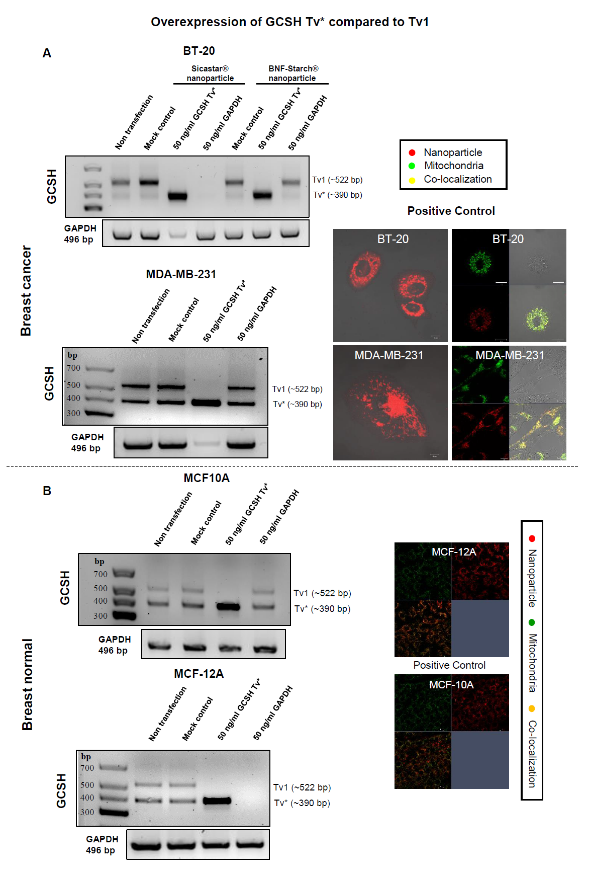

Supplemental Figure 2. Tv* and Tv1-GFP plasmids for stable overexpression.
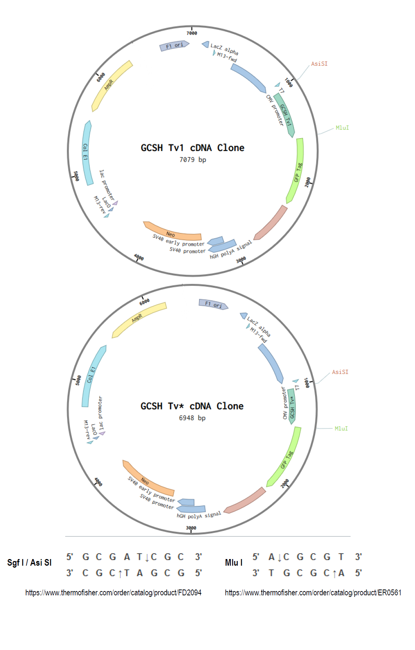

Supplemental Figure 3. Long-term survival and relapse-free survival are determined by low GCSH levels. Histograms were generated with the R2 platform (http://r2platform.com / http://r2.amc.nl), a genomics analysis and visualization platform that provides an interface to high throughput data. A: Kaplan-Meyer curve for the correlation of overall survival with GCSH expression. Red: low GCSH expression. Blue: high GCSH expression.
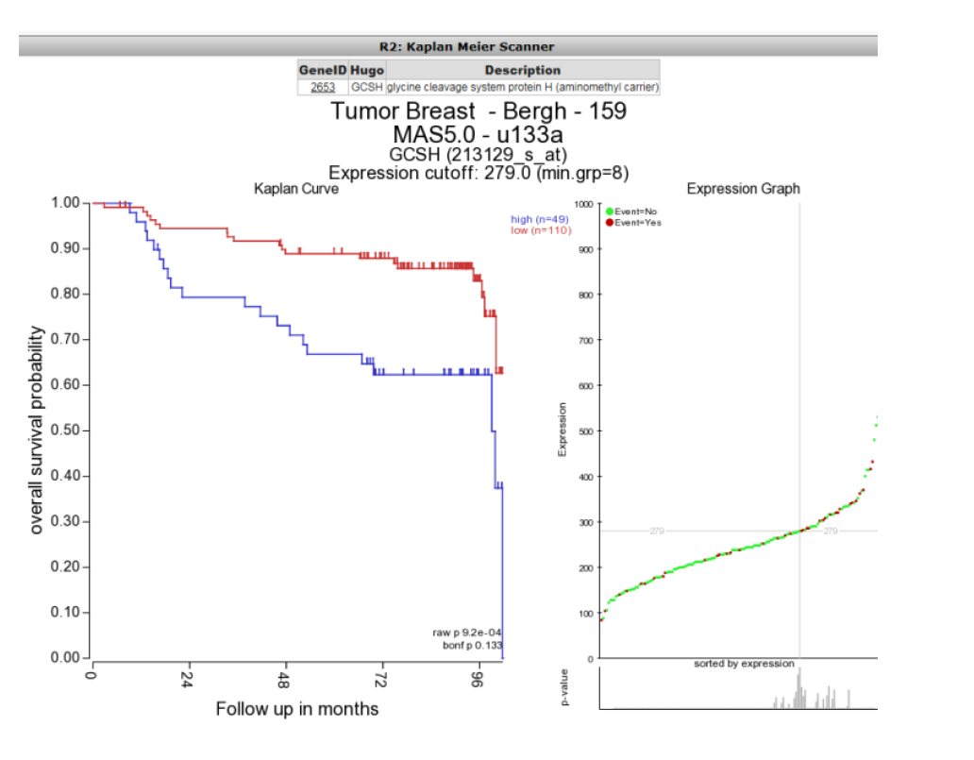

Supplementary figure 4: Uncut gels and blots of figure 2.
RT-PCR analysis using GCSH Tv1 specific primers.
PCR: GCSH PCR: GAPDH
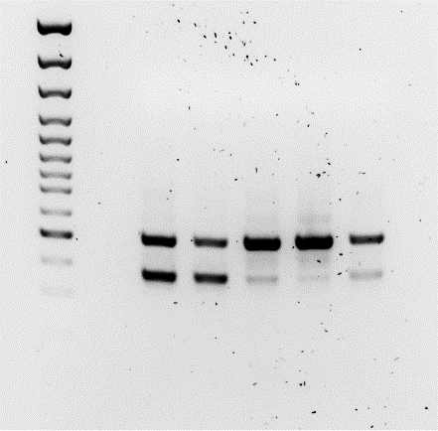
GCSH, PCNA, ß-Actin and AMT protein content in all 5 cell lines was visualized by western blotting.
Western Blot: GCSH Western Blot: PCNA
Western Blot: ß-Actin Western Blot: AMT

Supplementary figure 5. Uncut gels and blots of figure 3.
Northern blotting demonstrated a positive antisense binding of the Tv* to isolated RNA of the cancer cell line MCF-7.
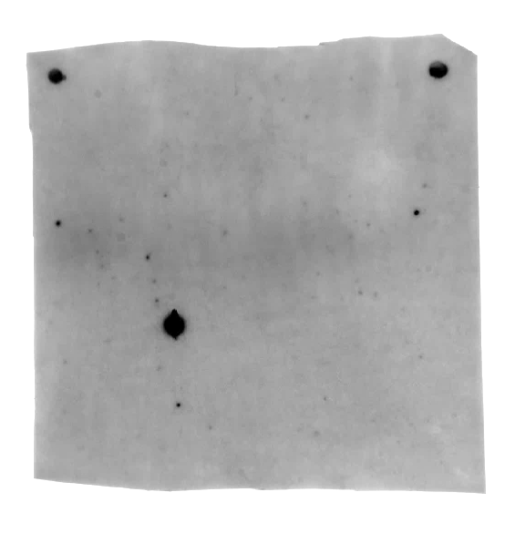

Supplementary figure 6. Uncut gels of figure 4.
- Evidence of the stable binding between Tv* and nanoparticles. All of the 50 ng Tv*-DNA was completely bound to the nanoparticles which cannot pass the agarose gel.
- RT-PCR of GCSH transcripts Tv1 and Tv* of non-transfected (n.t.), mock-transfected (C), Tv*-transfected or GAPDH-transfected MCF-7 cells. Results were similar with silica and magnetic nanoparticles: Tv*-overexpression decreased Tv1 expression, and Tv* was found as the most prominent band. In general, control transfection (nanoparticles, w/o DNA) did not alter the GCSH transcript profile.
Supplementary figure 7. Uncut gels of figure 5.

PCR: GCSH and GAPDH
RT-PCR of GCSH transcripts Tv1 and Tv* of non- (n.t.), control- (C), Tv*- and Tv1-transfected MCF-7 cells. Tv*-overexpression revealed comparable results to nanoparticle mediated transfection: low Tv1 and high Tv* signals. Surprisingly, Tv1-overexpression did not increase the Tv1 content. Furthermore, no Tv* amplificat could be detected but instead a third ~ 300 bp transcript variant (Tv?) appeared.
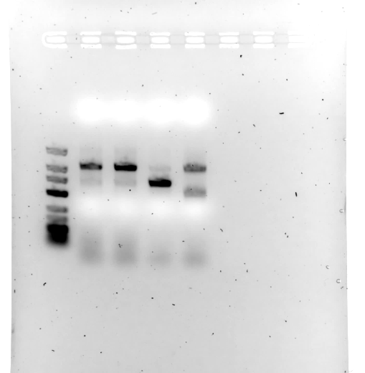

Supplementary figure 8. Uncut western blots of figure 5.
Immuno blots of GCSH, AMT and ß-actin proteins in non-treated (n.t.), mock-treated (C), three individually transfected Tv1- and Tv*-overexpressor MCF-7 cell populations.
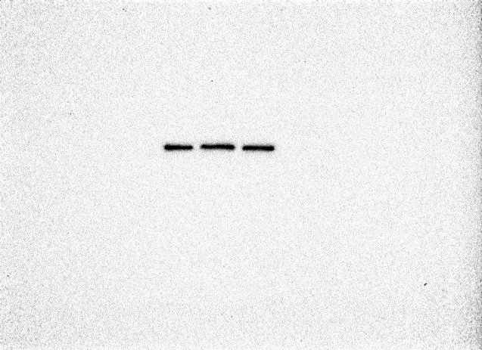
Western Blot: cSHMT Western blot: mSHMT

Western blot: GNMT

