Prevalence of Strongyloides stercoralis infection and hyperinfection syndrome among renal allograft recipients in Central Europe.

Wolfgang Winnicki^{1¶*}, Michael Eder^{1¶}, Peter Mazal², Florian J. Mayer³, Gürkan Sengölge¹, Ludwig Wagner¹

¹Department of Internal Medicine III; Division of Nephrology and Dialysis, Medical University of Vienna, Vienna, Austria
²Department of Clinical Pathology, Medical University of Vienna, Vienna, Austria
³Department of Laboratory Medicine, Medical University of Vienna, Vienna, Austria

* Corresponding author
E-mail: wolfgang.winnicki@meduniwien.ac.at

¶These authors contributed equally to this work.

Supplementary Figure 1:
Time course of relative S. stercoralis IgG signal. Strongyloides stercoralis IgG signals were analyzed at month one and twelve after transplantation (n=50). A decrease of the IgG signal was detected over time (month one: 0.37±0.2, month twelve: 0.31±0.13; p=0.003).

Supplementary Figure 2:
Strongyloides stercoralis larva in pleural effusion stained by immunofluorescence and visualized by confocal microscopy. An S. stercoralis larva in pleural effusion stained by S. stercoralis positive human serum (green) and DNA/nuclei visualization by DAPI (blue).
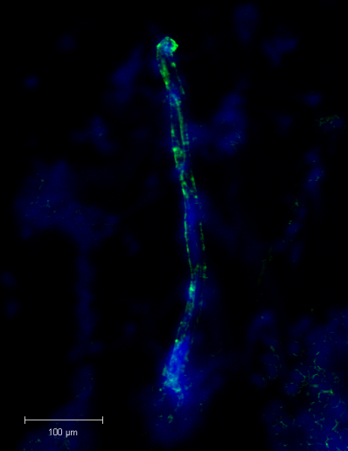
Pleural effusion cytology was prepared using a cytospin preparation from pleural effusion sediment. In brief, 6 mL of pleural effusion was centrifuged at 1500 RPM and the pellet was resuspended in culture medium. One hundred µL of the resultant cell suspension was placed into the funnel of a Shandon Cytocentrifuge (Shandon Southern Instruments, Inc., Sewickley, PA, USA). The cytoslide was air-dried for 2 hours and fixed in acetone for 5 minutes. S. stercoralis IgG positive human serum was diluted 1:50 and the cell containing area was overlaid after wetting in PBS with the S. stercoralis positive serum, followed by placing a hydrophobic circle around the area with a Dako pen (DAKO, Glostrup, Denmark). In parallel, an S. stercoralis negative serum has been used as control. Following an incubation period overnight at 4 °C, slides were washed in PBS and the secondary antibody (rabbit anti-human IgG conjugated with Alexa 488) was incubated for 1 hour at room temperature. 5 minutes before washing, DAPI was added onto the slide for counterstaining DNA/nuclei. After washing in PBS, slides were mounted in Vectashield mounting medium for fluorescence (Vector Laboratories Inc., Burlingame, CA, USA). Images were recorded by confocal microscopy.
Supplementary Figure 3:
Relative S. stercoralis IgG signal in renal allograft recipients with non-migrant (n=155) and migrant (n=45) background. There was no statistical significant difference in IgG signals between non-migrants and migrant recipients (0.36 ± 0.02 vs. 0.40 ± 0.05; p=0.79).
The square with the highest signal in the migrant group represents the patient who has developed a hyperinfection syndrome.

