Title: Relationship of common variants in VEGFA gene with osteonecrosis of the femoral head: A Han Chinese population based association study

Author names and affiliations: Wenlong Ma ^{1*}, Kun Xin ^{2*}, Ke Chen ¹, Hongtao Tang ¹, Honggan Chen ¹, Liqiang Zhi ³ and Hongliang Liu ⁴

¹ Department of Hip Injury and Disease, Luoyang Orthopedic Hospital of Henan Province, Luoyang, Henan, China;
² Department of orthopedics, Taihe Hospital of Traditional Chinese Medicine, Taihe, Anhui, China;
³ Department of Joint Surgery, Honghui Hospital，Xi’an Jiaotong University, Xi'an, Shaanxi, China;
⁴ Department of Trauma, Honghui Hospital，Xi’an Jiaotong University, Xi'an, Shaanxi, China.
*These authors contributed equally to the work.

Corresponding Author:
Liqiang Zhi, M.D. & Ph.D., Department of Joint Surgery, Honghui Hospital, Xi’an Jiaotong University Health Science Center, No.555, Youyi East Road, Xi'an, Shaanxi, China, 710054.
Tel: 86-29-88418009; Fax: 86-29-62818386; E-mail: osteolqzhi@163.com

Hongliang Liu, M.D. & Ph.D., Department of Trauma, Honghui Hospital, Xi’an Jiaotong University Health Science Center, No.555, Youyi East Road, Xi'an, Shaanxi, China, 710054.
Tel: 86-29-88418023; Fax: 86-29-62818386; E-mail: osteohlliu@163.com

Supplemental Table S1. Basic information for the 22 selected SNPs.
CHR | POS | SNP | Alleles | avHet | FUNC
6 | 43785475 | rs10434 | A/G | 0.45 | untranslated-3
6 | 43771590 | rs113747229 | C/T | 0.07 | intron,near-gene-5
6 | 43770093 | rs1570360 | A/G | 0.31 | near-gene-5
6 | 43772357 | rs1885657 | C/T | 0.44 | intron
6 | 43770613 | rs2010963 | C/G | 0.44 | near-gene-5,untranslated-5
6 | 43771240 | rs25648 | C/T | 0.27 | coding-synon,near-gene-5,untranslated-5
6 | 43773103 | rs3024987 | C/T | 0.29 | intron
6 | 43779511 | rs3025006 | C/T | 0.49 | intron
6 | 43779634 | rs3025007 | C/T | 0.48 | intron
6 | 43779840 | rs3025010 | C/T | 0.46 | intron
6 | 43779886 | rs3025011 | A/T | 0.11 | intron
6 | 43780225 | rs3025012 | A/G | 0.22 | intron
6 | 43780620 | rs3025017 | A/G | 0.11 | intron
6 | 43781373 | rs3025020 | C/T | 0.36 | intron
6 | 43781426 | rs3025021 | C/T | 0.39 | intron
6 | 43782819 | rs3025029 | A/G | 0.24 | intron
6 | 43783300 | rs3025032 | C/T | 0.34 | intron
6 | 43783622 | rs3025035 | C/T | 0.27 | intron
6 | 43783932 | rs3025036 | C/G | 0.35 | intron
6 | 43785588 | rs3025053 | A/G | 0.16 | untranslated-3
6 | 43779212 | rs62401162 | C/T | 0.23 | intron
6 | 43768652 | rs699947 | A/C | 0.44 | near-gene-5
CHR: chromosome; POS: genomic position; avHet: average of heterogosity; FUNC: function.

Supplemental Table S2. Results of the gene by environmental factor analysis for 22 selected SNPs.
SNP | ENV | Z statistics | P | OR
rs699947_A | smoking | 0.72 | 0.4686 | 1.14
rs1570360_A | smoking | 0.64 | 0.5205 | 1.15
rs2010963_C | smoking | 0.30 | 0.7679 | 1.05
rs25648_T | smoking | -0.70 | 0.4813 | 0.84
rs113747229_T | smoking | 0.25 | 0.8046 | 1.07
rs1885657_C | smoking | -0.61 | 0.5432 | 0.90
rs3024987_T | smoking | -0.65 | 0.5188 | 0.88
rs62401162_C | smoking | -0.27 | 0.7872 | 0.94
rs3025006_C | smoking | 0.32 | 0.7468 | 1.05
rs3025007_T | smoking | -1.07 | 0.2835 | 0.83
rs3025010_C | smoking | 1.01 | 0.3122 | 1.20
rs3025011_T | smoking | -0.69 | 0.4886 | 0.84
rs3025012_G | smoking | -0.02 | 0.9866 | 1.00
rs3025017_A | smoking | -0.72 | 0.4685 | 0.84
rs3025020_T | smoking | -2.36 | 0.0184 | 0.69
rs3025021_T | smoking | -1.56 | 0.1197 | 0.74
rs3025029_A | smoking | -0.99 | 0.3228 | 0.82
rs3025032_T | smoking | 0.74 | 0.4572 | 1.21
rs3025035_T | smoking | 0.79 | 0.4316 | 1.17
rs3025036_G | smoking | 0.45 | 0.6557 | 1.10
rs10434_A | smoking | 0.35 | 0.7229 | 1.07
rs3025053_A | smoking | -0.11 | 0.9135 | 0.97
ENV: environmental factor.

Supplemental Table S3. eQTL data for rs2010963 on gene VEGFA.
Gene Symbol | SNP | P | Effect Size | T-Statistic | Tissue
VEGFA | rs2010963 | 3.90×10⁻⁷ | -0.21 | -5.2 | Thyroid
VEGFA | rs2010963 | 0.0002 | -0.14 | -3.8 | Esophagus - Muscularis
VEGFA | rs2010963 | 0.00025 | -0.18 | -3.7 | Pancreas
VEGFA | rs2010963 | 0.00063 | -0.16 | -3.5 | Adrenal Gland
VEGFA | rs2010963 | 0.0079 | -0.15 | -2.7 | Esophagus - Gastroesophageal Junction
VEGFA | rs2010963 | 0.012 | -0.33 | -2.6 | Brain - Spinal cord (cervical c-1)
VEGFA | rs2010963 | 0.014 | -0.22 | -2.5 | Minor Salivary Gland
VEGFA | rs2010963 | 0.015 | -0.096 | -2.5 | Artery - Aorta
VEGFA | rs2010963 | 0.016 | -0.073 | -2.4 | Cells - Transformed fibroblasts
VEGFA | rs2010963 | 0.022 | -0.056 | -2.3 | Artery - Tibial
VEGFA | rs2010963 | 0.05 | -0.22 | -2 | Brain - Cerebellar Hemisphere
VEGFA | rs2010963 | 0.054 | -0.17 | -1.9 | Brain - Cerebellum
VEGFA | rs2010963 | 0.088 | -0.06 | -1.7 | Skin - Sun Exposed (Lower leg)
VEGFA | rs2010963 | 0.11 | 0.071 | 1.6 | Breast - Mammary Tissue
VEGFA | rs2010963 | 0.12 | -0.044 | -1.6 | Muscle - Skeletal
VEGFA | rs2010963 | 0.13 | -0.11 | -1.5 | Colon - Sigmoid
VEGFA | rs2010963 | 0.16 | -0.086 | -1.4 | Cells - EBV-transformed lymphocytes
VEGFA | rs2010963 | 0.16 | -0.088 | -1.4 | Liver
VEGFA | rs2010963 | 0.19 | -0.089 | -1.3 | Small Intestine - Terminal Ileum
VEGFA | rs2010963 | 0.2 | 0.043 | 1.3 | Adipose - Subcutaneous
VEGFA | rs2010963 | 0.2 | -0.068 | -1.3 | Heart - Left Ventricle
VEGFA | rs2010963 | 0.22 | -0.13 | -1.2 | Brain - Cortex
VEGFA | rs2010963 | 0.22 | -0.044 | -1.2 | Esophagus - Mucosa
VEGFA | rs2010963 | 0.22 | -0.039 | -1.2 | Skin - Not Sun Exposed (Suprapubic)
VEGFA | rs2010963 | 0.33 | -0.069 | -0.97 | Prostate
VEGFA | rs2010963 | 0.37 | -0.051 | -0.9 | Artery - Coronary
VEGFA | rs2010963 | 0.39 | -0.033 | -0.86 | Adipose - Visceral (Omentum)
VEGFA | rs2010963 | 0.4 | 0.032 | 0.84 | Heart - Atrial Appendage
VEGFA | rs2010963 | 0.4 | -0.033 | -0.85 | Lung
VEGFA | rs2010963 | 0.57 | -0.082 | -0.58 | Brain - Hippocampus
VEGFA | rs2010963 | 0.6 | -0.074 | -0.52 | Brain - Hypothalamus
VEGFA | rs2010963 | 0.69 | -0.027 | -0.4 | Pituitary
VEGFA | rs2010963 | 0.71 | -0.0096 | -0.37 | Whole Blood
VEGFA | rs2010963 | 0.73 | 0.036 | 0.35 | Brain - Caudate (basal ganglia)
VEGFA | rs2010963 | 0.73 | -0.037 | -0.34 | Brain - Putamen (basal ganglia)
VEGFA | rs2010963 | 0.73 | -0.015 | -0.34 | Nerve - Tibial
VEGFA | rs2010963 | 0.74 | 0.046 | 0.33 | Brain - Amygdala
VEGFA | rs2010963 | 0.76 | 0.034 | 0.31 | Brain - Frontal Cortex (BA9)
VEGFA | rs2010963 | 0.76 | 0.034 | 0.31 | Brain - Nucleus accumbens (basal ganglia)
VEGFA | rs2010963 | 0.77 | 0.047 | 0.3 | Brain - Substantia nigra
VEGFA | rs2010963 | 0.78 | 0.027 | 0.28 | Vagina
VEGFA | rs2010963 | 0.79 | 0.025 | 0.26 | Ovary
VEGFA | rs2010963 | 0.79 | 0.022 | 0.26 | Spleen
VEGFA | rs2010963 | 0.87 | 0.018 | 0.16 | Uterus
VEGFA | rs2010963 | 0.88 | 0.01 | 0.16 | Testis
VEGFA | rs2010963 | 0.92 | -0.012 | -0.1 | Brain - Anterior cingulate cortex (BA24)
VEGFA | rs2010963 | 0.96 | -0.0018 | -0.047 | Stomach

Supplemental table S4. Summarized information of eQTL signals achieved genome-wide significance.
Gene Symbol | SNP | P | Effect Size | Tissue
GNMT | rs113747229 | 5.50×10⁻⁶ | -0.54 | Thyroid
VEGFA | rs2010963 | 3.90×10⁻⁷ | -0.21 | Thyroid
MRPS18A | rs3024987 | 3.20×10⁻⁶ | -0.24 | Cells - Transformed fibroblasts
VEGFA | rs3025006 | 6.50×10⁻⁷ | 0.19 | Thyroid
TCTE1 | rs3025017 | 2.90×10⁻⁵ | 0.46 | Muscle - Skeletal
POLH | rs699947 | 2.00×10⁻⁶ | 0.19 | Whole Blood

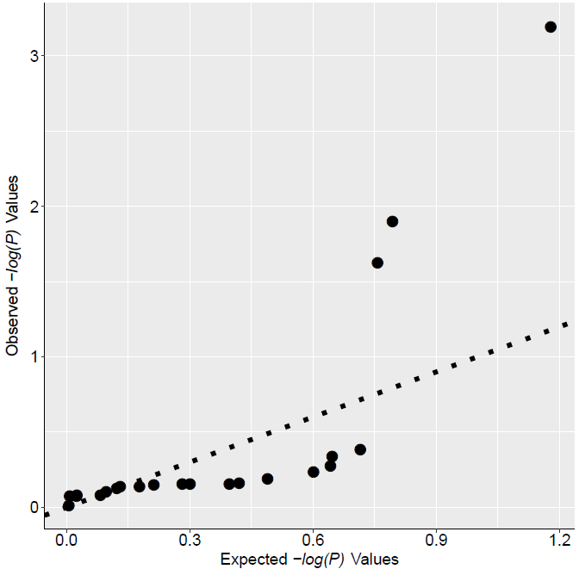
Supplemental Figure S1. Q-Q plot of the single marker based association results.

